Yes-cart. Requirements to installer. v 0.2

Introduction.

Yes-cart installer is targeted for people with minimal IT experience, that have minimal knowledge about web servers, databases, etc.

Objective.

Yes-cart installer allows to install yes-cart e-commerce platform to different kind of
environments, that may be clear or may have already configured components, like data bases,
http / web services, etc. Installer must perform minimal configuration for 3rd party services to allow start of yes-cart platform.

Gather information about yes-cart configuration.

Yes-cart has a set of preconfigured databases, storefront themes and graphics assets. Yes-cart not support at this moment database localization (i.e. product has description on one language only). The set of allowed themes and databases depends, from selected language. For example stationery and laptops preconfigured databases available if user select eng. language. For russian language allowed jewelry and parfurmery. Some preconfigured databases has minimal set of information and products, skus, categories, images, etc. must be added via import process. Import not a part of installer, but has to be initiated by installer.

Yes-cart support multi store per single war, i.e. signle war may serve different storefronts on different urls. Example server with ip address 192.168.1.23 has two different names and storefronts: bestlaptop.com and hplattops.com , that belong to one merchant (one db, one payment gateway), but has different visual themes.

User may provide necessary information , but he also may skip it and significant default has to be used to configure yes-cart.
What information need to be collected.

Configuration parameter | Where must be used. How impact the installation process. What artifacts will be used. Comments | What to use if user skip this step of configuration .
Solution language | Filter available preconfigured yes-cart databases and themes. | Current OS language or english if OS has different than russian or english locales
Select one of preconfigured merchant configuration. Empty db configuration also present in this list |  | First from list.
Input one ore more url, that will be served by storefront | Need to provide hint in case if host already has domain name. Need to provide hint for adding url with www if user input domain name without it and vise versa.  Provided names substituted into db script.  Provided names added into hosts file in case if host’s names different from provided names. | Use default urls from specified set: (www.)demo-local.yes-cart.com
Select is storefront will be accesable via local hos | localhost must be added to db script.
Storefront name | Substituted in db script and localization property files. | Yes-Cart local demo storefront
Admin user email and password | Used in JAAS tables. Must be substituted in db script | admin@demo-local.yes-cart.com  password
Marketing email and name | Substituted in email templates property files. | marketing@demo-local.yes-cart.com  Marketing at local yes-cart demo
Cart password | Cart stored on client side. To prevent cart manipulation , it has to be crypted. Or need to be generated. Used in xml descriptor. | Generate it

Gather information about yes-cart runtime.

At this moment yes-cart supports tomcat http server (jboss in nearest future). And 3 databases Derby, MySQL and Oracle. And two OS - Windows and Linux (RedHat based distributions) .
Installation process must be very sophisticated to configure yes-cart runtime environment.

The activity diagram is depicted below.
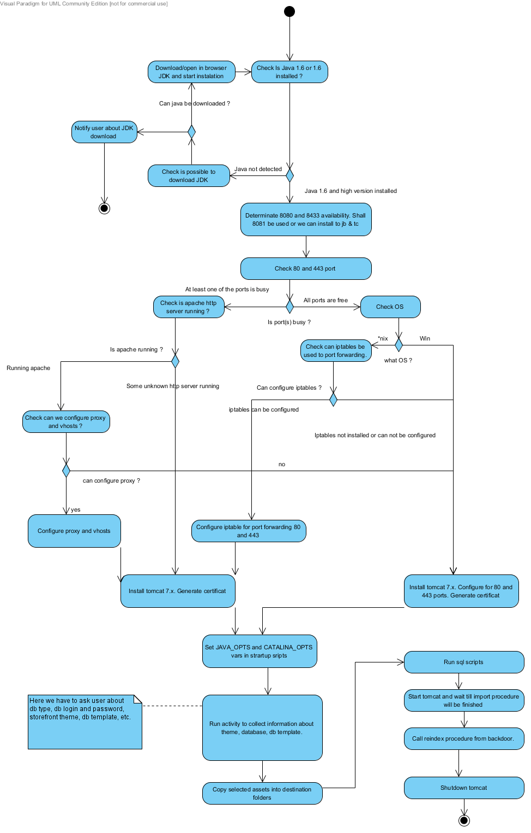

3rd party components, that must be included into installer:

1. JAI
2. Tomcat 7
3. Derby db
4. JDBC drivers for derby, mysql, oracle.

3rd party components, that may be dowloaded:

1. Java JDK 1.6 SE.

