Nan Xu, Ph.D.

Assistant Professor (starting Dec 2024)

Email: nanxu@umd.edu

Website: [www.inspirelab.site](https://www.inspirelab.site)

LinkedIn: [linkedin.com/in/nan-xu2022](https://www.linkedin.com/in/nan-xu2022)

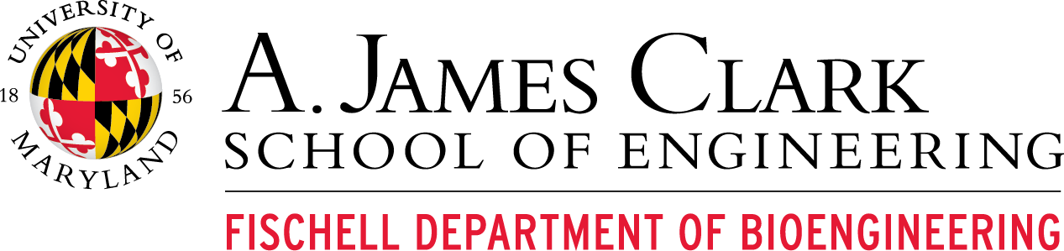

# POSTDOCTORAL ASSOCIATE POSITION -- ANALYSIS

The Imaging- and Neuro-computations for Precision Informatics Research (INSPIRE) Lab is launching at the Fischell Department of Bioengineering at the University of Maryland, College Park!

We are seeking a self-motivated postdoctoral associate in computational/analytical neuroscience to join us. INSPIRE Lab integrates data science and brain science. We model and analyze spatiotemporal brain dynamics, uncovering brain function and neurological disorders using multimodal imaging data. Please visit [www.inspirelab.site](http://www.inspirelab.site/) for more information.

This position focuses on developing novel analyses for functional neuroimaging data to gain new insights into the functional brain dynamic system. The successful applicant will lead this role while receiving mentorship in research, scientific communication, conference presentations, manuscript writing, and contributing to grant writing. S/he will also be responsible for training junior trainees and assisting in the maintenance of the lab's computing systems and environment.

Located in A. James Clark Hall, the INSPIRE Lab is adjacent to neuroimaging core facilities and has high-performance computing power. UMD's proximity to government research facilities (e.g., NIH, NSF, DOD, FDA, etc.) and world-leading hospitals offers numerous collaboration opportunities. The campus is conveniently located near Washington D.C. and Baltimore, providing diverse living and recreational options.

The PI of the INSPIRE Lab is committed to providing personalized guidance and support tailored to individual goals, while actively promoting Diversity, Equity, and Inclusivity (DEI). Compensation is based on NIH postdoctoral guidelines and includes a competitive benefits and retirement package offered by UMD. The position offers a renewable, annual contract with the expectation of completing 2-3 years of postdoctoral training. The preferred start date is January 2025, though this is negotiable.

**Qualifications:**

* Ph.D. in Electrical & Computer Engineering, Biomedical/Bioengineering, Computational Neuroscience, or a related field.
* Strong expertise in computational neuroscience, including data science, statistical analysis, and coding skills (Python and MATLAB).
* Demonstrated experience in preprocessing and analyzing functional neuroimaging data, such as fMRI, MEG, EEG, and/or optical imaging data.
* Proficiency in tools such as FSL, ANTs, AFNI, FreeSurfer, and Linux OS.
* Excellent communication and writing skills.

**How to Apply:** Please assemble the following: 1) a letter of interest/cover letter, 2) CV, and 3) a list of three references. The cover letter should describe your previous experience, interest and expectations for the position, and preferred start date. Email the application as a single PDF file to Dr. Nan Xu ([inspirelabx@gmail.com](mailto:inspirelabx@gmail.com)) with “Postdoc Application – analysis” in the subject line.

*Offers of employment are contingent on completion of a background check. Information reported by the background check will not automatically disqualify you from employment. The University of Maryland, College Park, an equal opportunity/affirmative action employer, complies with all applicable federal and state laws and regulations regarding nondiscrimination and affirmative action; all qualified applicants will receive consideration for employment. The University is committed to a policy of equal opportunity for all persons and does not discriminate on the basis of race, color, religion, sex, national origin, physical or mental disability, protected veteran status, age, gender identity or expression, sexual orientation, creed, marital status, political affiliation, personal appearance, or on the basis of rights secured by the First Amendment, in all aspects of employment, educational programs and activities, and admissions.*