**0630-Java编程语言基础--基础语法(下2）**

**本节内容接上节内容，继续讲解 Java 基础语法的剩余内容。主要包括流程控制中的条件语句、循环语句以及跳转语句、数组的相关操作以及用户输入的操作。涉及的知识点包括流程控制、数组和用户输入操作。**

**(接上部分)**

**2.数组**

**(1)一维数组** 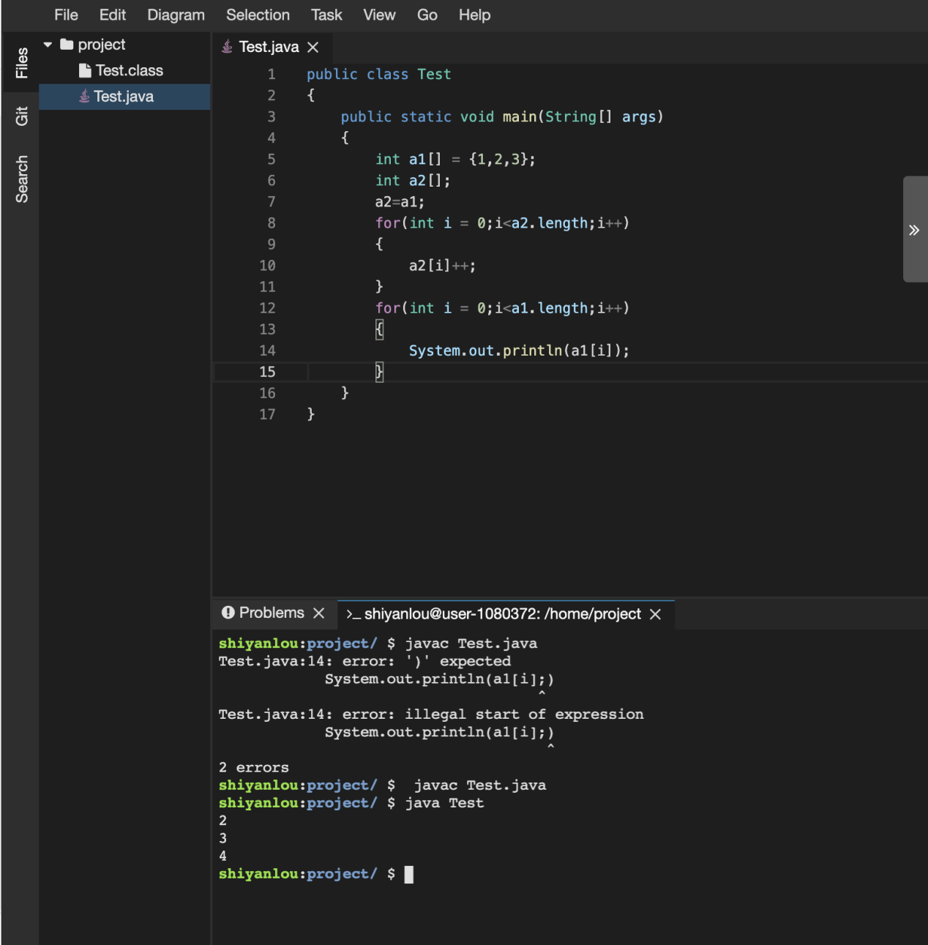

public class Test

{

public static void main(String[] args)

{

int a1[] = {1,2,3};

int a2[];

a2=a1;

for(int i = 0;i<a2.length;i++)

{

a2[i]++;

}

for(int i = 0;i<a1.length;i++)

{

System.out.println(a1[i]);

}

}

}

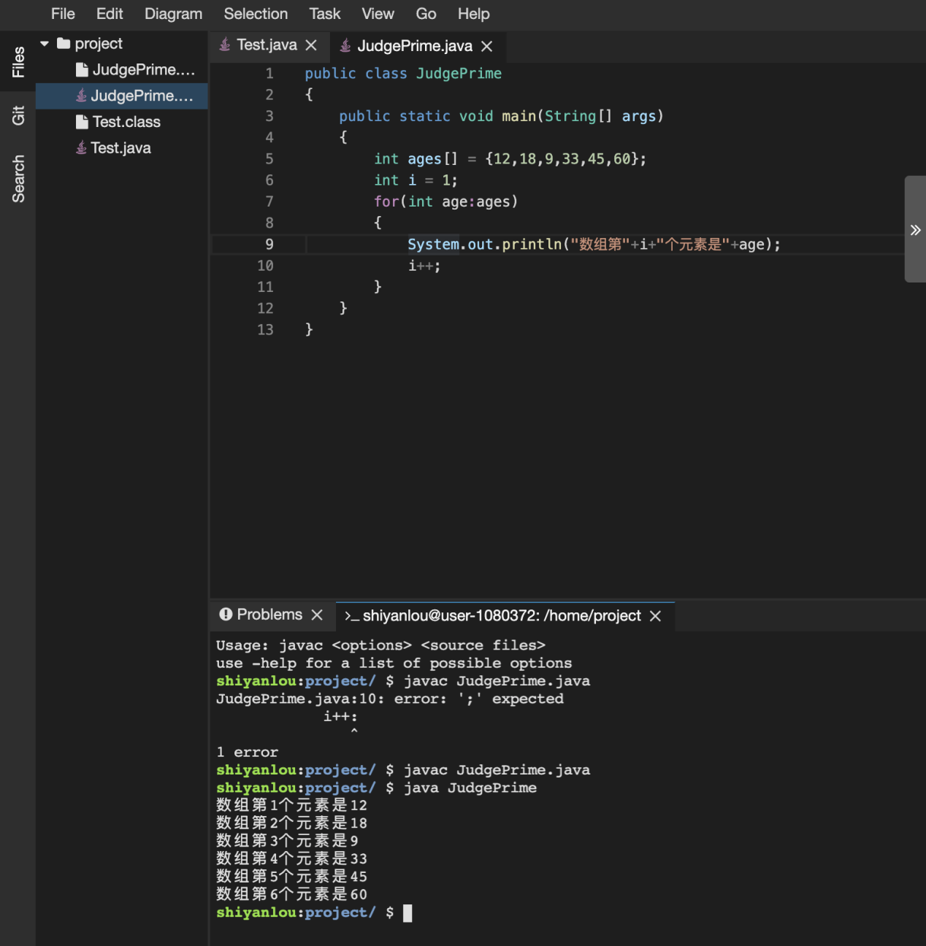

public class JudgePrime

{

public static void main(String[] args)

{

int ages[] = {12,18,9,33,45,60};

int i = 1;

for(int age:ages)

{

System.out.println("数组第"+i+"个元素是"+age);

i++;

}

}

}

1. **二维数组**

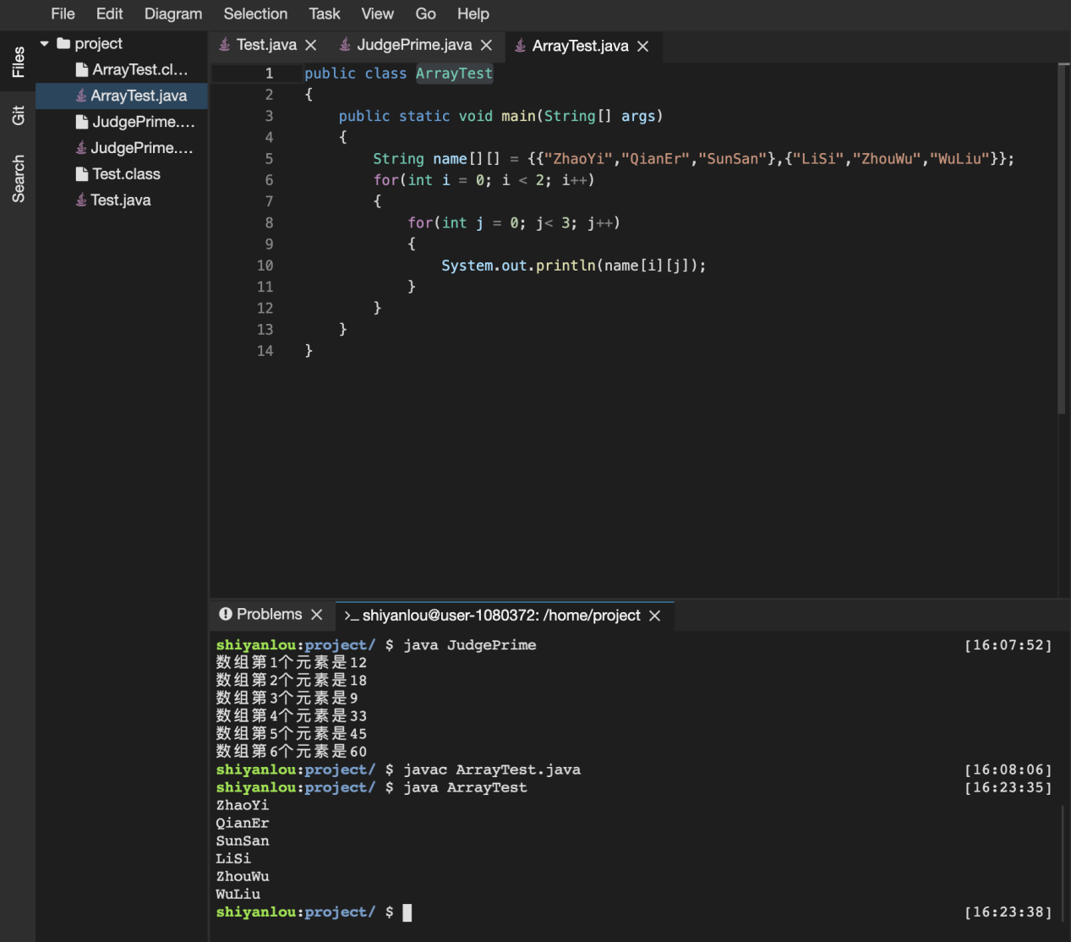

public class ArrayTest

{

public static void main(String[] args)

{

String name[][] = {{"ZhaoYi","QianEr","SunSan"},{"LiSi","ZhouWu","WuLiu"}};

for(int i = 0; i < 2; i++)

{

for(int j = 0; j< 3; j++)

{

System.out.println(name[i][j]);

}

}

}

}

1. **练习-数组应用**

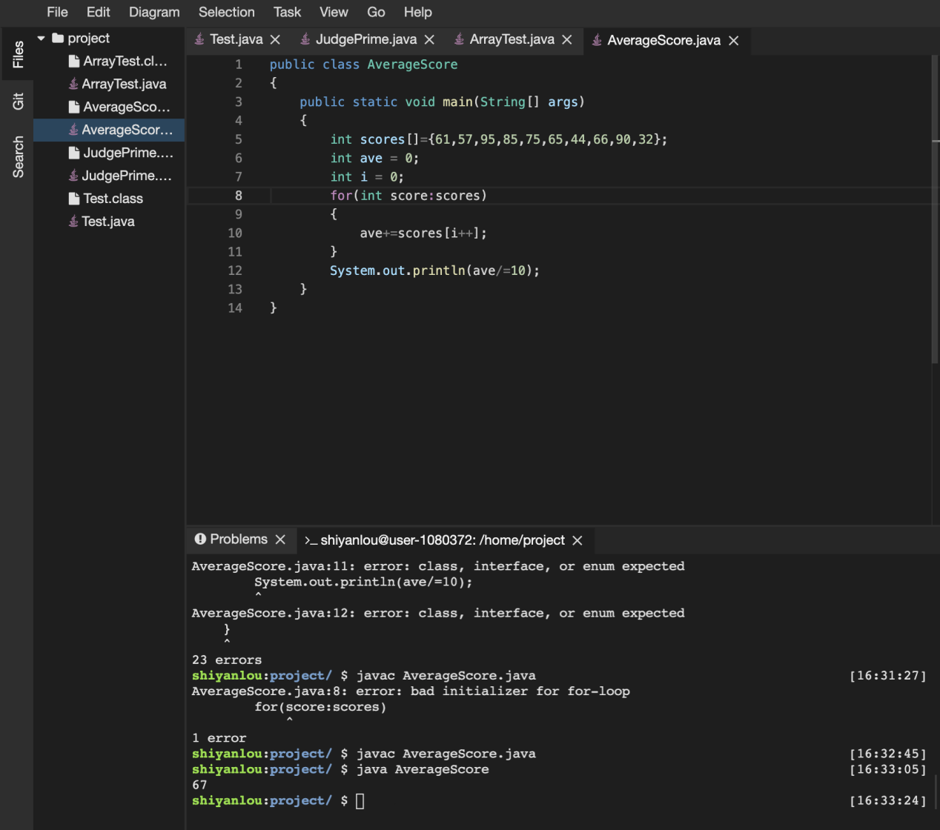

public class AverageScore

{

public static void main(String[] args)

{

int scores[]={61,57,95,85,75,65,44,66,90,32};

int ave = 0;

int i = 0;

for(int score:scores)

{

ave+=scores[i++];

}

System.out.println(ave/=10);

}

}

1. **用户输入操作**

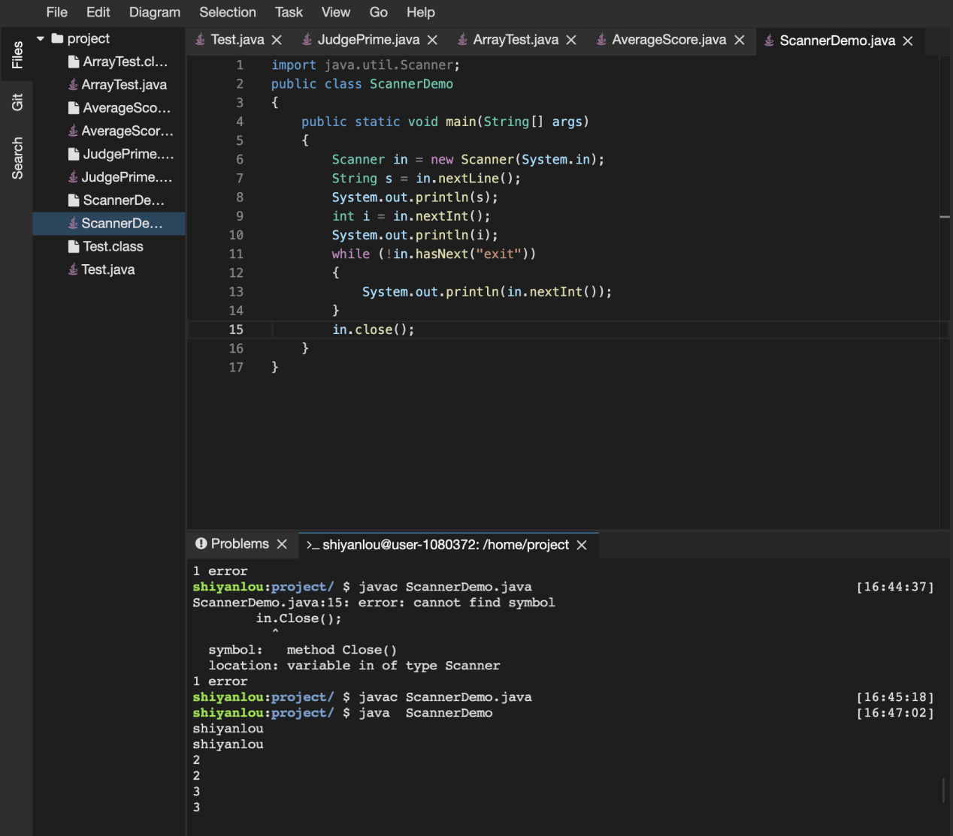

import java.util.Scanner;

public class ScannerDemo

{

public static void main(String[] args)

{

Scanner in = new Scanner(System.in);

String s = in.nextLine();

System.out.println(s);

int i = in.nextInt();

System.out.println(i);

while (!in.hasNext("exit"))

{

System.out.println(in.nextInt());

}

in.close();

}

}

1. **练习题**

**(1)用户输入**

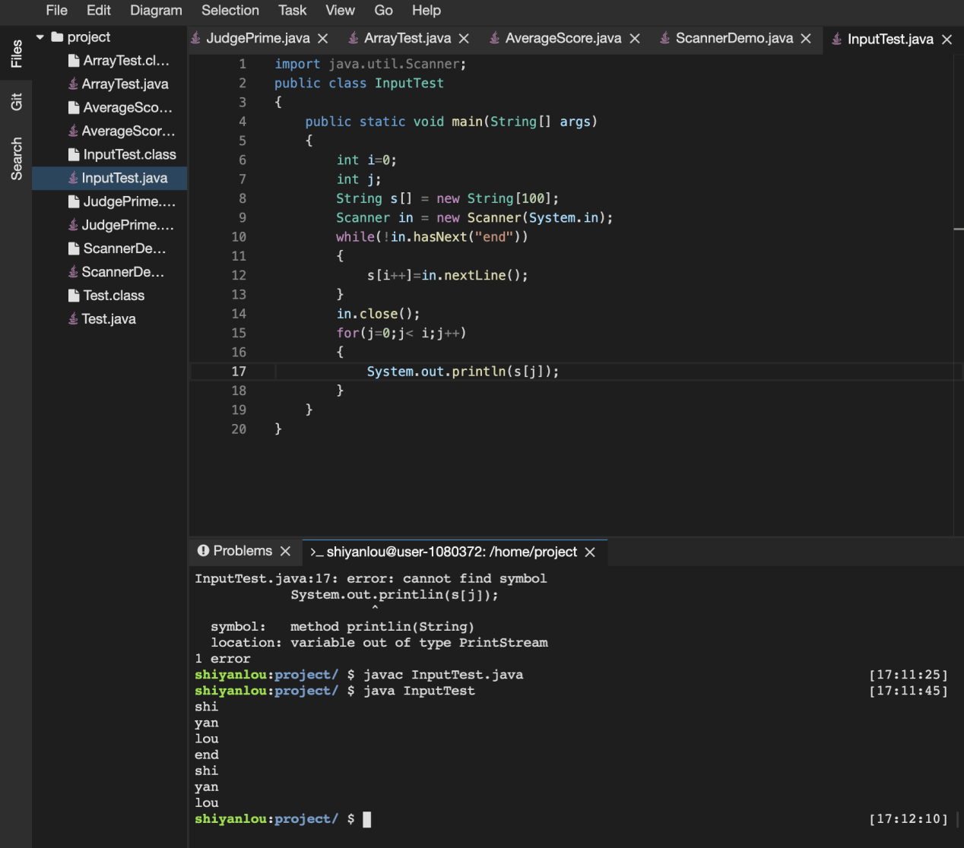

import java.util.Scanner;

public class InputTest

{

public static void main(String[] args)

{

int i=0;

int j;

String s[] = new String[100];

Scanner in = new Scanner(System.in);

while(!in.hasNext("end"))

{

s[i++]=in.nextLine();

}

in.close();

for(j=0;j< i;j++)

{

System.out.println(s[j]);

}

}

}

1. **最大最小值**

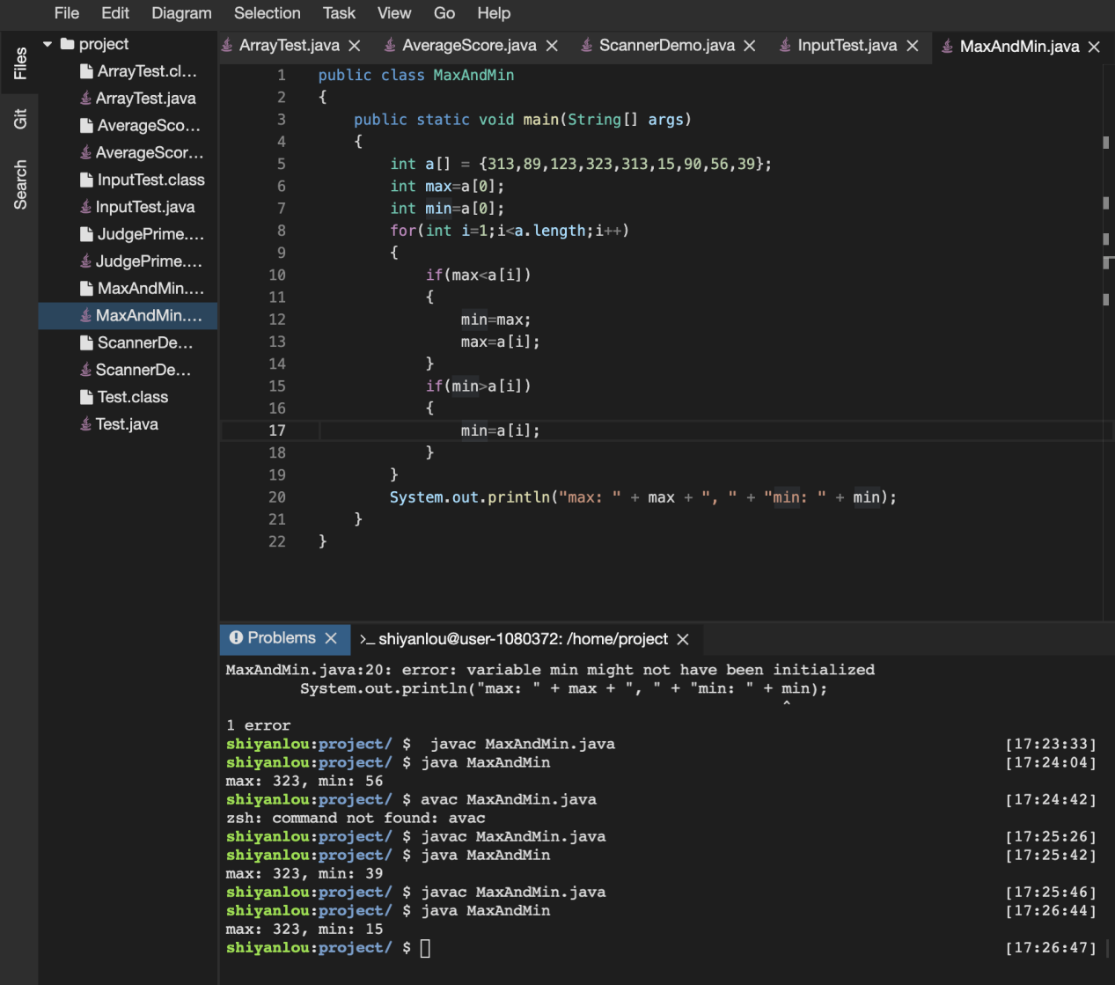

public class MaxAndMin

{

public static void main(String[] args)

{

int a[] = {313,89,123,323,313,15,90,56,39};

int max=a[0];

int min=a[0];

for(int i=1;i<a.length;i++)

{

if(max<a[i])

{

min=max;

max=a[i];

}

if(min>a[i])

{

min=a[i];

}

}

System.out.println("max: " + max + ", " + "min: " + min);

}

}