**EXP—1**

**LED Blinking with Push Button**

**Aim:-** Write an embedded C program to interface LED and push button withArduino UNO.

**Software used:**- Arduino IDE and Simulator

**Program:-**

**// Program to interface LED with Arduino UNO**

const int buttonPin = 4;  // Pin connected to pushbutton

const int ledPin = 12;  // Pin connected to LED

int buttonState; // Give pushbutton a value

void setup()

{

pinMode(ledPin, OUTPUT);  // Set LED pin as output

pinMode(buttonPin, INPUT); // Set pushbutton pin as input

 }

void loop() { buttonState = digitalRead(buttonPin); // Read input from pin 4

if(buttonState == LOW) { // If pushbutton is pressed, set as low

 digitalWrite(ledPin, HIGH); // Turn on LED

delay((500));

 digitalWrite(ledPin, LOW);

 delay(500);

}

else

{

  digitalWrite(ledPin, LOW); // Otherwise, turn off LED

   }

   }

**Interfacing Diagram:-**

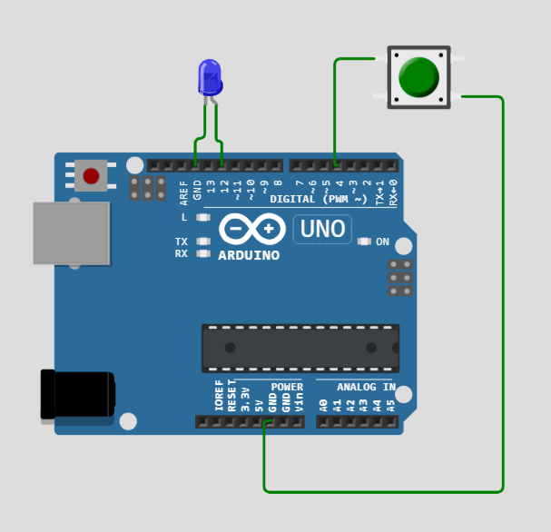

**Results:-** The embedded program is written and simulated successfully.