**Physics Line-Link Puzzle Game**

***Version 1***

***Components explanation***

**Node**

Is a component which use to define a ball which player interact to.

**PhysicNodeActivator**

Is a component which use to activate physics after dropped from ceil, It should be included with game object which is places Node component when the game scene have the ceil.

**CeilAndFloorControls**

Is a component which use to define ceil which nodes drops from and active nodes physics after trigger exit by PhysicNodeActivator component, in addition it’s use for blow controls.

**BoardControllerLineLinkPhysic**

Is a component which handle all puzzle solving rules, you can configuring following variables from inspector:

* **Moving Node Offset** - Offset from finger which touched on a node
* **Match Count** - Minimum quantity of nodes to be solve
* **Levelling Count** - Minimum quantity of nodes to increase a node level after solve [not implemented]
* **Swap Speed** - Move speed of node while swapping position
* **Clear Delay** - Delay before solved nodes are clearing
* **Drop Delay** - Delay before dropping new nodes
* **Node Prototypes** - An nodes game object which instantiating later in a board
* **Input Camera** - A camera which use to receiving touch/click input, if leave it none “Main Camera” will be used, A orthographic camera which can see every nodes is recommend
* **Can Link Difference Node**– If set to true, player can link with nodes which is not same color
* **Node Quantity** – Quantity of balls that spawn in a game
* **Node Drop Transforms** – An positions that balls spawn
* **Line Prototype**– Line renderer prototype, line which links between nodes
* **Highlight Prototype** – Highlight effect of linked nodes
* **Line Offset**– Line offset from nodes
* **Highlight Offset**– Highlight effect offset from nodes
* **Can Circuit Link On**– If linked equal or more than this value, player can link with first node as circuit link (Minimum: 3, lesser will not able for circuit link)
* **Show Linking Line**– If true, line from last node to touch position will be shown

***Setup guide***

1. **Node** – You can add “Node” component to any game object which is included any Collider2D it’s required for touch events and add Rigidbody2D because it’s movable object, you can set rigibody variables as you wish  
     
   **Example**   
   - I’ve create four circle sprites with difference colors  
   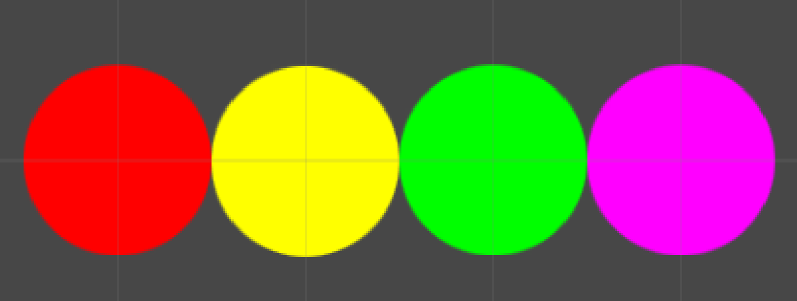  
     
   - Then include “Node”, “CircleCollider2D” and “Rigidbody2D” component to each nodes  
   - PhysicNodeActivator should be included to Node, if you want the game to have the ceil.
2. **Frames –** A game have frames that prevent balls to crossing out, for this example I’ve create 3 colliders for left-side, right-side and a bottom side which is curved  
   Left side and Right side – Just create empty GameObject (From menu GameObject -> Create Empty) then add BoxCollider2D, set size x = 5, y = 1136 and move them to each side  
   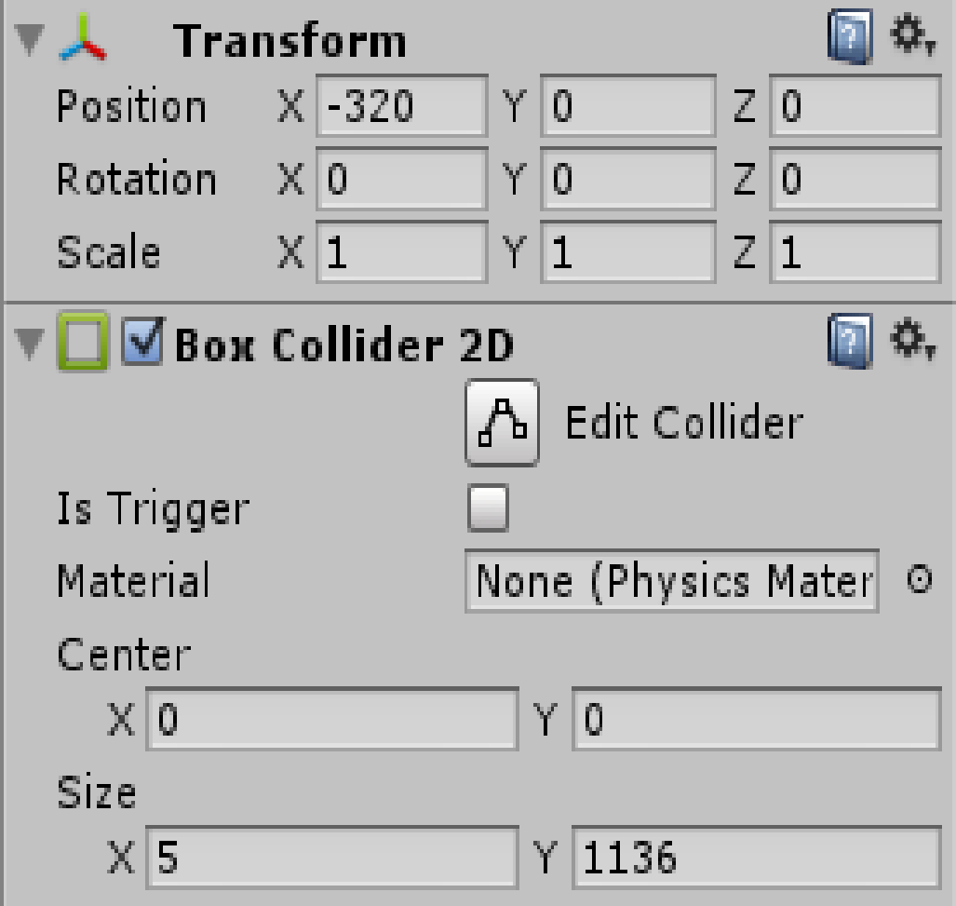  
   Top(Ceil), Bottom side – Just create a sprite which is curved and add PolygonCollider2D  
   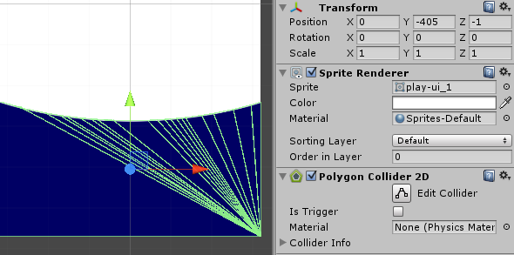
3. **Spawn Positions –** An empty game objects that its position used for locate to spawn nodes, Just create game objects and move to positions that you want balls to spawn**.**
4. **BoardControllerLineLinkPhysic** – You can add “BoardControllerLineLinkPhysic” component to any game object then add an nodes to “Node Prototypes” and setting as you wish  
   **Example**- I’ve create empty gameobject and then add “BoardControllerLineLinkPhysic” component  
   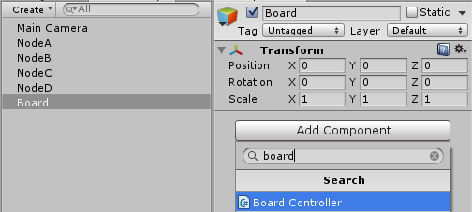  
   - Place an nodes to “Node Prototypes”  
   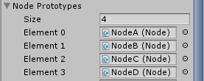  
   - Place an spawn positions to “Node Drop Transforms”  
   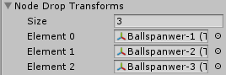
5. **CeilAndFloorControls -** If you want the game to have the ceil frame you have to define it (as in 2.) then include this component to any game object and place the ceil here.

Now your game is ready to play, to reskin just change balls sprites ☺

**Thank you for purchase**

Contact: [ittipon.bay@gmail.com](mailto:ittipon.bay@gmail.com) <Ittipon>

Demo: <http://bit.ly/1pImIqb>