
Organizing Your Website:
Taking Stock of Content

The content inventory and planning process

A content inventory and analysis is an excellent way to determine what content exists on your current website, what needs to be updated, what can be removed, and what new content you need to create to meet your communications goals. After completing an inventory and analysis, it will be easier to build your new site, knowing what is needed and what is not.

While the tools and methods you use are up to you, it is often beneficial to follow the process outlined above when working with content. This is true for any website, but especially when adopting the common website structure from Harvard Web Publishing, since you will likely need to spend time organizing your content. Below are some tools and methods you may find helpful.

Step 1: Build the inventory
Begin by generating a list of all of the webpages and documents on your current website. A helpful tool to automate this process is xml-sitemaps.com. You can build the inventory by hand (you may need to in some cases described below), but this tool can save time.

- Go to xml-sitemaps.com.

- Enter your website URL, click “start,” and XML Sitemap will generate a list of the pages on your site for free.

- Scroll to “download sitemap in text format” to download the list as a text (.txt) file.

- Download the Excel content inventory template from HWP’s website.

- Open the .txt file and copy the URLs into the content inventory template, to the “content inventory-current site” tab.

- If your site is large, or if it is not easy to tell what the page is from the URL, you can add in the page title, and the current website section to help with navigating the spreadsheet. If a piece of content is not a webpage (such as a PDF) you can make note of this in the “format” column.

Please note: XML Sitemap will only crawl the first 500 pages of a website. Pages after 500 will not be captured. XML sitemap cannot crawl iSites. For iSites, or other sites that do not allow web crawlers, you may have to look at the folder structure of the website or click through all of the pages to manually create an inventory of the site. Harvard Web Publishing can provide assistance with the creation of a content inventory as part of Premium level service.

Step 2: Evaluate existing content
Review each page, PDF and other assets listed on the inventory. For each line in the spreadsheet, indicate the following:

- OUCH status

O = Out-of-date. Content that is still useful and will move to the new site, but should be updated.
U = Unnecessary. Content that is not needed at all. It should not be moved to the new site.
C = Current. Content that is fine as is, up-to-date, and just needs to be moved to the new site.
H = Have to write. H will not be used on your first pass of the content inventory, so nothing on the inventory of the current site should be marked H. H will be used for the gap analysis part of the exercise below.

- Owner: Who in your organization is responsible for writing and updating this content? This information will be helpful when you start updating content.

- Other fields: Use the notes field to elaborate on the status of the content as needed. There is a priority field if you would like to determine what content is most important to your organization, and an audience field if your site serves multiple audiences, if you find this information helpful for your site. All of the above columns are just suggested methods – use whatever method works best for your department when evaluating your content.

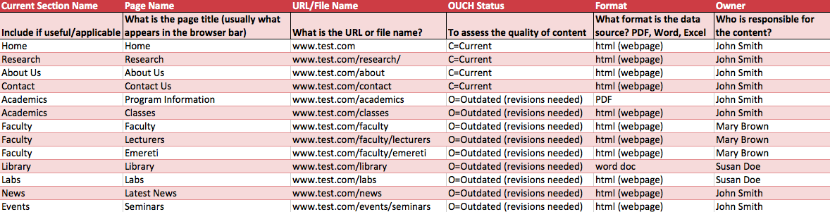

Step 3: Identify gaps in content
Next, identify what content you would like to add to the new site, and begin the content plan – a roadmap for your new site.

- Sort your content by OUCH status.

- Copy the O and C content over to the tab titled “content plan.” The U content should be left behind since it is content you have marked for exclusion from the new site.

- In the “content plan – new site” tab, add lines for content you would like to add to the site. Think about what kind of content you will need to add to serve your audiences and achieve your communications goals.

- Assign all of the new content an H status, as well as an owner, and any other information you included for your current content (e.g. priority, audience).

Step 4: Map content into the new site structure
Harvard Web Publishing provides standard information architecture (IA) frameworks for academic, administrative, project, and lab/research websites. These frameworks provide common sections to help site visitors find what they need, such as Academics, Services, About, and People.

- Refer to the Organize Your Website section on the HWP site to find a guide to using the IA for your particular site (academic, administrative, project, or lab/research).

- Using the categories provided on the IA, start assigning new content to the appropriate section using the “new section name” column. The corresponding sections for an Academic site, for example, would be Academics, Research, People, and so on. This is where the content will reside in the new site.

- You can also indicate the subsection at this point, or later on. To determine how to best organize the pages within a section, review HWP’s “Section Navigation Best Practice,” in the Organizing Your Website PDF.

Step 5: Gather and Manage Content

- Connect with the owners of the website content to start collecting the content you need to have updated or written, ideally providing deadlines.

- The content plan spreadsheet can then become a helpful way of tracking content as you add it to the new site, whether you are simply moving over content, or writing something new. You can use the “status” column in the content plan to keep track of the process in a way that works best for your organization.

- Need help formatting your content? Be sure to visit the Create Your Content section on the HWP site for best practices and ideas for OpenScholar content types, web writing, formatting pages, and more.

- Don’t forget, images and multimedia are content as well. Don’t wait until the last minute to include them, as finding images and compressing and uploading video can take time.

