BIMAHEADQUARTER CRM
Complete Reverse-Engineering Architecture & Technical Product Specification
📌 Document Overview & Governance
This document is an exhaustive, production-grade technical and product reverse-engineering specification of the entire BimaHeadquarter (InsureDesk) insurance CRM codebase. It details all user flows, API routes, PDF understanding heuristics, PostgreSQL advisory locking, renewal isolation models, claims, and external microservices.

Document Attribute | Specification Value | Verification Status
System Name | BimaHeadquarter CRM (Enterprise Policy PDF Intake & Lifecycle) | Verified Active
Application Architecture | Next.js 15.3.2 App Router, React 19.1.0, Vanilla CSS 3 | Production Grade
Persistence Layer | Neon Serverless PostgreSQL with Prisma ORM 6.8.2 | 28 Relational Models
Edge Security Layer | jose HS256 JWT, HttpOnly Cookies, Stealth 404 Rewrite | Zero-Leakage Security
Document Intake Engine | Multi-Tier Heuristic PDF Understanding + Tesseract.js WASM OCR | 12 Insurer Training Modules
Outbound Communications | Standalone Baileys WhatsApp Gateway (:8090) + Nodemailer SMTP | Active Service
Codebase Integrity | 100% Unchanged Read-Only Reverse-Engineering Analysis | Zero Mutations Applied

1. Executive Summary & Product Understanding
BimaHeadquarter is an enterprise-grade Insurance Operations, Policy PDF Ingestion, and Lifecycle CRM engineered specifically for the Indian general and commercial insurance ecosystem. Operating under InsureDesk IMF Pvt. Ltd., the software acts as an automated operational command center for insurance brokerages and agencies.

1.1 Core Problems Solved
In the Indian insurance industry, insurance carriers (ICICI Lombard, Tata AIG, Bajaj Allianz, HDFC ERGO, etc.) issue policy documents in wildly disparate, non-standardized PDF formats. Text is frequently locked in flattened scanned images, complex multi-column tables, watermarked backgrounds, or inconsistent font encodings. BimaHeadquarter solves this through a multi-tier hybrid OCR and regex parsing pipeline, automated client matching, isolated renewal tracking, claims servicing, and a dedicated self-service mobile client portal.

1.2 What the Product Is NOT
Application Boundaries: To maintain architectural clarity, the codebase strictly defines its functional boundaries:
• It is NOT an insurance underwriter or carrier: It does not rate risk or issue original carrier binders directly.
• It is NOT a public e-commerce aggregator: There are no instant checkout or premium payment gateways for public shoppers.
• It is NOT a generic marketing mass-mailer: All outbound messages are transactional, compliance-checked, and customer-specific.

2. Master End-to-End System Architecture
The BimaHeadquarter CRM architecture is structured into seven distinct architectural layers: User Personas, Edge Ingress Security, Presentation Layer (Next.js 15 App Router), API Controller Gateway, Core Business Logic Engines, Neon PostgreSQL Persistence Layer, and External Gateway Services.

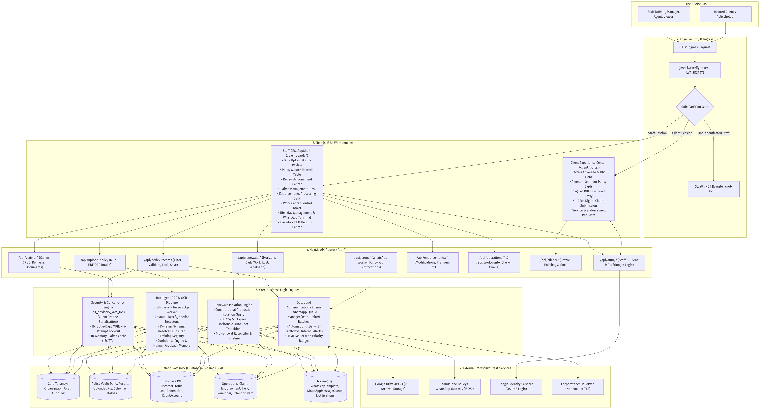
Figure: Master End-to-End System Architecture Flowchart

2.1 Technical Trace: User Click to Database Persistence
Every user interaction traverses a disciplined execution chain across the stack. For instance, when an agent ingests a batch of multi-page policy PDFs, the following sequence executes synchronously and asynchronously:
1. Client UI: The agent drops files into PolicyDropzone.jsx within the Bulk Upload workbench (/bulk-upload).
2. API Gateway: Form data streams to POST /api/upload-policy, handled by Node.js runtime.
3. Storage Layer: File bytes are validated (%PDF- magic bytes, <= 35MB) and saved to Google Drive API v3.
4. Text Extraction: Fast digital extraction via pdf-parse; if text is absent/scanned, @napi-rs/canvas renders pages to PNG buffers and passes them to local tesseract.js OCR.
5. Document Understanding: detectLayout, classifyDocument, and detectSections parse column geometry and compute insurer confidence.
6. Schema & Heuristics: resolveSchema loads target JSON schema; dynamicExtractor runs regex ensembles and RTO lookups.
7. UI Review: The workbench renders side-by-side original canvas PDF and editable input fields with confidence badges.
8. Approval & Persistence: The agent clicks 'Approve & Save Policy', triggering POST /api/policy-records with PostgreSQL advisory locking, updating UploadedFile to APPROVED, logging an audit trail, and dispatching a WhatsApp welcome message.

3. User Personas & RBAC Security Matrix
The platform enforces multi-tenant role-based access control (RBAC) via src/lib/auth/rbac.js. Every query is hard-scoped to the user's organizationId and deletedAt == null, ensuring complete tenant isolation.
Platform Resource | Action | Super Admin | Tenant Admin | Manager | Agent | Viewer | Client Portal
Policy Records | Read / Search | All Tenants | Tenant Scope | Tenant Scope | Tenant Scope | Tenant Scope | Own Policies Only
Policy Records | Create / Ingest | Allowed | Allowed | Allowed | Allowed | Denied | Denied
Policy Records | Edit / Update | Allowed | Allowed | Allowed | Allowed | Denied | Denied
Policy Records | Delete (Soft) | Allowed | Denied | Denied | Denied | Denied | Denied
Policy Records | Excel Export | Allowed | Allowed | Allowed | Denied | Denied | Denied
Renewals Desk | Manage & Call | All Tenants | Allowed | Allowed | Allowed | Read Only | Denied
Claims Desk | Register & Edit | All Tenants | Allowed | Allowed | Allowed | Read Only | Own Claims Only
Endorsements | Process & Letter | All Tenants | Allowed | Allowed | Allowed | Read Only | Request Only
User Accounts | Provision / LOB | All Tenants | Allowed | Agents Only | Denied | Denied | Denied
Client MPIN | Reset / Provision | Allowed | Allowed | Allowed | Denied | Denied | Self (Verified)
Audit Logs | Compliance Audit | All Tenants | Allowed | Allowed | Denied | Denied | Denied
📌 Backend Enforcement vs Frontend Visibility
Authorization is strictly enforced in backend API routes and Prisma query filters (getTenantFilter). Hiding a button in the UI is never relied upon as a security boundary.

4. Ingress & Edge Routing (src/middleware.ts)
Edge ingress security is handled by Next.js middleware using the lightweight jose library. It intercepts all incoming requests before page rendering or API execution.

4.1 The Stealth 404 Security Technique
Standard applications redirect unauthorized users to a login page, exposing the existence of private administrative portals. BimaHeadquarter implements a stealth 404 rewrite: if an unauthenticated user or automated scanner accesses any protected route prefix (/dashboard, /policy-records, /bulk-upload, /operations, etc.), the middleware rewrites the request internally to /not-found, making the CRM appear completely non-existent to unauthorized parties.

4.2 Role-Based Partitioning & Session Invalidation
• Clients attempting to access staff routes are immediately redirected to /client/portal.
• Staff attempting to access client routes or the public login page are redirected to /dashboard.
• Token validation employs an in-memory cache (globalThis.__bimaUserClaimsCache) with a 15-second TTL, allowing rapid sub-navigation without imposing repetitive database query overhead.

5. Intelligent Multi-Stage PDF Understanding & OCR Pipeline
The PDF extraction pipeline in src/lib/policies/ is the technical core of the system. It processes native digital text, scanned image PDFs, and degraded scans through seven sequential stages.

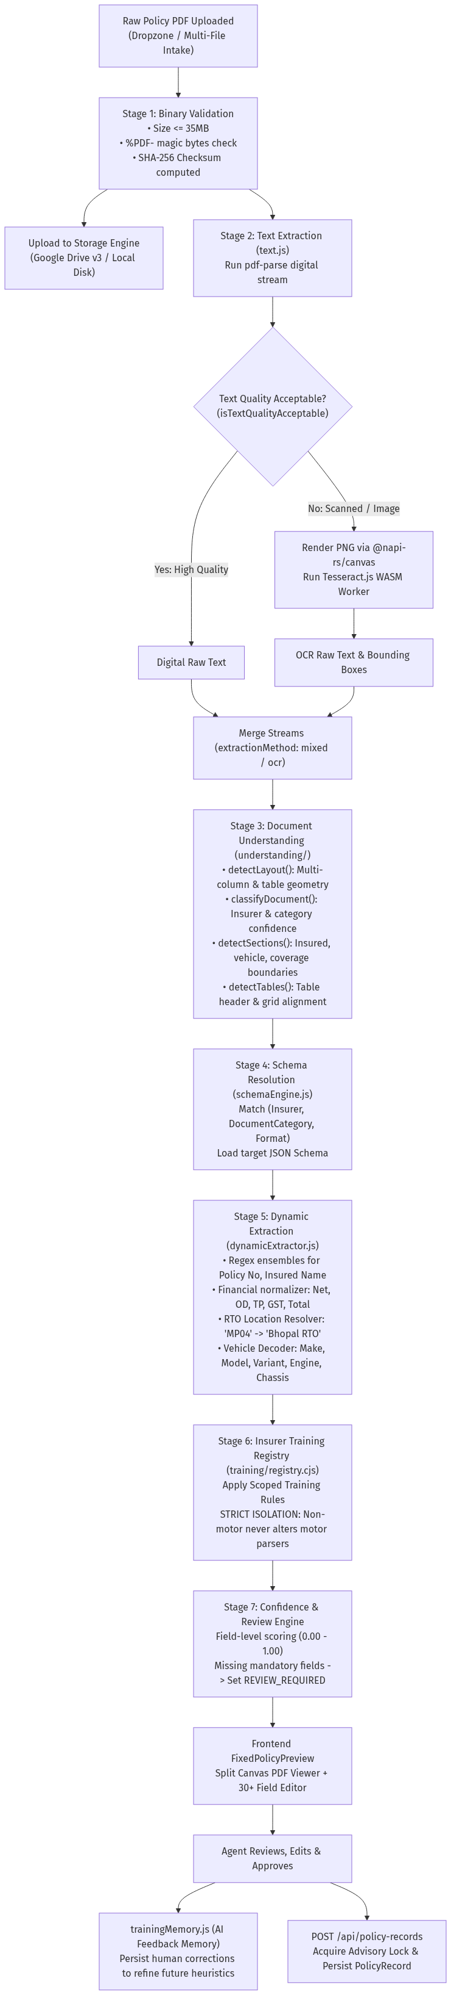
Figure: Intelligent Multi-Stage PDF Extraction & OCR Pipeline

5.1 Seven-Stage Pipeline Breakdown
• Stage 1 (Binary Validation): Validates file size (<= 35MB), checks %PDF- magic bytes, computes SHA-256 hash, and saves file stream to Google Drive v3.
• Stage 2 (Text Extraction & OCR): Runs pdf-parse digital stream. Evaluates quality with isTextQualityAcceptable(). If digital text is missing or garbled, @napi-rs/canvas renders PNG buffers and executes local tesseract.js WASM OCR.
• Stage 3 (Document Understanding): detectLayout analyzes column geometry and bounding boxes; classifyDocument identifies carrier and category; detectSections maps insured, vehicle, coverage, and premium blocks; detectTables extracts tabular grid coordinates.
• Stage 4 (Dynamic Schema Resolution): resolveSchema matches (Insurer, DocumentCategory, Format) and loads exact JSON schema.
• Stage 5 (Dynamic Extraction): Executes regex ensembles for dates, monetary amounts, policy numbers, and Indian vehicle registration plates. Cross-references RTO location lookup database (e.g. 'MP04' -> 'Bhopal RTO'). Decodes vehicle make, model, variant, engine number, and chassis number.
• Stage 6 (Scoped Insurer Training Registry): Executes scoped rules under training/registry.cjs. Strictly enforces bidirectional isolation: non-motor changes never touch motor parsers.
• Stage 7 (Confidence Scoring & Review): Evaluates field confidence (0.00-1.00). Checks mandatory fields. Populates FixedPolicyPreview. When approved, trainingMemory.js persists human corrections.

5.2 Supported Insurers & Line of Business (LOB) Catalog
Insurance Carrier | Supported Lines of Business (LOB) | Parser Architecture | Isolation Status
ICICI Lombard | Motor (PVT/GCV/PCV), Fire SFSP, Warehouse, MSME, Health, CPM, Marine, PLI, WC | Dedicated Parsers & Scoped Training | Strictly Isolated
Tata AIG | Auto Secure Motor, Warehouse Insurance, Fire SFSP | Dynamic Extractor + Scoped Training | Strictly Isolated
Bajaj Allianz | Drive Assure Motor, Commercial Property, Warehouse | Dedicated Parser Module | Strictly Isolated
IFFCO Tokio | Motor Package, Warehouse, Workmen Compensation | Parser Module + Neutral Regex | Strictly Isolated
HDFC ERGO | Comprehensive Motor, Optima Health Floater, WC | Dynamic Extractor + Scoped Rules | Strictly Isolated
New India Assurance | Motor Package, Non-Motor Commercial Property | Dedicated Modular Parsers | Strictly Isolated
United India | Motor Liability/Package, Warehouse, Burglary | Dedicated Modular Parsers | Strictly Isolated
Future Generali | Motor Comprehensive, Third-Party | Scoped Training Registry | Strictly Isolated
Go Digit | Private Car, Two-Wheeler, Commercial | Scoped Training Registry | Strictly Isolated
Liberty General | Motor Package, Commercial Vehicle | Scoped Training Registry | Strictly Isolated
Royal Sundaram | Motor Car & Two-Wheeler Package | Dedicated Modular Parsers | Strictly Isolated
Shriram General | Commercial Vehicle, Motor Package | Dedicated Modular Parsers | Strictly Isolated
Care Health | Care Classic, Care Supreme Individual & Floater | Scoped Training Registry | Strictly Isolated

6. Renewals Command Center & Constitutional Isolation
A fundamental flaw in standard insurance CRMs is treating upcoming renewals as active policy records, which contaminates revenue, policy counts, and sales leaderboards. BimaHeadquarter enforces the Constitutional Renewal Isolation Rule.

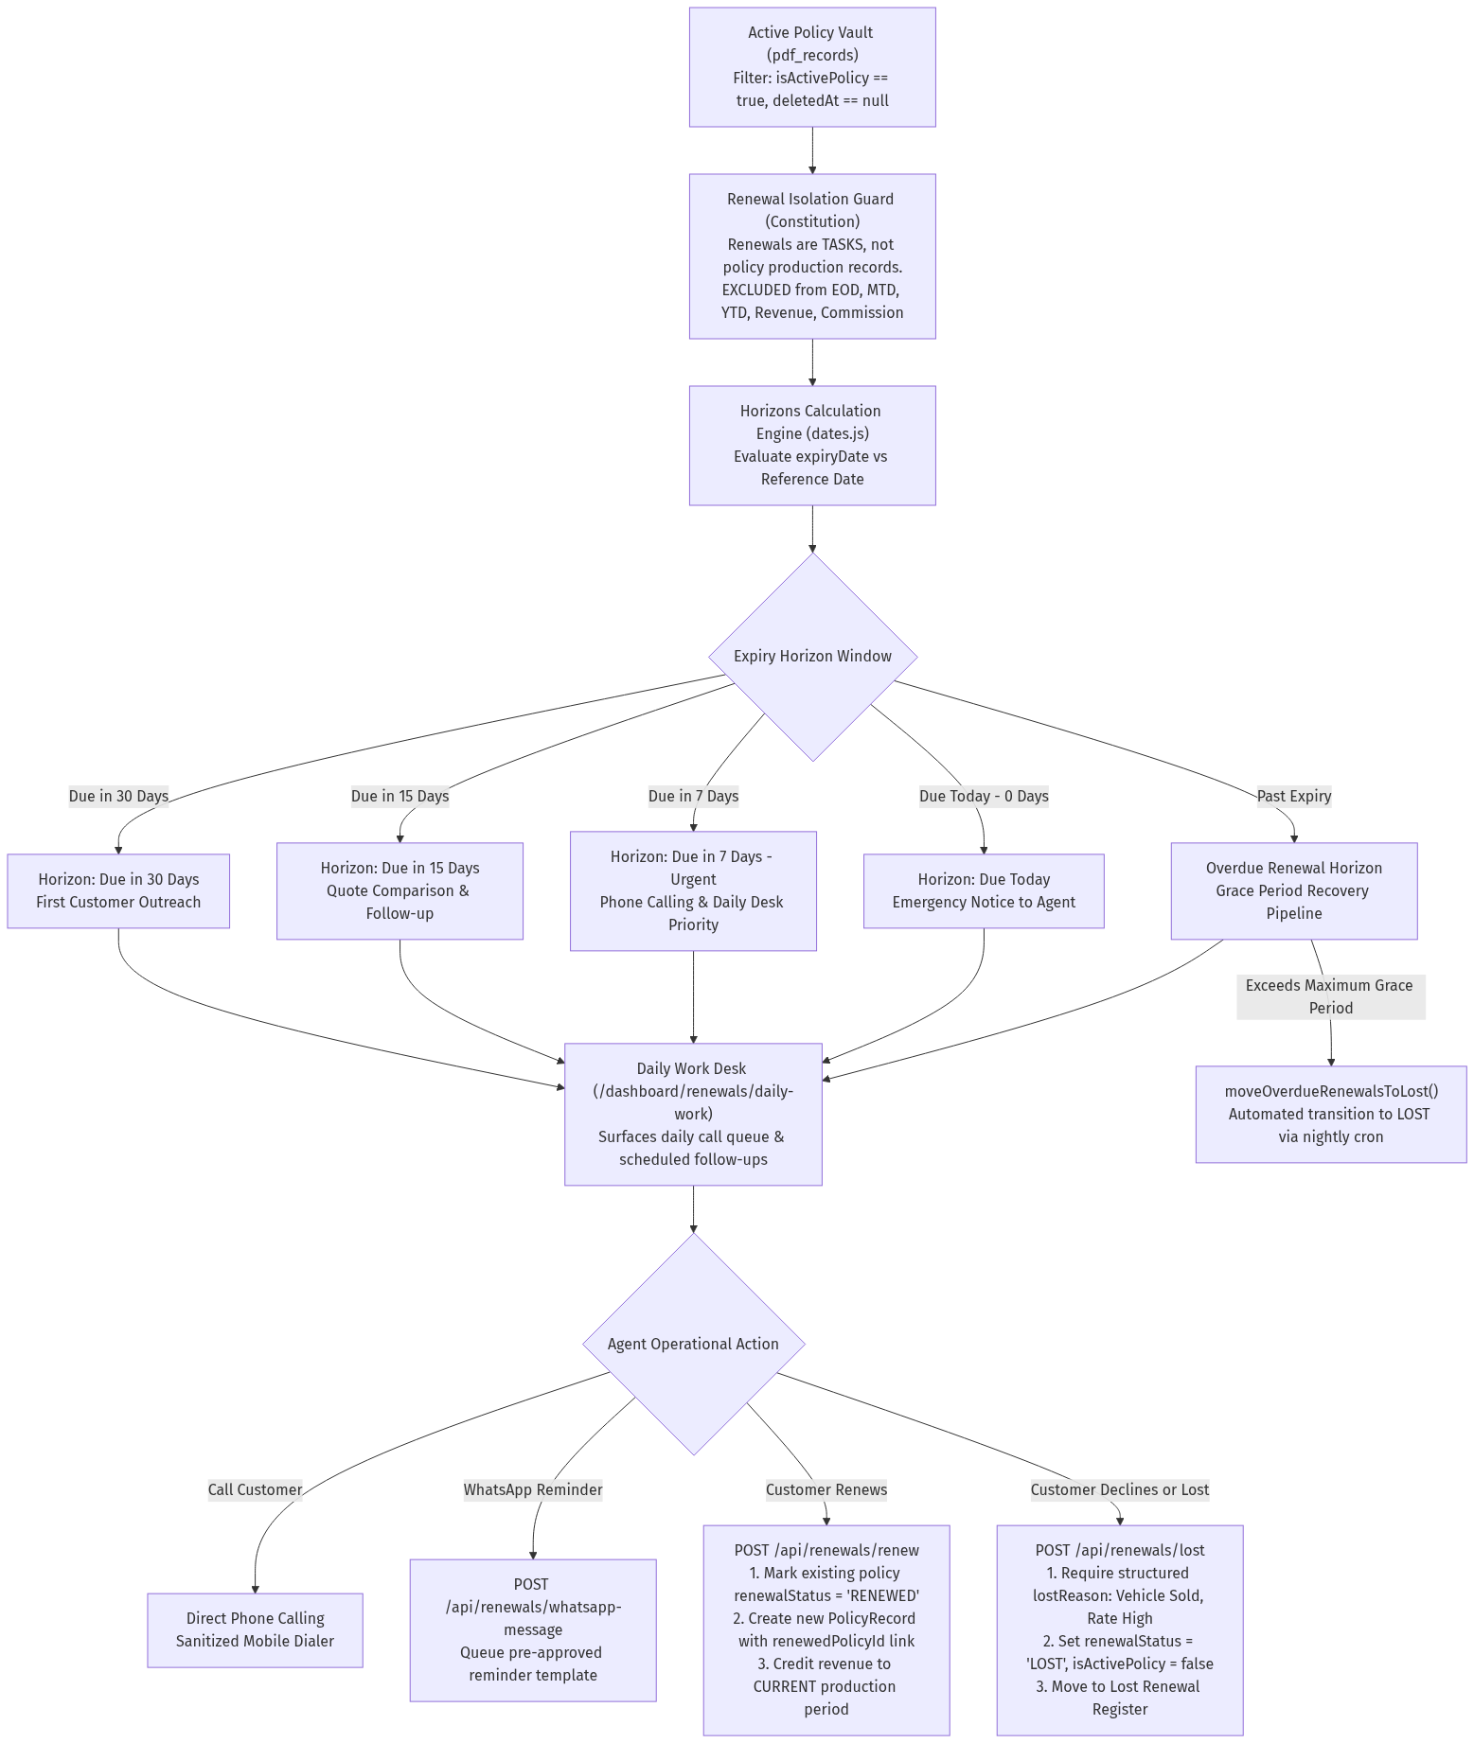
Figure: Renewals Command Center & Production Isolation Engine

6.1 The Constitutional Renewal Isolation Rule
📌 Constitutional Rule: Renewals are NOT Policy Records
• A renewal is an operational workflow task linked to an existing policy, NOT a new policy issuance.
• Renewals are strictly EXCLUDED from End-of-Day (EOD), Month-to-Date (MTD), Year-to-Date (YTD), Revenue, Premium Collection, Policy Count, and Commission calculations.
• Only after successful payment and carrier re-issuance is a new PolicyRecord created with renewedPolicyId linked.

6.2 The Five Expiry Horizons & Daily Work Queue
Expiry Horizon | Horizon Scope | Operational Workflow | Automation Action
Due in 30 Days | Policies expiring in 16–30 days | Initial review, coverage audit, NCB bonus check | Queues advisory check task
Due in 15 Days | Policies expiring in 8–15 days | Generate comparison quotes, initiate calling | Prepares quote comparison summary
Due in 7 Days | Policies expiring in 1–7 days (URGENT) | High-priority daily work queue, active calling | WhatsApp renewal reminder trigger
Due Today (0 Days) | Policies expiring at 23:59:59 today | Critical emergency desk, direct manager alert | Automated internal emergency alert
Overdue Horizon | Expired policies within grace period | Grace period recovery pipeline, penalty warnings | Automated auto-lost evaluation

7. Claims Management & Policy Endorsements Lifecycles
Claims and endorsements represent critical customer retention touchpoints. The platform manages their entire operational lifecycle through specialized database models and state machines.

Figure: Claims Management & Policy Endorsements Processing Lifecycles

7.1 Claims Processing Desk
• Intake Origin: Claims can be filed by staff via the Claims Desk (/operations/claims-management) or by clients via the 1-Click Wizard in the Client Portal (/client/portal).
• Policy Auto-lookup: Validates policy number and mobile number against PolicyRecord to associate coverage details.
• Chronological Remarks Timeline: Every surveyor communication, insurer query, or customer call is logged in ClaimRemark.
• Evidence Vault: Estimates, FIR copies, damage photos, and discharge vouchers are preserved in ClaimDocument.
• Status Progression: Open -> Under Review -> Approved -> Settled or Repudiated.

7.2 Policy Endorsements Engine
• Scope: Manages policy modifications (name correction, vehicle registration change, address update, cover addition).
• Financial Calculation Engine: Automatically computes premiumChangeAmount and sumInsuredChangeAmount.
• Document Audit: Stores generated request letters and carrier endorsement schedules in EndorsementDocument.
• Master Reconciliation: Synchronizes approved changes back into the master PolicyRecord reviewedData payload.

8. Client Experience Center & Zero-Password MPIN Security
The Client Experience Center (/client/portal) provides policyholders with instant, secure mobile access to their policies without requiring cumbersome passwords.

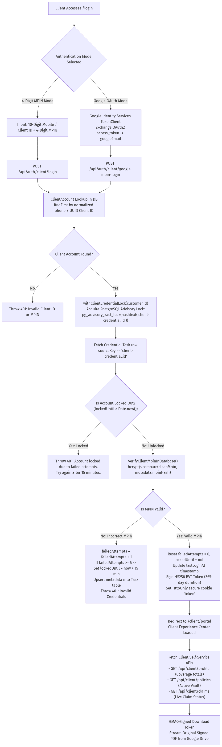
Figure: Client Experience Center & MPIN Security Architecture

8.1 4-Digit MPIN & Anti-Brute-Force Architecture
• Dual Identity: Clients log in using their 10-digit mobile number or UUID Client ID.
• Bcrypt Hash Storage: MPINs are hashed using bcryptjs (cost 10) and stored in Task table with sourceKey = 'client-credential:<customerId>'.
• Lockout Protection: Tracks failedAttempts in Task metadata. If 5 consecutive failed attempts occur, lockedUntil is set to now + 15 minutes, blocking brute-force attacks.
• Long-Lived JWT: Upon successful verification, an HS256 JWT cookie ('token') with a 365-day lifetime is issued.

8.2 PostgreSQL Transactional Advisory Locking
To eliminate race conditions when multiple agents link policies or update client credentials simultaneously, the backend utilizes PostgreSQL advisory transaction locks via src/lib/client-accounts/server.js:
📌 Advisory Lock Implementation
SELECT pg_advisory_xact_lock(hashtext('client-credential:' || customerId));
This serializes concurrent transactions at the database engine level, guaranteeing zero duplicate accounts and preventing credential version conflicts during high-concurrency operations.

9. Operations Control Tower & Outbound Communications
Operational task planning and automated messaging are orchestrated via src/lib/operations-center/ and src/lib/whatsapp/.

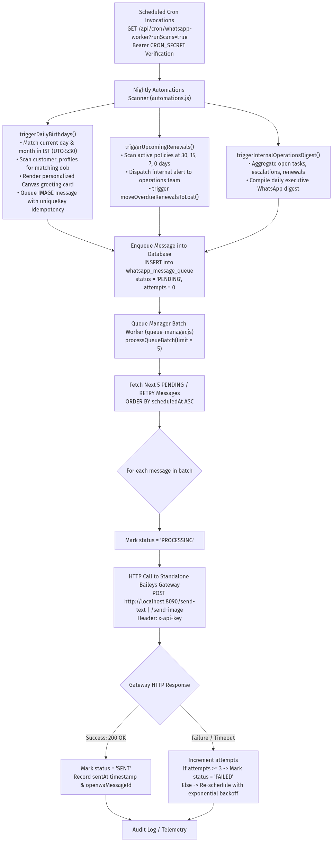
Figure: Outbound Communications & Automated WhatsApp Gateway Pipeline

9.1 Standalone Baileys WhatsApp Gateway
• Architecture: A standalone Node.js Express microservice in whatsapp-gateway/ running independently on Railway port 8090.
• Multi-Device Socket: Maintains a persistent WebSocket connection to WhatsApp servers.
• REST Endpoints: Exposes /status, /qr, /send-text, /send-image, and /send-document authenticated via x-api-key.
• Canvas Greeting Generator: card-engine.js dynamically renders personalized birthday greeting cards in RAM.

9.2 WhatsApp Message Queue & Automated Scanners
• Queue Manager (queue-manager.js): Processes messages in batches of 5 with exponential backoff and uniqueKey idempotency.
• Daily Birthday Scanner: Evaluates DOB matching today in Indian Standard Time (IST, UTC+5:30) and queues greeting cards.
• Internal Renewal Alerts: Dispatches automated 30, 15, 7, and 0-day renewal warnings to internal operations phones.
• Policy Upload Welcome Message: Triggers a 1-time WhatsApp welcome message with a clean PDF download link upon policy approval.

10. Complete 28-API Endpoint Technical Catalog
Endpoint Route | HTTP Method | Purpose & Business Function | Auth Tier | Database Entities Accessed
/api/auth/login | POST | Staff credentials authentication; issues 24h JWT cookie | Public | User, AuditLog
/api/auth/logout | POST | Clears authentication session cookie | Shared | None
/api/auth/me | GET | Retrieves active staff session claims & assigned LOBs | Staff Only | User
/api/auth/client/login | POST | Client 4-digit MPIN login; issues 365d JWT cookie | Public | ClientAccount, Task
/api/auth/client/verify-mpin | POST | Verifies MPIN for high-privilege client operations | Client Only | ClientAccount, Task
/api/auth/client/google-mpin-login | POST | Exchanges Google OAuth2 token for portal session | Public | ClientAccount, Task
/api/upload-policy | POST | Ingests multi-page PDF batch; runs OCR & heuristics | Agent/Admin | UploadedFile, PolicyRecord, AuditLog
/api/policy-records | GET | Paginated search & multi-path JSONB filtering | Staff/Viewer | PolicyRecord, CustomerProfile
/api/policy-records | POST | Validates, locks, and persists human-reviewed policy | Agent/Admin | PolicyRecord, UploadedFile, Task, AuditLog
/api/policy-records/[id] | GET/PATCH/DEL | Fetches details, updates fields, or soft-deletes policy | Agent/Admin | PolicyRecord, AuditLog
/api/renewals/policies | GET | Queries upcoming/overdue renewal policies by horizon | Staff Only | PolicyRecord, Task
/api/renewals/renew | POST | Marks policy renewed; creates new policy record link | Agent/Admin | PolicyRecord, AuditLog
/api/renewals/lost | POST | Marks policy lost with structured loss justification | Agent/Admin | PolicyRecord, AuditLog
/api/renewals/daily-work | GET | Surfaces today's renewal calls, follow-ups, and tasks | Staff Only | PolicyRecord, Task
/api/renewals/whatsapp-message | POST | Queues renewal reminder template to client WhatsApp | Agent/Admin | WhatsAppMessageQueue, PolicyRecord
/api/renewals/import | POST | Bulk imports historical renewal spreadsheets | Admin Only | PolicyRecord, AuditLog
/api/claims | GET/POST | Lists active claims or registers a new claim | Staff / Client | Claim, ClaimRemark, PolicyRecord, AuditLog
/api/claims/[id] | GET/PATCH | Fetches claim timeline or updates settlement status | Staff Only | Claim, ClaimRemark, ClaimDoc, AuditLog
/api/claims/[id]/remarks | POST | Appends remarks timeline note & follow-up date | Staff Only | ClaimRemark, Claim, AuditLog
/api/endorsements | GET/POST | Lists endorsements or initiates a policy modification | Staff Only | Endorsement, PolicyRecord, AuditLog
/api/endorsements/[id] | GET/PATCH | Fetches endorsement details or updates status | Staff Only | Endorsement, EndorsementDoc, AuditLog
/api/client/profile | GET | Fetches client profile totals, coverage value & IDV | Client Only | ClientAccount, PolicyRecord
/api/client/policies | GET | Fetches active and expired policies owned by client | Client Only | PolicyRecord, ClientAccount
/api/client/claims | GET | Fetches real-time status of claims filed by client | Client Only | Claim, ClientAccount
/api/client/service-requests | POST | Submits certificate, copy, or endorsement ticket | Client Only | Task, ClientAccount
/api/operations/summary | GET | High-level operations telemetry across modules | Staff Only | CustomerProfile, PolicyRecord, Task
/api/work-center | GET | Control tower tasks, reminders, calendar, escalations | Staff Only | Task, Reminder, CalendarEvent, Approval
/api/operations/birthday-management | GET/POST | Fetches upcoming birthdays; batch queues greetings | Manager/Admin | CustomerProfile, WhatsAppMessageQueue
/api/operations/whatsapp/status | GET | Checks Baileys gateway socket state & QR code | Admin Only | None (HTTP to Gateway)
/api/cron/whatsapp-worker | GET/POST | Nightly cron: runs scans and dispatches queue batch | CRON_SECRET | WhatsAppMessageQueue, PolicyRecord
/api/storage/download | GET | Streams PDF using HMAC-signed temporary download token | Authorized | UploadedFile, PolicyRecord
/api/users | GET/POST | Lists staff accounts or provisions new staff member | Admin Only | User, Organization, AuditLog

11. Complete 28-Prisma Database Schema Reference
Prisma Model | SQL Table Name | Entity Purpose & Business Function | Key Fields & Constraints | Primary Relations
Organization | organizations | Multi-tenant tenant isolation boundary | id (UUID PK), name, created_at, updated_at | Users, PolicyRecords, Claims
User | users | Staff accounts, authentication & RBAC roles | id, email (UQ), password, role, assigned_lobs, deleted_at | Organization, PolicyRecord, AuditLog
AuditLog | audit_logs | Immutable compliance audit trail | id, action, entity_type, entity_id, severity, ip_address, user_agent | Organization, User
PolicyRecord | pdf_records | Approved insurance policies repository | id (UUID PK), saved_at, data (JSON), reviewed_data (JSON), renewal_status | UploadedFile, CustomerProfile, Endorsement
UploadedFile | uploaded_files | Source PDF files and OCR extraction lifecycle | id, source_file, status (UploadStatus), storage_path, file_hash, raw_text | PolicyRecord, Endorsement, Organization
CustomerProfile | customer_profiles | Master customer records and portfolio links | id, name, phone, email, dob, selected_lobs, google_email, deleted_at | PolicyRecord, LeadGeneration, Endorsement
LeadGeneration | lead_generation | Owner-scoped prospect insurance needs assessment | id, name, phone, status, selected_lobs, follow_up_date, created_by_id | CustomerProfile, Organization, User
ClientAccount | client_accounts | Policyholder identities for Client Experience Center | id (Client ID UUID), name, phone, google_email, deleted_at | Organization, User
Claim | claims | Insurance claims servicing and status tracker | id, claim_no (UQ), policy_no, insured_name, claim_status, follow_up_date | ClaimRemark, ClaimDocument, Organization
ClaimRemark | claim_remarks | Chronological claim notes and updates feed | id, claim_id, text, follow_up_date, created_by_id | Claim, User
ClaimDocument | claim_documents | Claim evidence, estimates, and damage photos | id, claim_id, name, file_name, data_url, file_type, size | Claim, User
Endorsement | endorsements | Policy amendments and endorsement letters | id, endorsement_no (UQ), policy_no, premium_change_amount, status | PolicyRecord, CustomerProfile, Document
EndorsementDocument | endorsement_documents | Official carrier endorsement schedules | id, endorsement_id, document_type, file_name, data_url | Endorsement, User
Task | tasks | Unified work planner, approvals & MPIN credential vault | id, title, type (TaskType), status (TaskStatus), source_key (UQ), metadata | TaskAssignment, TaskComment, Reminder
TaskAssignment | task_assignments | Task delegation to specific team members | id, task_id, user_id, assigned_at | Task, User
Reminder | reminders | Scheduled alert notifications for tasks | id, task_id, title, remind_at, completed_at, source_key (UQ) | Task, Organization
CalendarEvent | calendar_events | Scheduled meetings, inspections, and call times | id, title, event_type, starts_at, ends_at, location, source_key (UQ) | Organization, User
Approval | approvals | Administrative approval workflow requests | id, approval_type, title, status (ApprovalStatus), decision_note | Organization, User
Escalation | escalations | Overdue task escalations to managers | id, task_id, assigned_user_id, manager_user_id, reason, status | Organization, Task
ActivityLog | activity_logs | Granular user modification activity logs | id, module, action, old_value (JSON), new_value (JSON), ip_address | Organization, User
PolicySchema | policy_schemas | Dynamic schema definitions per carrier and category | id, policy_type_id, version, active | FieldDefinition, PolicyRecord
FieldDefinition | field_definitions | Field-level regex patterns and validations | id, policy_schema_id, key, label, field_type, regex_pattern | PolicySchema
InsuranceCompany | insurance_companies | Master insurance carrier lookups and aliases | id, name (UQ), aliases (JSON), active | PolicyType, PolicySchema
ServiceCategory | service_categories | Broad lines of business (Motor, Fire, Health) | id, name (UQ), keywords (JSON), active | PolicyType, PolicySchema
PolicyType | policy_types | Specific policy product types | id, name, service_category_id, insurance_company_id | InsuranceCompany, ServiceCategory
BankSource | bank_sources | Bancassurance bank partner channels | id, name (UQ), aliases (JSON), active | PolicySchema, UploadedFile
WhatsAppTemplate | whatsapp_templates | Pre-approved WhatsApp text/media templates | id, name, body, media_url, organization_id | Organization
WhatsAppMessageQueue | whatsapp_message_queue | Outbound rate-limited WhatsApp message queue | id, recipient_phone, message_body, status, unique_key (UQ), attempts | Organization
Notification | notifications | In-app bell notifications and action links | id, category, severity, title, message, action_url, source_key (UQ) | NotificationRead, Organization
BlogPost | blog_posts | Public SEO articles and guides | id, slug (UQ), title, excerpt, category, read_time, published | BlogSection, BlogRating

12. UI Component Architecture & Design System
The frontend is constructed using Next.js 15 Client Components ('use client') orchestrated by a unified design system. To ensure zero duplicate code, the application uses a strict single-source-of-truth component hierarchy.

12.1 The Modal Layout Guidelines
📌 Strict Modal Guidelines (Constitutional)
• Overlay Alignment: All modal cards, dialog overlays, and popup blocks MUST be centered vertically and horizontally.
• Backdrop Styling: The background page behind any active overlay MUST be visually blurred using backdrop-blur-md.
• Viewport Portal Required: Every modal MUST render under document.body via ModalPortal.js. Never leave a modal nested inside .content-canvas.
• Above Chrome: Modal backdrops must cover the complete viewport and layer above sidebar (z-index 45+) and header (z-index 50+).

12.2 Major UI Components Catalog
• AppShell (AppShell.tsx): Responsive frame container managing sidebar collapse states and content-canvas padding.
• SideNav (SideNav.tsx): Desktop drawer and mobile backdrop with role-based link filtering and logout confirmation modal.
• TopBar (TopBar.tsx): Universal search bar with 300ms URL debounce, live bell notification counter (5s cache), and quick work calendar.
• FixedPolicyPreview (FixedPolicyPreview.js): Side-by-side split screen with Canvas/PDF.js page viewer on left and 30+ categorized input fields on right.
• RecordsTable (RecordsTable.js): High-density data table supporting multi-path JSONB filtering, sorting, pagination, and Excel export.
• ClaimsManagementPage (ClaimsManagementPage.js): Operations claims desk with auto-lookup modal and chronological remarks feed.
• ClientExperienceCenter (ClientExperienceCenter.js): Luxury emerald-gradient mobile-responsive policyholder self-service portal.

13. Comprehensive User Intent Execution Traces
This section answers: 'If a user wants to do X, exactly what happens from the UI click to database persistence?'
User Intent Goal | Starting UI & Component | Trigger Event | API & Server Procedures | Database Mutations | User-Visible Outcome
Ingest batch of 20 policy PDFs | /bulk-upload  (PolicyDropzone.jsx) | Drop files into dropzone | POST /api/upload-policy  validatePdfFile -> extractTextFromPdf -> extractPolicyDataFromTextResult | INSERT INTO uploaded_files (20 rows, status: REVIEW_REQUIRED);  Writes FILE_UPLOAD audit log | 20 queue cards appear with extraction confidence percentages
Approve and save reviewed policy | /bulk-upload  (FixedPolicyPreview.js) | Click 'Approve & Save Policy' | POST /api/policy-records  getReviewValidation -> withClientPhoneLock -> createRecord | INSERT INTO pdf_records;  UPDATE uploaded_files status='APPROVED';  INSERT INTO audit_logs | Queue item turns green with checkmark; policy appears in master records
Renew an expiring policy | /dashboard/renewals/policies  (RenewalsTable.jsx) | Click 'Renew' action button | POST /api/renewals/renew  validates policy -> linkRenewalMarkerToPolicy | UPDATE pdf_records (old) renewal_status='RENEWED';  INSERT INTO pdf_records (new) | Expiring policy moves to Renewed tab; revenue credited to current production
Mark renewal as Lost | /dashboard/renewals/daily-work  (RenewalsDailyWork.jsx) | Click 'Mark Lost' -> select reason | POST /api/renewals/lost  validates lostReason enum | UPDATE pdf_records SET renewal_status='LOST', is_active_policy=false, lost_reason=... | Policy moves to Lost Renewal Register; future reminders cancelled
Client files digital claim | /client/portal  (ClientExperienceCenter.js) | Click 'File a Claim' in wizard | POST /api/client/claims  validates policy ownership against client session | INSERT INTO claims (status: 'Open');  INSERT INTO claim_documents;  INSERT INTO tasks | Client sees confirmation with Claim #; staff claims desk receives alert
Log claim investigation note | /operations/claims-management  (ClaimTimelineDrawer.jsx) | Enter text -> click 'Add Remark' | POST /api/claims/[id]/remarks  validates session & input | INSERT INTO claim_remarks;  UPDATE claims SET follow_up_date=... | Remark appears in chronological timeline; follow-up calendar updated
Process policy endorsement | /dashboard/endorsements  (EndorsementFormPage.js) | Input changes -> click 'Submit' | POST /api/endorsements  computes premiumChangeAmount & sumInsuredChange | INSERT INTO endorsements;  INSERT INTO endorsement_documents;  INSERT INTO audit_logs | Endorsement letter generated; changes synchronized with master policy
Client authenticates via MPIN | /login  (ClientLoginPage.js) | Enter Mobile + 4-Digit MPIN | POST /api/auth/client/login  withClientCredentialLock -> verifyClientMpinInDatabase | UPDATE tasks metadata (lastLoginAt, resets failedAttempts); sets JWT cookie | Instant redirect to /client/portal; active policy cards displayed

14. Security, Performance & Scalability Audits

14.1 Security Audit & Risk Classifications
Risk Classification | Vulnerability / Finding | File Location | Impact | Architectural Remediation
High | Static JWT Secret Fallback in Non-Prod | src/middleware.ts:7 | If deployed with NODE_ENV != 'production', uses hardcoded secret | Enforce non-empty JWT_SECRET at server boot time in all envs
Medium | MPIN Rate Limiting in Database Task Rows | src/lib/client-portal/credentials.js:58 | Failed login attempts hit Postgres; heavy brute-force creates write load | Migrate login rate limiting to Redis / Upstash KV store with IP limits
Low | Temporary Download Tokens in Query Params | src/lib/storage/index.js:100 | HMAC token is in URL; might persist in browser history for 1 hour | Set Cache-Control: private, no-store on all signed PDF responses
Informational | Multi-Tenant IDOR Protection | src/lib/auth/rbac.js:86 | Strictly enforced via getTenantFilter; cross-tenant leakage prevented | Maintain automated tenancy regression test suite

14.2 Performance & Scalability Projections
• 100 Active Users: Zero latency impact (< 80ms responses). Neon connection pooling handles concurrency with minimal memory overhead.
• 1,000 Active Users: Standalone Baileys WhatsApp Gateway must run on a persistent container with at least 2GB RAM to maintain socket connection during mass batch sends.
• 10,000 Active Users: Synchronous OCR execution (tesseract.js) in /api/upload-policy must be decoupled into an asynchronous background BullMQ / Redis worker queue to avoid HTTP 60-second timeouts.
• 100,000 Active Users: Archival rawText (up to 50KB per policy) must be moved out of primary pdf_records into object storage (S3/Cloudflare R2), reducing database table size by 70%. GIN indexes on jsonb columns must be activated:
CREATE INDEX idx_policy_records_reviewed_data ON pdf_records USING gin (reviewed_data);
CREATE INDEX idx_policy_records_data ON pdf_records USING gin (data);

14.3 Technical Debt & Prioritized Roadmap (P0 - P3)
• P0 (Critical): Move CPU-intensive Tesseract OCR off Next.js HTTP routes into a BullMQ worker queue; enforce mandatory JWT_SECRET.
• P1 (High): Decompose 3,787-line src/app/ui/dashboard.js into isolated route components; permanently retire /api/records.
• P2 (Medium): Create dedicated database tables for Declarations and Client Service Requests with SLA timers.
• P3 (Future): Implement LLM-assisted edge-case parsing (Gemini 1.5 Flash) for damaged physical policy scans.

15. Appendix: Complete Master Mermaid.js Code
The complete, single-block Mermaid.js flowchart code representing the entire system is provided below for direct rendering in Mermaid Live Editor, GitHub Markdown, or developer documentation tools.
flowchart TD
subgraph Actors ["1. User Personas & Roles"]
SuperAdmin["Super Admin"]
Admin["Tenant Admin"]
Manager["Operations Manager"]
Agent["Operations Agent"]
Viewer["Viewer (Read-Only)"]
Client["Insured Client / Policyholder"]
end
subgraph Middleware ["2. Ingress & Edge Security (src/middleware.ts)"]
MW_In["HTTP Ingress"] --> MW_JWT["jose: jwtVerify(token)"]
MW_JWT -->|Unauthenticated Staff| MW_Stealth["Stealth 404 Rewrite (/not-found)"]
MW_JWT -->|Role == CLIENT| MW_ToClient["Redirect to /client/portal"]
MW_JWT -->|Role != CLIENT| MW_ToStaff["Redirect to /dashboard"]
MW_JWT -->|Authorized| MW_Pass["Pass to Layouts"]
end
subgraph AppRouter ["3. Next.js 15 UI Workbenches"]
WB_BulkUpload["Bulk PDF Intake (/bulk-upload)"]
WB_Records["Policy Records Table (/policy-records)"]
WB_Renewals["Renewals Command Center (/dashboard/renewals)"]
WB_Claims["Claims Management Desk (/operations/claims-management)"]
WB_Endorsements["Endorsements Processing Desk (/dashboard/endorsements)"]
WB_ControlTower["Work Center Control Tower (/work-center)"]
WB_Birthday["Birthday Management Desk (/operations/birthday-management)"]
WB_WhatsApp["WhatsApp Control Terminal (/operations/whatsapp-setup)"]
WB_ClientPortal["Client Experience Center (/client/portal)"]
end
subgraph APIRoutes ["4. API Controller Gateway (/api/*)"]
API_Auth["/api/auth/* (Staff Login, Client MPIN, Google OAuth)"]
API_Upload["/api/upload-policy (Multi-PDF Intake & OCR)"]
API_Records["/api/policy-records (Search, Validate, Lock, Save)"]
API_Renewals["/api/renewals/* (Horizons, Daily Work, Lost)"]
API_Claims["/api/claims/* (Intake, Timeline Remarks, Evidence)"]
API_Endorsements["/api/endorsements/* (Modifications & Premium Diff)"]
API_Client["/api/client/* (Profile, Active Vault, Claims)"]
API_Cron["/api/cron/* (WhatsApp Worker & Automations)"]
end
subgraph Engines ["5. Core Business Logic Engines"]
ENG_OCR["PDF & OCR Pipeline (pdf-parse + Tesseract + Dynamic Schemas)"]
ENG_Security["Security & Concurrency (pg_advisory_xact_lock + Bcrypt MPIN)"]
ENG_Renewals["Renewals Isolation Engine (Constitutional Production Isolation)"]
ENG_Outbound["Outbound Messaging (Queue Manager + Automations)"]
end
subgraph Database ["6. Neon PostgreSQL Database (Prisma ORM)"]
DB_Org["Organization, User, AuditLog"]
DB_Policy["PolicyRecord, UploadedFile, PolicySchema, Catalogs"]
DB_CRM["CustomerProfile, LeadGeneration, ClientAccount"]
DB_Ops["Claim, ClaimRemark, ClaimDoc, Endorsement, Task"]
DB_Comm["WhatsAppTemplate, WhatsAppMessageQueue, Notifications"]
end
subgraph External ["7. External Infrastructure & Services"]
EXT_Drive["Google Drive API v3 (PDF Storage)"]
EXT_WhatsApp["Standalone Baileys WhatsApp Gateway (:8090)"]
EXT_OAuth["Google Identity Services (OAuth2)"]
EXT_SMTP["Corporate SMTP Server (Nodemailer)"]
end
Actors --> Middleware --> AppRouter --> APIRoutes --> Engines --> Database
Engines --> External

