**Step 1**: Create an empty project

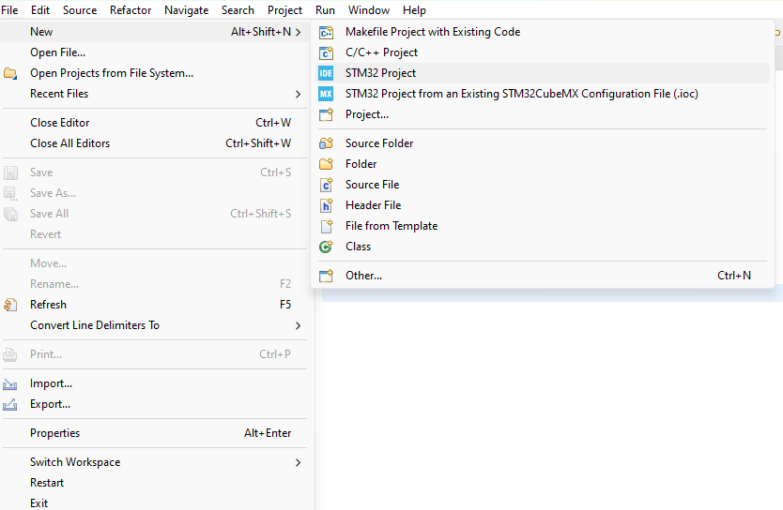

File🡪new🡪stm32 project🡪select your MCU(in this case stm32f103c8t6)

Chose an empty project

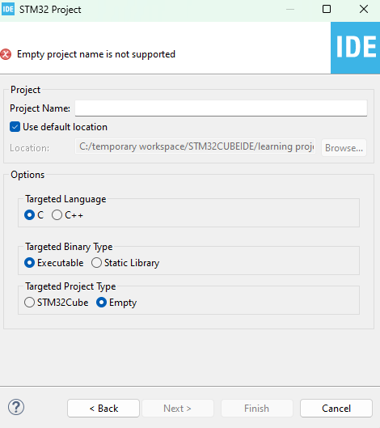

**Step 2:** go to the project file location and replace Inc, Src and Startup files with CMSIS, Core, HAL, Startup, and Peripherals that you have downloaded from Git Hub.

Please make sure that add the files to your project correctly.

You may have to add the .c or .h files as header file or source file.

**Step 3**: right click on the project name in the STM32CUBEIDE and go to the properties🡪C/C++ General🡪Paths and symbols

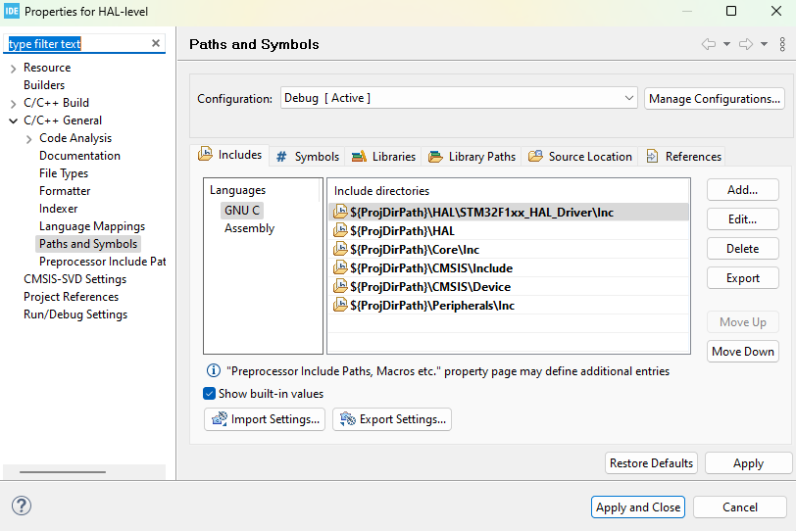

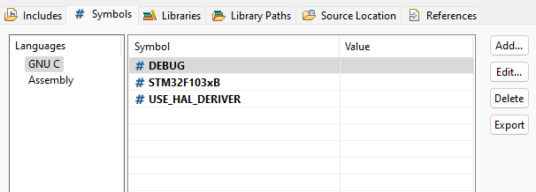

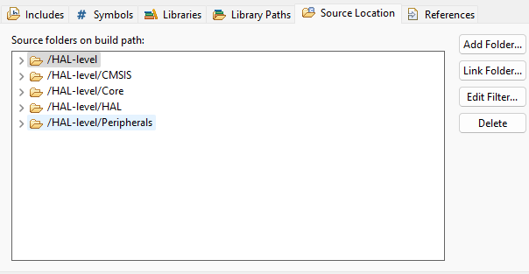

Now you have a minimum project.