Lab 4 README.pdf

Lab 4 Partners
Mark Lee, 36183168
Seyed-Ebrahim Mir-Mohammadsadeghi, 84477686

Break Down

1. Directory path of SOF and solution:
rtl/output_files/rc4.sof
rtl/output_files/Chain1.cdf

2. Status
Everything in the lab is working, and according to the provided instructions. There are some caveats, however, as we will discuss below.

Task 1:
- Write 00 to FF in a RAM block – Check

Task 2:
- Write a single decryption core – Check
- Decrypt messages based on switches for key – Check

Note: the code looks for an MIF file under “rtl/message.mif”, and not “rtl/secret_messages/...”

Task 3:
- Cycle from key 24’h000_000 to 24’hFFF_FFF or until code is cracked – Check
- Display key on hex display – Check
- Success/Failure LEDS – Check
- Check for valid characters – Check
  - The code immediately exits the loop upon an invalid character to save time
  - This is a superiour method time-wise compared to completing the decryption and comparing each index at the end.

Task 3 With Bonus:
- Use 4-cores simultaneously – Check
- Custom LEDs that show which core completed the decryption – Extra
- Has a testbench “task3_bonus_TB.sv”

3. Annotated simulation screenshots as required by the lab
The screenshots are organized from top to bottom and in chronological order. These can be found lower in the document.

4. Information on how to run the simulations
The simulations use imitation RAM and ROM blocks written in Verilog, since the original RAM and ROM do not compile in ModelSim. The code for these imitation blocks were provided with permission by Justin Chang. This code is not used anywhere in the actual project.

For testbenching we used one massive testbench called task3_TB.sv.
5. Any additional information
Modules were created, and each has their own respective file. These files were called upon by the main “ksa.sv” file.
- “task1_fsm.sv” for task 1, the code is recycled in later stages, but not used directly
- “task2a_fsm_ebi_ver.sv” for tasks 2, 3, and 3 with bonus
- “task2b_fsm_crack.sv” for tasks 2, 3, and 3 with bonus
- “task2_fsm” which handles the task2a and task2b
- “decrypted_msg.v” for the ROM containing the output information
- “encrypted_msg.v” for the RAM containing the input information
- “task3_fsm.sv” which handles the task2 with an fsm of its own.
- “task3_bonus_fsm.sv” which handles the task2 with an fsm of its own.

There are rigorous comments in each code module that may be helpful for understanding the “what” & “why”s of the code.

Please note that comments containing “//&?&” is just a shorthand that I use to CTRL-F to areas in the professor’s code that requires adjustment.

Annotated Screenshots
Each FSM here is shown.

Most of these images are from the simulation of brute force on message 1, it has a small key, which makes simulating it being cracked on ModelSim far more tolerable on my computer.

task3_fsm
This FSM’s order is “ITERATE_KEY”, then “WAIT_ITERATE”, “DECRYPT_KEY”, and loop around until the process has been completed. However the first “ITERATE_KEY” state is skipped, so that the all zeros key is not ignored as a possibility.
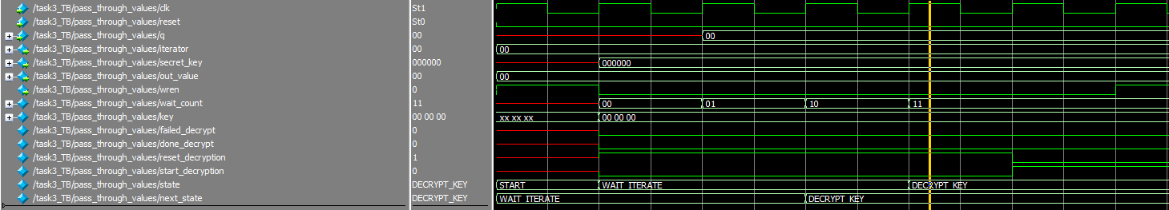

After “WAIT_ITERATE” comes the “DECRYPT_KEY” state, where all the subsequent FSMs get called. Naturally, this is the state that this FSM stays in the longest.
If the decryption fails for that particular key, we then iterate the key.
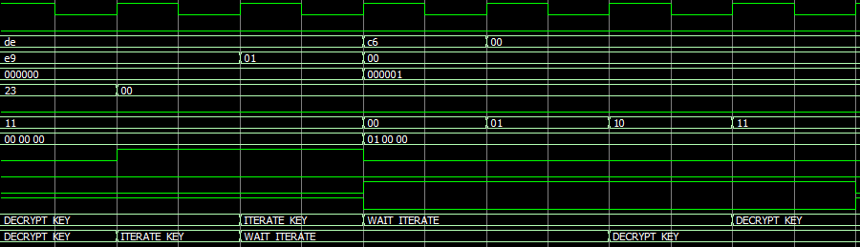

This overall process is continually repeated.
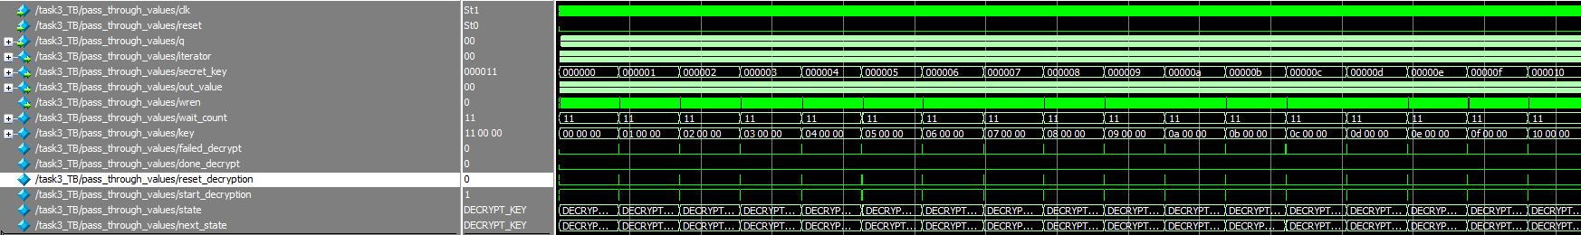
Over and over again.

Let’s now go back to the fact that this FSM simply manages others.

This FSM is a very simple one, immediately after starting, it calls the decryption core and makes it start with the key it provides (and iterates).
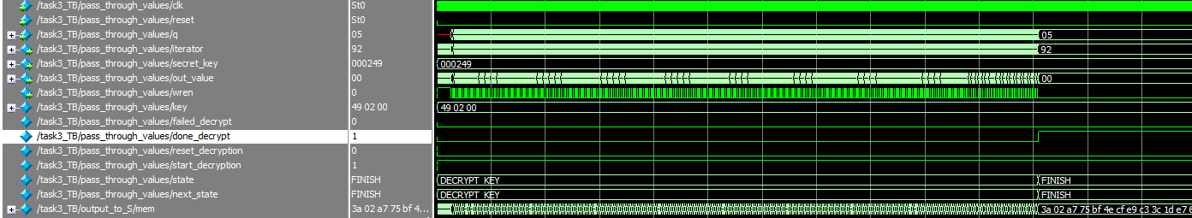

Once the decryption module (task2_fsm) completes its work, it sends a “done_decrypt” signal, and the task3_fsm enters its “FINISH” state, where RAM is suspended and unchanged.

task2_fsm
This is nominally labelled “fsm” but it is simply a collection of wires, regs, and muxes to handle the combination of task2a_fsm and the task2b_fsm. And does not have any states.

task2a_fsm
The task2a fsm does not use iterator_k, the wire is from a slightly previous version of the code, which has been removed. The code has been tweaked for extra wires such as these.
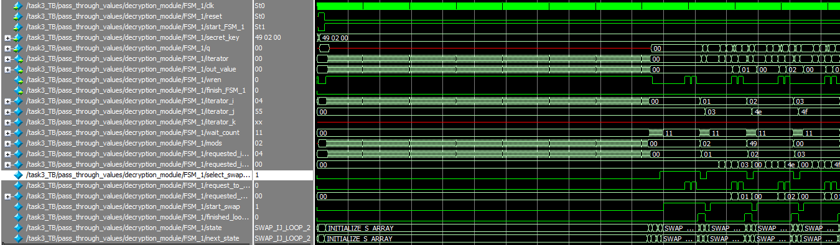
The task2a_fsm starts by doing the first loop, and by placing the values into S_memory. During this process, the value of “q” is irrelevant to us so it is seen as don’t cares.
Once the S_memory has been filled from 00 to FF, it continues onto the second loop. Here the values of iterator_i and iterator_j are incremented, and then the swap_ij_fsm is called.
From a more zoomed in perspective we can see that while this FSM is in the SWAP_IJ_LOOP_2 state, the swap_fsm is changing values.
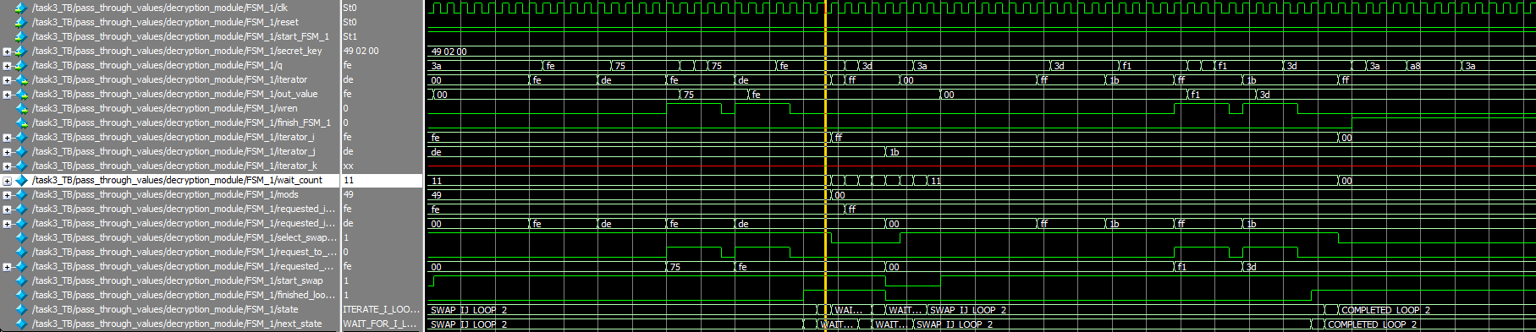
After the swap_ij_fsm finishes, the task2a_fsm iterates iterator_i, waits, iterates iterator_j, waits again, and then calls the swap_ij_fsm once more.
This process is repeated until loop_2 is completed. Where we can see the finish_FSM_1 wire is set high.

task2_swap_ij_fsm
As mentioned earlier this fsm is used in both task2a and task2b. Here it is held in a suspended state until it is told to start.
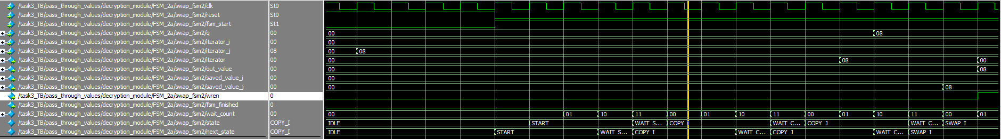

Here we can see that “fsm_reset” was disabled, and “fsm_start” was enabled. Immediately we exit the “IDLE” state and give the S_memory time to gather the necessary information while in the “START” and “WAIT_START” states. “IDLE” initializes values, “START” increments a counter for number of cycles to wait, and “WAIT_START” restarts that counter, so that the next state can use the same reg for its own counter.

After the value from location s[i] is saved, we go to the location for s[j] and saved that value as well. We then place the value from s[j] into the location at s[i] in the “SWAP_I” state.

Then the earlier value from s[i] is placed in the location at s[j] in the “SWAP_J” state. After a wait state, the swap_ij_fsm is finished, and is ready to be reset and called again.

The below image is spliced down the middle (at the yellow bar) for easier viewing.
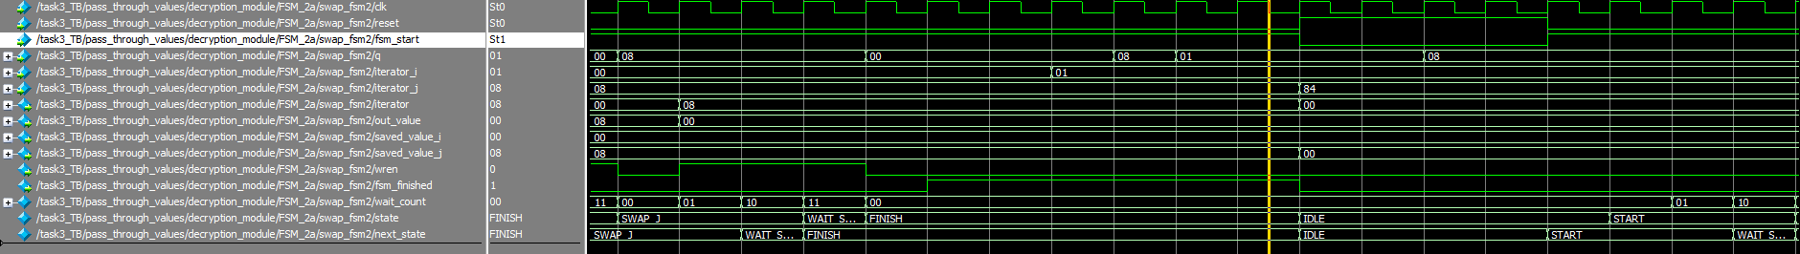
An FSM diagram has been included at the end of the document for the swap_ij_fsm.

task2b_fsm
We start in the “START” state,
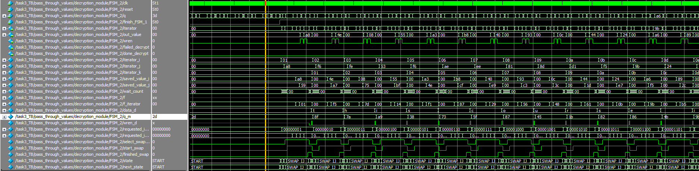
Here all our values are initialized to be zeros.

momentarily the finish_FSM_1 signal comes in, and the FSM starts iterating through loop 3.

Here the FSM goes into ITERATE_I, WAIT_FOR_I, ITERATE_J, WAIT_FOR_J,
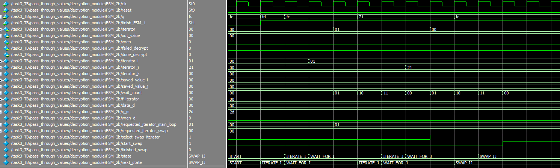

and then SWAP_IJ.

We then retrieve the information from the encrypted RAM in the “RETRIEVE_K” state.
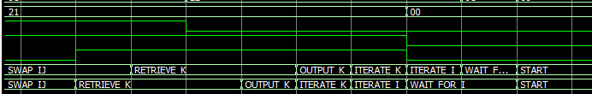

From there the value for k is used to access a location in memory in both the RAM and ROM. The moment where the encrypted memory is first called and q_m becomes valid is apparent.

Eventually the decryption is completed.
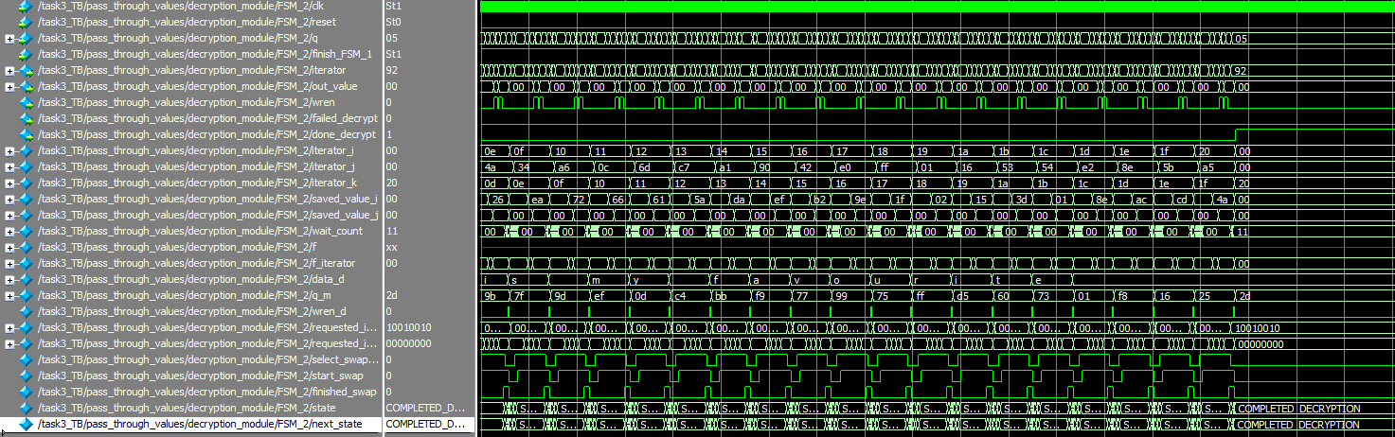
and we can see the “done_decrypt” signal is set high.

As well as the result.
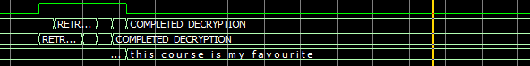

task3_bonus_fsm
This fsm calls and handles 4 different decryption cores (task2_fsm).
The states are the same as in task3_fsm. It behaves nearly identically, it simply has more cores to start up.
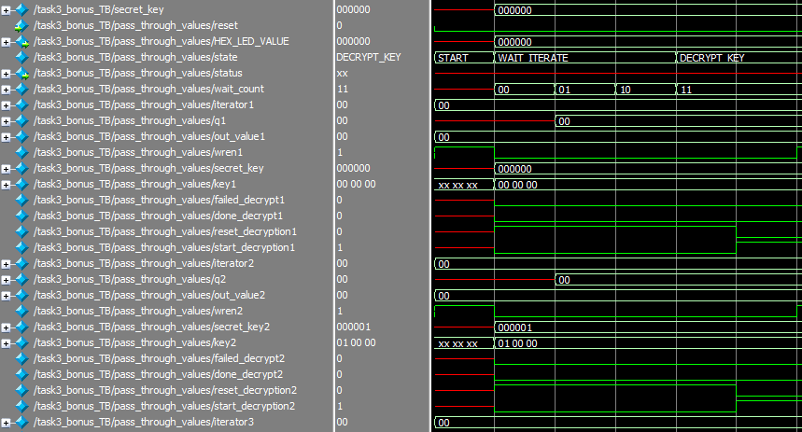
Another detail is that it increments the secret_key by four at a time, with the main secret_key going in the first core and delegates each of the next 3 keys to the next 3 cores.
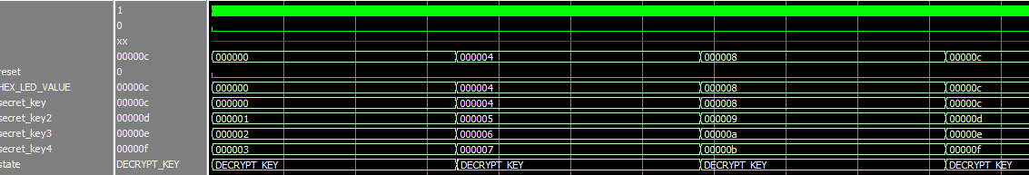
And that is the totality of the unique behaviour.

Messages

Messages 1-3,
Key = 249: "this course is my favourite "
Key = 3FF: "congratulations on task two "
Key = 2AA: "ubc elec and comp engineering "

Message 4, Key: 087B2D
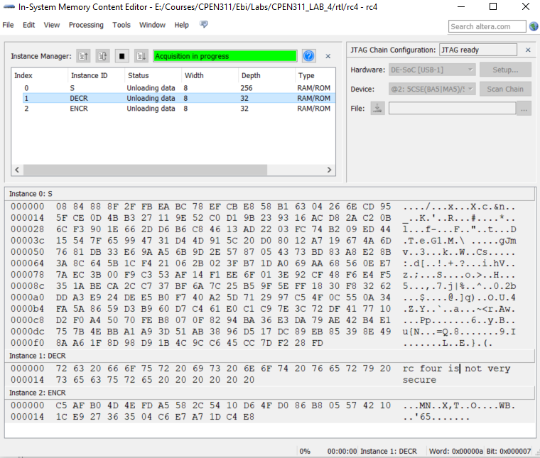

Message 5, Key: 04000C
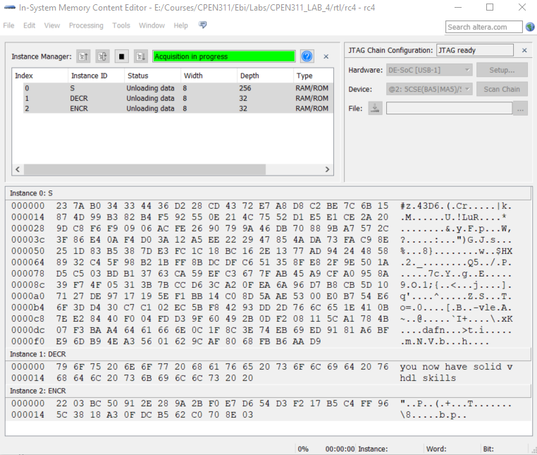

Message 6, Key: 000000

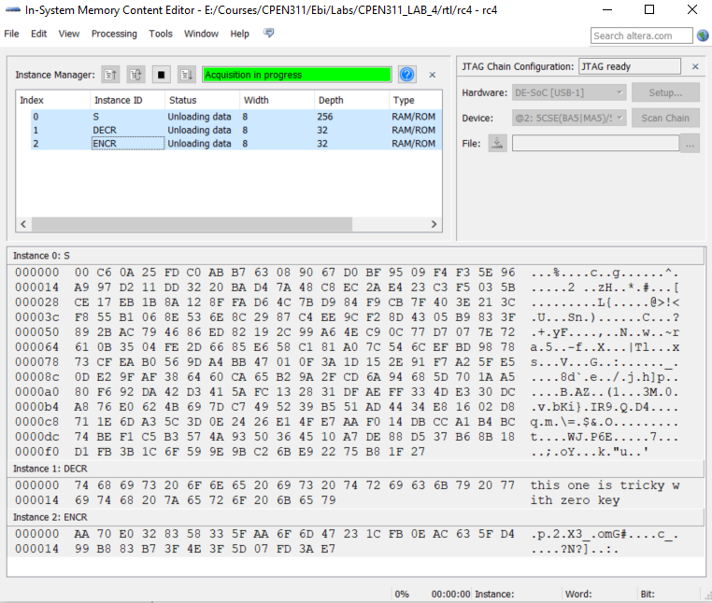

Message 7, Key: 02640F
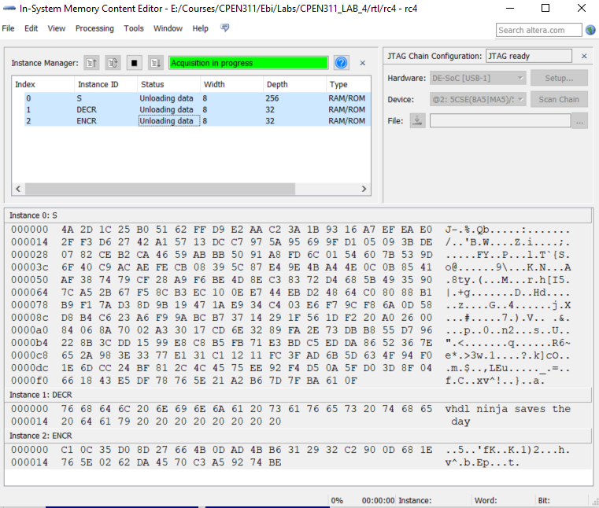

Message 8, Key: 3FFFFF
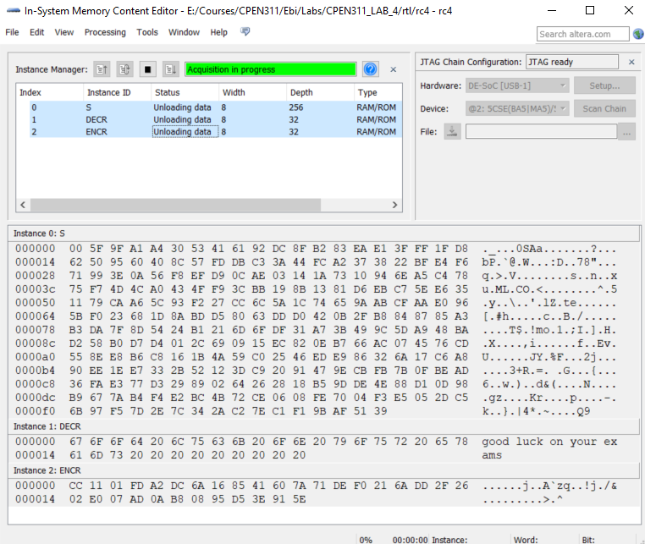

Reference

SWAP_IJ_FSM Diagram
Reset has not been drawn on all states for the sake of visual simplicity. In the actual desing, the FSM can be reset at any moment.
