Lab 5 README.pdf

Lab 5 Partners
Mark Lee, 36183168
Seyed-Ebrahim Mir-Mohammadsadeghi, 84477686

Break Down

1. Directory path of SOF and solution:
rtl/dds_and_nios_lab_time_limited.sof
rtl/Chain1.cdf

2. Status
Everything in the lab is working, and according to the provided instructions. There are some caveats, however, as we will discuss below.

Task 7:
- LFSR with correct sequence – Check
Task 8:
- Instantiate the DDS – Check
Task 9:
- Modulate DDS with LFSR – Check
- ASK – Check
- BPSK – Check
Task 10:
- Connect signals to VGA – Check
- ASK – Check
- BPSK – Check
- LFSR – Check
- Use cross clocking logic – Check
Task 11:
- Create PIOs – Check
- Write ISR – Check
- Write FSK to VGA screen – Check

Latches:
There are latches in the provided code, and NOT from our code. As per
https://piazza.com/class/kjkioroxku03a6?cid=370
these latches will not be considered.

3. Annotated simulation screenshots as required by the lab
The screenshots can be found lower in the document.

4. Information on how to run the simulations
For “waveform_gen_TB.sv” and “sincos_lut_TB.sv” an installation of Quatus/ModelSim Altera 16.1 is required, as it is a system verilog testbench that calls a VHDL module.

5. Any additional information
Modules were created, and each has their own respective file. These files were called upon by the main “dds_and_nios_lab.v” file.
- “fast_to_slow.sv” for task 10,
- “slow_to_fast.sv” for task 10,
- “Nbit_register_async_reset.sv” for flip flops
- “Nbit_register_async_reset_in.sv” as a special flip flop used in “fast_to_slow.sv”
- “LFSR.sv” the used LFSR module
- “lfsr_ebi.sv” a generic LFSR module that can handle more than 5 bits
- “clock_divider.sv”
- “mux4to1.sv”

Youtube video of the VGA screen:
https://youtu.be/fl_4Vw-mmPA

There are rigorous comments in each code module that may be helpful for understanding the “what” & “why”s of the code.

Please note that comments containing “//&?&” is just a shorthand that I use to CTRL-F to areas in the professor’s code that requires adjustment.

Annotated Screenshots
Each FSM here is shown.

Waveform_gen_TB

sincos_lut_TB, sin cos lookup table
In this testbench I increment addr forever, and observe the values coming through.

The forever loop in the testbench will overflow and the test loops.
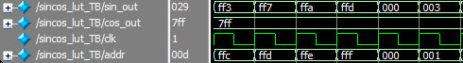

LFSR – simple

LFSR – with self-initializing & reset handling FSM
Here we see the LFSR reset its flip flops when first starting, and setting the initial value.
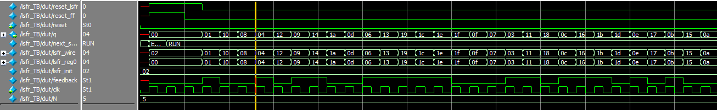

Clock Divider
This is fairly self explanatory. The clock divider will wait until the provided number of clock cycles before swapping the outclk.

Slow to fast, cross clocking logic
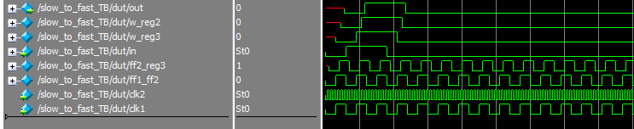
Fast to slow, cross clocking logic
