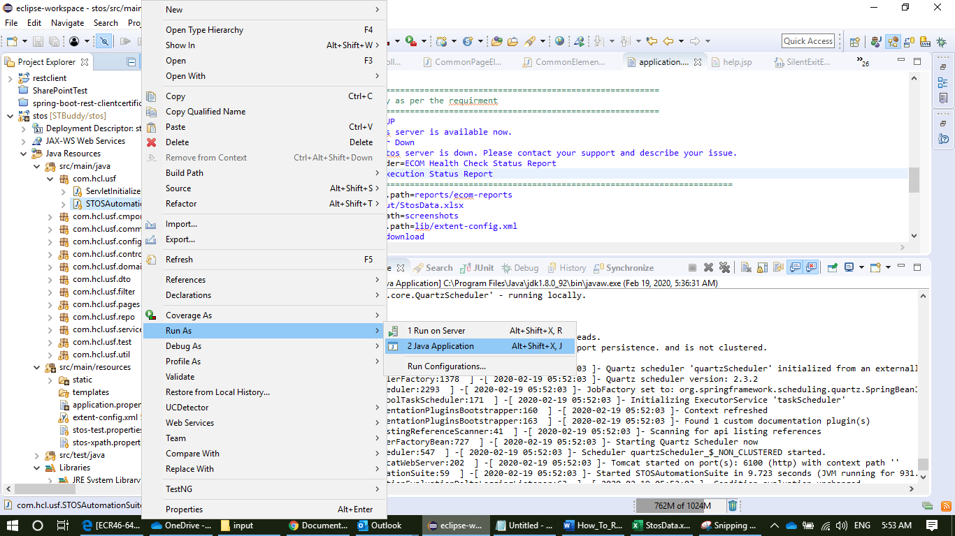

Right Click to Class and Run

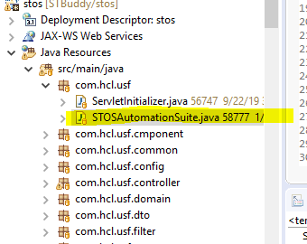

Once Run Start page will come

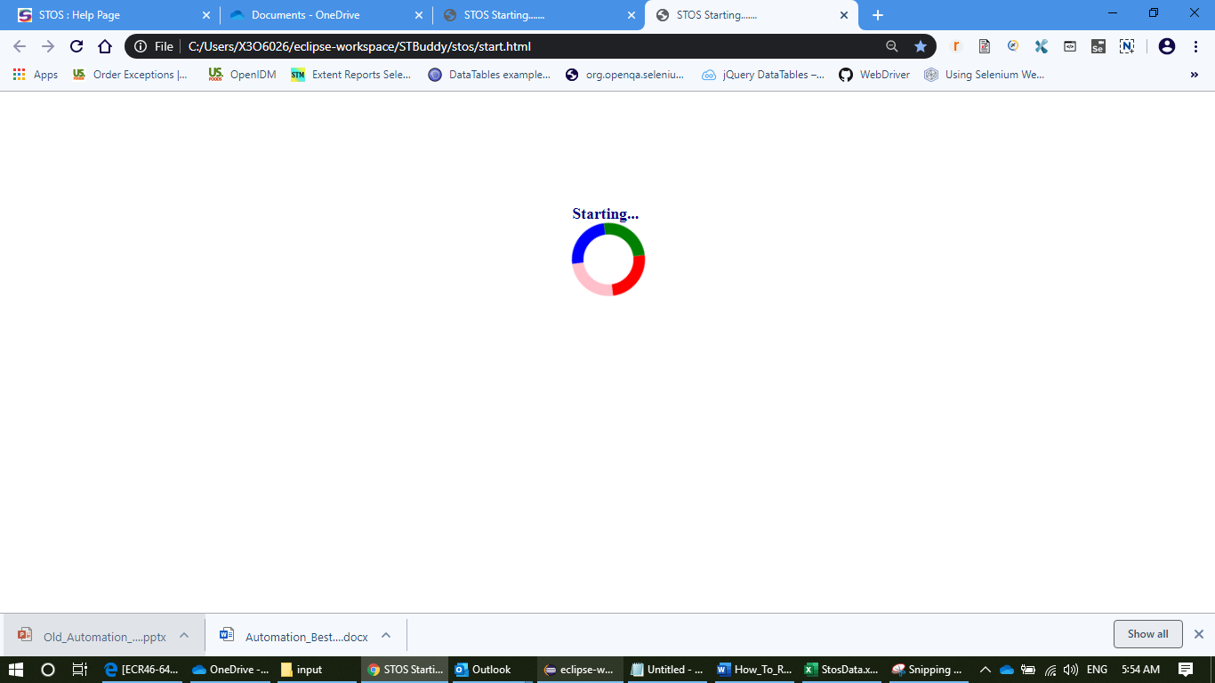

See the eclipse log

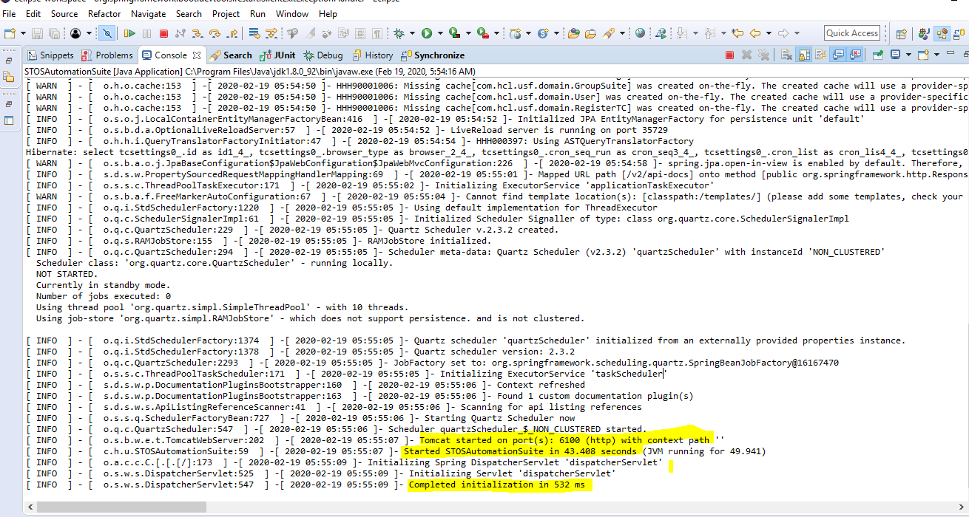

1. Create the tab in StosData

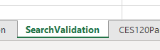

2. Create a data row in **SearchValidation** as per requirement



3. Go to Windows Chrome browser and type <http://localhost:6100>

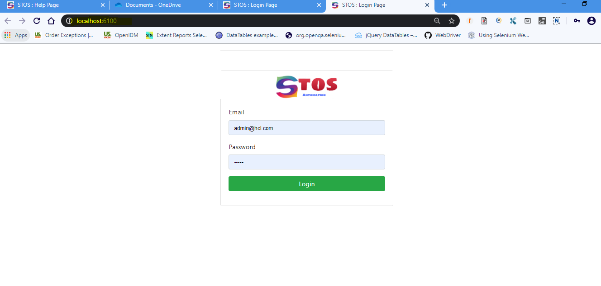

4. Login into Stos application with user name [admin@hcl.com/admin](mailto:admin@hcl.com/admin)

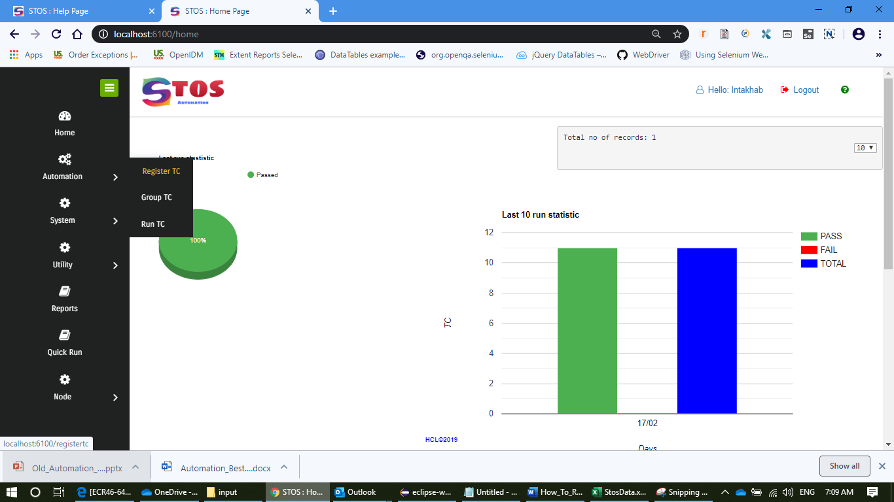

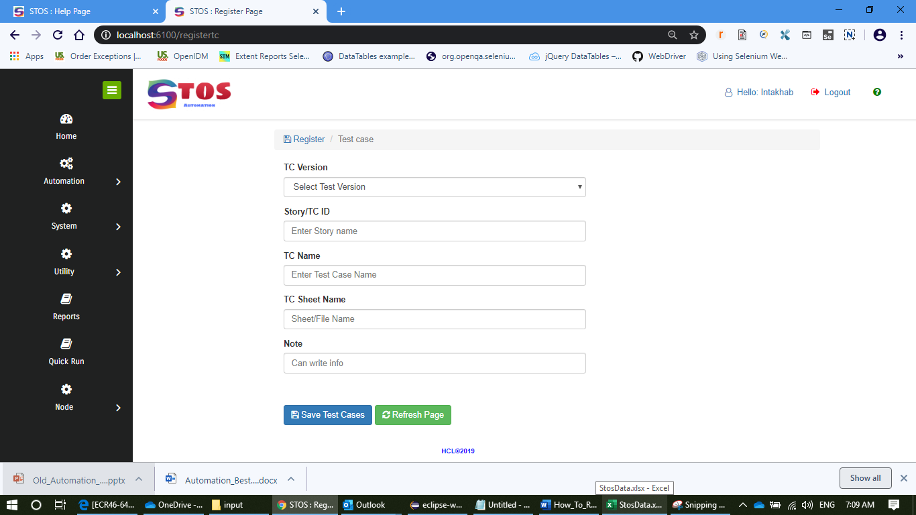

Here Choose TC Version-

TCID like **EC45-108**

TC Name like **FindRemoveItemsOnPageTest**

Sheet Name like which we have created in step1

Save it

5. Your register TC will show in last

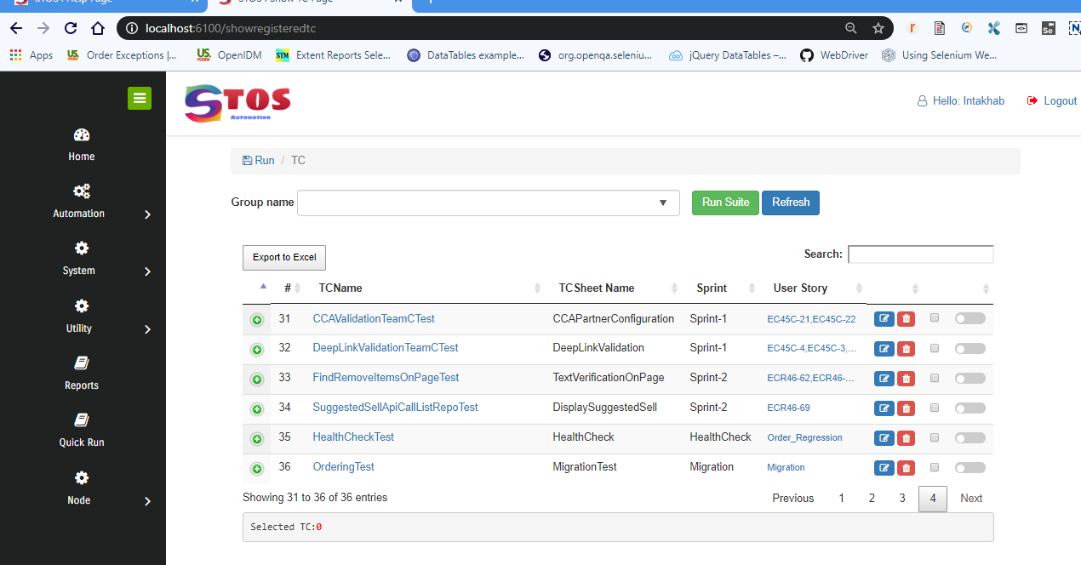

6. Can click on Run suite or TCName link

