JMS
Installation
CW-5000480 – 0.2 – concept

Document Information

General
Document Title: | JMS
Area or Project: | Installation
Project Code:
Document Number: | CW-5000480
Document Version + Status: | 0.2 – concept
Date Created: | June
Initial Author: | mpoyhone
Date Last Modified: | June
Approved by:

Copyright © 2007 Cordys Software B.V. All rights reserved.
The information in this document is confidential, constitutes the intellectual and proprietary property of Cordys Software B.V, and is protected by intellectual property laws and international intellectual property treaties.
Cordys, the Cordys logo, the Cordys name and logo, Cordys CenterCourt, Center Court, Cordys WCP, Cordys Web Collaboration Platform, Cordys BAC, Cordys CPC, Cordys Collaborative Process Components, Cordys ECX, Cordys Enterprise Collaboration Exchange, Cordys NCX, Cordys Network Collaboration Exchange, Cordys, Just Collaborate, Cordys, the Art of Opportunities, iCordys, myCordys and bizzApps are registered trademarks Cordys Software B.V.
All other trademarks mentioned herein maybe/are the trademarks or registered trademarks of their respective owners and should be noted as such.
No part of this document may be reproduced or transmitted in any form or by any means, electronic or mechanical, for any purpose, without the express written permission of Cordys Software B.V. The information contained in this document is subject to change without notice. Cordys Software B.V. does not warrant that the information contained in this document is error free.

TABLE OF CONTENT

1. Introduction 5
1.1 Document Purpose 5
1.2 Audience 5
1.3 Purpose 5
1.4 Definitions, acronyms, and abbreviations 5
1.5 References 5
2. Installing 6
2.1 Installation prerequisites 6
2.2 Installing the JMS Connector 7
2.2.1.1 Installing the ISV package 7
2.2.1.2 Unloading older versions 7
2.3 Creating the JMS Connector within the organization 12
3. Configuration 15
3.1 Configuration of JMS Connector 15
3.2 Configuration of JMS mapping to WebSphere MQ: JMSAdminGUI 15
3.2.1.1 The Tool 15
3.2.1.2 Create a profile 15
3.2.1.3 Creating a new Queue Connection Factory 17
3.2.1.4 Create the Queues 19
3.3 Configuration of the JMS Connector 21
3.3.1.1 Configuration of the classpath for Websphere MQ 21
3.3.1.2 WebSphere MQ message ID passing (advanced) 22
3.3.1.3 Configuration of the JMS specific parts 23
3.3.1.4 Configuration of BTC 26
3.3.1.5 Configuration files for the Binary Transformation Channel Engine 27
3.3.1.6 Configuration of Triggers 27
3.3.1.7 Special Destinations 28
4. Migrating To Other Environments 31
4.1 Introduction 31
4.2 Exporting the configuration to XML Store 31
4.3 Importing the configuration from XML Store 32
4.4 Update the configuration data 34
5. Problem Solving 35
5.1 Using the log files 35
5.2 Trigger problems 35
5.3 JMS Connector doesn’t want to start 36

- Introduction

Document Purpose
This document contains the instructions how to install and configure the JMS Connector. In case of WebSphere MQ this document also handles what is needed besides the JMS Connector self, to get the software up-and-running.

Audience
Installing the JMS Connector and creating the configuration is to a large degree normal installation work. However, for creating the right destinations and triggers, knowledge about the technical solution is necessary.

Purpose
The purpose of this document is to provide all the information needed for a successful deployment of the JMS Connector in combination with WebSphere MQ. Most of the steps are the same for other message queuing systems, only the JNDI configuration will be different.

Definitions, acronyms, and abbreviations
Term | Description
Destination | The JMS term for a queue or a topic
Destination Manager | The component responsible for managing destinations. Only used by JMS Connector. In the JNDI this is the queue connection factory.
BTC | Binary Transformation Channel, an engine for transforming XML messages to binary messages and visa-versa

References
Code | Description

- Installing

Installation prerequisites
JMS connector needs the right WebSphere MQ jars to be able to connect to the queue manager. This means that either a local WebSphere MQ installation or the WebSphere Client (5.3 fix-pack 11 or higher) is needed.
The MQ installation consists of two steps: first unpacking the installation program to a local directory and then running the installation.
After installation of MQ, it is necessary to manually move the Java subdirectory found in the directory where MQ is unpacked and move it to the directory where MQ is installed.
The Java subdirectory contains the jar files needed for the JMS Connector and the program JMS Admin needed to configure the JMS to MQ mapping (the JNDI).

Installing the JMS Connector

Installing the ISV package
To install the JMS Connector, the ISV package containing the connector should be copied to the directory:
[Cordys Install]\Web\wcp\isvcontent\packages
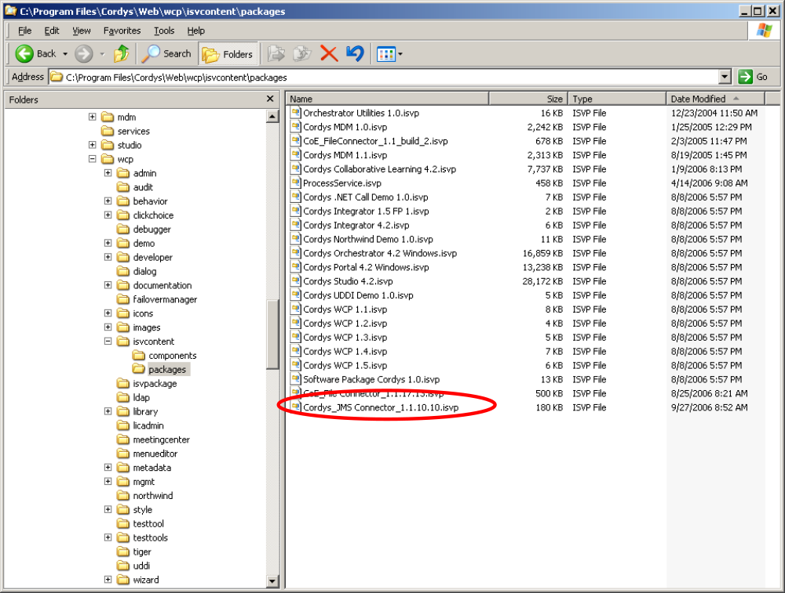
Figure 1: The directory containing the ISV's

Within the Cordys environment, loading an ISV is done in the System organization. Use the ISV Package Registry in the Admin Tools menu.

Unloading older versions
In case that an older version is present, this version should first be unloaded. This is done by selecting first the ISV and on the Installation details tab press the Unload button.
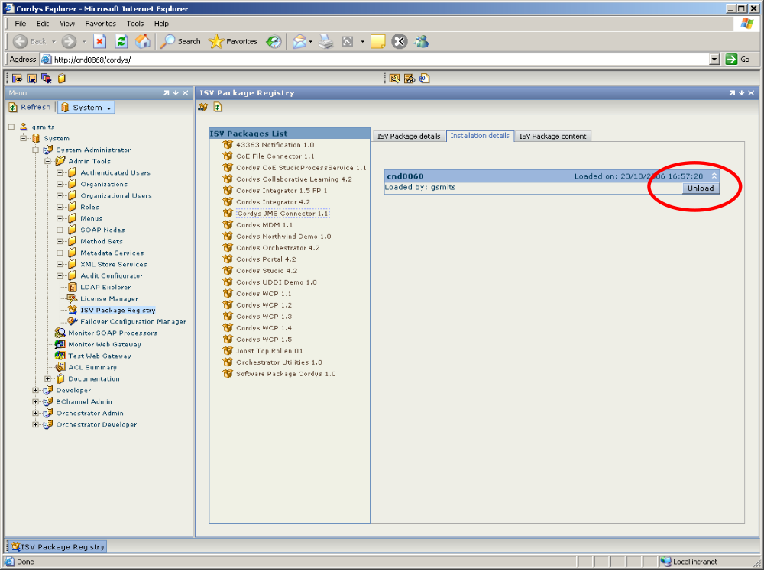
Figure 2: Unloading an existing ISV

As a result of unloading the ISV, a question dialog appears to first confirm the unloading. Press Ok.
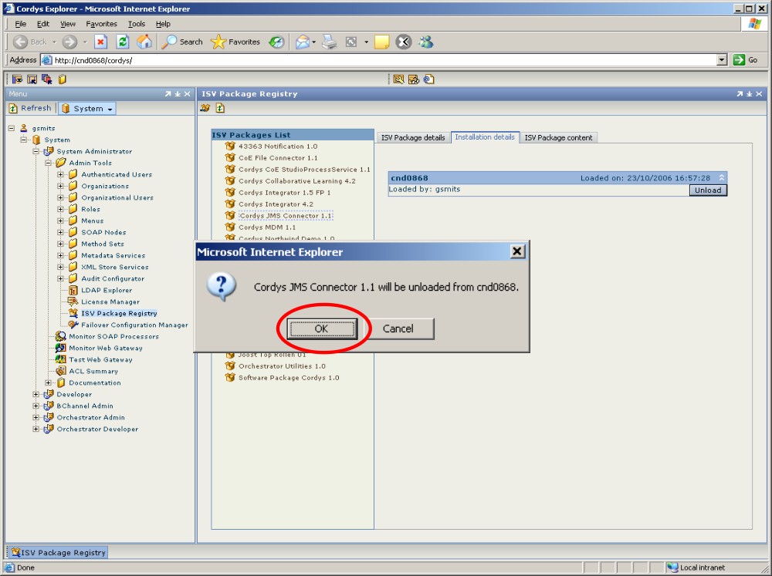
Figure 3: Confirm the unloading

The next question is if the references of roles and method sets should be deleted. Press No to make sure that both are kept.
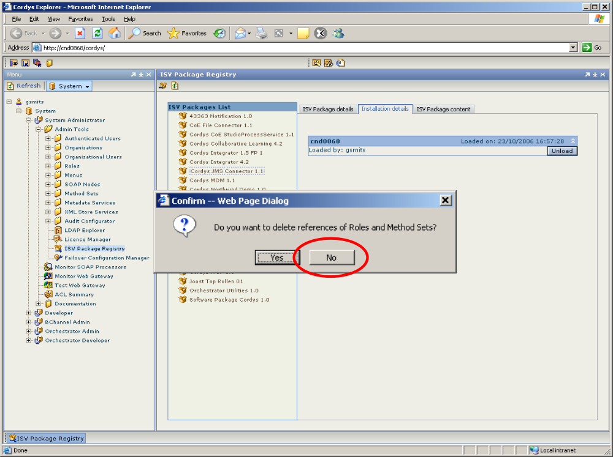
Figure 4: Do not delete references

The next step is loading the new ISV package containing the JMS Connector

Remark on what to do when mistakenly deleting references
After installing the ISV, the SOAP node can be created with the JMS Connector soap processor. During this installation, the methods of the JMS Connector are automatically attached to the SOAP nodes. When unloading the ISV and answering mistakenly “yes” on the question: “Do you want to delete references of Roles and Method Sets?” the method set is removed from the SOAP node. By loading the ISV again, the method set is not automatically attached to the SOAP node. This has to be done manually. Also the roles have to be applied again.

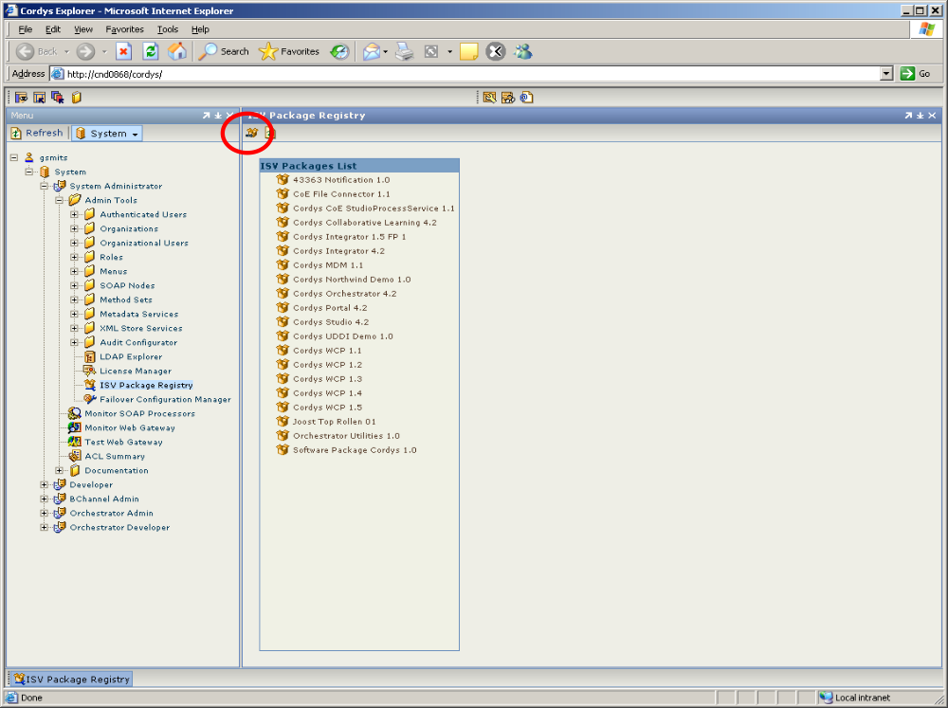
Figure 5: Load a new ISV package

Press marked button (Load ISV Package) to start loading ISV package. Now the wizard is started
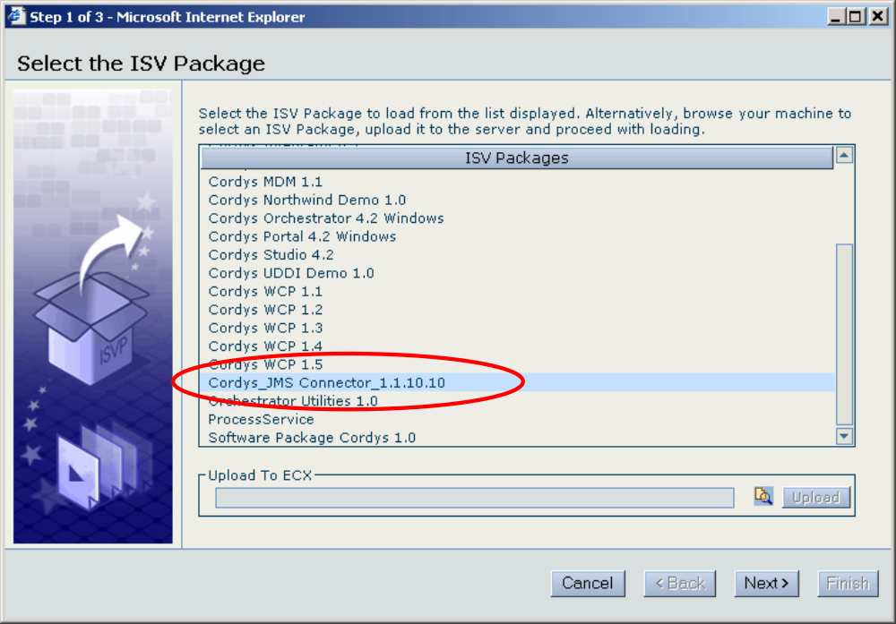
Figure 6: The ISV Package import Wizard

The following steps of the wizard are simply pressing the next button until the finish button can be pressed and the ISV package is installed.

Creating the JMS Connector within the organization
ALERT


The current user must have a role in Cordys Studio 4.2 ISV package (everyoneInCordys Studio 4.2 is sufficient).
In order to use the JMS Connector, a soap node and soap processor has to be created for the JMS Connector. This is done by selecting the New option in the popup menu of the Soap Nodes.
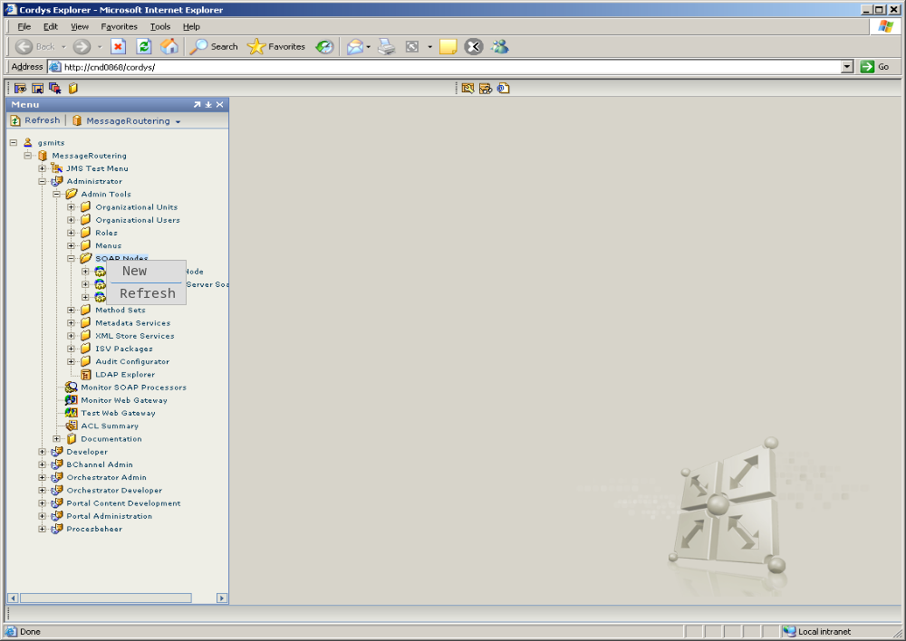
Figure 7: Starting the New SOAP Node Wizard

The New SOAP Node Wizard will appear. Select the JMS Connector.

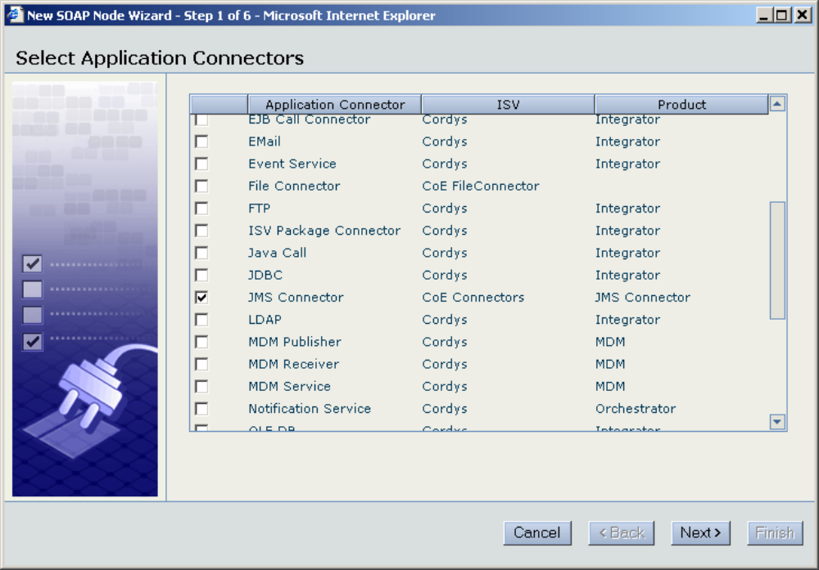
Figure 8: The SOAP Node Wizard

The next step is defining the name of the SOAP Node and attaching the method set of the JMS Connector.
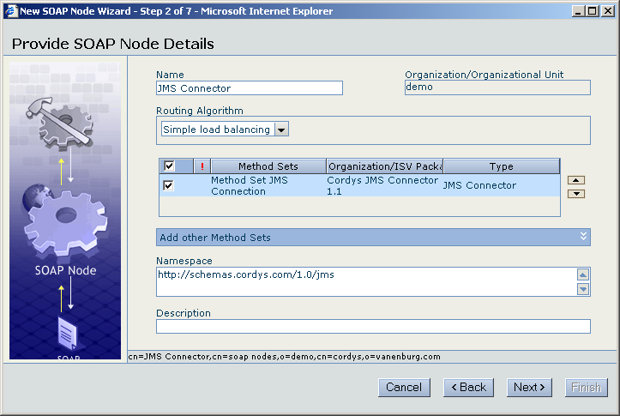
Figure 9: Adding the JMS Connector Methods to the SOAP node.

The next step is to name the SOAP processor attached to the SOAP node and checking the property Startup Automatically.
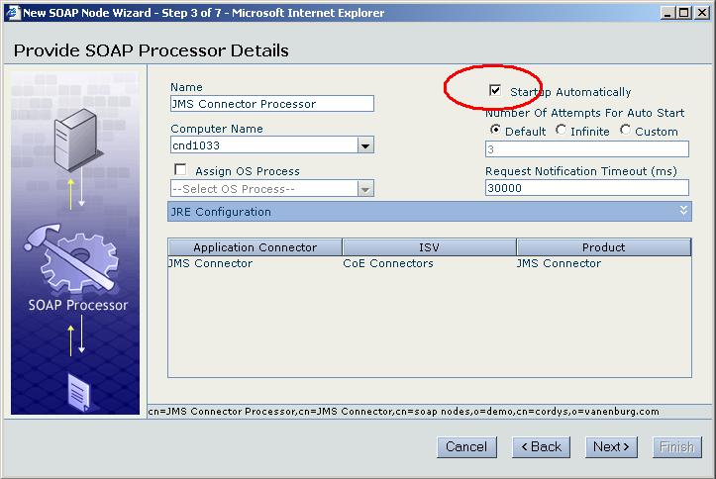
Figure 10: Setting the SOAP processor properties

The last step is setting the JMS Connector properties. This can be done during the creation of the SOAP node or also later. In that case finish the wizard. In the chapter on configuration the details on configuring the JMS Connector are provided.
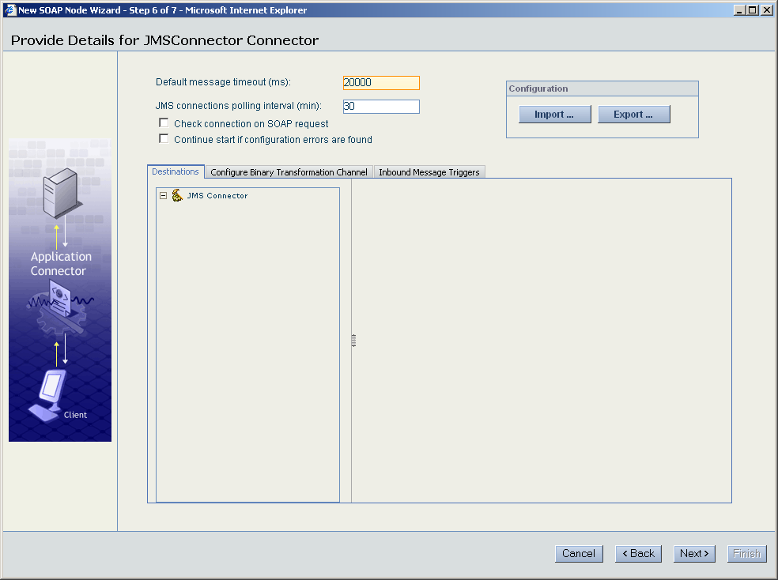
Figure 11: Setting the JMS Connector properties

Remark: Loading the last screen can take some while due to its complexity
- Configuration

Configuration of JMS Connector
The configuration of the JMS Connector consists of the following steps:
- If needed create the physical queues in WebSphere MQ
- Define with JMS Admin how the physical queues will be called within Java directory service: JNDI. JMS will use the JNDI to find the physical queue names and properties.
- Also, using JMS Admin, extra mapping information can be provided about code pages and message formats used by the physical queues.
- Define in the JMS Connector configuration page the mapping of the destination names to the JNDI destination names. Also define the destination manager and how it maps to the JNDI Context Factory which must be provided by the JMS server vendor.
- Define also on the configuration page, the BTC information needed to transform messages when writing and reading from the destinations.
- Define the triggers for incoming messages.

Configuration of JMS mapping to WebSphere MQ: JMSAdminGUI

The Tool
To map the JMS destinations to the MQ queues, the tool JMSAdminGUI is used. JMSAdminGUI is a graphical interface which is not part of WebSphere MQ but can be downloaded from the IBM website using the URL:
http://www-1.ibm.com/support/docview.wss?uid=swg24004691
Unpack the zip file to a directory. The directory will contain the command jmsadmingui.bat to start the JMSAdminGUI application.
Note: WebSphere MQ comes with a command line tool jmsadmin.bat, which is rather awkward to use.
Start it by double clicking on jmsadmingui.bat. If this is the first time, then the tool must first be configured to use WebSphere MQ:

Create a profile
First create a new profile:
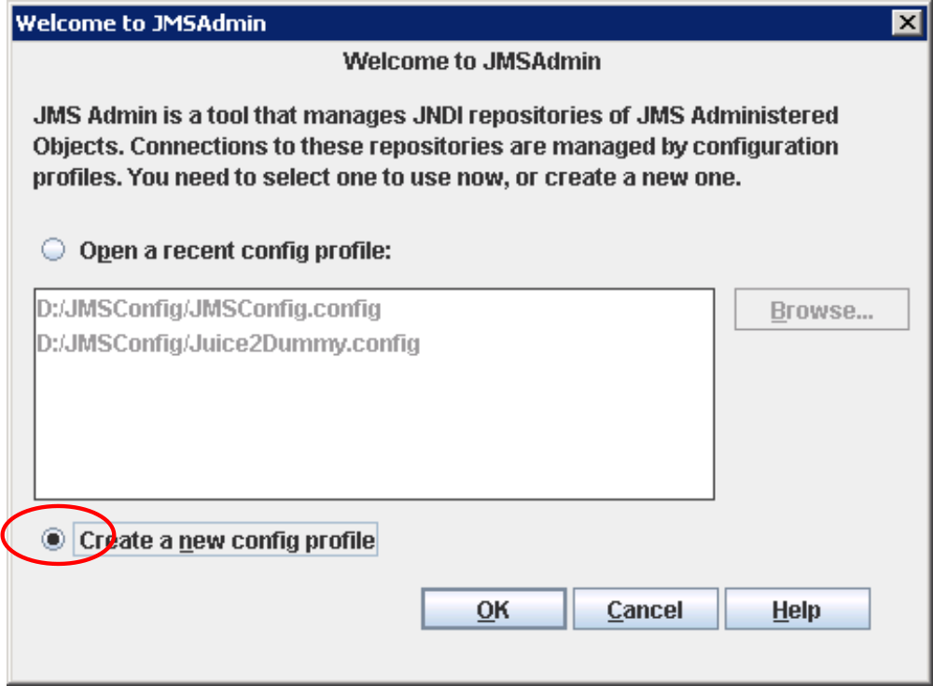
Figure 12: Create a new profile for JMSAdminGUI

Next, provide a name for the profile:
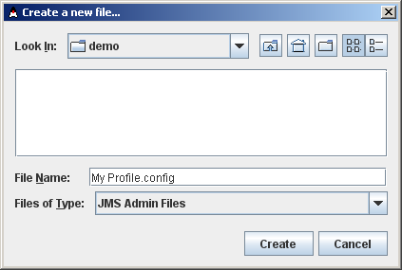
Figure 13: Provide a profile name

The last step is to provide the properties to connect to the WebSphere MQ environment:
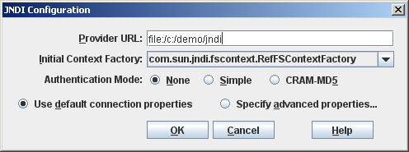
Figure 14: Setting the connection properties

The two properties to be set are:
- Provider URL: file:/c:/demo/jndi. This is a file based URL pointing to the place where the .binding file is stored. This file will contain all the settings about destinations and destination managers to be made with JMSAdminGUI. This parameter is also used in the JMS Connector for defining the destination manager.
- Initial Context Factory: com.sun.jndi.fscontext.RefFSContextFactory. This is a factory method to be used when the Java directory is based on a flat file.

Creating a new Queue Connection Factory
From the menu, create a Queue Connection Factory:
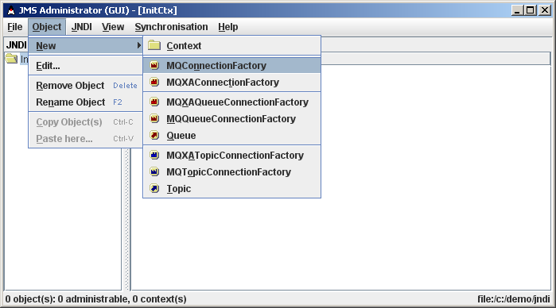
Figure 15: Creating a Queue Connection Factory

On the first tab for Object Identification, the name of the JNDI name of the destination manager is set to point the queue manager name in WebSphere MQ. This name is going to be given in the JMS Connector configuration page for the destination manager.
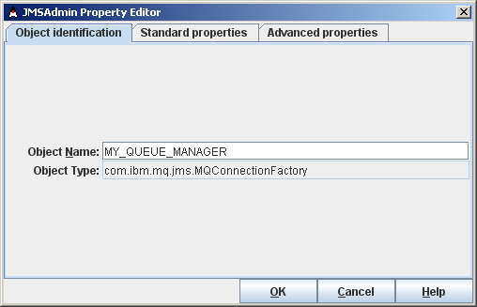
Figure 16: Naming the connection factory
The next step is to provide the properties how the JNDI destination manager maps to the Queue Manager of WebSphere MQ on the tab Standard properties. The Queue Manager must be name of the actual WebSphere MQ queue manager. Note that the transport must be set to Client if connecting to another computer and Bindings if connecting to the same computer.
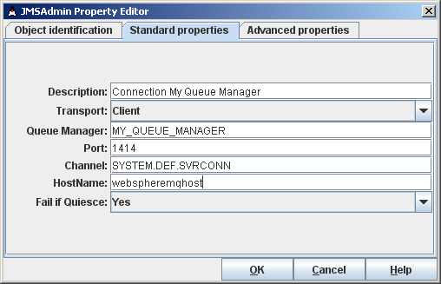
Figure 17: Mapping to the Queue Manager

The tab for Advanced properties doesn’t have to be filled.

Create the Queues
From the menu, select the command to create a new queue as shown in the figure:
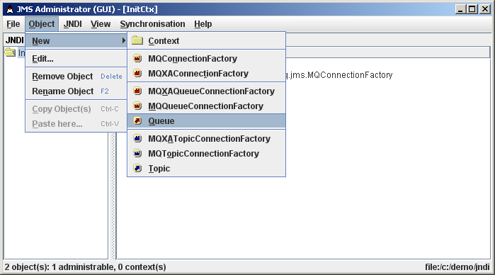
Figure 18: Create a new queue

The Object identification tab contains the JNDI name of the destination. This name is going to be used in the JMS Connector configuration page for the destination.
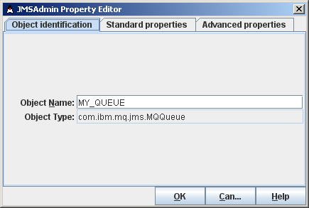
Figure 19: Filling in the JNDI name

The next step is to provide the mapping to the MQ names of the queue and queue manager on the tab for Standard properties:
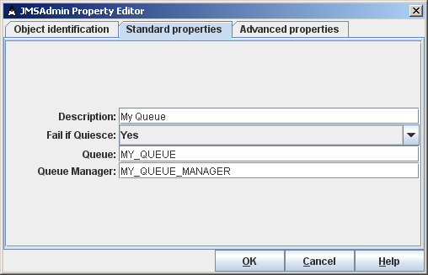
Figure 20: Mapping the JNDI name to the MQ names

If JMS Connector is used to communicate with non-JMS clients that expect WebSphere MQ message formats, open the third tab, Advanced properties and set the Targclient property to value MQ. This will force JMS to write messages using the MQSTR header instead of the more advanced MQRFH header.
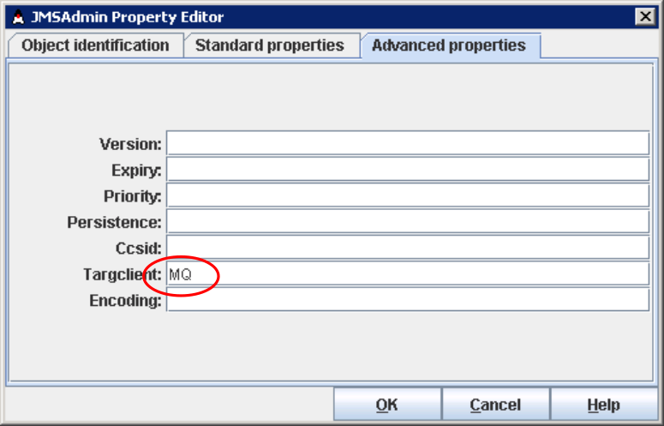
Figure 21: Specify the header format

After creating the first queue, the dialog will contain:
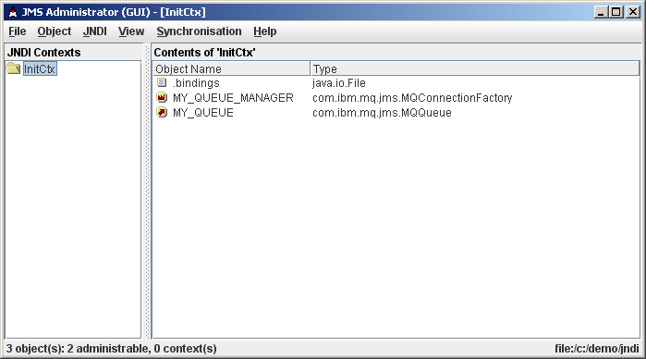
Figure 22: The first destination and destination manager

For additional queues, repeat the queue creation step.

Configuration of the JMS Connector
The JMS Connector can be configured during loading the ISV or later by selecting the soap processor properties in the Monitor Soap Processors, by navigating through the Cordys Menu.
Administrator → Monitor SOAP Processors → [right click] properties
The first tab General contains the generic connector properties. In the section ‘JRE Configuration’ the classpath, containing the JAR files needed by the soap processor, can be specified. These JAR’S are the client side libraries of WebSphere MQ, needed to connect to the queue managers and queues.
Note: The JRE Configuration section needs to be expanded by pressing the button, to make the input fields visible.

Configuration of the classpath for Websphere MQ
Add the following jars to the classpath in the JRE Configuration:
- [WebSphere MQ Install]\Java\lib\fscontext.jar;
- [WebSphere MQ Install]\Java\lib\com.ibm.mq.jar;
- [WebSphere MQ Install]\Java\lib\com.ibm.mqjms.jar;
- [WebSphere MQ Install]\Java\lib\providerutil.jar;
- [WebSphere MQ Install]\Java\lib\connector.jar;
If BTC engine is used, additional jars containing the BTC stages must also be added.

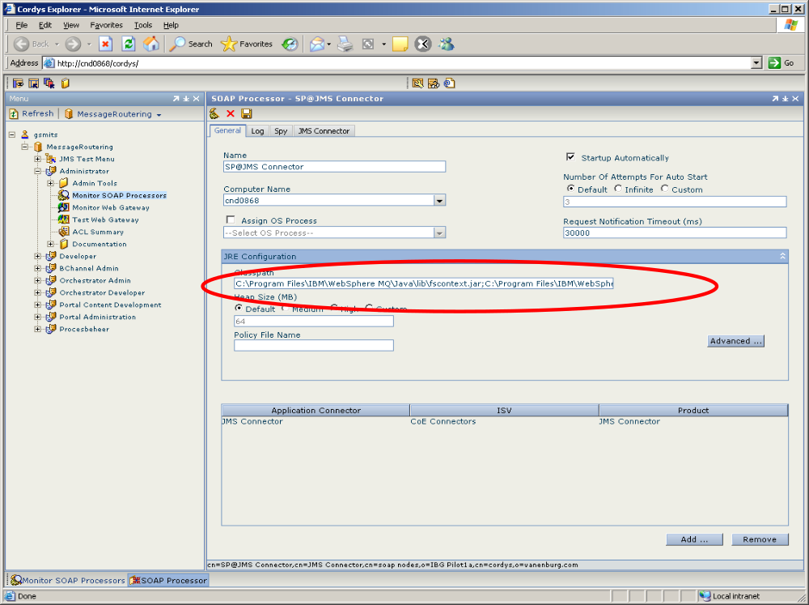
Figure 23: Setting the classpath to contain all JARS necessary

WebSphere MQ message ID passing (advanced)
In some situations it is necessary to pass on the message ID, although this is not standard possible under the JMS standard.
But there are situations where this behaviour is needed because, for example, in the original situation WebSphere MQ and MQSI (message broker) functionality was used directly and WebSphere MQ allows passing of the Message ID. When the Cordys ESB is positioned between the front office and back office to provide orchestration of the message flow, this feature must be preserved.
As stated, this is a feature not possible in standard JMS so this must be enabled by setting an extra flag in the advanced JRE properties.
Add the extra flag for the setting the message identity, using the Advanced button
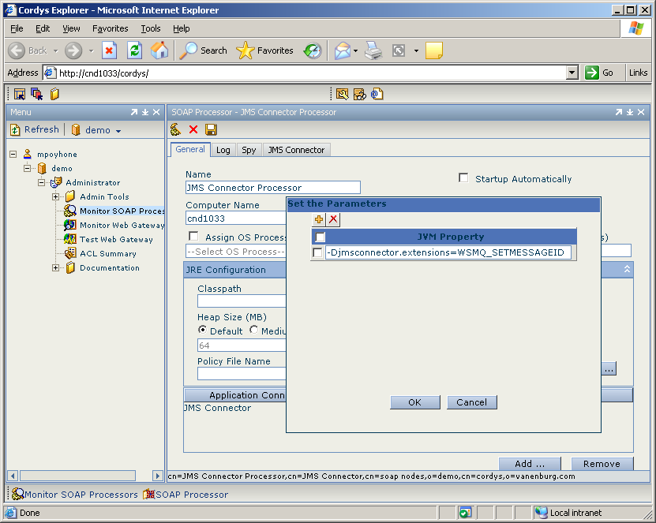
Figure 24: Setting the advanced JRE configuration

Create a new property using the ‘+’ button and add:
-Djmsconnector.extensions=WSMQ_SETMESSAGEID

Configuration of the JMS specific parts
In the JMS Connector tab the specific JMS configuration has to be done. This consist of three parts (separated by the three lower tabs):
- Setting the destinations and destination manager
- Setting the BTC properties (optional)
- Setting the Triggers (optional)

Create a generic user for Triggers and doing BTC transformations
There are two places that a user has to be given, namely to call a method (e.g. starting a flow) from a trigger and for using BTC. In this document we assume that a generic user is created: Cordys System User with enough permission to execute the method and BTC. For example, when the method starts a flow, this user needs permissions in Orchestrator.

Configuration of JMS Connector parameters
The parameter JMS connections polling interval (min) is default 30 minutes. When the JMS Connector loses connection to the MQ server, it will start polling to reestablish the connection with the interval specified with this parameter. Change the parameter to 1 minute. After reestablishing the connection, the polling will automatically stop.

Configuration of destination manager
To configure the destination manager, right click the JMS Connector item on the left side, select Add destination manager and in the pop-up dialog give the destination manager name (e.g. MyDestinationManager). In property page enter the following properties:
- JMS Vendor: WebSphere MQ
- Provider URL: file:/c:/demo/jndi
- JNDI name: MY_QUEUE_MANAGER (replace with one in JNDI)
See the following figure:
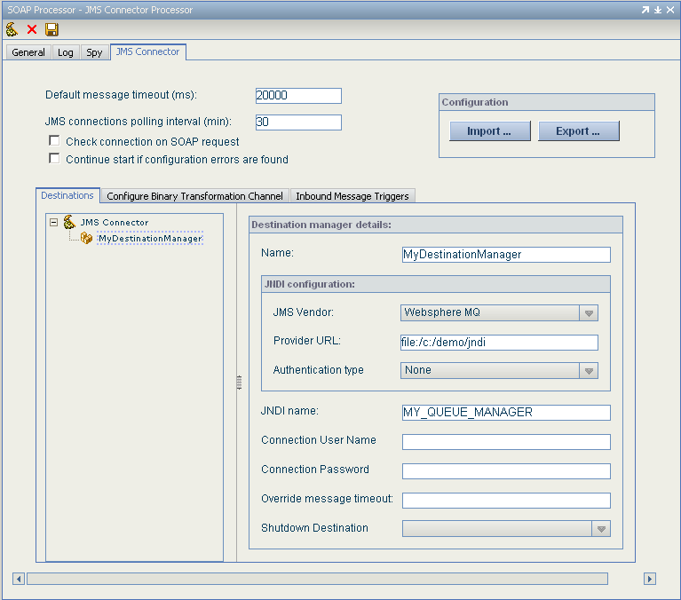
Figure 25: Setting the Destination Manager

Configuration of destinations
To configure the destination, right click the destination manager on the left side, select Add destination and in the pop-up dialog give the destination name (e.g. MyDestination). In property page enter the following properties:
- Name: the name of the destination as known within Cordys
- JNDI name: the name as used in JNDI and as set with JMS Admin
- BTC protocol (optional)l: A BTC protocol name configured in the BTC tab.
- Error Destination (optional): Name of the destination where messages are put into in case of an error (the message could not be delivered to the assigned queue or a trigger SOAP request failed for an incoming message).
See the following figure:
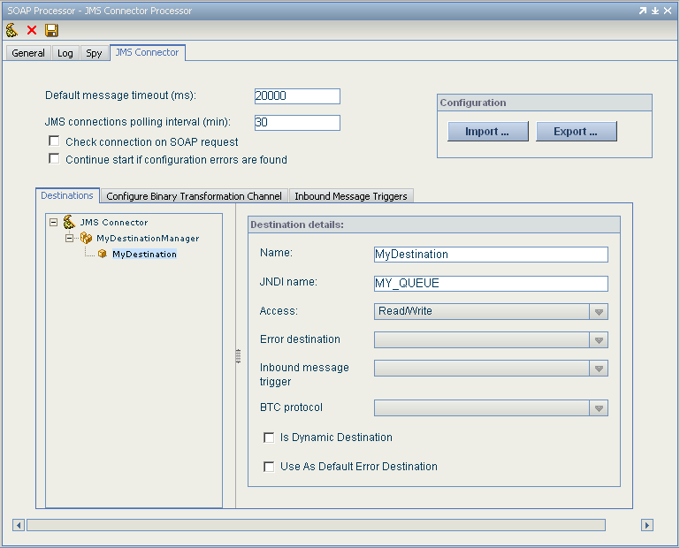
Figure 26: Defining the configuration for each destination

Configuration of destinations with triggers
Some destinations will call a method on incoming messages, e.g. start a flow, by using triggers. This is configured using the Inbound message trigger field on the Destination tab and configuring the trigger using the Inbound Message Trigger tab.
Multiple destinations can share the same triggers.
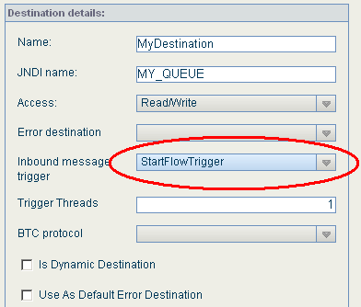
Figure 27: Setting the trigger

Configuration of BTC
For destinations, which need a transformation from XML to binary or visa-versa, the BTC protocol has to be configured, using the Configure Binary Transformation Channel tab. The following properties have to be set:
- Store Type: XML Store. This is the place were the BTC configurations are stored.
- Protocol: The actual protocol to be used on this destination. This protocol is defined within the configuration files
- Organization: demo (Organization containing the configuration)
- User: Cordys System User
- Key: /BTC/my-btc-config. this is the path in XML store to the configuration files
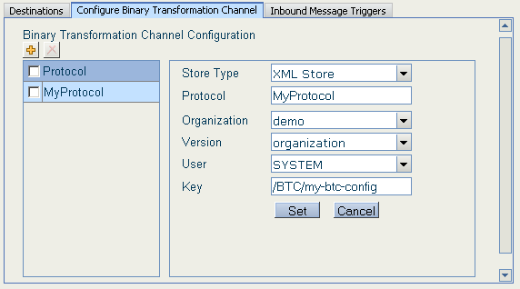

Configuration files for the Binary Transformation Channel Engine
The BTC configuration files are stored in the XML Store under the folder BTC. It is referenced in the JMS Connector with the path:
/BTC/my-btc-config
To locate the file in XML Store the following navigation through the menu structure is used:
Administrator → Admin Tools → XML Store Services Collection → BTC

Configuration of Triggers
When a message arrives from queue, the JMS connector can be configured to automatically trigger a SOAP request with this message. To start a business process, the following properties have to be set:
- Namespace: http://schemas.cordys.com/1.0/coboc. This is the namespace used by the Orchestrator processor for its methods.
- Method name: RequestProcess. The actual method in Orchestrator which starts a flow.
- Organizational DN: demo. This is the organization in which the flow will run
- User DN: Cordys System User. This is the account under which the flow will be started.
- Parameter configuration XML: see the code segment below.
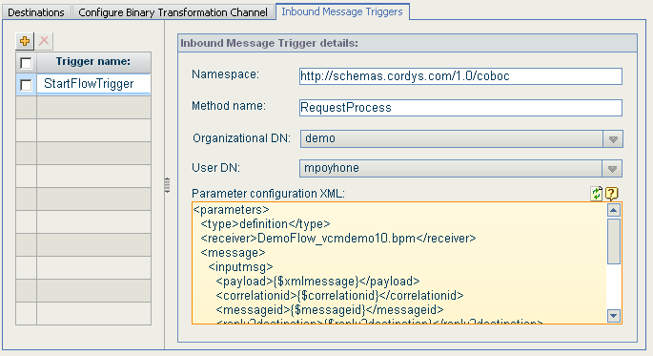
Figure 28: Setting the message trigger
You can insert the variables in to the XML by clicking the question mark icon.
The following code segment is used to map the incoming JMS message to the message used in the flow. Refer to the JMS manual for the actual meaning of each field and how to use them.
<parameters>
<type>definition</type>
<receiver>DemoFlow_vcmdemo10.bpm</receiver>
<message>
<inputmsg>
<payload>{$xmlmessage}</payload>
<correlationid>{$correlationid}</correlationid>
<messageid>{$messageid}</messageid>
<reply2destination>{$reply2destination}</reply2destination>
<properties>{$properties}</properties>
<fromdestination>{$fromdestination}</fromdestination>
</inputmsg>
</message>
<source>Run from JMS Connector</source>
</parameters>
Trigger SOAP requests are handled synchronously, meaning that the trigger worker thread will send the SOAP request and wait for the SOAP response. This allows the SOAP request to be processed within one JMS transaction, so if the SOAP request fails, the message is put into the error queue (if one was configured). By default there is only one trigger worker thread which means that only one incoming message can be processed at a time. To create more threads which wait for the incoming messages, use the Trigger Threads parameter for the destination:
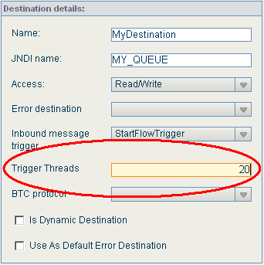

Special Destinations
There are two checkboxes for marking the destination as a special case:
- The default error destination
- The dynamic destination

The default error destination
To avoid that one has to specify an error destination for every destination and allow for central redirecting to another error destination, one of the destinations can be marked as the default error destination.
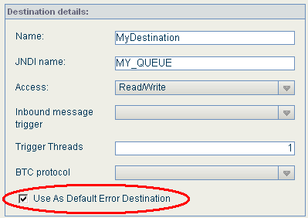
Figure 29: Marking one destination as default error destination

Remark: Make sure that only one destination per destination manager is marked as ‘Default Error Destination’. The UI allows that multiple destinations are marked, but when starting the Connector, error messages will be logged that this is not allowed.

The dynamic destination
A destination can be marked as a dynamic destination. Only one destination per destination manager should be marked as such. When a message enters the JMS Connector and its reply2destination field refers to an unknown destination, a dynamic destination will be used.
The incoming message is handled by an explicitly defined destination (by polling for messages or by using a trigger). If a dynamic destination is needed because the reply2destination field refers to a physical queue which is not part of the destination managers set of destinations, the destination manager will look for a dynamic destination in its own set of destinations.
This dynamic destination can be used to send messages to the physical queue or to use the physical queue as the reply2destination. The XML to specify this is:
<destination physical-name=”QueuManager.QueueName”>
Name of dynamic queue
</destination>

And for the reply2destination:
<reply2destination physical-name=”QueuManager.QueueName”>
Name of dynamic queue
</reply2destination>

The attribute physical-name is used for storing the information about the physical (MQ) queue manager and queue name, separated by a ‘.’ (dot).
The dynamic destination is used to provide extra information about the unknown queues, namely the message header type and the character set. Normally this information is provided by the JNDI to MQ mapping, but that is not used for dynamic destinations. To specify that the MQ header MQSTR is to be used, specify targetClient=1 (and for MQRFH2: specify targetClient=0). The code page can be specified using CCSID=character set id. The fields are separated using commas.

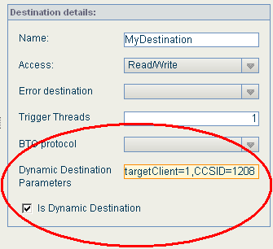
Figure 30: Marking a destination as dynamic destination

Remark: The UI allows for marking multiple destinations per destination manager as dynamic destination. However, this should not be done, because this will result in errors when restarting the connector.

- Migrating To Other Environments

Introduction
In general the development takes place in its own development environment. When ready, the products of development are packaged and installed on other environments, e.g. test, acceptation and production environments.
Because of the advantage of mimicking as much as possible the circumstances of the production environment in the development environment, changes are that the same settings of the JMS Connector can be used. Especially because the destination names are symbolical names, the final mapping in JMSAdminGUI can take care of the final mapping to the physical queues.
To avoid that in each environment the same JMS Connector configuration has to be reentered again, the possibility exist to export the content to XML Store and make it part of an ISV. After installing the ISV on the other environment and installing the JMS Connector, the configuration can be reloaded again from XML Store and modified according the needs of actual environment.

Exporting the configuration to XML Store
The first step to export is going to the tab JMS Connector and selecting the Export button.
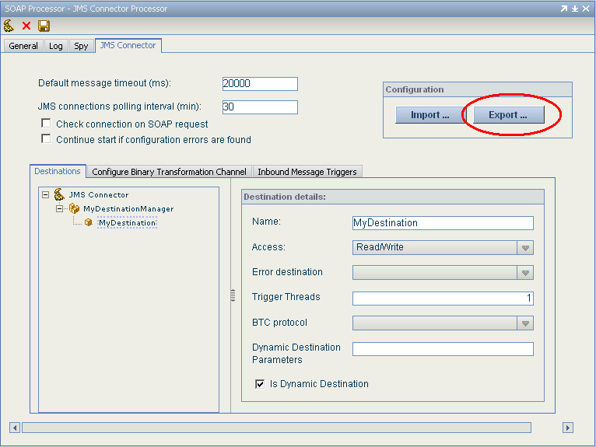
Figure 31: Selecting the export facility

As a result, the export dialog will appear:
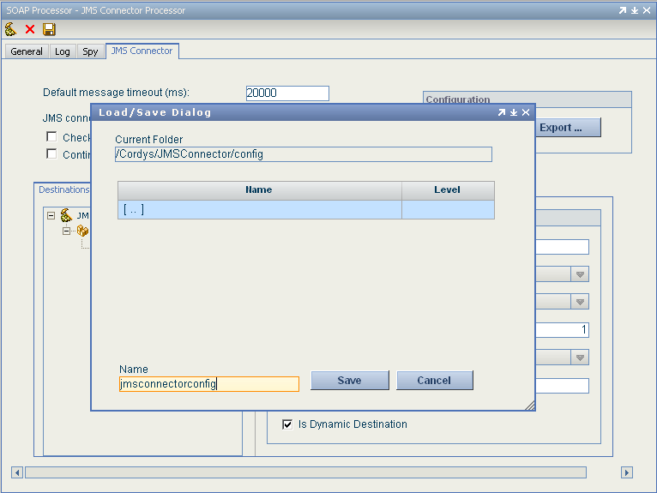
Figure 32: Selecting the export directory

The JMS Connector comes with a first suggestion to use:
/Cordys/JMSConnector/config
but any place in XML Store can be used. The middle section of the dialog allows for navigating the XML Store and finding an appropriate place.
When creating an ISV for the products developed, the JMS Connector configuration in the XML Store should also be selected or one could create a separate ISV for it.

Importing the configuration from XML Store
After the ISV with JMS Connector configuration is installed in the new environment, this configuration can be loaded in the JMS Connector.
Go to the tab JMS Connector and select the Import button:
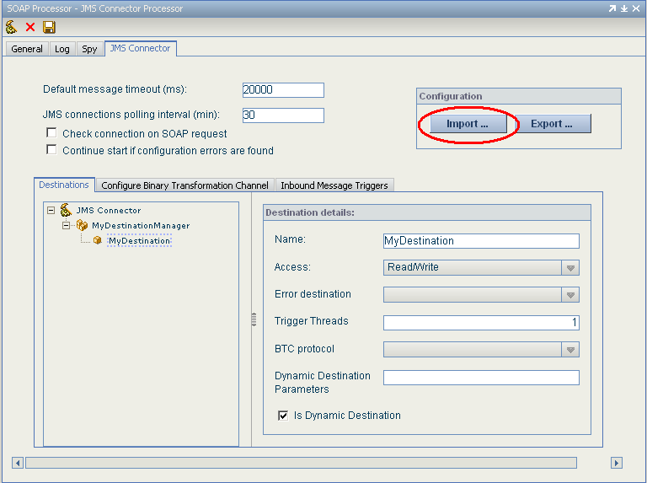
Figure 33: Starting the import facility

The import dialog will appear:
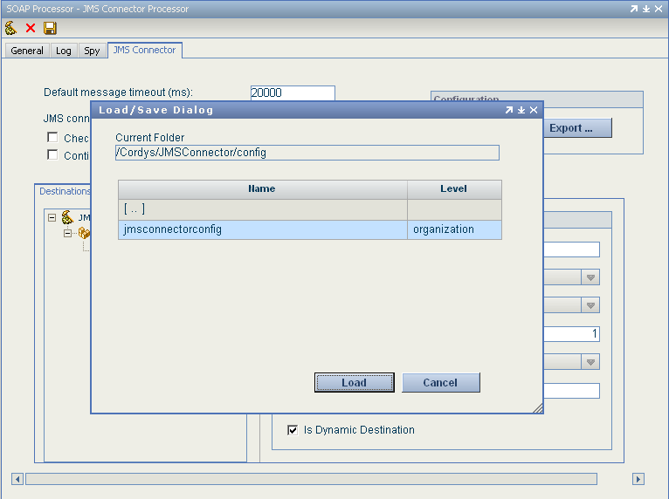
Figure 34: Importing the configuration data

Again, the JMS Connector will suggest the use of this directory:
/Cordys/JMSConnector/config
If this is not the used directory, the middle section allows navigating to the directory where the configuration is stored.

Update the configuration data
The last step will be to update the configuration data to the actual situation in this environment. For example, the triggers and BTC data contains information about the organization and user, which might be different in this environment.
- Problem Solving
When using the JMS Connector, specific problems can arise, which can be difficult to analyze and solve. This chapter provides hints how to deal with problems.

Using the log files
Default, the JMS Connector will only log errors which make it difficult to understand the context in which the errors have occurred. By configuring the JMS Connector to provide more information, the errors can be understood in their context.
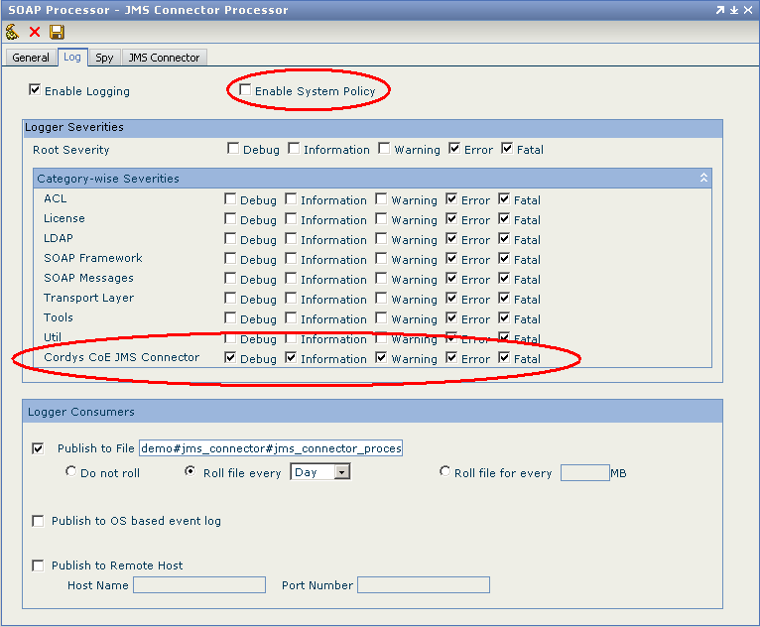
Figure 35: Increasing the debug information

The first step is to switch of Enable System Policy to allow other ways of logging. The second step is to expand the Category-wise Severities section on the form and mark Cordys CoE JMS Connector.
The log files can be viewed in the Log Viewer or directly on the file system.
This is defined in the section Logger Consumers. Viewing the log using the flat file can provide a faster way to search the file, but in this case, the time stamps, which are numeric values, are unusable. In the Log Viewer, times are shown in a readable format.

Trigger problems
When using triggers, it is often difficult to see why the trigger fails. The error is often in the trigger definition, but the logging indicating the problem can be service being targeted by the method invocation. Examining the log files will often reveal that the user issuing the method call doesn’t have the right roles.

JMS Connector doesn’t want to start
In all cases, the log files will provide information about the causes.

WebSphere MQ did not start
To be able to start the connector, it is necessary the WebSphere MQ is running.

JNDI Configuration problems
When the JMS Connector doesn’t start, the Log viewer should be used to examine the problem. When starting the JMS Connector, a connection is made to the JNDI to resolve the Cordys names to the JNDI names. If a destination name is mistyped, an error will result and the connector doesn’t start.
For example a missing jar might cause these errors:
throwable : java.lang.ClassCastException: javax.naming.Reference
at com.cordys.coe.ac.jmsconnector.DestinationManager.initialize(DestinationManager.java:126)

com.cordys.coe.ac.jmsconnector.exceptions.JMSConfigurationException: JNDI not found or destination manager MyDestinationManager not found in JNDI.
Original Exception:
javax.naming.NoInitialContextException: Cannot instantiate class:
com.sun.jndi.fscontext.RefFSContextFactory [Root exception is
java.lang.ClassNotFoundException:
com.sun.jndi.fscontext.RefFSContextFactory]

BTC Configuration problems
During startup of the connector, the BTC configurations are read from XML Store and parsed. The XML store key must point to a valid BTC definition file.

