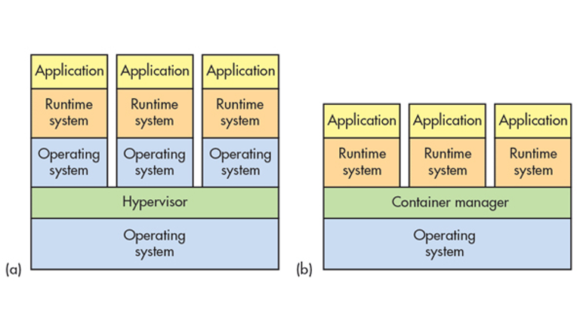

**What’s the Difference between Containers and Virtual Machines?**

Containers and virtual machines are two ways to deploy multiple, isolated services on a single platform. So how do they differ?

Embedded developers need to deploy ever-more complex systems to take advantage of hardware whose functionality and performance continue to grow at accelerated rates. Writing a single application is still manageable for a small microcontroller, but it’s impractical for larger systems that need a more modular approach. Adding an operating system to the mix makes multiple applications easier to work with; however, these days even a single operating system isn’t always the best solution.

Hypervisors are a way to manage virtual machines (VMs) on processors that support the virtual replication of hardware. Not all processors have this type of hardware—it’s typically found in mid- to high-end microprocessors. It’s standard fare on server processors like Intel’s Xeon and found on most application processors such as the Arm Cortex-A series. Typically, a VM will run any software that runs on the bare metal hardware while providing isolation from the real hardware.