Atmel START Configuration

SPI Driver
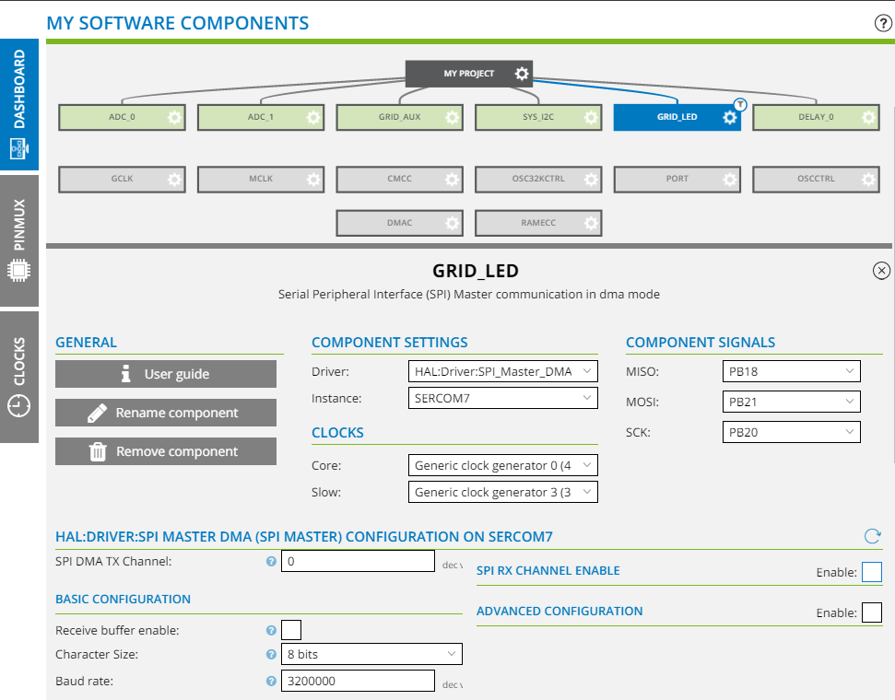

DMAC Driver
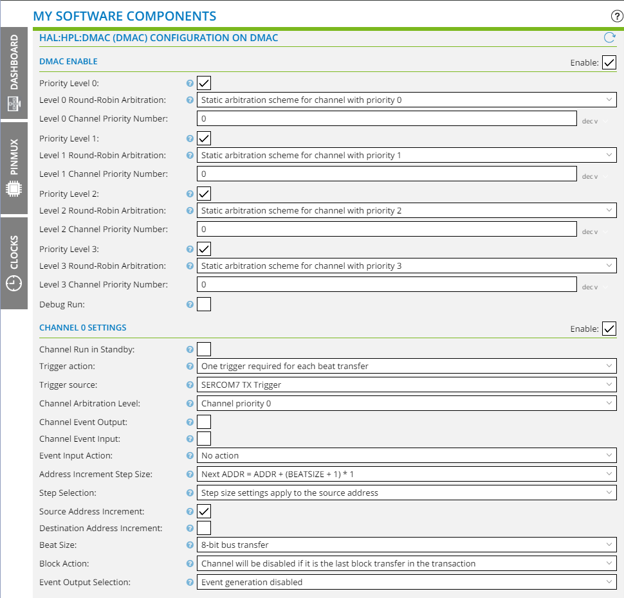

Clock Configuration
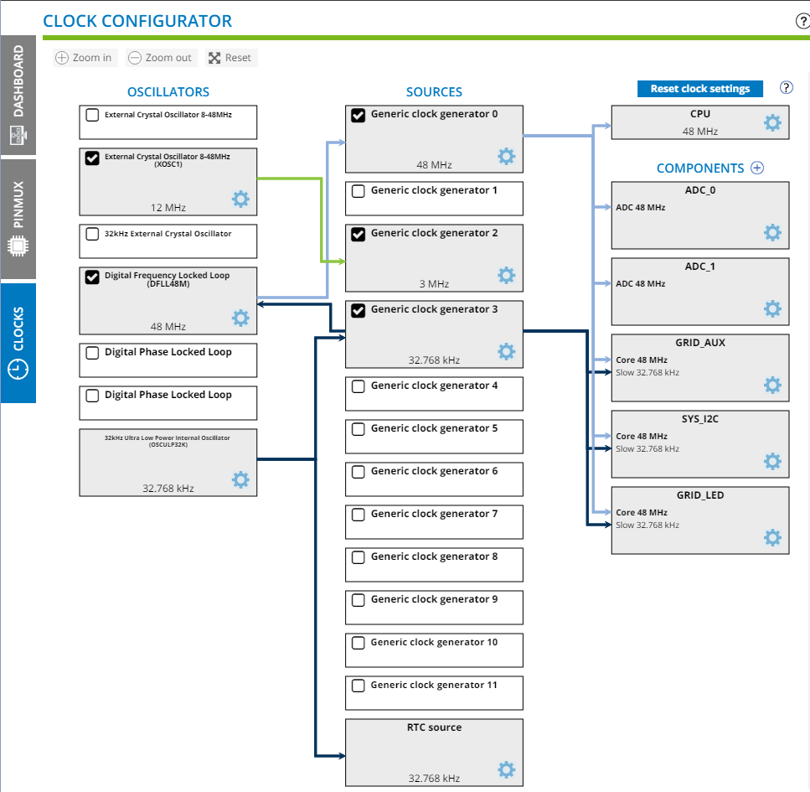

main.c
- Intialize the SPI interface
- Setup callback function
- Forever:
  - Update the frame buffer
  - Enable the DMA
  - Transfer the data

// Starting the DMA trensfer
dma_spi_done = 0;
spi_m_dma_enable(&GRID_LED);
gpio_toggle_pin_level(LED0);
io_write(io2, frame_buffer, FRAME_BUFFER_SIZE);
while (dma_spi_done == 0)
{
}
gpio_toggle_pin_level(LED0);

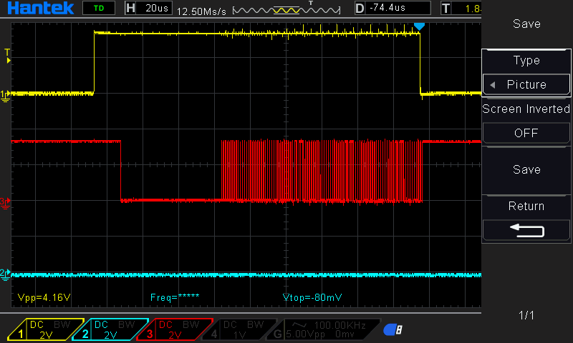Figure 1: Transfer wavefrom (4 LEDs)

