Grid4 Firmware Development Guide
Firmware development for ATSAMD51 Targets
Table of Contents
Target microcontroller: SAMD51 3
Useful links: 3
ATSAMD51N19A Product page 3
Main features 3
Operating conditions 3
Power consumption 3
Memories 3
High-Performance Peripherals 3
System Peripherals 3
ATSAMD51 interfaces in the Grid4 design 4
High-Performance Peripherals 4
SERCOM 4
System Peripherals 4
ATSAMD51 SERCOM UART interface (K+F) 5
TX Complete interrupt for packets 5
Clock Configuration 6
USART Configuration (GRID_X) 7
Common settings 7
Component settings 7
Clocks 7
Basic configuration 7
Advanced configuration 7
Component signals 7
SYS_I2C Bus 8
Configuration 8
Component settings 8
Clocks 8
Basic configuration 8
Advanced configuration 8
Component signals 8
ADC_0 & ADC_1 9
Known issues 9
To be confirmed 9
To be confirmed 9
Understanding the ADC Clock and Sampling Rate 9
Understanding Result Accumulation 9

Target microcontroller: SAMD51

Useful links:

ATSAMD51N19A Product page

Main features
Relevant features of the microcontroller that make it suitable for the Grid4 project.

Operating conditions
The datasheet specifies 1.71V to 3.63V, -40°C to +105°C, DC to 120 MHz

Power consumption
The datasheet specifies a nominal 65uA/MHz active power consumption.
P_{core} = 0.065*120 = 7.8mA @120MHz

Memories
ATSAMD51N19A has the most memory from the D51 family.
1 MB self programmable flash with ECC
256KB main memory (SRAM)

High-Performance Peripherals
- 32-channel DMA
- QSPI up to 75MHz with execute-in-place support
- Full-Speed (12Mbps) USB2.0 (device and embedded host)

System Peripherals
- 32-channel event system
- Up to 8 SERCOM interfaces (UART, I2C, SPI etc.)
- Dual 12-bit, 1 MSPS Analog-to-Digital Converter
- Dual 12-bit, 1 MSPS Digital-to-Analog Converter

ATSAMD51 interfaces in the Grid4 design
The Grid uses most of the available peripheral interfaces of the SAMD51 platform.

High-Performance Peripherals

SERCOM
GRID Communication | GRID_X | 4x SERCOM/UART
GRID Aux Communication | GRID_AUX | 1x SERCOM/UART
Peripheral configuration | SYS_I2C | 1x SERCOM/I2C
LED driver |  | 1x SERCOM/UART/SPI ?
LCD driver (optional) |  | 1x SERCOM/SPI

System Peripherals
GRID Communication | GRID_X | 4x SERCOM/UART
GRID Aux Communication | GRID_AUX | 1x SERCOM/UART
Peripheral configuration | SYS_I2C | 1x SERCOM/I2C
LED driver |  | 1x SERCOM/UART/SPI ?
LCD driver (optional) |  | 1x SERCOM/SPI

Grid4 Firmware Overview
ADC → SRAM

ADC 16bit mode (x256 oversampling) 1MSPS/256 = 4KSPS
8 analog inputs per ADC channel 4KSPS/8 = 0.5KSPS effective

ATSAMD51 SERCOM UART interface (K+F)

TX Complete interrupt for packets
The following code shows that tx complete interrupt is only called after the whole packet is transferred.
static void tx_cb_GRID_AUX(const struct usart_async_descriptor *const io_descr)
{
struct io_descriptor *io;
static uint8_t example_GRID_AUX[2];
example_GRID_AUX[0] = 0x55;
example_GRID_AUX[1] = 0x11;
gpio_toggle_pin_level(LED0);
usart_async_get_io_descriptor(io_descr, &io);
io_write(io, example_GRID_AUX, 2);
}

Clock Configuration
The target hardware has an 8 MHz ceramic resonator connected to XOSC1 on the microcontroller. All clock sources must be generated from the XOSC1 or the internal sources.
The SERCOM and ADC peripherals can run from a clock source of up to 100MHz.
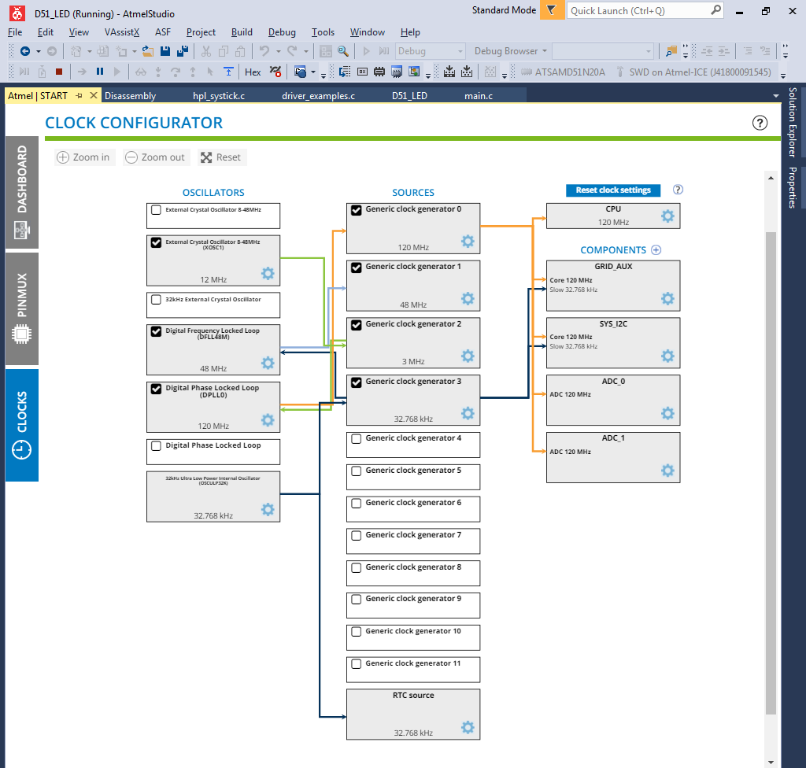

USART Configuration (GRID_X)

Common settings

Component settings
Driver | HAL:Driver:USART_Async
Mode | UART
Instance |  | As defined later!

Clocks
Core | GCG 0 (120MHz)
Slow | GCG 3 (32.768kHz)

Basic configuration
Receive buffer enable | True
Transmit buffer enable | True
Frame parity | False
Character size | 8 bits
Stop bit | One stop bit
Baud rate | 2000000 | 2000 for testing and debugging

Advanced configuration
Default settings

Component signals
Component name: | Instance: | Component Signal RX: | Component Signal TX:
GRID_AUX | SERCOM2 | PB24 | PB25
GRID_NORTH | SERCOM1 | PA01 | PA00
GRID_EAST | SERCOM0 | PC16 | PC17
GRID_SOUTH | SERCOM6 | PC12 | PC13
GRID_WEST | SERCOM4 | PB09 | PB08

SPI Configuration (GRID_LED)

Component settings
Driver | HAL:Driver:SPI_Master_Async
Instance | SERCOM7

Clocks
Core | GCG 0 (120MHz)
Slow | GCG 3 (32.768kHz)

Component signals
MISO | PB18 | Not used
MOSI | PB21
SCK | PB20 | Not used

Basic configuration
Receive buffer enable | False
Character Size | 8
Baud rate | 4 000 000

Advanced configuration
Default settings

SYS_I2C Bus
SYS_I2C Bus is used to configure the USB interface chip and other miscellaneous peripheral controllers.

Configuration

Component settings
Driver | HAL:Driver:I2C_Master_Async
Mode | I2C Master Standard/Fast-mode
Instance | SERCOM5

Clocks
Core | GCG 0 (120MHz)
Slow | GCG 3 (32.768kHz)

Basic configuration
I2C Bus clock speed (Hz) | 100000

Advanced configuration
Default settings

Component signals
SCL | PA22
SDA | PA23

ADC_0 & ADC_1
ADC_0 and ADC_1 are used to read the analog user interface controls on the Grid4 modules.
On B16 and P16 modules two eight channel analog multiplexers are connected to the converters.
Address pins are MUX_A, MUX_B, MUX_C → PC19, PC20, PC21 respectively.

Known issues
ADC fails to convert (result register is empty) if clock settings are incorrect
60MHz → ADCCLOCK does not work!
12MHz → ADCCLOCK works!

To be confirmed
Averaging and oversampling with decimation to support up to 16-bit result.
Selectable sampling time
Loading factory calibration

Understanding the ADC Clock and Sampling Rate
ADC runs off of Generic Clock Generator. ADC Prescaler divides the frequency (Div2, Div4… Div256)
Sampling takes one CLK_ADC cycle by default (can be set to more, may be useful!). After sampling the conversion takes another 12 cycles (for 12-bit result).
Example: “In order to obtain 1MSPS in 12-bit resolution with a sampling time length of four CLK_ADC cycles, f_{CLK_ADC} must be 1MSPS * (4 + 12) = 16MHz. As the minimal division factor of the prescaler is 2, GCLK_ADC must be 32MHz.”

Understanding Result Accumulation
The results of multiple, consecutive conversions can be accumulated.

Understanding Oversampling and Decimation
To increase the resolution by n bits, 4^{n} samples must be accumulated.
Result resolution | Number of samples to be averaged
13 bits | 4 samples
14 bits | 16 samples
15 bits | 64 samples
16 bits | 256 samples

Understanding Offset and Gain Correction
The correction will introduce a latency of 13 CLK_ADC clock cycles. In free running mode this latency is introduced on the first conversion only, since its duration is always less than the propagation delay. In single conversion mode this latency is introduced for each conversion.

Understanding Master-Slave operation
ADC1 will serve as a slave of ADC0 by writing a '1' to the Slave Enable bit in the Control A register of theADC1 instance (ADC1.CTRLA.SLAVEEN). When enabled, GCLK_ADC0 clock and ADC0 controls are internally routed to the ADC1 instance.
Is this syncronized dual channel sampling?

Understanding Master-Slave operation
ADC1 will serve as a slave of ADC0 by writing a '1' to the Slave Enable bit in the Control A register of theADC1 instance (ADC1.CTRLA.SLAVEEN). When enabled, GCLK_ADC0 clock and ADC0 controls are internally routed to the ADC1 instance.

ADC Configuration

Component settings
Driver | HAL:Driver:ADC_Async
Instance | ADC0 & ADC1

Clocks
ADC | GCG 0 | Max 32MHz @1MSPS 12Bit

Basic configuration
Conversion Result Resolution | 12-bit | Check 16-bit (averaging)
Reference Selection
Prescaler configuration | Div2 | Prescaled Clock =< 16MHz
Free Running Mode | False
Differential Mode | False
Positive Mux Input Selection | ADC AIN7 Pin | Instance: ADC_0
Negative Mux Input Selection | Internal ground

Advanced configuration
Default settings

Component signals
AIN/7 | PA07 | Instance: ADC_0
AIN/4 | PC02 | Instance: ADC_1

