Test & Verification Log
2018-11-07 3
2 boards stencil + reflow soldered (REVA #1, REVA #2) 3
uC support circuitry hand soldered (REVA #1) 3
uC programming cycle (REV #1) 3

2018-11-07

#1, #2: stencil + reflow soldered
Lead-free solder paste: ESAC305/8 (from AG TERMOPASTY)
Effected components
- U100 (FUSB303) → paste stuck in stencil → needs verification, ask assembly house
- U101 (USBLC6-2) → reflows nicely → OK!
- U1 (SAMD51N20) → reflows nicely → OK!
- J100 (J USBTYPEC) → reflows nicely → needs verification

#1: uC support circuitry hand soldered
Effected componets
- C2, C3, X1 (Main resonator)
- C4-C8, C9, C10, C13, C16 (uC decoupling)
- R1, R2, FB1, C11, C12, (analog supply)
- C14, C15, L1 MISSING (Not in stock) (core switching regulator)
- R19, R20, J68 (Debug header)
- U102, C103, C104, FB101 (+3V3 UC Regulator)
- S1, C1, R6, R6, R8 (Mapmode switch, hard to solder) → Check R3, R6 ratio (2.5V high)
- J2, J3 (DAC Headers) fitted for low-level debugging

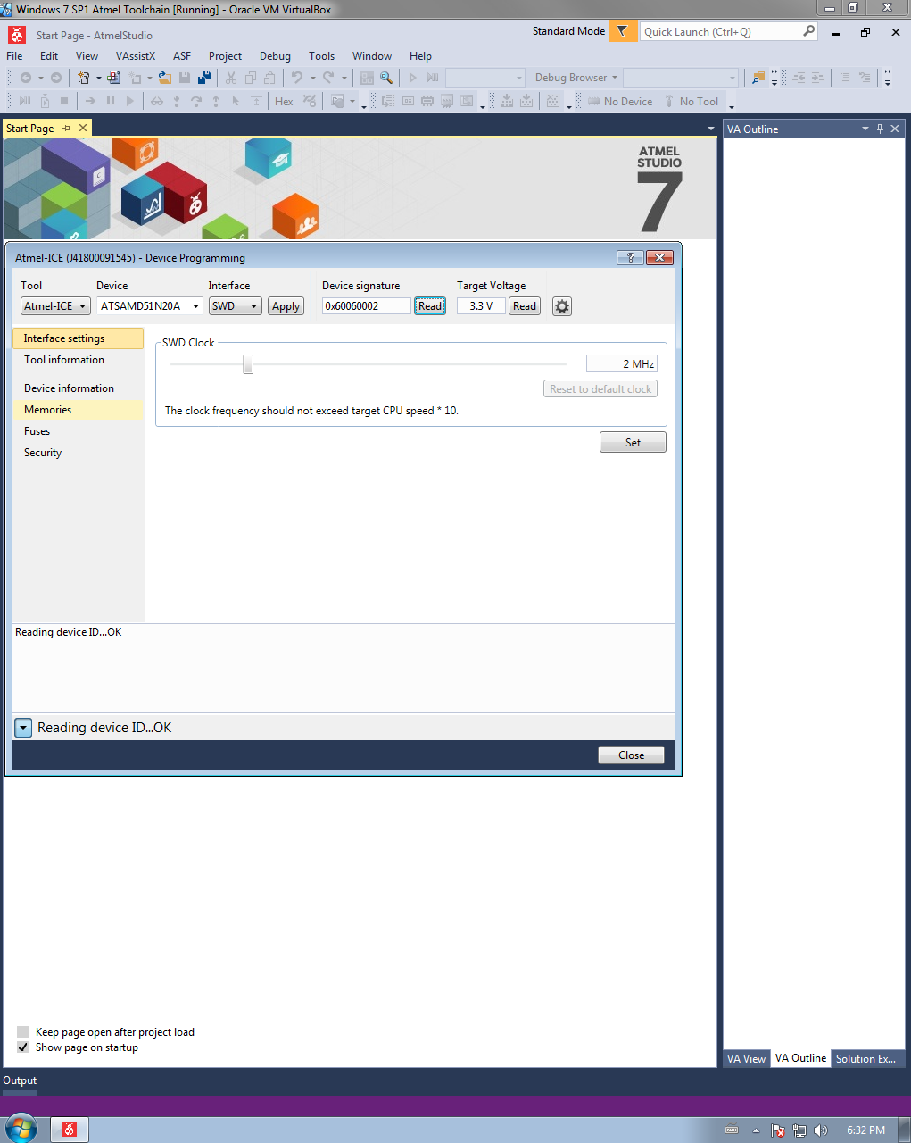
#1 uC programming cycle
Testing #1 in Atmel Studio using the Atmel ICE debugger (SWD)
- Device signature recognized OK!
- Target voltage OK!
- Fuses can be read OK!
Trying to blink LED to verify clock settings
- Programming LED blink example OK!
- Running from external 12MHz XTAL OK!

