TECHNICAL REFERENCE · INTERNAL
988 Data Editor Internals
A Streamlit application for governed, audited editing of the Canadian 988 crisis-line resource dataset. This document specifies its architecture, algorithms, data contracts, concurrency model, and deployment topology.
CODEBASE | csv-editor · branch gcp_launch
DATASET | 290 rows × 17 columns
RUNTIME | Python 3.12 · Streamlit 1.60
PLATFORM | Cloud Run + IAP + GCS + BigQuery
CONTENTS
01 Purpose and scope | 09 Validation and schema
02 Technology stack | 10 Storage and concurrency
03 System architecture | 11 Audit trail
04 Module map | 12 Import and export
05 Configuration system | 13 Security model
06 Grid and edit bridge | 14 Deployment and operations
07 State and view machine | 15 Tooling, tests, CI
08 Algorithms | 16 Limitations

01 Purpose and scope
The 988 Data Editor is a single-page web application that lets an authenticated steward correct individual cells of a published reference dataset, review every pending change as a diff, and publish the result atomically with a permanent before/after record written to a compliance change log.
The dataset it governs is the geo-coded 988 crisis-line directory: 290 rows describing crisis lines, mobile crisis teams, poison control centres, and community resource databases across Canada, each with a service category, contact details, hours of operation by channel, a free-text description, and a latitude/longitude pair. It is published as a single Parquet object in Google Cloud Storage and consumed downstream; this application is the only sanctioned write path to it.

What the application does
• Edit — an in-browser grid of the whole dataset. Double-clicking a cell opens a type-appropriate editor (text box, dropdown, multi-line area, or numeric spinner) positioned over that cell.
• Search — as-you-type filtering across all columns, with matching cells highlighted. Filtering never discards pending edits on rows that scroll out of the match set.
• Review — a second screen showing only edited rows, each changed cell rendered as old → new, with per-cell validation findings and a one-click revert.
• Publish — a confirmation dialog, then a compare-and-swap write to storage and a structured change-log insert. Format errors block the publish; missing required values are flagged but do not.
• Import — a full-dataset replacement from an uploaded CSV, gated on an exact column-shape match and whole-file validation.
• Export — a timestamped CSV snapshot of the currently published state, re-fetched from storage rather than taken from the session.

What it deliberately does not do
• No login form. The application never receives, stores, or verifies a credential. Identity arrives as a cryptographically signed header from Google Cloud Identity-Aware Proxy (§13).
• No row insertion or deletion. Only cell-level updates and whole-file replacement. The change-log schema reserves a delete change type for completeness, but nothing in the UI emits one.
• No in-app user or role management. Access control is an IAM grant on the load balancer's backend service; everyone the proxy admits has identical rights inside the app.
• No server-side persistence of drafts. Pending edits live only in Streamlit session state and are lost if the session ends.

Intended audience for this document
Engineers maintaining or extending the application, platform staff responsible for its GCP deployment, and reviewers assessing its data-integrity and audit properties. Operational instructions for data stewards are covered separately in the user guide.

02 Technology stack
The stack is deliberately narrow: one web framework, one dataframe library, one columnar file format, and the two Google Cloud client libraries required by the production storage provider. There is no JavaScript build step, no CSS framework, no ORM, and no client-side application framework.
COMPONENT | VERSION | ROLE IN THE SYSTEM
streamlit | ≥1.48 (1.60 in use) | Web framework and server. Supplies the rerun execution model, session_state, the WebSocket transport, modal dialogs (st.dialog), request-header access (st.context.headers), and the sandboxed st.iframe used to inject the grid's JavaScript.
pandas | ≥2.0 (3.0 in use) | The in-memory dataset is a single DataFrame indexed by a stable row id. Used for load, filter, merge-edits, and CSV serialisation. DataFrame.attrs carries the storage version stamp (§10).
pyarrow | ≥15.0 | Parquet codec for both the local and GCS parquet providers. Read and write are entirely in-memory (io.BytesIO) on the GCS path — no temporary file ever touches the container disk.
PyYAML | ≥6.0 | Parses config.yaml via yaml.safe_load. The whole application schema, validation rule set, and provider selection come from this one file.
google-auth | ≥2.30 | Verifies the IAP identity JWT: signature against Google's IAP key set, plus an exact audience match.
PyJWT[crypto] | ≥2.8 | Required by google-auth to parse the JWK-format key document at public_key-jwk, which is the endpoint the active provider uses.
google-cloud-storage | ≥2.16 | Reads and writes the Parquet blob, and supplies the if_generation_match precondition that implements optimistic concurrency control.
google-cloud-bigquery | ≥3.20 | Streaming inserts into the change-log table via insert_rows_json. Also backs the alternative bigquery storage provider, which issues real MERGE query jobs.
db-dtypes | ≥1.2 | BigQuery-specific pandas extension dtypes, required when materialising query results to a dataframe.
ruff | ≥0.16 | Linting, run as a pre-commit hook. Rule set is intentionally conservative: E4, E7, E9, F, I.

Front-end technique
The grid is not a Streamlit widget. Streamlit's st.dataframe and st.data_editor cannot give every cell an independent background colour and remain editable at the same time — pandas.Styler CSS is dropped on any column left editable. Because per-cell colour is load-bearing here (error, warning, edited, search-match are four distinct states that must be visible simultaneously), the grid is emitted as a hand-built HTML <table> through st.markdown(unsafe_allow_html=True), with roughly 180 lines of vanilla JavaScript supplying the interaction and a hidden text input acting as the transport back to Python. §6 specifies that mechanism in full.
Styling is a single injected <style> block: CSS custom properties, sticky table headers, a pinned first column, and a set of targeted overrides against Streamlit's own data-testid hooks. The only external asset is the Open Sans web font.

03 System architecture
In production the application runs as a container on Cloud Run, reachable only through an external HTTPS Application Load Balancer with Identity-Aware Proxy enabled on its backend service. IAP performs the Google sign-in, then attaches a signed JWT to every forwarded request. The container reads its dataset from a Parquet object in GCS and writes its audit trail to a BigQuery table in a separate project.
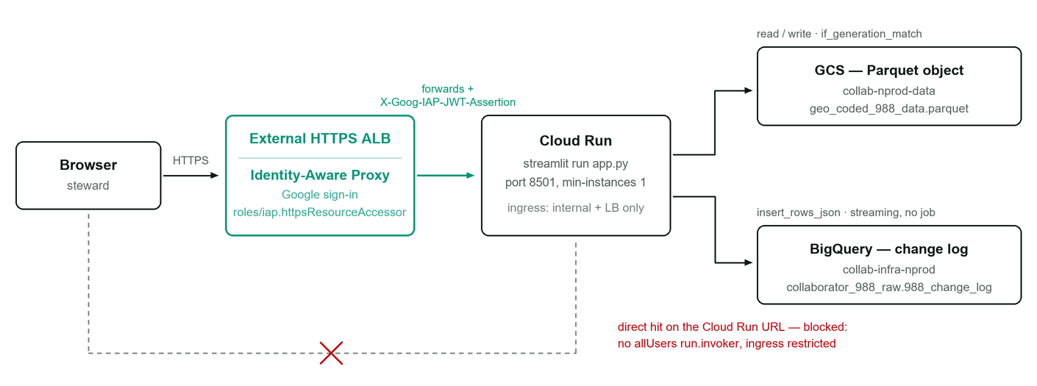
FIG. 1 Production request path. The green segment is the only route by which an identity can enter the application; the dashed path is the bypass that deployment configuration must keep closed, since the app trusts the JWT header on arrival.

The rerun execution model
Streamlit does not maintain a persistent view tree. Every user interaction re-executes app.py top to bottom in the session's Python process, and the resulting widget tree is diffed against the browser's. Three consequences shape this codebase:
1. All mutable state lives in st.session_state — a per-session dictionary that survives reruns. Module-level variables do not.
2. Expensive singletons are memoised with @st.cache_resource: get_config(), get_auth_provider(), get_storage_provider(). These caches are process-wide, shared across concurrent sessions — which is precisely why the storage version baseline is stamped onto the dataframe rather than onto the provider object (§10).
3. Re-render is the only update mechanism. There is no partial DOM patching under application control; changing a single cell's colour means re-emitting the entire table markup. At 290 rows × 17 columns this is roughly 5,000 cells per render, which the browser handles comfortably but which sets a practical ceiling on dataset size (§16).

Request lifecycle for one cell edit
A committed edit travels: browser DOM event → hidden input mutation → Streamlit WebSocket frame → apply_bridge_edit callback → session_state.edits mutation → full script rerun → regenerated table markup → DOM diff. Nothing is written to storage until the user explicitly publishes.

04 Module map
Roughly 1,330 lines of UI in app.py, 395 lines of pure logic in core/, and 655 lines of pluggable I/O in providers/. The core package has no Streamlit import anywhere and is therefore unit-testable without a server.
app.py 1330 Streamlit UI: views, toolbar, grid renderer, JS bridge,
publish/import dialogs, CSS injection
config.yaml 238 Provider selection + the 17-column schema and rule set
core/
config.py 92 YAML loader; ColumnRule and AppConfig frozen dataclasses
validation.py 121 Per-cell rule engine; two severities; normalisation
audit.py 100 Change-log row builders (insert / update / delete,
before / after states, change_id generation)
csv_import.py 30 Column-shape diff + whole-dataframe validation sweep
publish.py 52 Write-ordering policy for data vs. audit, and the
PublishOutcome result type
providers/
auth/
base.py 57 AuthProvider ABC + User value object
iap.py 84 Identity-Aware Proxy, JWK key set [registered]
gcp_iap.py 102 Identity-Aware Proxy, x509 key set [unregistered]
__init__.py 30 Name to class registry, lazy import factory
storage/
base.py 75 StorageProvider ABC, ROW_ID, version stamping helpers
local_csv.py 72 Local CSV, atomic replace, JSONL audit
local_parquet.py 106 Local Parquet, atomic replace, JSONL audit
bigquery.py 116 BigQuery table, parameterised MERGE publish
gcs_parquet.py 197 GCS Parquet with generation CAS + BigQuery change log
__init__.py 44 Name to class registry, lazy import factory
sample_data/
geo_coded_988_data.parquet the 290-row production dataset, for local development
resources.csv older CSV sample, for the local_csv fallback
tests/
test_gcs_parquet_generation.py concurrency tests against an in-memory GCS fake

Dependency direction
app.py depends on core and on the two provider factories; it never imports a concrete provider class. core.audit imports one type alias from providers.storage.base and nothing else. Concrete providers import only their own base class and their third-party clients. Both registries use lazy imports — a deployment that never selects bigquery never imports google.cloud.bigquery on that path, so an unused backend's missing dependency cannot break startup.
IMPLEMENTATION NOTE providers/auth/gcp_iap.py is present but not in the registry; _REGISTRY in providers/auth/__init__.py contains only iap. Setting auth.provider: gcp_iap in config.yaml raises AuthError: Unknown auth provider. The two differ substantively: iap.py calls id_token.verify_token against public_key-jwk (JWK format, which is why PyJWT[crypto] is a dependency), whereas gcp_iap.py calls verify_oauth2_token against public_key (x509 format). Only the former is reachable.

05 Configuration system
One YAML file is the single source of truth for provider selection, dataset identity, and the entire column schema including every validation rule and every editor type. The file path defaults to config.yaml beside app.py and can be redirected with the CSV_EDITOR_CONFIG environment variable — the mechanism used to keep a local-development configuration alongside the committed production one.
app: title, subtitle -> landing card and toolbar text
auth: provider + per-provider block -> identity source
storage: provider + per-provider block -> where the dataset lives
dataset: display_name + columns[] -> editors, validation, audit column set

Loading and immutability
core/config.py parses the file with yaml.safe_load and wraps the raw dictionary in a frozen AppConfig dataclass whose properties read through with defaults, so a missing key degrades rather than raising. Each column entry is projected into a frozen ColumnRule:
@dataclass(frozen=True)
class ColumnRule:
name: str # physical column name in the dataset
label: str # column header shown in the grid
type: str = "text" # text | textarea | enum | float | integer | date | number
required: bool = False # blank -> warning, never an error
options: tuple = () # enum domain
min / max: float | None # numeric bounds, inclusive
max_length: int | None # character cap
regex / regex_hint: str | None # full-match pattern + the message shown on failure
normalize: str | None # "postal_code" is the only implemented transform
align: str = "left"
editable: bool = True # False renders the cell locked and rejects bridge edits

options is coerced to a tuple so the dataclass stays hashable and genuinely immutable. AppConfig.columns rebuilds the ColumnRule list on each access; the wrapping get_config() is @st.cache_resource-memoised, so the YAML is parsed once per process and a configuration change requires a restart, not a rerun.

The rule field drives three things at once
A single type value determines the editor widget the JavaScript layer creates, the validation branch taken in validate_cell, and the glyph appended to the column header:
TYPE | EDITOR CREATED | VALIDATION APPLIED | HEADER GLYPH
text | <input type="text"> | length, regex | —
textarea | <textarea>, Shift+Enter for newline | length, regex | ¶
enum | <select> from options | exact membership in options | ▾
float / number | <input type="number" step="any"> | float() parse, then min/max | #.#
integer | <input type="text"> | parse, is_integer(), then min/max | —
date | <input type="text"> | five accepted formats, tried in order | —

A * suffix on the header marks required: true. Note that integer, date, and number are implemented in the validation engine but unused by the current 988 schema; only text, textarea, enum, and float appear in config.yaml.

06 The grid and the edit bridge
This is the least conventional part of the system and the part most likely to surprise a new maintainer. The grid is static HTML with no Streamlit widget protocol behind it, so an edit made in the browser has no native path back to Python. The bridge is what supplies that path.

Rendering
render_html_grid() emits one <table class="de-grid"> as a single markdown string. Each data cell carries the state the JavaScript layer needs as data attributes:
<td class="de-cell de-cell-edit"
data-pos="42" <!-- ordinal within the currently rendered row list -->
data-col="province_territory" <!-- physical column name -->
data-editable="1"
data-type="enum" <!-- which editor to construct -->
data-options="[&quot;AB&quot;,&quot;BC&quot;, ...]"
data-value="ON">ON</td>

Cell class assignment is a strict precedence chain, evaluated per cell — the first match wins, so a cell that is both edited and matching the search term shows as edited:
PRIORITY | CLASS | CONDITION | APPEARANCE
1 | de-cell-err | key present in errors | red fill, red inset outline, bold
2 | de-cell-warn | key present in warnings | amber fill, amber outline
3 | de-cell-edit | key present in edits | green tint
4 | de-cell-match | search term is a substring of the cell | yellow highlight
— | de-cell-locked | editable: false (additive) | muted text, not-allowed cursor

The header row is position: sticky; top: 0 and the row-number column is position: sticky; left: 0, with a three-level z-index ladder so the top-left corner cell stays above both. The container gets max-height: 560px with vertical overflow on the editing and import screens, and no cap on the review screen, which shows only edited rows.

The round trip
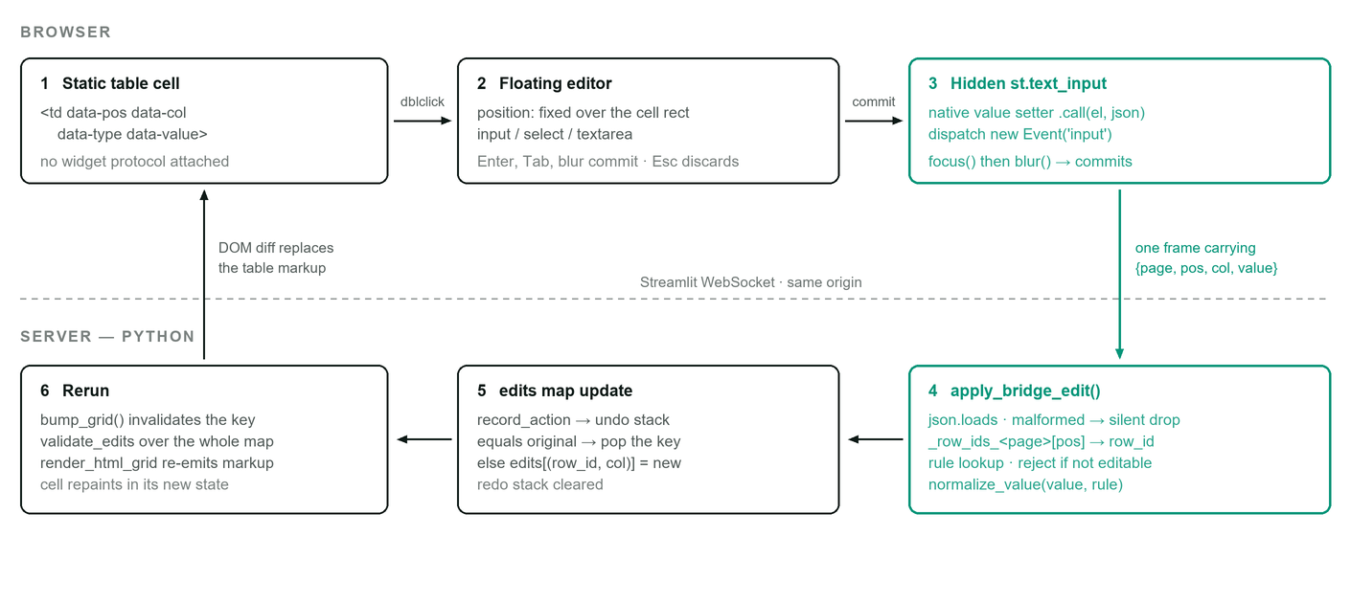
FIG. 2 One committed cell edit, end to end. The green path is the bridge proper: the only way a value crosses from static markup into Streamlit's widget state.

Why the native setter is necessary
Streamlit's text input is a React-controlled component. Assigning input.value = x directly updates the DOM node but not React's internal value tracker, so React's synthetic change event is suppressed as a no-op and the server never hears about it. The bridge therefore resolves the value setter from HTMLInputElement.prototype and invokes it with the element as receiver, which bypasses React's tracker, then dispatches a real bubbling input event:
function setNativeValue(el, value) {
const desc = Object.getOwnPropertyDescriptor(Object.getPrototypeOf(el), 'value');
desc.set.call(el, value);
el.dispatchEvent(new Event('input', { bubbles: true }));
}

The subsequent focus() / blur() pair is what makes Streamlit treat the input as committed and fire the on_change callback. The input itself is styled to a 1×1 pixel, zero-opacity, pointer-events-none box so it is never visible or focusable by a user.

Handler rebinding, not flag-guarding
The JavaScript is delivered through st.iframe, whose document is destroyed and recreated whenever the view changes. Listeners it installed on the parent document survive that destruction in the parent's listener list but close over a dead realm, so they no longer fire. A one-shot "already bound" flag therefore produces a silent failure: a later run sees the flag, skips binding, and defers to a handler that can never run — the bug that once left the review grid uneditable. The code instead parks each handler reference on the parent window (P.__deKeysHandler, P.__deTableHandler, P.__deFitObserver) and unconditionally removes the stale one before installing a live replacement on every run.

Escaping, and why newlines are load-bearing
esc() HTML-escapes every emitted value and then re-encodes carriage returns and newlines as the numeric character references &#13; and &#10;. This is a correctness requirement, not cosmetics: st.markdown(unsafe_allow_html=True) runs the string through a Markdown parser before it reaches the DOM, and a blank line inside a raw-HTML block terminates that block — everything after it is parsed as prose. One multi-paragraph cell would shatter the grid and dump the remaining table markup onto the page as visible text. The 988 dataset contains 105 multi-paragraph description cells; the older CSV sample contained none, which is why the defect stayed latent. Numeric character references keep the emitted markup on one physical line while still decoding to real newlines in the DOM, so cell.dataset.value hands the textarea its original text and multi-paragraph values survive an edit round trip unchanged.

Keyboard handling
A capture-phase keydown listener on the parent document intercepts Ctrl/Cmd+Z and Ctrl/Cmd+Shift+Z or Ctrl+Y, locates the Undo or Redo button by the leading glyph in its text content (↶ / ↷) and clicks it if enabled. It bails out when the event target is inside an input, textarea, or contenteditable, so native text-field undo continues to work inside an open cell editor.

07 State model and view machine

Session state keys
user | The User value object (username, display_name, provider) derived from the verified IAP assertion. None renders the landing page.
original_df | The dataset exactly as loaded from storage, indexed by _row_id. Never mutated in place except by a successful publish. Carries the storage version stamp in .attrs.
edits | {(row_id, column): new_value}. The complete set of pending changes. A cell restored to its original value has its key removed, never a key with an equal value (§8.1).
undo_stack / redo_stack | Lists of inverse instructions, not snapshots (§8.2).
view | One of editing, review, import_upload, import_review. Publish confirmations are st.dialog modals layered over the current view rather than separate states.
grid_ver | A monotonic counter bumped whenever the grid must be re-emitted. Changing it changes the rendered markup, defeating any component-level caching that would otherwise show stale cells.
import_df / import_edits | An uploaded CSV pending review and any inline corrections made to it. Kept deliberately separate from edits, so an import never contaminates the editor's undo history.
_row_ids_<page> | The ordered row-id list for each rendered grid, written immediately before rendering. The bridge sends an ordinal position, and this list is what resolves it back to a row id — which is why filtering and reordering remain safe (§8.6).
publish_busy / publish_blocked / publish_error | The three-state gate that makes the publish button single-shot and gives it a spinner before the blocking write begins (§8.10).
just_published / audit_warning / export_ready / export_error | One-shot message carriers, read and immediately cleared on the next render.

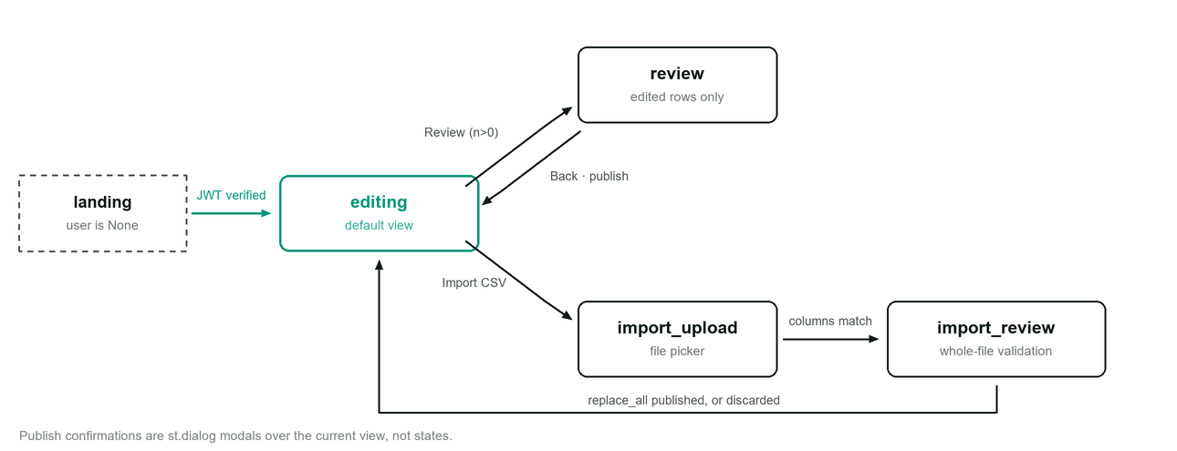
FIG. 3 View transitions. There is no edge from import_review back to import_upload or into review : once a file is accepted the only exits are publishing it or discarding it, which prevents an import and a cell-edit session from merging.

Guarded transitions
• editing → review requires at least one pending edit; the button is disabled at zero and labelled with the live count.
• editing → import_upload with pending edits first raises a Discard unpublished edits? modal. Confirming clears edits and both history stacks.
• Publish from review is disabled when any error-severity finding exists, or when the edit count is zero.
• Publish from import_review is disabled on any error-severity finding across the entire uploaded file.
• Any StorageError raised during a view render is caught in main() and rendered as an error panel with a Retry button that clears original_df and forces a reload.

08 Algorithms
Most of the application's behaviour reduces to a small number of precisely specified operations over one dictionary of pending edits. They are listed here in the order a value encounters them.

8.1 Edit accumulation with identity collapse
Pending changes are a flat dictionary keyed by (row_id, column). The single non-obvious rule is that setting a cell back to its stored value deletes the key rather than storing an equal value:
def set_edit(row_id, column, new_value):
original = str(original_df.at[row_id, column])
new = "" if new_value is None else str(new_value)
if new == original:
edits.pop((row_id, column), None) # identity collapse
else:
edits[(row_id, column)] = new

This makes the dictionary a true minimal diff at all times, which every downstream consumer relies on: the "Review changes (n)" badge count, the publish dialog's row and cell totals, the disabled state of the Review button, the set of rows shown on the review screen, and the change-log rows written at publish. Without collapse, a user who typed a wrong value and corrected it would publish a no-op change and write a spurious before/after pair into the compliance log.
Rendering applies the diff functionally rather than mutating the baseline: merge_edits(df, edits) copies the frame and writes each pending value into the copy, so original_df remains a clean reference for computing old values, reverts, and audit snapshots. Cost is O(|edits|) per render plus the frame copy.

COMPLEXITY
Insert, lookup, and delete are all O(1) hash operations. The map's size is bounded by the number of cells a human edits in one sitting — in practice tens, not thousands.

8.2 Undo and redo by inverse instruction
History is not a stack of dataset snapshots. It is a stack of inverse instructions — the command pattern with an explicit undo record — so memory is proportional to the number of actions rather than to actions × dataset size. Each instruction is one of two shapes:
{"row": r, "col": c, "inst": "MODIFY", "value": v} # restore this pending value
{"row": r, "col": c, "inst": "DELETE"} # remove any pending value

Before any mutation, record_action(row, col) captures the current state of that one cell as an instruction and pushes it to the undo stack, then clears the redo stack — the standard linear-history rule that a new action invalidates the redo branch. Undo pops an instruction, pushes the cell's present state onto the redo stack, and applies the popped instruction. Redo is the exact mirror. Because both operations push the inverse of what they are about to apply, the pair is involutive: undo then redo returns to the identical map.
_apply_instruction re-checks identity collapse when applying a MODIFY: if the restored value equals the stored original, the key is popped instead of set. This keeps the invariant of §8.1 true through arbitrary undo/redo sequences.

PROPERTIES
• One stack entry per cell touched, regardless of dataset size. Space is O(k) for k actions; time is O(1) per undo or redo.
• History is cleared on publish, on dataset reload, and on discarding edits for an import — every point at which the baseline changes and older instructions would no longer be meaningful.
• The reverting arrow on each row of the review screen's diff panel calls revert_edit, which records an action first, so a revert is itself undoable.

8.3 Cell validation dispatch
validate_cell(value, rule) is a pure function returning either None or a (severity, message) pair. The order of checks is fixed and significant:
1. Blank test. None or whitespace-only. If the rule is required, return (WARNING, "required — currently blank"); otherwise return None immediately. A blank value is never subjected to type, length, or pattern checks — that is what makes optional fields genuinely optional.
2. Type branch, on rule.type:
– enum — exact membership in options; no case folding, no trimming beyond the strip already applied.
– float/number — attempt float(text), then compare against min/max where present (inclusive bounds).
– integer — parse as float, reject unless is_integer(), then apply bounds.
– date — try five formats in order: %Y-%m-%d, %Y/%m/%d, %d-%m-%Y, %d/%m/%Y, %m/%d/%Y; the first that parses wins. Note the ambiguity: 03/04/2026 matches the day-first format before the month-first one.
3. Length cap — max_length against the stripped string.
4. Pattern — re.fullmatch(rule.regex, text). Full match, not search, so a pattern needs no anchors to be strict. On failure the configured regex_hint is the message shown, falling back to a generic phrase.

The type branch and the length/pattern checks are not mutually exclusive: a text-typed column with both max_length and regex has both applied. Only the first failure is reported, because each check returns immediately.

SEVERITY POLICY
Exactly one condition produces a WARNING — a required field left blank. Every other failure is an ERROR. The distinction is enforced at the gate, not at the finding: errors_only() and warnings_only() partition the findings map, and only the errors partition disables the Publish button. The rationale is operational: the 988 source data already contains blanks in required fields, and refusing to publish any unrelated correction until every such blank is filled would make the tool unusable.

RANGE MESSAGE CONSTRUCTION
_range_message builds the failure text from whichever bounds exist — "must be a number, −90 to 90", "must be a number ≥ 0", "must be a whole number". Integral floats are printed without a trailing .0, and the ASCII hyphen is replaced with U+2212 MINUS SIGN so negative bounds render correctly in the proportional UI font.

8.4 Postal code normalisation
Applied on commit, before validation, to any column declaring normalize: postal_code:
text = value.strip()
compact = re.sub(r"\s+", "", text).upper()
text = f"{compact[:3]} {compact[3:]}" if len(compact) == 6 else compact

All internal whitespace is removed and the string is upper-cased; if exactly six characters remain, a single space is reinserted at the midpoint. So m5s 2s1, M5S2S1, and M5S 2S1 all normalise to M5S 2S1, which then satisfies the configured pattern ^[A-Za-z][0-9][A-Za-z] [0-9][A-Za-z][0-9]. Input of any other length is left compacted and upper-cased, and fails the pattern check with the configured hint "must match A1A 1A1". This is the only normalisation transform implemented; every other column is merely whitespace-trimmed.

8.5 Search filtering
A case-folded literal substring test, OR-reduced across all columns of each row:
mask = (display_df.drop(columns=[ROW_ID], errors="ignore")
.apply(lambda col: col.astype(str).str.lower().str.contains(term, regex=False))
.any(axis=1))
return display_df[mask]

Three properties are deliberate. regex=False means the term is matched literally, so a steward searching for (416) or .ca gets what they typed rather than a regex error or a wildcard match. The filter runs against the edit-merged frame, not the stored baseline, so a row becomes findable by a value the user just typed. The filter affects display only — edits is untouched, so edits on rows that leave the match set are preserved and the pending count never changes when the search term does.
Cost is O(rows × columns) string comparisons per keystroke, executed server-side on every rerun: roughly 4,930 comparisons for this dataset, which is negligible. On a dataset an order of magnitude larger, this becomes the dominant per-keystroke cost and would want either debouncing or a precomputed lowercase index.

8.6 Position-to-row-id resolution
The bridge cannot send a row id, because a row id may be any string and would need escaping through two layers of markup. It sends an ordinal instead. Immediately before rendering any grid, the renderer's caller stores the exact ordered row-id list under _row_ids_<page>; the callback resolves row_ids[pos] from that same list. Because the list is rewritten on every render, it always describes the markup the user actually double-clicked — filtering, sorting, or switching pages between render and commit cannot mis-target a cell. The callback bounds-checks 0 ≤ pos < len(row_ids) and silently drops anything outside it.
The page field in the payload (editing, review, or import) selects both the row-id list and the destination edit map, which is how one renderer and one bridge serve three different grids writing to two different maps.
Displayed row numbers are computed separately by row_number() using df.index.get_indexer([row_id])[0] + 1 against the unfiltered frame, so row 214 keeps the label "214" when a search reduces the visible grid to four rows.

8.7 Change-log row construction
For a cell-edit publish, the flat edit map is first inverted into a per-row patch map, then each patched row emits exactly one before/after pair sharing a generated change id:
by_row = {}
for (row_id, column), value in edits.items():
by_row.setdefault(row_id, {})[column] = value
for row_id, patch in by_row.items():
before = {col: original_df.at[row_id, col] for col in data_columns}
after = {**before, **patch}
change_id = "CHG-" + uuid4().hex[:8].upper()
emit(before, change_state="before", change_type="update", change_id)
emit(after, change_state="after", change_type="update", change_id)

Grouping by row is what makes the log readable: a row with three edited cells produces one before/after pair, not three. Both rows carry the complete 17-column snapshot, not just the changed columns, so each log entry is independently interpretable without replaying history. A full-replace import instead emits one after-only row per imported row with change_type="insert", since there is no meaningful prior state to diff a fresh file against.
Change ids are the first 8 hex characters of a UUID4, giving 232 values — enough to distinguish entries within a publish, and not intended as a global primary key.

8.8 Optimistic concurrency control
The GCS provider implements compare-and-swap against the object's generation number. GCS objects are immutable: overwriting a path creates a new generation at that path, and the JSON API's if_generation_match precondition makes a write conditional on the caller's expected generation still being current, returning HTTP 412 otherwise. §10 specifies the full protocol and Fig. 4 traces two concurrent editors through it.

8.9 Grid height fitting
The editing grid should fill the viewport exactly, which requires a measurement no CSS expression can make. The injected script measures the grid container's distance from the top of the viewport and sets a custom property consumed by the container's height:
const top = grid.getBoundingClientRect().top;
document.documentElement.style.setProperty(
'--de-grid-h', Math.max(window.innerHeight - top - 16, 220) + 'px');

It is invoked twice — immediately and again inside requestAnimationFrame — because the first measurement can be taken before Streamlit has finished laying out the toolbar above it. A MutationObserver on document.body re-fits on any subtree change, debounced at 80 ms to coalesce the burst of mutations a rerun produces. A resize listener covers window changes. A 220 px floor keeps the grid usable on a short viewport.
On the review and import screens the autosizer is explicitly torn down rather than left running: its callback belongs to a realm that is about to be destroyed, and --de-grid-h still holds a height fitted for 290 rows, which the much shorter review grid would otherwise inherit as dead space.

8.10 The two-phase publish gate
A publish blocks the Streamlit script for the duration of a network write, during which no re-render can occur — so a naive button would appear inert and invite a second click. The gate splits the interaction across two reruns:
1. First click sets publish_busy = True and calls st.rerun(scope="fragment"), returning immediately without writing anything.
2. The dialog repaints with the button disabled and carrying a CSS keyframe spinner, then the same code path re-enters with busy true and performs the write.
3. On failure, fail_publish() clears busy, sets publish_blocked = True, records the message, and reruns — the button stays disabled, so a failed publish cannot be resubmitted by clicking again.

The busy and idle states use different widget keys (publish_go_busy / publish_go) so Streamlit treats them as distinct widgets and the spinner style attaches cleanly to one of them. reset_publish_gate() clears all three flags whenever a dialog is freshly opened.

8.11 Initials derivation
The avatar label comes from the verified email with no external lookup: replace @ with a space, split on whitespace, and take the first character of the first and last tokens, or the first two characters when only one token remains — upper-cased, with ? as the empty fallback. For jordan.lee@example.org this yields JE.

8.12 Atomic local file replacement
Both local providers write through a temporary file created in the same directory as the target and then call os.replace(). Same-directory placement guarantees the same filesystem, which is what makes the rename atomic; a reader therefore observes either the complete old file or the complete new one, never a partially written one. The temporary file is unlinked on failure. This is the local analogue of the GCS generation swap, minus the conflict detection.

09 Validation and the 988 schema
All 17 columns, their editors, and their rules as configured. Every value in the application is handled as a string end to end: providers read with string coercion, edits are strings, and numeric columns are validated by parsing rather than by dtype.
# | COLUMN | TYPE | REQUIRED | RULE DETAIL
1 | service_category | enum | YES | 9 options: 211 and Other Resource Databases; 811 and Health Information; Child Protection Services; Crisis Lines — International, Local, National, Provincial/Territorial; Mobile Crisis Teams; Poison Control
2 | name | text | YES | —
3 | address | text | NO | —
4 | city_town | text | YES | —
5 | province_territory | enum | YES | 28 options: 15 two-letter codes (13 Canadian plus CA and DC for international lines) followed by 13 full province and territory names. Codes are listed first because they are what the Parquet actually stores; the long names exist for older CSV exports.
6 | postal_code | text | NO | normalised to A1A 1A1, then pattern ^[A-Za-z][0-9][A-Za-z] [0-9][A-Za-z][0-9]$
7 | phone_1 | text | YES | no pattern — the source data mixes formats, and a pattern would produce mass false errors
8 | phone_2 | text | NO | —
9 | phone_3 | text | NO | —
10 | website | text | NO | pattern ^https?://.+ — hint "must start with http:// or https://"
11 | coverage_area | text | NO | —
12 | hours_call | text | NO | free text, conventionally 24/7 or Mo 8:00-19:00,Tu 8:00-19:00,… — not machine-validated
13 | hours_sms | text | NO | as above
14 | hours_chat | text | NO | as above
15 | description | textarea | NO | multi-paragraph in 105 of 290 rows — see the escaping note in §6
16 | latitude | float | YES | −90 to 90 inclusive
17 | longitude | float | YES | −180 to 180 inclusive

Where validation runs
• Editing and review screens — validate_edits() walks only the pending edit map. Unedited cells are never re-validated, so pre-existing defects in the source data do not light up the grid and cannot block an unrelated correction. Cost is O(|edits|).
• Import review — validate_dataframe() walks every cell of the uploaded file, since a fresh file has no baseline to diff against. Cost is O(rows × columns), about 4,930 checks for a 290-row file.

Both produce the same {(row_id, column): (severity, message)} shape, which is why one grid renderer and one diff panel serve both flows.

Gate semantics
FINDING | CELL APPEARANCE | EFFECT ON PUBLISH
Error — enum, range, parse, length, or pattern failure | red fill and outline, inline ✗ message | BLOCKED summary turns red: "k cells invalid"
Warning — required field left blank | amber fill and outline, inline ⚠ message | ALLOWED counted separately in the summary

10 Storage providers and concurrency control
Storage is abstracted behind an ABC with a five-method contract and two capability flags. Named providers are resolved from a registry through a factory, using lazy imports so an unselected backend's client library is never imported.
class StorageProvider(ABC):
name: str
audit_before_data_write: bool = False # write ordering policy (Sec. 11)
supports_import: bool = False # enables the Import CSV toolbar button
@abstractmethod def load(self) -> pd.DataFrame # indexed by a stable row id
@abstractmethod def apply_edits(self, df, edits) # persist a cell-level diff
def replace_all(self, new_df) # whole-dataset replacement
def check_writable(self, df) # pre-flight staleness probe
def write_audit(self, metadata, records) # change-log emission
def display_name(self) -> str # label shown in the toolbar

PROVIDER | BACKING STORE | IMPORT | WRITE ATOMICITY | CONFLICT DETECTION | AUDIT SINK
gcs_parquet  PRODUCTION | One Parquet object in GCS, read and written entirely in memory | YES | Whole-object generation swap | CAS ON GENERATION | BigQuery table, written before the data
local_parquet | Local Parquet file | YES | temp file + os.replace | NONE | <file>.audit.jsonl
local_csv | Local CSV file | YES | temp file + os.replace | NONE | <file>.audit.jsonl
bigquery | BigQuery table, queried on load | NO | Single parameterised MERGE | NONE | Optional audit_table

Row identity
Every provider must return a frame indexed by _row_id. When id_column is configured, that column becomes the index and is checked for duplicates, raising StorageError if any are found — a duplicate key would let one edit silently overwrite a different row. When id_column is null, a RangeIndex makes file order the identity. The 988 deployment uses the latter, which is why a full-replace import is a legitimate operation but a row reordering outside the app would invalidate any in-flight session.

String coercion
Editing is string-based throughout, so every provider coerces on load. The Parquet providers must mask nulls to the empty string before astype(str) — otherwise pandas stringifies missing values into literal "<NA>" and "nan" text, which would fail validation and, worse, be published back into the dataset as real content.
return df.astype(object).where(df.notna(), "").astype(str)

The generation compare-and-swap protocol
GCS assigns each object version a monotonically increasing generation number. The provider uses it as an optimistic lock, with three cooperating pieces:
1. Load pins the read. The generation is fetched first via a metadata-only reload(), then the download is issued with if_generation_match=<that generation>. The order matters: fetching the bytes first and the generation second could return a generation newer than the bytes in hand, and a later publish would then silently overwrite the write that bumped it.
2. The baseline rides on the dataframe. stamp_version() stores it in DataFrame.attrs, which copy() propagates, so it survives the whole edit-and-merge round trip. It must not live on the provider object: that object is a process-wide @st.cache_resource singleton shared by every concurrent session, and a baseline stored there would guard nothing.
3. Write is conditional. upload_from_string(..., if_generation_match= <baseline>). A 412 is translated into a plain-language StorageError telling the user that nothing was overwritten and the other person's changes are intact. On success, the new generation is stamped back onto the session's frame, so a second publish in the same session is not rejected as stale against the write it just made.

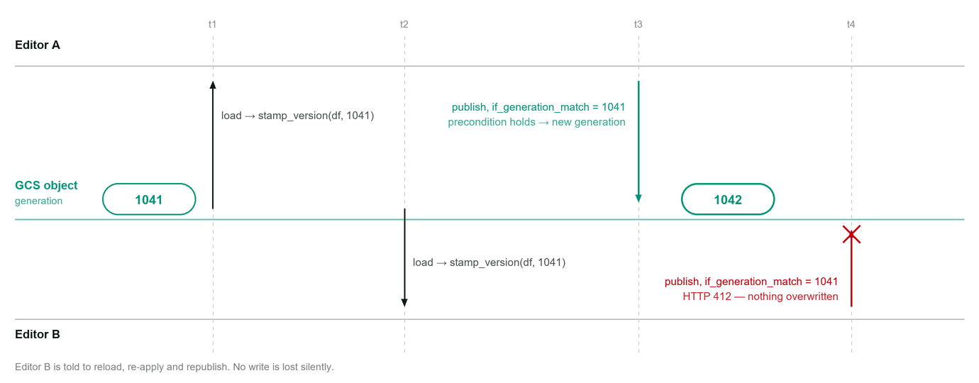
FIG. 4 Compare-and-swap on the object generation. Without the precondition, Editor B's whole-object write at t4 would overwrite Editor A's t3 publish in full — a much larger blast radius than a per-cell conflict, because the unit of write is the entire dataset.

The pre-flight probe
check_writable() is called before any change-log write and re-reads the live generation to compare against the session's baseline. Its purpose is not to close the race — the conditional write itself remains the authoritative guard — but to narrow it, so a publish that is already doomed fails before it can leave the compliance log describing a change that never landed. For the local providers it is a documented no-op.

The BigQuery provider's publish
The alternative bigquery provider takes a different approach entirely: it converts the edit map into one row per patched row, then executes a single parameterised MERGE:
MERGE `project.dataset.table` T
USING UNNEST(@patches) S
ON CAST(T.id AS STRING) = CAST(S.id AS STRING)
WHEN MATCHED THEN UPDATE SET col_a = COALESCE(S.col_a, T.col_a),
col_b = COALESCE(S.col_b, T.col_b)

Patches are passed as an ARRAY<STRUCT> query parameter rather than interpolated into SQL text, so edited values cannot alter the statement's structure. The SET clause covers the union of all columns edited anywhere in the batch; COALESCE(S.col, T.col) makes a NULL in the patch struct mean "this row did not change this column", which is how rows with different edited-column sets travel in one statement. The CAST on both sides of the join condition accommodates a non-string key column. The whole MERGE is a single atomic BigQuery job. This provider performs no version checking, so it is genuinely last-write-wins — though at per-cell rather than whole-dataset granularity.

Extending the layer
A new backend requires no changes to app.py: implement the ABC, register a lazy loader, name it in config.yaml.
# providers/storage/postgres.py
class PostgresStorageProvider(StorageProvider):
name = "postgres"
def load(self): ...
def apply_edits(self, df, edits): ...
# providers/storage/__init__.py
register_storage_provider("postgres",
lambda: _import("providers.storage.postgres", "PostgresStorageProvider"))

11 Audit trail
Every publish, of either kind, produces change-log rows before or after the data write according to the provider's declared policy. Each row carries the complete data snapshot plus five metadata columns:
COLUMN | VALUES | MEANING
the 17 data columns | string | Full row snapshot in this state. Not a sparse diff — each row stands alone.
change_id | CHG-XXXXXXXX | Ties a before row to its matching after row. Freshly generated per changed row.
change_state | before / after | Which side of the change this snapshot represents.
change_type | update / insert / delete | update from cell edits, insert from an import. delete is defined for schema completeness and never emitted.
changed_by | email | The verified identity from the IAP assertion. Not user-supplied.
changed_at | ISO 8601 UTC, seconds | One timestamp for the whole publish, so all rows of a publish share it.

Write ordering is a per-provider policy
core/publish.py centralises the ordering decision and returns a PublishOutcome carrying either a blocking error or a non-blocking warning. The two orderings fail in opposite directions, and the choice is a deliberate trade-off, not an inconsistency:
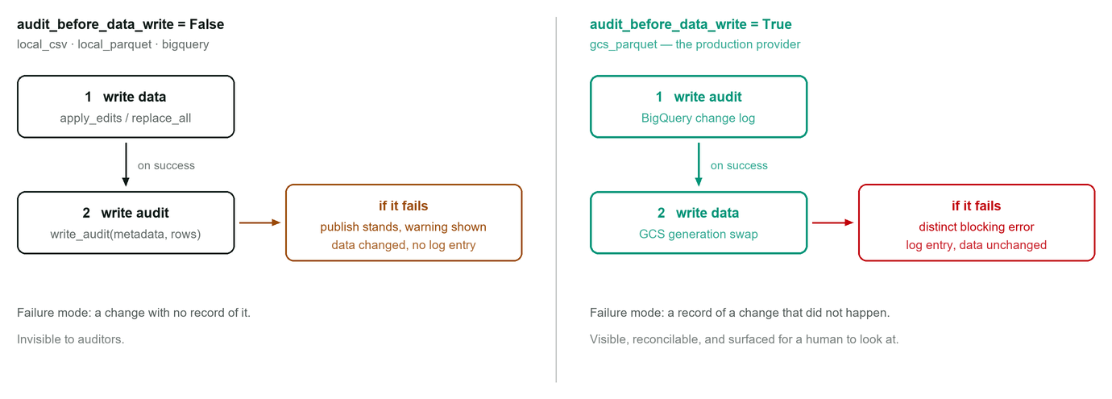
FIG. 5 The one edge that differs between the two orderings is which write goes first — and that single edge determines which of two irreconcilable states a partial failure can leave behind. The production provider chooses the state an auditor can see.
For a compliance log, an over-recorded change is strictly safer than an unrecorded one, so the production provider writes the log first and reports the mismatch as its own distinct blocking message rather than a silent warning. A failed write_audit on that provider aborts the publish before any data moves, with the message "Publish failed — no changes were saved".

Sinks
• gcs_parquet streams rows into collab-infra-nprod.collaborator_988_raw.988_change_log via insert_rows_json. Any per-row rejection returned by the API is raised as a StorageError rather than ignored. Because this is a streaming insert (tabledata.insertAll) and not a query job, the runtime service account needs roles/bigquery.dataEditor but not roles/bigquery.jobUser.
• Local providers append one JSON object per publish to <path>.audit.jsonl, carrying the metadata and the full record list.
• The bigquery provider writes to audit_table if configured, and skips the audit silently if not.

12 Import and export

Export
Export deliberately reflects the latest published state, not the session's working copy. The handler re-fetches from the storage provider, reindexes to exactly the configured column list and order — dropping any extra physical columns and materialising any missing ones — serialises to CSV, and names the file 988-Export-{YYYYMMDD}T{HHMMSS}Z.csv from a UTC clock.
Delivery is a one-click operation, which st.download_button cannot provide: its payload must exist at render time, before the fetch has happened, so it would always cost a click to prepare and a second to download. Instead the CSV bytes are base64-encoded into a data: URI, embedded in a one-pixel st.iframe carrying a script that creates an anchor with a download attribute and clicks it immediately. A StorageError during the refetch is surfaced as an error panel and no download is triggered.

Import
Import is a full-dataset replacement, not a merge. It is available only when the active provider sets supports_import = True; otherwise the toolbar button is disabled with an explanatory tooltip.
1. Guard. With pending edits, a modal requires explicit confirmation that they will be discarded. Confirming clears edits and both history stacks.
2. Upload. A .csv-restricted file picker. The file is parsed with dtype=str, keep_default_na=False, so nothing is coerced to NaN and the string "NA" stays the literal text "NA".
3. Column-shape check. Two order-preserving set differences compare the file's columns to the configured schema. Missing and unexpected columns are both rejected and both listed by name. Column order in the file is irrelevant — the frame is reindexed to the schema order — but the column set must match exactly.
4. Whole-file validation. Every cell of every row is checked against the same rules used in the editor. The result renders in the same grid, so small defects can be corrected inline without re-uploading; corrections accumulate in import_edits, entirely separate from the editor's edits.
5. Publish. Enabled only at zero error-severity findings. The confirmation dialog states the row count and that the entire dataset will be replaced.

The imported frame is reindexed to the schema and given a fresh RangeIndex, so positional row ids are renumbered from the file. It carries no version baseline of its own, so before the write the publish handler stamps it with the baseline the session loaded — stamp_version(final_df, version_of(original_df)) — which is what keeps the compare-and-swap meaningful for an import. Audit rows are emitted as one insert per imported row.
DESIGN CONSEQUENCE There is no route from import_review back to the editor other than an explicit Discard import. This is intentional: a partially reviewed import merged into a cell-editing session would make the pending-change set ambiguous, and the change log could no longer describe the publish as either an update or an insert.

13 Security model
The application has no credential entry point of any kind. The AuthProvider base class exposes only authenticate_from_headers() — there is no authenticate(username, password) to call and no OAuth callback to handle. Adding either would require re-adding a login screen that this codebase deliberately does not contain.

Identity verification
On every rerun, the active provider reads X-Goog-IAP-JWT-Assertion from the request headers and calls google.oauth2.id_token.verify_token against Google's IAP-specific JWK key set at https://www.gstatic.com/iap/verify/public_key-jwk with the configured audience. Three outcomes are distinguished, and the distinction is deliberate:
header absent | Returns None. Treated as "not signed in" and rendered as the landing page with a Log in button. No error is shown, because this is the normal state for a request that has not yet passed through IAP.
header present, untrustworthy | Raises AuthError — bad signature, wrong audience, expired token, or a missing audience configuration. Rendered as "Sign-in is unavailable: …" with the Log in button suppressed, because that button would send the visitor straight back to the same failure.
header present, valid | The email claim becomes the user identity, after stripping the accounts.google.com: prefix IAP applies. A token with no email claim is rejected as AuthError.

Why only the signed JWT is trusted
IAP also sets plaintext X-Goog-Authenticated-User-Email and -Id headers. Neither is read anywhere in this codebase. A plaintext header is trivially forgeable by anyone who can reach the backend without traversing the proxy, so a missing or invalid JWT is always treated as "not logged in" rather than falling back to a header that carries no cryptographic guarantee.
DEPLOYMENT-DEPENDENT ASSUMPTION Signature verification is defence in depth, not the access-control gate. The gate is the roles/iap.httpsResourceAccessor IAM grant on the backend service. Verification protects against a forged or replayed assertion; it does not protect against a backend reachable outside the load balancer path, because an attacker there simply omits the header and is shown the landing page — but every deployment control that keeps the Cloud Run service private (--no-allow-unauthenticated, --ingress=internal-and-cloud-load-balancing, run.invoker granted only to the load balancer's service agent) must hold for the model to be sound.

Sign-in and sign-out
The landing page's Log in control is a real browser navigation (st.link_button), never a Streamlit button. A Streamlit button triggers a rerun over the existing WebSocket, which replays the script against the same missing header forever; only a fresh HTTP navigation can be intercepted by IAP to start the sign-in flow. The default target is /, correct whenever the app is reachable only through IAP; IAP_LOGIN_URL overrides it for deployments where a browser can arrive some other way.
There is no local sign-out. Clearing st.session_state would accomplish nothing — the next rerun re-reads the same still-valid assertion and signs the same person straight back in. The avatar popover's Switch account link appends gcp-iap-mode=CLEAR_LOGIN_COOKIE to the configured login URL, which is IAP's own supported mechanism for ending its session, with query-string joining handled correctly for URLs that already carry parameters.

Injection surfaces and their handling
SURFACE | RISK | CONTROL
Cell values rendered into hand-built HTML | Stored XSS through a malicious cell value | Every emitted value passes through html.escape(), including values placed in data- attributes; enum option lists are JSON-encoded and then escaped
Bridge payload from the browser | Arbitrary (row, column, value) injection by a user with devtools | JSON decode failures dropped silently; ordinal bounds-checked against the server's own row list; column resolved against the configured rule set; a rule that is absent or editable: false is rejected
BigQuery publish | SQL injection through edited values | Values travel as an ARRAY<STRUCT> query parameter; no value is interpolated into statement text
Uploaded CSV | Schema drift or type confusion in the published dataset | Exact column-set match required; every cell validated before publish is enabled; parsed with no NA coercion
changed_by in the change log | Attribution forgery | Taken from the verified JWT claim only; never from a form field or client-supplied value

Container posture
The image is python:3.12-slim, runs as a non-root user (uid 1000), sets STREAMLIT_SERVER_HEADLESS=true and disables usage-statistics collection. The .dockerignore excludes .git, tests, and any local audit JSONL. Credentials are never baked in: on Cloud Run the runtime service account supplies Application Default Credentials, and GOOGLE_APPLICATION_CREDENTIALS is needed only for local development against real GCP resources.

14 Deployment and operations

Environment variables
VARIABLE | REQUIRED | PURPOSE
IAP_AUDIENCE | YES | Expected JWT audience. /projects/PROJECT_NUMBER/global/backendServices/SERVICE_ID for an external HTTPS load balancer, or /projects/PROJECT_NUMBER/apps/PROJECT_ID for App Engine. Absent, every sign-in fails with a configuration message.
IAP_LOGIN_URL | OPTIONAL | Target of the landing page's Log in navigation. Defaults to /.
CSV_EDITOR_CONFIG | OPTIONAL | Path to an alternative configuration file. Used to run locally against local_parquet without editing the committed config.yaml.
GOOGLE_APPLICATION_CREDENTIALS | OPTIONAL | Service-account key path. Omit on Cloud Run, where Application Default Credentials come from the attached runtime service account.

IAM for the runtime service account
• roles/storage.objectAdmin on the collab-nprod-data bucket, or the narrower objectViewer + objectCreator pair — the application overwrites the Parquet object but never deletes it.
• roles/bigquery.dataEditor on the collaborator_988_raw dataset in collab-infra-nprod. roles/bigquery.jobUser is not required, because the change-log write is a streaming insert rather than a query job.

WebSocket lifetime — four settings that matter
Streamlit disables every widget whenever its connection state is not CONNECTED, so a routine reconnect greys out the entire toolbar for about a second. Four platform defaults cause needless reconnects and must be changed:
SETTING | DEFAULT → REQUIRED | WHY
Backend service timeout (global LB) | 30s → 3600s | For WebSocket traffic GCLB treats this as the connection's maximum lifetime, not an idle timeout. The 30-second default forces a reconnect every 30 seconds. This is the primary fix.
Session affinity (global LB) | NONE → GENERATED_COOKIE | Without it a reconnect can land on a different Cloud Run instance, which holds no copy of the session — unpublished edits live only in session_state and would be silently lost, plus a full Parquet reload.
Cloud Run request timeout | 300s → 3600s | The same mechanism one layer down; caps the WebSocket at five minutes if left at the default.
Cloud Run min instances | 0 → 1 | Prevents a reconnect from paying a cold start, which turns a one-second blip into several.

Diagnosis is straightforward: in DevTools, filter Network to WS and watch the close/reopen cadence. Roughly 30 seconds implicates the load balancer timeout; roughly 300 seconds implicates the Cloud Run timeout. Alternatively watch data-test-connection-state on [data-testid="stApp"] flip away from CONNECTED at each blip.
Two Streamlit-side values are worth knowing. server.websocketPingInterval defaults to 30 seconds with the ping timeout set equal to it; shortening it to 20 in .streamlit/config.toml helps if pongs are delayed through IAP past the timeout, though that is a code change requiring a rebuild. server.disconnectedSessionTTL defaults to 120 seconds — a session whose socket stays down longer may be reaped server-side, pending edits included.

Making reconnects legible rather than alarming
Because Streamlit's status widget is the only element that distinguishes "reconnecting" from "this button is broken", the CSS keeps the Streamlit header in the DOM — it cannot be display: none, since the status widget lives inside it — and instead collapses it to zero height, makes it click-through, hides its other chrome, and re-pins the status widget to the bottom-right corner. Disabled primary buttons are rendered as faded green rather than the default grey-with-dashed-border, which read as broken. A 0.15s transition delay on the opacity change is what makes a short blip nearly invisible: transitions run only on changes, so a button genuinely disabled at paint time still appears disabled immediately, while a momentary mid-life toggle waits out the delay and never visibly flickers.
OPERATIONAL NOTE These presentation changes make reconnects tolerable; they do not reduce them. The four platform settings above are the actual fix.

Deployment sequence
1. Deploy to Cloud Run with public access off and ingress restricted: --no-allow-unauthenticated --ingress=internal-and-cloud-load-balancing.
2. Front it with an external HTTPS Application Load Balancer using a serverless NEG backend.
3. Enable IAP on that backend service (Console → Security → Identity-Aware Proxy).
4. Grant roles/iap.httpsResourceAccessor on the backend service to the users or group who should have access. This is the real access-control gate.
5. Derive the audience string from the project number and backend service id, and set it as IAP_AUDIENCE on the service.
6. Apply the four WebSocket-lifetime settings above.
7. Before first real use, confirm manually that the live Parquet object's and the change-log table's column names match the 17 name: values in config.yaml exactly. A mismatch surfaces as a StorageError on first read or write, not at config-load time.

15 Tooling, tests, CI

Test suite
The committed suite targets the property that matters most and is hardest to verify by inspection: that the GCS generation preconditions actually prevent one editor from silently clobbering another. It drives the real provider against an in-memory fake of the GCS object model — a store holding bytes plus a monotonically increasing generation, a blob exposing reload, download_as_bytes, and upload_from_string with precondition semantics, and a code = 412 exception standing in for PreconditionFailed. Fake modules are injected into sys.modules for the duration of each test, so the suite needs no network and no google-cloud-* installation.
python -m pytest tests/ -q

Linting
Ruff at a 110-character line length, with a deliberately conservative rule selection: E4 (imports), E7 (statements), E9 (syntax and IO errors), F (pyflakes — genuine bugs), and I (import ordering). Style and modernisation rule sets are excluded on the stated grounds that they would surface a large volume of unrelated noise on first adoption. A pre-commit hook runs Ruff over staged Python files on every commit.
pip install -r requirements-dev.txt
pre-commit install
pre-commit run --all-files # after changing the hook config

Continuous integration
A single GitHub Actions workflow builds the container and pushes it to GitHub Container Registry on every push to gcp_launch and on any v* tag. Images are tagged by commit SHA via docker/metadata-action, authenticated with the workflow's own GITHUB_TOKEN under packages: write. The workflow does not run the test suite or the linter — those are enforced locally by the pre-commit hook.

Local development
With the shipped configuration the app stops at the landing page on a workstation: auth is iap, there is no proxy in front, so there is no identity and no form to fill in. Two routes exist — deploy behind a real IAP, or set st.session_state.user to a providers.auth.base.User directly, for example through streamlit.testing.v1.AppTest. Pointing CSV_EDITOR_CONFIG at a config using local_parquet lets the editor run against the real 290-row dataset in sample_data/ with no GCP setup at all.

16 Limitations and trade-offs

Accepted by design
• Whole-object writes. Every publish rewrites the entire Parquet object. The generation precondition prevents a silent clobber, but the loser of a race must reload and re-apply their edits by hand — there is no merge, and no preservation of their pending changes across the reload.
• Pending edits are session-local and volatile. They live only in st.session_state. A browser refresh, a session TTL expiry, or a reconnect that lands on a different instance without session affinity loses them with no recovery path.
• No row insert or delete. Adding or removing a resource requires a full CSV import. The change log's delete type is defined but never emitted.
• No field-level permissions. Every identity IAP admits can edit every editable column of every row.
• Search highlighting is cell-granular. The whole matching cell is tinted; the matched substring is not individually marked.
• Two required-but-blank policies are not separable. A blank required field is always a warning and never blocks, per column as well as globally — there is no configuration to make one specific required column blocking.

Scale characteristics
At 290 rows the whole dataset renders in one table with no pagination and no virtualisation, and the per-keystroke search cost is negligible. Three costs grow linearly with row count and would need attention well before an order-of-magnitude increase: the markup size of a full re-render, the O(rows × columns) search scan on every keystroke, and the whole-object read-modify-write on every publish. The import path's whole-file validation grows the same way but runs once rather than per interaction.

Documentation drift to be aware of
VERIFY BEFORE RELYING ON IT README.md states under "Notes & known trade-offs" that concurrent editors are uncoordinated and last publish wins. That is accurate for bigquery, local_csv, and local_parquet, but no longer accurate for gcs_parquet, which implements the generation compare-and-swap described in §10 and refuses a stale publish outright. README.md and CONFIG.md also document gcp_iap and a google_oauth provider as selectable options; only iap is registered, and no google_oauth module exists in the tree.
Two smaller inconsistencies: requirements.txt lists requests and pyarrow twice each, and carries commented-out "optional" entries for packages that are in fact mandatory for the default provider pair. Neither affects behaviour.

Fragility worth knowing about
• The bridge depends on Streamlit internals. It locates the hidden input by the generated class st-key-cell_bridge and relies on the native-setter technique working against Streamlit's React input. A change to either in a future Streamlit release would break cell editing silently — the editor would open and appear to commit, but no value would reach the server.
• The CSS targets data-testid attributes. Header collapsing, status widget pinning, popover styling, and element-toolbar suppression all hook Streamlit's internal test ids, which carry no stability guarantee across versions.
• Undo/redo ordinals assume a stable index. History instructions reference row ids; after a full-replace import with positional ids, previously recorded ids would refer to different rows — which is exactly why history is cleared on every import and every publish.

