988 DIRECTORY · HOW-TO GUIDE
Editing the 988 Directory
How to correct a record, add one, remove one, check your work and publish — plus how to pull a copy of the data out, or load a whole new file in.
WHAT'S IN HERE
00 The screen | 06 What the colours mean
01 Edit a cell | 07 Review your changes
02 Add a row | 08 Publish
03 Delete a row | 09 Export a copy
04 Find a record | 10 Replace everything with an import
05 Undo and redo | 11 Quick reference

00 The screen
Everything happens on one page. The whole directory is in the table, and the controls you need sit along the top.
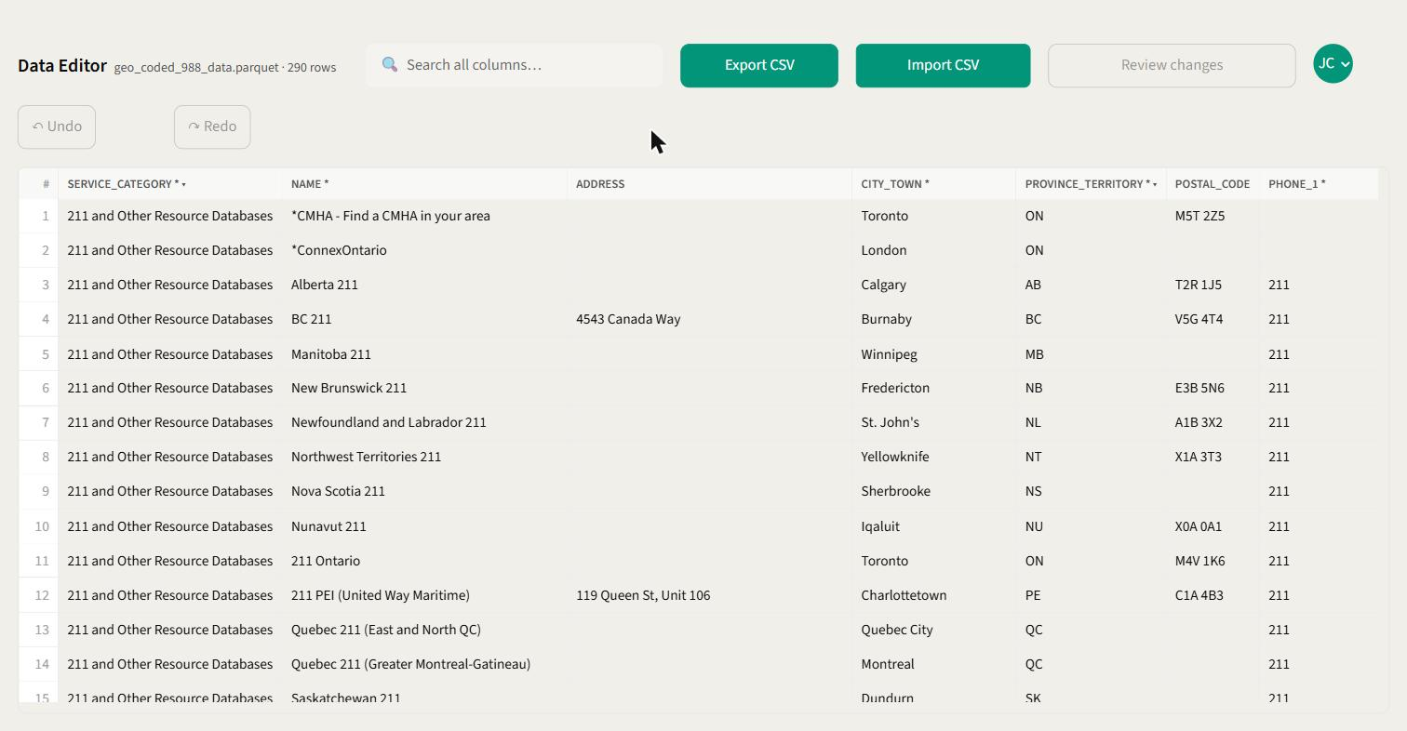
THE EDITOR The toolbar runs across the top; the directory fills the rest of the page. The file name and row count sit next to the title — here, geo_coded_988_data.parquet · 290 rows .
A few things worth knowing before you start:
• Scroll sideways to reach the rest of the columns. There are 17 in total — hours, website, description, latitude and longitude are off to the right.
• The row number on the far left stays put as you scroll, so you can always tell which record you're looking at.
• Column headers carry hints. A * means the field should be filled in, ▾ means you pick from a list rather than typing, ¶ means it's a long text box, and #.# means it takes a number.
• Nothing you type is saved until you publish. You can change as much as you like and still walk away from it.

01 Edit a cell
The example used through this guide: row 9 is Nova Scotia 211 , but its city is listed as Sherbrooke — which is in Quebec. It should say Halifax.
1. Double-click the cell you want to change.
A small box opens directly on top of it with the current value already selected, so you can start typing straight away.
2. Type the new value.
What you get depends on the column: an ordinary text box for most, a drop-down list for things like province or service category, a bigger box for the description, and a number box for latitude and longitude.
3. Press Enter to keep it.
Tab or clicking somewhere else also keeps it. Press Esc if you've changed your mind — the cell goes back to how it was.

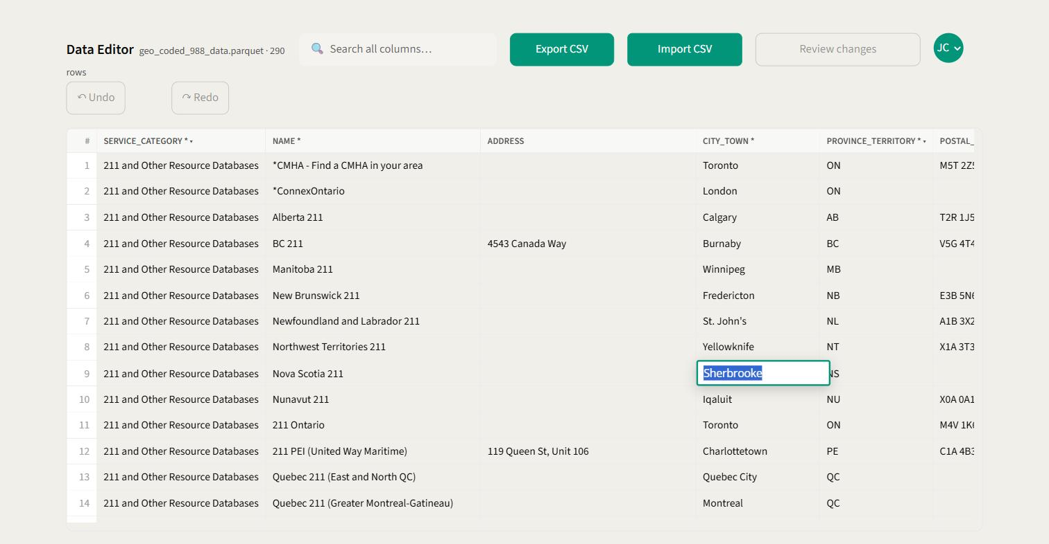
STEP 1 Double-clicking the CITY_TOWN cell on row 9 opens the editor right over the cell, with Sherbrooke selected.
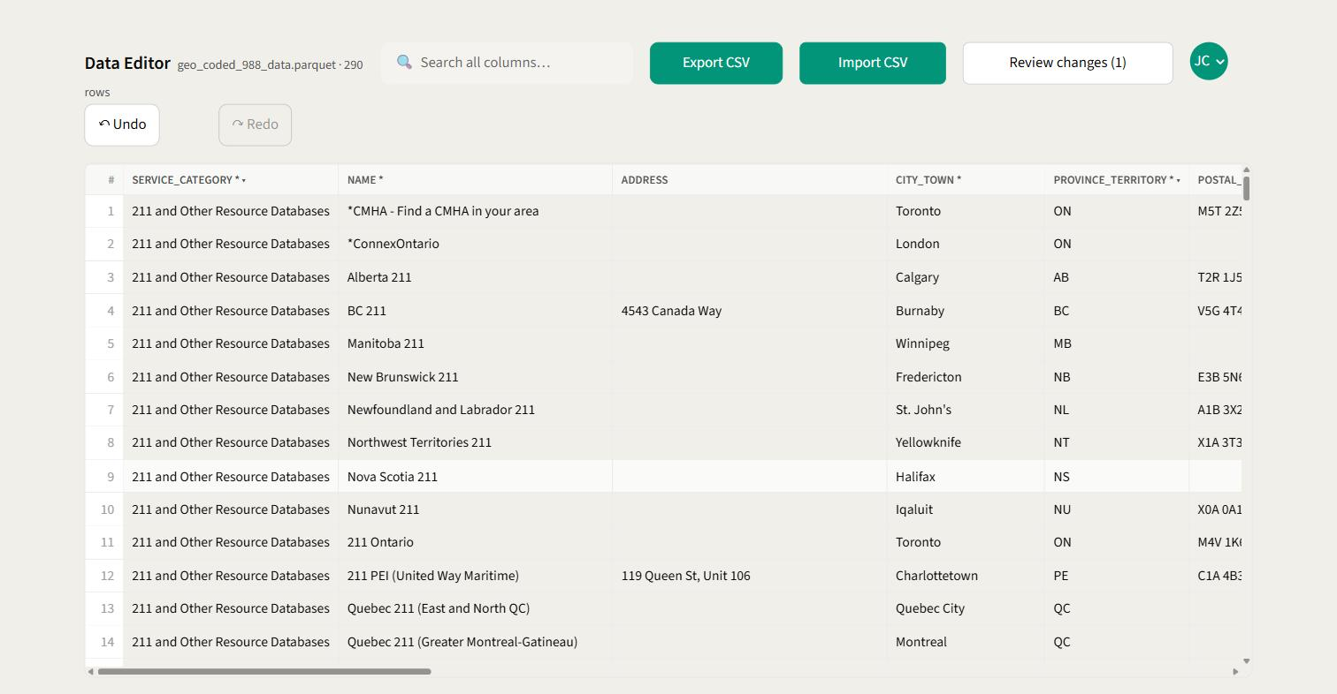
STEP 3 After pressing Enter the cell turns green to mark it as changed, Review changes wakes up with a count of (1) , and Undo becomes available.
GOOD TO KNOW If you change a cell and then put the original value back, the tool notices and stops counting it as a change. The counter goes back down on its own — you don't have to undo it.

Editing a long description
The DESCRIPTION column opens a larger box that holds several paragraphs. In there, Enter starts a new line instead of saving, so use Shift + Enter for a line break and click outside the box when you're finished.

02 Add a row
For a service that isn't in the directory yet. The new row starts empty at the bottom of the table, and it isn't part of the directory until you publish.
1. Click ＋ Add Row in the toolbar.
A blank row appears at the very bottom, numbered one past the last — 291 in a directory of 290 — and the editor opens on its first cell so you can start typing straight away. A green bar down the left of the row number marks it as a record that isn't in the directory yet.
2. Fill in the cells.
Exactly like editing anything else: double-click a cell, type, press Enter . Work across the row with the horizontal scrollbar. You don't have to fill in everything — only the fields you actually know.
3. Look at what's still outlined in amber.
Every required field you've left empty is flagged. Amber never stops you publishing, but a record with no name or no province isn't much use to anyone looking for help, so fill in what you can.
4. Click Review changes, then publish.
The row is listed as New row, with a count of how many of the 17 fields you filled in. Publishing is the same as for any other change — see 07 Review your changes and 08 Publish.

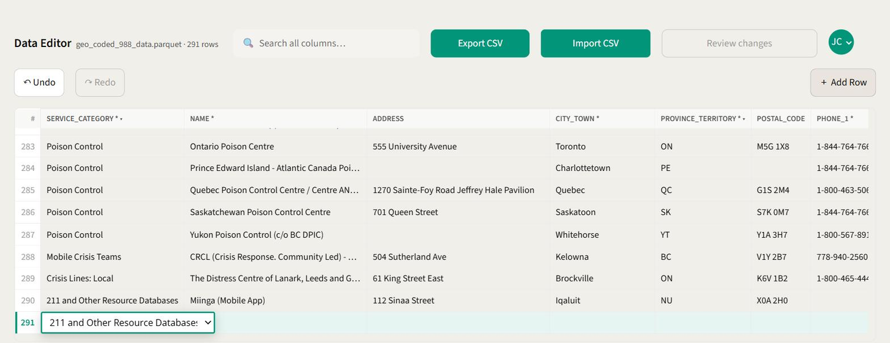
STEP 1 Add Row drops a blank row 291 at the bottom and opens its first cell for you. The row count in the header has already gone up to 291.
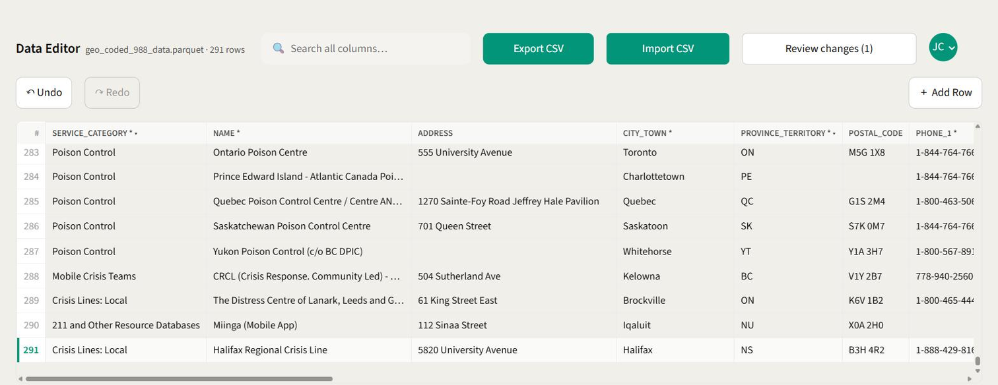
STEP 2 The finished record. Note the counter: Review changes (1) . A new row is one change no matter how many cells you typed into.
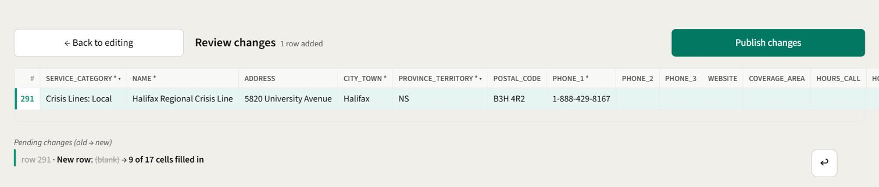
ON THE REVIEW SCREEN New rows are summarised rather than listed cell by cell. The ↩ button beside it takes the whole row back out again.
ONE CHANGE, NOT SEVENTEEN A new row travels as a single unit. It counts as one on the Review changes badge, it's listed as one line on the review screen, and Ctrl + Z removes the whole row rather than clearing it a cell at a time.

Things worth knowing
• Clicking ＋ Add Row twice won't give you two blank rows. If the row at the bottom is still empty, the button simply puts your cursor back in it.
• An empty row isn't a change. Add one, type nothing, and the tool ignores it — it isn't counted and it isn't published.
• A row you've added stays on screen even while a search is filtering the table, so you can't lose it behind a search term.
• The usual colours apply while you type: red for a value that doesn't fit the column, amber for a required field still blank. Red still blocks publishing — see 06 What the colours mean.

If you change your mind, Ctrl + Z takes the row out again, and so does the ↩ button next to it on the review screen. Either way nothing has been written to the directory — nothing is, until you publish.

03 Delete a row
For a service that has closed, or a record that's in the directory twice. Like every other edit, a deletion is only pending until you publish.
1. Right-click anywhere on the row.
A small menu opens with one item on it: ✕ Delete Row. Right-clicking inside an open cell editor gives you the browser's own menu instead — press Esc to close the editor first.
2. Click ✕ Delete Row.
A confirmation names the row number and reads back the first few values of the record, so you can be sure you're on the row you meant.
3. Click OK.
The row disappears from the table straight away, the row count in the header drops by one, and Review changes goes up by one. Cancel leaves everything exactly as it was.
4. Click Review changes, then publish.
Deleted rows are the one thing you can still see on the review screen after they've vanished from the editor: greyed out, struck through, and marked with a red bar down the left.

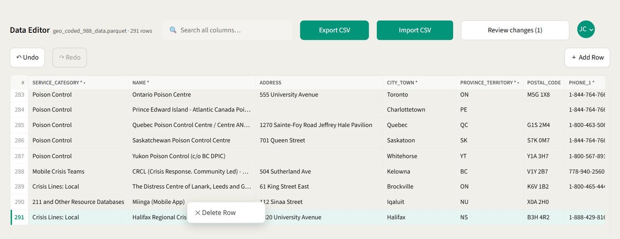
STEP 1 Right-clicking row 290 opens the row menu. Delete Row is the only thing on it, so there's nothing to hit by accident.
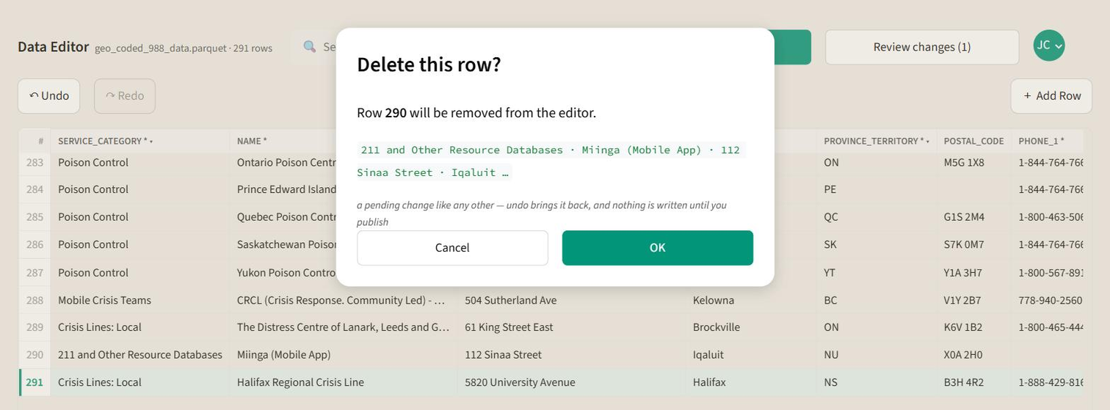
STEP 2 The confirmation reads the record back to you before anything happens. Nothing is written to the directory at this point.
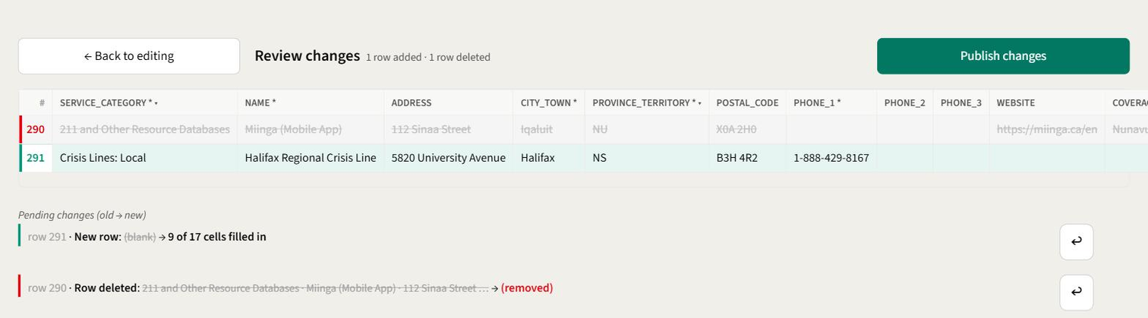
ON THE REVIEW SCREEN Row 290 struck through and marked (removed) , with the new row 291 from the previous section below it. ↩ beside either line puts it back.
UNDO WORKS RIGHT UP TO PUBLISH Ctrl + Z brings a deleted row back, and so does the ↩ button next to it on the review screen — where the tooltip reads Keep this row after all.

Things worth knowing
• Row numbers don't close up when a row disappears. You'll see the numbering skip where the deleted row used to be; it settles back into a run once you publish.
• You can delete a row you added yourself in the same session. It's just taken back out — there was never anything in the directory to remove.
• Deleting a row cancels any cell edits you'd made to it. The row travels as a whole, so those edits are no longer counted separately.
• Search doesn't get in the way: find the record first, right-click it in the results, and delete it there.

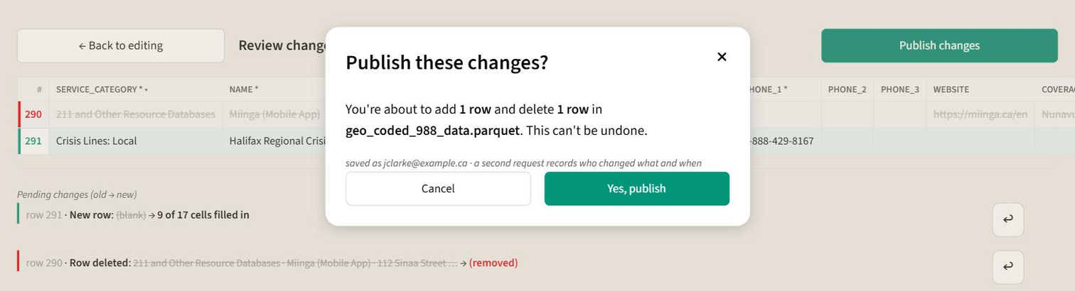
BEFORE YOU COMMIT The publish confirmation counts rows added and rows deleted separately from cell edits, so you can see at a glance that it matches what you meant to do.
A PUBLISHED DELETION CAN'T BE UNDONE Once you publish, the record is out of the live directory and there's no “undelete”. The change log keeps the full row exactly as it was, with your name and the time, so it can be reconstructed — but that means someone reading the log and typing it back in. Before a clean-up of several rows, take an Export CSV first.

04 Find a record
290 rows is a lot to scroll. The search box narrows the table to just what you need.
1. Click the search box and type what you're looking for.
It looks across every column at once — an organisation name, a city, part of a phone number, a web address. Capital letters don't matter.
2. Press Enter .
A blue bar appears telling you how many rows matched, and the matching cells are picked out in yellow so you can see why each row is there.
3. Click Clear search to get the full list back.

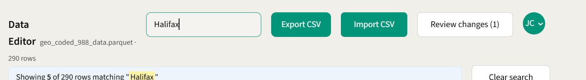
SEARCHING Typing Halifax narrows 290 rows to 5. Note the count: four records in the file mention Halifax, and the fifth is the row we just corrected — search looks at your unsaved edits too.
YOUR EDITS ARE SAFE Searching only changes what you can see. If you've edited a row that then drops out of the results, the change is still there and still counted — the number next to Review changes never moves when you search.
Search also takes your typing literally, so you can look for (416) or .ca without anything strange happening.

05 Undo and redo
Two buttons sit just under the toolbar and step back and forward through everything you've changed this session.
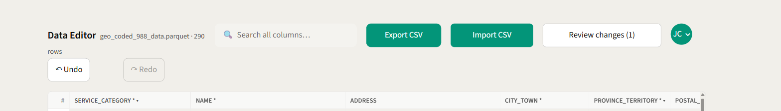
UNDO AND REDO Undo is available because there's one change to step back through; Redo stays greyed out until you've actually undone something.
• Undo takes back your most recent change, one cell at a time. Keyboard: Ctrl + Z .
• Redo puts it back. Keyboard: Ctrl + Y , or Ctrl + Shift + Z .
• Hover over either button and it'll tell you how many steps it has left.
• A button greys out when there's nothing left to do in that direction.

If you start editing again after undoing something, the redo trail is dropped — the same way it works in Word or Excel.
ONE THING TO WATCH The shortcuts don't fire while you're typing inside a cell, so Ctrl + Z in an open editor undoes your typing, not your last saved change. That's deliberate. Close the editor first if you want to step back a whole change.
Undo history is cleared once you publish. Published changes can't be undone from here.

06 What the colours mean
The tool checks each cell as you edit it and colours anything that needs your attention. Only two colours actually stop you publishing.
Halifax | Green — changed. You've edited this cell and it hasn't been published yet. Nothing to fix.
Halifax | Yellow — search match. This cell contains what you searched for. It disappears when you clear the search.
(blank) | Amber — should be filled in. A field marked * has been left empty. Worth a look, but it won't stop you publishing — there are already gaps like this in the directory.
M5S 2S | Red — not a valid entry. The value doesn't fit what the column accepts. This does stop you publishing until it's fixed.
read only | Grey — locked. This column can't be edited here.

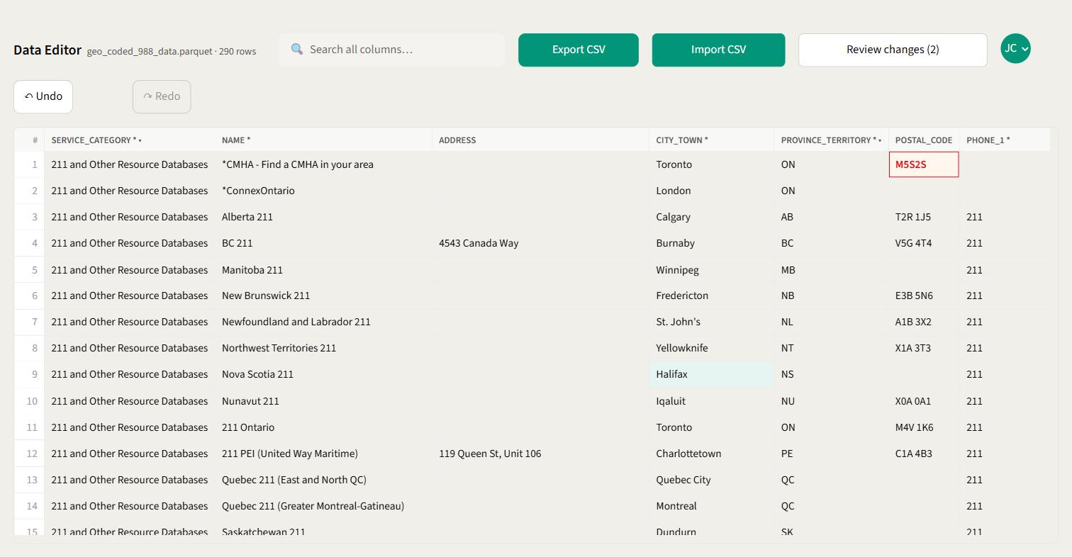
BOTH AT ONCE Row 1's postal code is short, so it's flagged red and will block publishing. Row 9's corrected city is green and perfectly fine. Note the postal code lost its space automatically — the tidy-up runs first, then the check.

Why a cell turns red
• Postal code has to look like A1A 1A1. Spacing and capitals are tidied up for you, so m5s2s1 becomes M5S 2S1 by itself — but if the wrong number of characters is there, it'll go red.
• Website has to start with http:// or https://.
• Latitude must be between −90 and 90; longitude between −180 and 180.
• Province and service category come from a fixed list, so you can only pick a valid one.

Hover over a red cell, or look at the review screen, and you'll get a short note telling you exactly what's expected.
EMPTY IS FINE Leaving an optional field blank never causes an error. The checks only run on cells that have something in them — so an empty postal code is fine, while a half-typed one is not.

07 Review your changes
Before anything is saved, you get a screen showing only what you've touched.
1. Click Review changes in the toolbar.
The number in brackets is how many cells you've edited. The button is greyed out until you've changed at least one.
2. Check the list.
Only the rows you edited are shown. Underneath the table, each change is written out in plain language — the row number, the field, the old value crossed out, and the new value beside it.
3. Fix anything that needs fixing.
Cells are still editable here, so you don't have to go back. Every change also has a ↩ button next to it that puts that one cell back to its original value and leaves the rest alone.
4. Use ← Back to editing if you want to change something else first.
Your pending changes come with you. Nothing is lost by moving between the two screens.

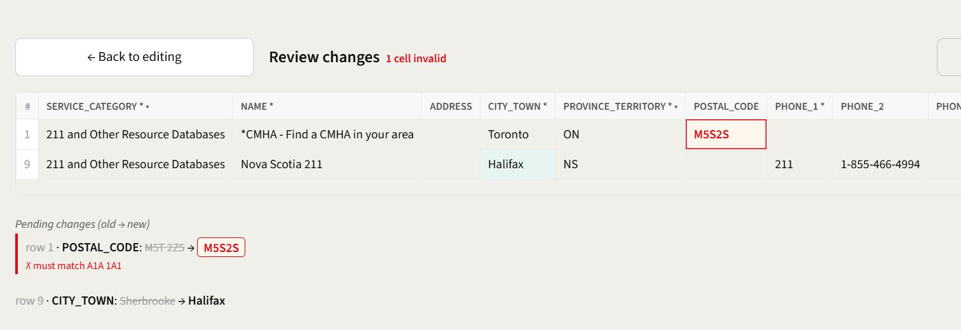
SOMETHING TO FIX Only the rows you touched are listed. Each change is spelled out underneath — old value struck through, new value beside it, and the reason anything red is being rejected.
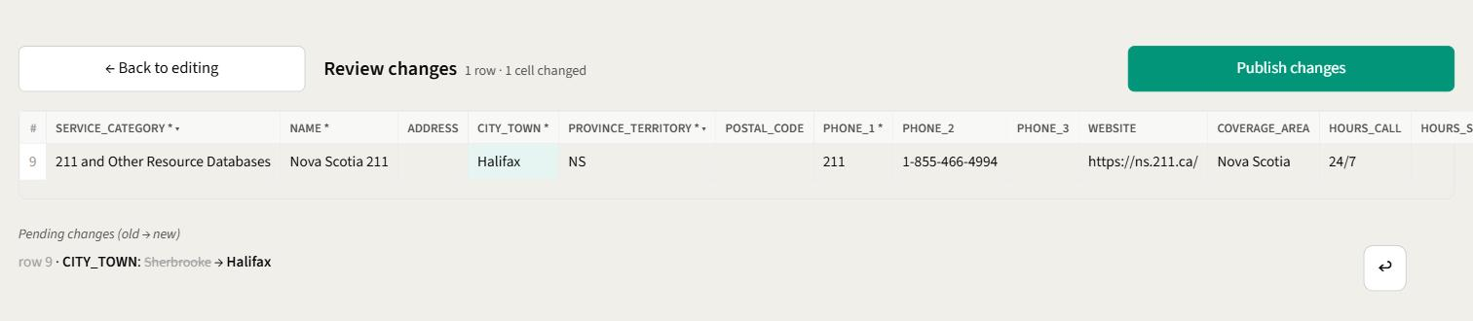
READY TO GO After clicking ↩ on the postal-code line, only the intended change is left and Publish changes lights up.
IF THE HEADING TURNS RED A red summary like 2 cells invalid means Publish changes is switched off until those cells are sorted out. Each one is outlined in red with a note saying what's wrong. An amber note about blank fields is just a heads-up and doesn't block anything.

08 Publish
Publishing writes your changes to the live directory and records who made them.
1. Click Publish changes on the review screen.
It's switched off if any cell is still red, or if you have no changes pending.
2. Read the confirmation.
It tells you exactly how many cells across how many rows are about to change, and which dataset it's writing to.
3. Click Yes, publish.
The button shows a spinner while it saves. Give it a moment — one click is enough, and the button won't accept a second one.
4. Look for the green confirmation.
You're returned to the editing screen with a message along the lines of Published 1 cell across 1 row. The green tint is gone and the change counter is back to zero.

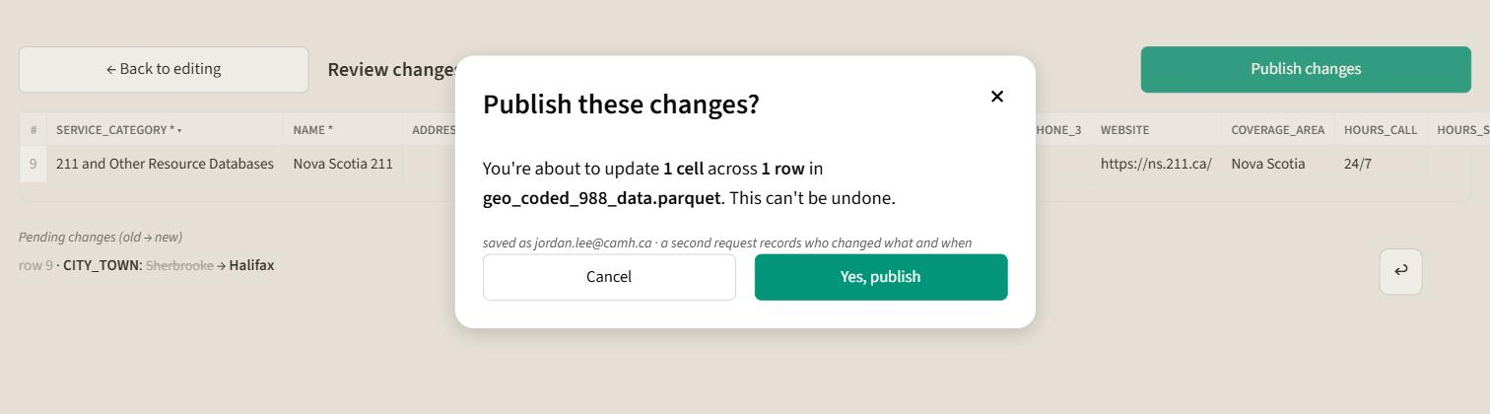
THE CONFIRMATION It names the exact counts and the dataset before you commit, and tells you which account the change will be recorded against.
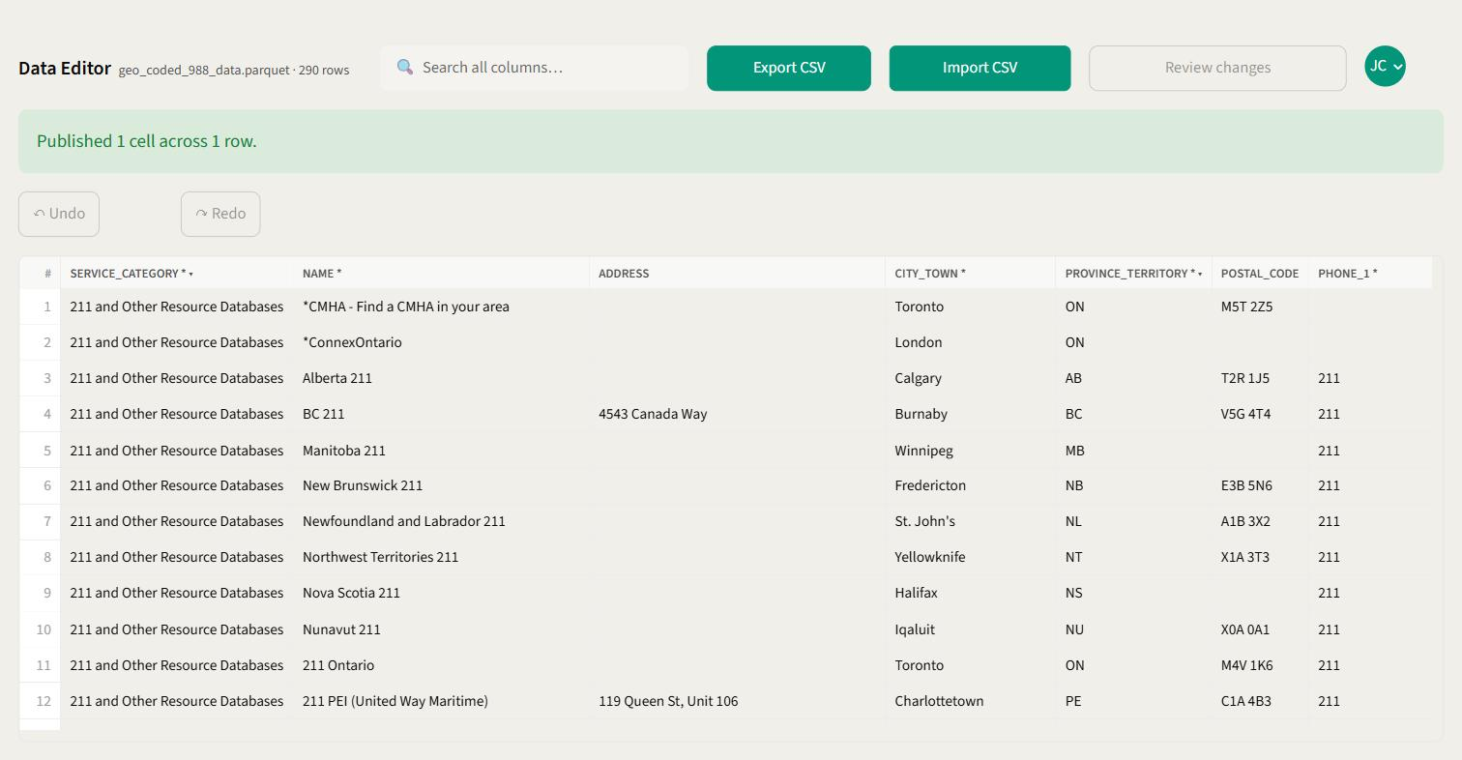
DONE The green banner confirms what was saved. Row 9 now reads Halifax as ordinary published data, the counter is back to zero, and the undo history is cleared.
PUBLISHING CAN'T BE UNDONE There's no "unpublish". If you publish something by mistake, the fix is to edit the cell back to what it was and publish again — both the mistake and the correction stay in the record.

If someone else published while you were working
You'll get a message saying nothing was overwritten and their changes are safe. This is working as intended: it stops two people quietly undoing each other's work. Reload the page to pick up the latest version, make your changes again, and publish.
WHAT GETS RECORDED Every publish is logged with your name, the time, and both the before and after version of each row you changed. You don't have to do anything for this to happen.

09 Export a copy
Use this when you want the data in a spreadsheet — for a report, a review, or to prepare a bulk update offline.
1. Click Export CSV in the toolbar.
2. The file downloads on its own.
It's named with the date and time it was taken, like 988-Export-20260911T143052Z.csv, so copies don't overwrite each other. Open it in Excel or anything that reads a spreadsheet.

WORTH UNDERSTANDING The export always gives you the published directory, not what's on your screen. Any changes you haven't published yet will not be in the file. If you want them included, publish first, then export.

10 Replace everything with an import
Import is for bulk updates. It swaps the entire directory for the contents of your file — it does not merge.
READ THIS FIRST Importing replaces all 290 rows with whatever is in your file. Any record not in your file will no longer be in the directory. Export a copy first, so you have the current version to go back to.
1. Export a copy first and edit that.
Starting from an export guarantees your columns match. Change what you need in Excel and save it as CSV.
2. Click Import CSV and choose your file.
If you have unpublished edits, you'll be asked to confirm first — importing throws them away.
3. Click Validate & Continue.
The columns have to match the directory exactly. If any are missing or there's one too many, you'll be told which by name and nothing will be loaded. Column order doesn't matter.
4. Work through anything flagged.
Every cell in the file is checked, not just the ones you changed. Problems are marked in red the same way as in the editor, and you can fix them here without going back to Excel and re-uploading.
5. Click Publish Changes, then confirm.
Only available once nothing is red. The confirmation tells you how many rows are about to replace the directory.

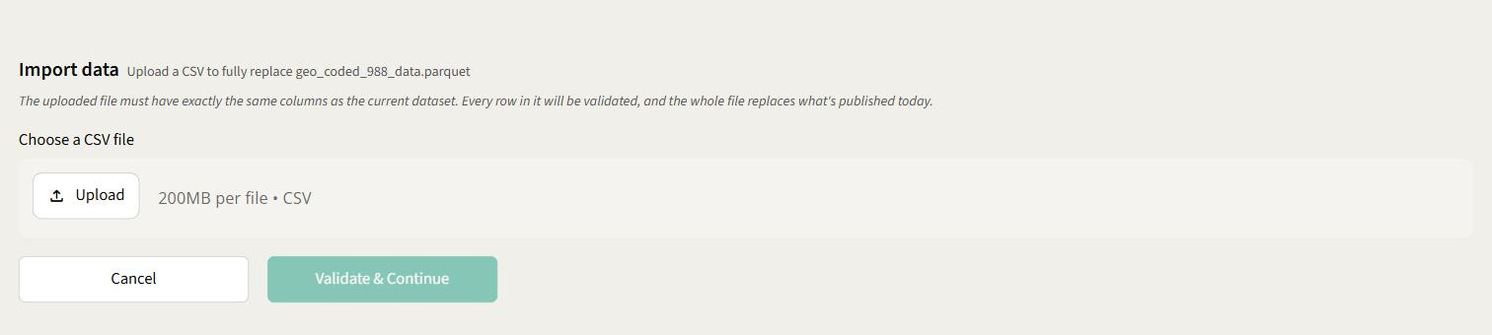
CHOOSING A FILE Validate & Continue stays greyed out until you've picked a file.
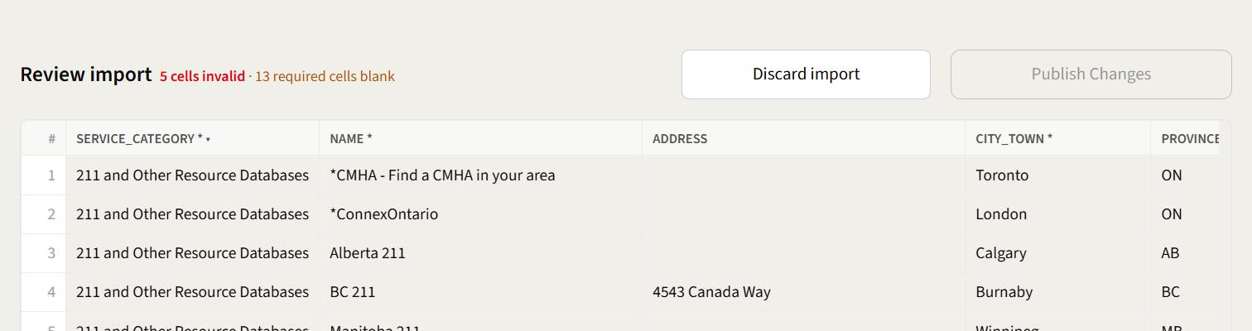
EVERY CELL IS CHECKED This is a straight re-import of today's directory, and it still reports 5 cells invalid · 13 required cells blank — those problems are already in the data. The 5 red ones have to be fixed before you can publish; the 13 amber ones are only flagged.
If you change your mind at any point, Discard import drops the file and takes you back to the editor. That's the only way back — an import can't be half-applied.

11 Quick reference

Keyboard
KEYS | WHAT IT DOES
Enter | Keep the value and close the cell editor
Tab | Keep the value and close the editor
Esc | Discard what you typed, restore the original
Shift + Enter | New line inside a description box
Ctrl + Z | Undo the last change
Ctrl + Y | Redo
Ctrl + Shift + Z | Redo

What stops a publish
SITUATION | BLOCKS PUBLISHING?
A cell is outlined in red | Yes — fix it first
A required field is blank (amber) | No — it's only a flag
You have no pending changes | Yes — there's nothing to publish
Someone else published first | Yes — reload and redo your changes

Column shorthand in the headers
MARK | MEANING
* | Should be filled in
▾ | Pick from a list
¶ | Long text box
#.# | Takes a number

