**Scan con Sonar Scannner**

**Archivos con bugs**

* Schedule.jsx
* Counseling_Activities/JoinCounseling.jsx
* Group.js
* Home.js
* Home21.module.css
* Schedule.module.css
* ScheduleGlobals.css
* Profile2.module.css

**Schedule.jsx**

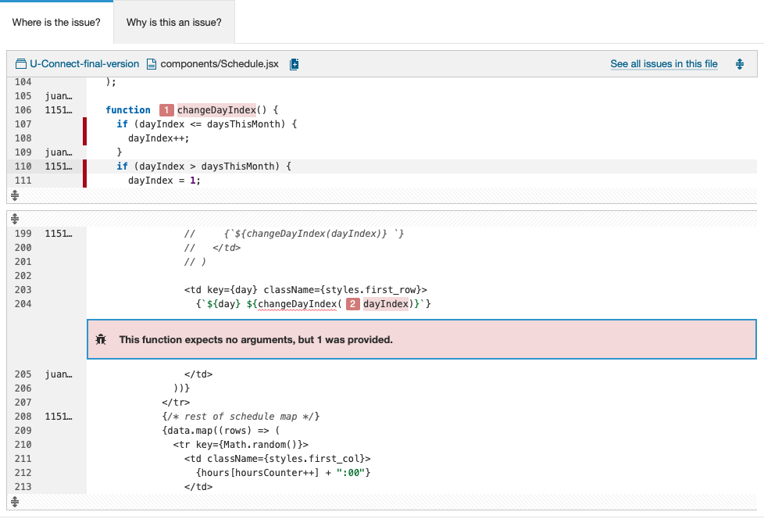

**JoinCounseling.jsx**

**Group.js**

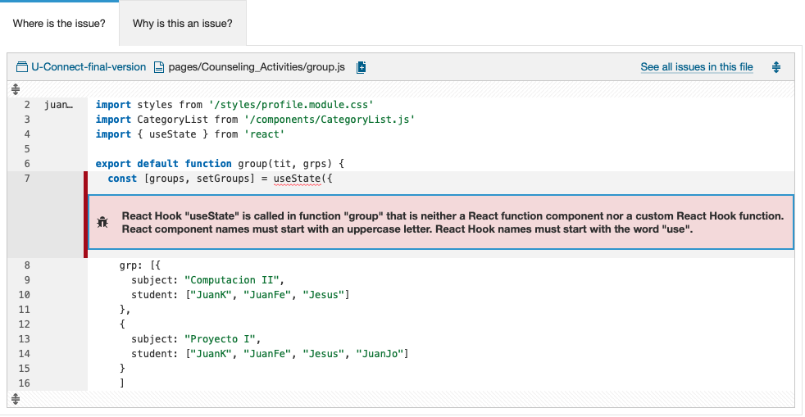

**Home.js**

**Home21.module.css**

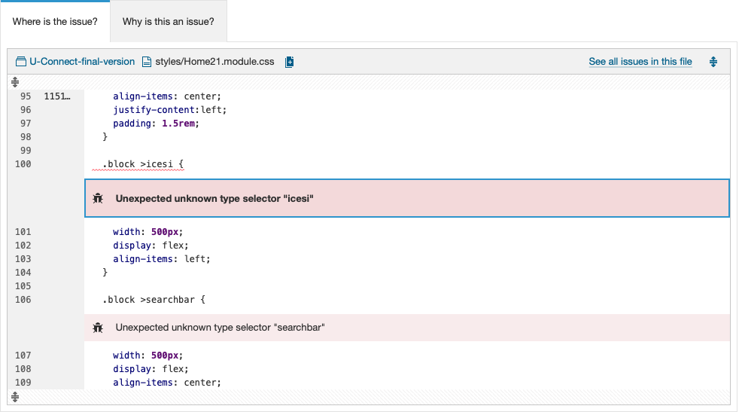

**Schedule.module.css**

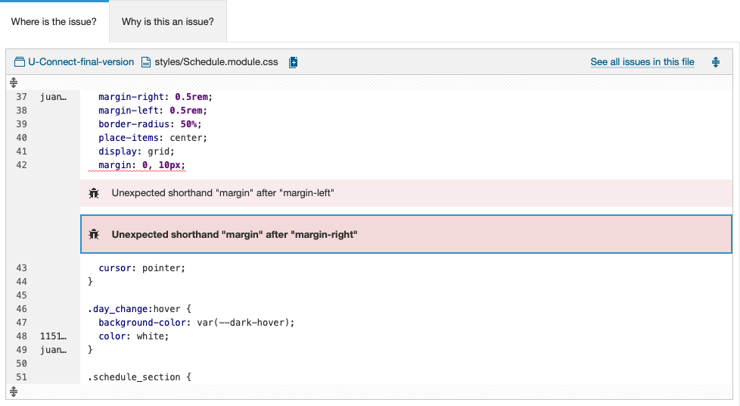

**ScheduleGlobals.css**

**Profile2.module.css**

**Archivos con Security Hotspots**

**Schedule.jsx**

