
COSBench Adaptor Development Guide
Version 2.5.2
April, 2013
Wang, Yaguang
This document describes how to extend COSBench to support new storage systems by developing corresponding adaptors. It depicts the model assumed by COSBench, lists interfaces to be implemented in adaptors, and demonstrates how to adopt new adaptors into the system.
Document Number: 328792-001US
INFORMATION IN THIS DOCUMENT IS PROVIDED IN CONNECTION WITH INTEL® PRODUCTS. NO LICENSE, EXPRESS OR IMPLIED, BY ESTOPPEL OR OTHERWISE, TO ANY INTELLECTUAL PROPERTY RIGHTS IS GRANTED BY THIS DOCUMENT. EXCEPT AS PROVIDED IN INTEL'S TERMS AND CONDITIONS OF SALE FOR SUCH PRODUCTS, INTEL ASSUMES NO LIABILITY WHATSOEVER, AND INTEL DISCLAIMS ANY EXPRESS OR IMPLIED WARRANTY, RELATING TO SALE AND/OR USE OF INTEL PRODUCTS INCLUDING LIABILITY OR WARRANTIES RELATING TO FITNESS FOR A PARTICULAR PURPOSE, MERCHANTABILITY, OR INFRINGEMENT OF ANY PATENT, COPYRIGHT OR OTHER INTELLECTUAL PROPERTY RIGHT. UNLESS OTHERWISE AGREED IN WRITING BY INTEL, THE INTEL PRODUCTS ARE NOT DESIGNED NOR INTENDED FOR ANY APPLICATION IN WHICH THE FAILURE OF THE INTEL PRODUCT COULD CREATE A SITUATION WHERE PERSONAL INJURY OR DEATH MAY OCCUR.
Intel may make changes to specifications and product descriptions at any time, without notice. Designers must not rely on the absence or characteristics of any features or instructions marked "reserved" or "undefined." Intel reserves these for future definition and shall have no responsibility whatsoever for conflicts or incompatibilities arising from future changes to them. The information here is subject to change without notice. Do not finalize a design with this information. The products described in this document may contain design defects or errors known as errata which may cause the product to deviate from published specifications. Current characterized errata are available on request. Contact your local Intel sales office or your distributor to obtain the latest specifications and before placing your product order. Copies of documents which have an order number and are referenced in this document, or other Intel literature, may be obtained by calling 1-800-548-4725, or by visiting Intel's Web Site http://www.intel.com/.
Software and workloads used in performance tests may have been optimized for performance only on Intel microprocessors. Performance tests, such as SYSmark* and MobileMark*, are measured using specific computer systems, components, software, operations and functions. Any change to any of those factors may cause the results to vary. You should consult other information and performance tests to assist you in fully evaluating your contemplated purchases, including the performance of that product when combined with other products. For more information, go to http://www.intel.com/performance.
*Other names and brands may be claimed as the property of others.
Copyright © 2013 Intel Corporation. All rights reserved. Intel and the Intel logo are trademarks of Intel Corporation in the U.S. and other countries.
0413/RJM/MESH/PDF 328792-001US
Contents
1 Introduction 6
2 Glossary 6
3 General Concepts 7
3.1 Overview 7
3.2 APIs 7
3.3 Client 8
3.4 Context 8
4 Auth API 8
4.1 Credential 8
4.2 Interfaces 8
4.2.1 init() 8
4.2.2 dispose() 9
4.2.3 getParms() 9
4.2.4 login() 9
5 Storage API 9
5.1 Interfaces 9
5.1.1 init() 9
5.1.2 dispose() 10
5.1.3 getParms() 10
5.1.4 setAuthContext() 10
5.1.5 getObject() 10
5.1.6 createContainer() 11
5.1.7 createObject() 11
5.1.8 deleteContainer() 11
5.1.9 deleteObject() 11
5.1.10 abort() 12
6 Adaptor Development 12
6.1 Overview 12
6.2 Plug-in Dependencies 12
6.2.1 Third-party Libraries 12
6.2.2 COSBench Bundles 12
6.3 Source Code Structure 13
6.4 Configurations 13
6.4.1 META-INF\MANIFEST 13
6.4.2 META-INF\spring\plugin-context.xml 14
7 Class Diagram and Call Flow 16
7.1 AuthAPI Lifecycle 17
7.2 StorageAPI Lifecycle 18
7.3 AuthAPI and StorageAPI Interaction 19
8 Parameters 19
9 Sample Project 19
10 Deployment 20
10.1 Register Adaptor Bundle 20
10.2 Update Bundle List 21

Revision History
Revision | Date | Description
2.0 | November 9, 2012 | Initial version for v2.0
2.1 | November 22, 2012 | Add diagrams and samples
2.2 | February 19, 2013 | Add deployment section
2.3 | March 18, 2013 | Add section 5.1.10 for “abort” method in storageAPI
2.4 | March 28, 2013 | - Add call flow for authAPI and storageAPI interfaces  - Add explanation for arguments in interface definition  - Reword some sentences
2.5 | April 10, 2013 | - Change folder name from “modules” to “plugins”

Introduction
COSBench is an open-source distributed benchmark tool used to quantify the performance of cloud object storage systems. That data enables users to compare various cloud object stores, evaluate hardware and software stacks, and identify bottlenecks for performance tuning.
Users can get more information about COSBench, download the installation package and other materials, and contribute at https://github.com/intel-cloud/cosbench. For information about installation, configuration, and use of the tool, see the “COSBench User Guide.”
COSBench natively supports OpenStack* Swift and Amplidata AmpliStor* v2.3, v2.5, and 3.1. COSBench is based on a modular, extensible design that includes pre-defined APIs for the development of adaptors to support additional storage systems.
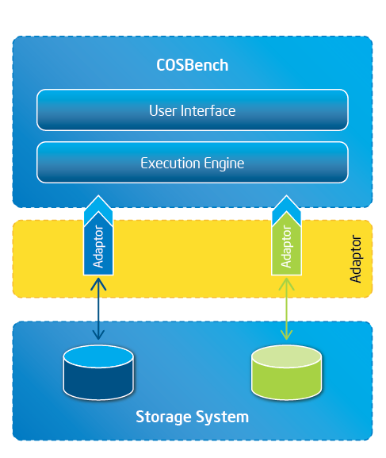
In this document, code samples use the character string “xxx” to represent the version of COSBench being used. In practice, users would substitute the actual COSBench version in place of “xxx” (e.g., 0.3.0).

Glossary
Adaptor: a bundle that implements the Auth API and/or Storage API
API: the interface exposed from COSBench to enable extensibility, currently including the Auth API and Storage API
Bundle (also referred to as OSGi Bundle or plug-in): a JAR file compliant with the Open Services Gateway initiative (OSGi) specification

General Concepts

Overview
The connection of COSBench to a storage system and its basic operation are depicted below; there are three major components:
- API
- Client
- Context
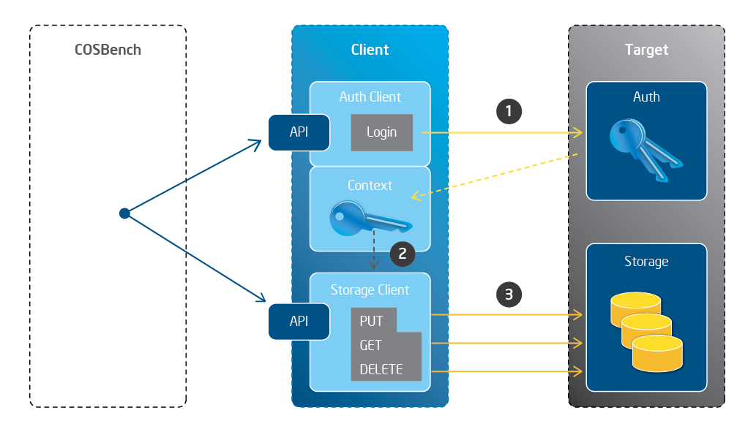
1. COSBench calls Login() through an authentication client using credentials, which are passed to the target authentication server to authenticate the credentials passed in. If authentication succeeds, a corresponding token is returned and stored in authentication context.
2. COSBench calls PUT/GET/DELETE() through the storage client, and the storage client acquires the authentication token from context.
3. After obtaining the token, the storage client makes calls to the target storage server.

APIs
COSBench defines two sets of APIs to adapt new storage systems:
- Auth API, to handle authentication-related work
- Storage API, to handle data-access-related work
The implementation of both APIs can be included in one OSGi bundle or separated into two OSGi bundles. If the authentication mechanism is a general-purpose one such as Open Auth or Kerberos, best practices call for implementing the Auth API in an individual bundle.

Client
Client is a class that encapsulates all interactions with target storage or authentication systems.

Context
Normally, it’s necessary to exchange information between an authentication client and a storage client, such as an authenticated token returned from the authentication system; that token is required by the storage client for subsequent storage operations. That type of shared information is maintained in one context, as a key-value pair.

Auth API

Credential
Credential consists of a parameter list that includes all information related for authentication on a storage client (e.g., username, password, and authentication URL). Different storage systems may use different parameter lists.

Interfaces
public void init(Config config, Logger logger);
public void dispose();
public Context getParms();
public AuthContext login();

init()
/**
* Initializes an <code>Auth-API</code> with parameters contained in the
* given <code>config</code>, whose content depends on the specific Auth
* type. Normally, it will also initialize one client for authentication.
*
* @param config
* - one instance from com.intel.cosbench.config.Config, which
* includes parameters for authentication, and it will be passed
* from execution engine.
* @param logger
* - one instance from com.intel.cosbench.log.Logger, which
* delivers logging capabilities to Auth-API, and it will be passed
* from execution engine.
*/
public void init(Config config, Logger logger);

dispose()
/**
* release the resources held by the Auth API.
*/
public void dispose();

getParms()
/**
* retrieve parameters and current settings used by the AuthAPI.
* @return Context - one com.intel.cosbench.context.Context instance which contains all parameters configured for the authentication mechanism.
*/
public Context getParms();

login()
/**
* trigger backend authentication mechanism.
* @return AuthContext - one com.intel.cosbench.context.AuthContext instance which contains all parameters configured for the authentication mechanism if authentication is successful, and otherwise, an exception will be raised.
*/
public AuthContext login();

Storage API

Interfaces
public void init(Config config, Logger logger);
public void dispose();
public Context getParms();
public void setAuthContext(AuthContext info);
public InputStream getObject(String container, String object, Config config);
public void createContainer(String container, Config config);
public void createObject(String container, String object, InputStream data, long length, Config config);
public void deleteContainer(String container, Config config);
public void deleteObject(String container, String object, Config config);

init()
/**
* Initializes a <code>Storage-API</code> with parameters contained in the
* given <code>config</code>, whose content depends on the specific storage
* type. Normally, it will also initialize one client for storage access.
*
* @param config
* - one instance from com.intel.cosbench.config.Config, which
* includes parameters for authentication, and it will be passed
* from execution engine.
* @param logger
* - one instance from com.intel.cosbench.log.Logger, which
* delivers logging capabilities to Storage-API, and it will be passed
* from execution engine.
*/
public void init(Config config, Logger logger);

dispose()
/**
* release the resources held by the Storage API.
*/
public void dispose();

getParms()
/**
* retrieve parameters and current settings used by the StorageAPI.
* @return Context - one Context instance which contains all parameters configured for the storage.
*/
public Context getParms();

setAuthContext()
/**
* associate authenticated context with Storage API for further storage operations.
* @param info - one AuthContext instance, normally, it's the return from login() in Auth API.
*/
public void setAuthContext(AuthContext info);

getObject()
/**
* download an object from a container.
*
* @param container - the name of a container.
* @param object - the name of an object to be downloaded.
* @param config - the configuration used for this operation.
* @return inputStream - the inputStream of the object content. If null that means the object doesn't
* exist or something bad happened.
*/
public InputStream getObject(String container, String object, Config config);

createContainer()
/**
* create a container.
*
* @param container - the name of a container.
* @param config - the configuration used for this operation.
*/
public void createContainer(String container, Config config);

createObject()
/**
* upload an object into a container.
*
* @param container - the name of a container.
* @param object - the name of an object to be uploaded.
* @param data - the inputStream of the object content.
* @param length - the length of object content.
* @param config - the configuration used for this operation.
*/
public void createObject(String container, String object, InputStream data, long length, Config config);

deleteContainer()
/**
* delete a container.
*
* @param container - the name of a container to be deleted.
* @param config - the configuration used for this operation.
*/
public void deleteContainer(String container, Config config);

deleteObject()
/**
* delete an object.
*
* @param container - the name of a container.
* @param object - the name of an object to be deleted.
* @param config - the configuration used for this operation.
*/
public void deleteObject(String container, String object, Config config);

abort()
/**
* Aborts the execution of an on-going storage operation (HTTP request) if
* there is one. The method expects to provide one approach to abort outstanding
* operation gracefully when the worker hits some termination criteria.
*/
public void abort();

Adaptor Development

Overview
An adaptor is actually an OSGi* (http://www.osgi.org) bundle. A few IDEs support the development of OSGi bundles, and the IDE used for COSBench is Eclipse* SDK 3.7 Indigo (http://www.eclipse.org).
Developing a new adaptor involves following steps:
- Import a few dependencies.
- Set up source code structure.
- Modify configurations.

Plug-in Dependencies

Third-party Libraries
- other libraries needed based on abcStor specific requirements.
- com.springsource.org.apache.commons.codec-1.30.jar
- org.apache.httpcomponents.httpclient_4.1.3.jar
- org.apache.httpcomponents.httpcore_4.1.4.jar
- cosbench-api_xxx.jar
- cosbench-config_xxx.jar
- cosbench-http_xxx.jar
- cosbench-log_xxx.jar

COSBench Bundles
Two primary bundling approaches are supported, corresponding to the two APIs to be implemented. These approaches are illustrated below using the sample bundles abcStor and abcAuth. Other approaches, such as leveraging existing auth or storage bundles, are not included.
- Two in one:
  - abcStor+abcAuth bundle
- One plus one:
  - abcStor bundle (Storage API)
  - abcAuth bundle (AuthAPI)

Source Code Structure
Source code typically makes use of two folders:
- The “api” folder includes all required API declarations, as well as calls to functionalities included in the “client” folder.
- The “client” folder includes storage/auth-specific implementation. Classes in this folder don’t need any COSBench bundles, based on considerations for the following two cases:
- If there is tested code in an adaptor developer site, the developer can put the code into the “client” folder and add the necessary wrapper in “api” to call into it.
- For a fresh, new implementation, the developer can focus on storage-specific implementations in client and build tests based on the contents of this folder, without the involvement of COSBench code or OSGi plug-in-related configurations, simplifying development efforts.
The reference code structure given below uses abcStor as an example; the full abcStor project is stored in the “plugin” folder in the COSBench package.
src
com.abc
api
abcStorage.java
abcStorFactory.java
client
abcStorClient.java
abcStorConstants.java
abcStorClientException.java

Configurations

META-INF\MANIFEST
Below is one sample for the MANIFEST file; adaptor developers must modify this code according to their specific development requirements. Normally, the adaptor developer must review the “Import-Package” list.
Manifest-Version: 1.0
Bundle-ManifestVersion: 2
Bundle-Name: Abc Storage Client Bundle
Bundle-SymbolicName: abc-stor
Bundle-Version: 2.2.0.GA
Bundle-Vendor: Abc Co.
Bundle-RequiredExecutionEnvironment: JavaSE-1.6
Import-Package: com.intel.cosbench.api.auth,
com.intel.cosbench.api.context,
com.intel.cosbench.api.storage,
com.intel.cosbench.client.http,
com.intel.cosbench.config,
com.intel.cosbench.log,
org.apache.commons.codec;version="[1.3.0,2.0.0)",
org.apache.commons.codec.net;version="[1.3.0,2.0.0)",
org.apache.http;version="[4.1.4,5.0.0)",
org.apache.http.client;version="[4.1.3,5.0.0)",
org.apache.http.client.methods;version="[4.1.3,5.0.0)",
org.apache.http.conn;version="[4.1.3,5.0.0)",
org.apache.http.entity;version="[4.1.4,5.0.0)",
org.apache.http.message;version="[4.1.4,5.0.0)",
org.apache.http.params;version="[4.1.4,5.0.0)",
org.apache.http.util;version="[4.1.4,5.0.0)"

META-INF\spring\plugin-context.xml
The sample code below illustrates “one plus one” bundling mode; there are two plug-in projects.
abcAuth
<?xml version="1.0" encoding="UTF-8"?>

<beans xmlns="http://www.springframework.org/schema/beans"
xmlns:xsi="http://www.w3.org/2001/XMLSchema-instance" xmlns:osgi="http://www.springframework.org/schema/osgi"
xsi:schemaLocation="
http://www.springframework.org/schema/beans
http://www.springframework.org/schema/beans/spring-beans-3.0.xsd
http://www.springframework.org/schema/osgi
http://www.springframework.org/schema/osgi/spring-osgi.xsd">

<bean name="authFactory" class="com.abc.api.abcAuth.AbcAuthFactory" />

<osgi:service ref="authFactory" context-class-loader="service-provider"
interface="com.intel.cosbench.api.auth.AuthAPIFactory">
</osgi:service>

</beans>
abcStor
<?xml version="1.0" encoding="UTF-8"?>

<beans xmlns="http://www.springframework.org/schema/beans"
xmlns:xsi="http://www.w3.org/2001/XMLSchema-instance" xmlns:osgi="http://www.springframework.org/schema/osgi"
xsi:schemaLocation="
http://www.springframework.org/schema/beans
http://www.springframework.org/schema/beans/spring-beans-3.0.xsd
http://www.springframework.org/schema/osgi
http://www.springframework.org/schema/osgi/spring-osgi.xsd">

<bean name="storageFactory" class="com.abc.api.abcStor.AbcStorageFactory" />

<osgi:service ref="storageFactory" context-class-loader="service-provider"
interface="com.intel.cosbench.api.storage.StorageAPIFactory">
</osgi:service>

</beans>
The code sample below is for “two in one” bundling mode; there is one plug-in project, and two OSGi services are defined in one plugin-context.xml:
abcStor + abcAuth
<?xml version="1.0" encoding="UTF-8"?>

<beans xmlns="http://www.springframework.org/schema/beans"
xmlns:xsi="http://www.w3.org/2001/XMLSchema-instance" xmlns:osgi="http://www.springframework.org/schema/osgi"
xsi:schemaLocation="
http://www.springframework.org/schema/beans
http://www.springframework.org/schema/beans/spring-beans-3.0.xsd
http://www.springframework.org/schema/osgi
http://www.springframework.org/schema/osgi/spring-osgi.xsd">

<bean name="authFactory" class="com.abc.api.abcAuth.AbcAuthFactory" />

<osgi:service ref="authFactory" context-class-loader="service-provider"
interface="com.intel.cosbench.api.auth.AuthAPIFactory">
</osgi:service>

<bean name="storageFactory" class="com.abc.api.abcStor.AbcStorageFactory" />

<osgi:service ref="storageFactory" context-class-loader="service-provider"
interface="com.intel.cosbench.api.storage.StorageAPIFactory">
</osgi:service>

</beans>

Class Diagram and Call Flow
The following class diagram shows the relationship between classes related to adaptor development.
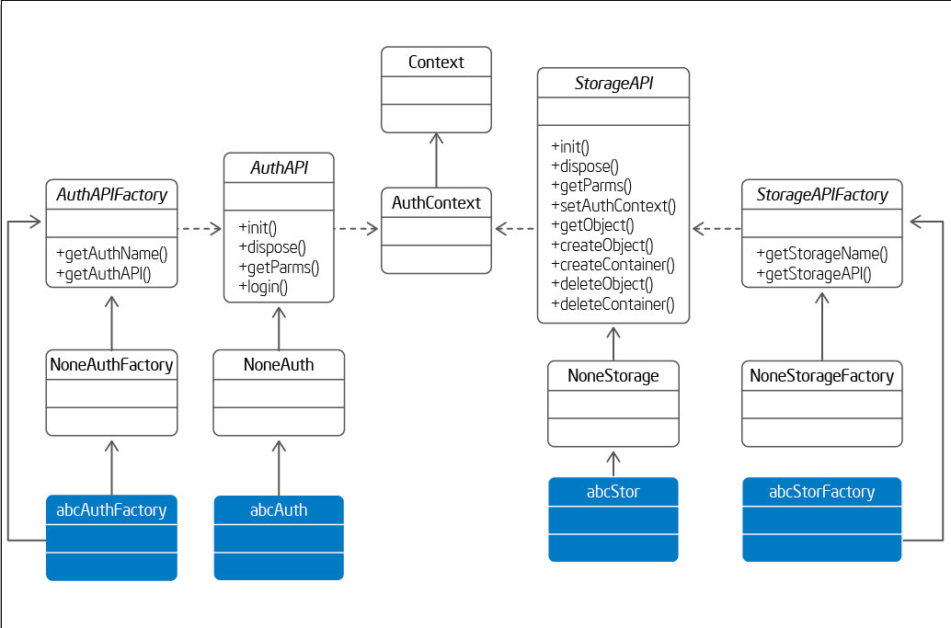

AuthAPI Lifecycle
The sequence for how authAPI (abcAuth) is initialized, performed, and disposed is illustrated below; the procedure is driven by the COSBench execution engine.
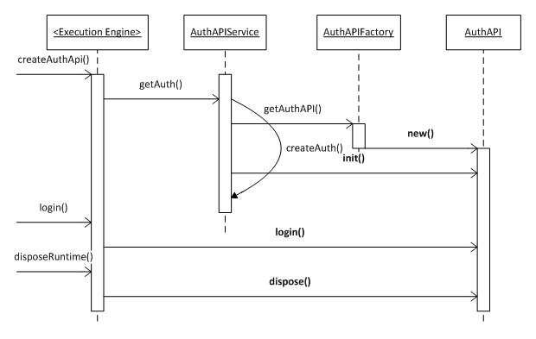

StorageAPI Lifecycle
The sequence for how storageAPI (abcStorage) is initialized, performed, and disposed is illustrated below; the procedure is driven by the COSBench execution engine.
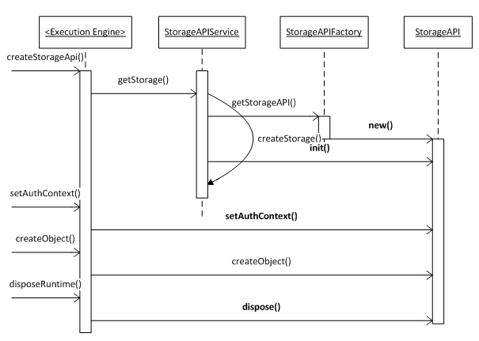

AuthAPI and StorageAPI Interaction
Inside COSBench, the execution engine calls login() on AuthAPI (abcAuth) to authenticate the user; after successfully getting valid auth context, it calls setAuthContext() to pass the returned auth context to StorageAPI (abcStor). At this time, COSBench can issue object-storage-related operations through information from auth context. The flow is illustrated below.
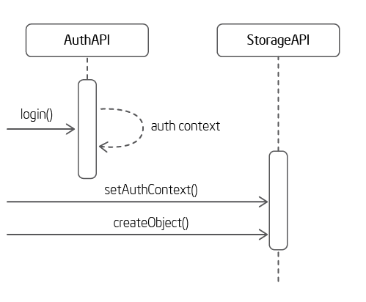

Parameters
A new auth or storage adaptor could require different parameters, and those parameters would be defined in the “config” attribute within the workload configuration file as key-value pairs separated by semicolons, as shown below (using abcAuth as an example):
<auth type="abcauth" config="username=test;password=testing;auth_url=http://192.168.10.1:8080/auth/v1.0;timeout=10000" />
Normally, the parameters will be read in “init()” to help initialize the client.

Sample Project
There is a sample project shipped with the release package within the “ext” folder; one auth sample and one storage sample are included.
libs
com.springsource.org.apache.commons.codec-1.3.0.jar
org.apache.httpcomponents.httpclient_4.1.3.jar
org.apache.httpcomponents.httpcore_4.1.4.jar
plugins
cosbench-api_xxx.jar
cosbench-config_xxx.jar
cosbench-http_xxx.jar
cosbench-log_xxx.jar
adaptor
abc-auth
src
com.abc
api
abcAuth.java
abcAuthFactory.java
client
abcAuthClient.java
abcAuthConstants.java
abcAuthClientException.java
META-INF
abc-stor
src
com.abc
api
abcStorage.java
abcStorFactory.java
client
abcStorClient.java
abcStorConstants.java
abcStorClientException.java
META-INF

Deployment
A few additional steps are needed to deploy adaptor bundles into COSBench.

Register Adaptor Bundle
The OSGi configuration file is located at conf/.driver/config.ini; a new adaptor bundle must register itself in it. Normally, COSBench-related plug-ins are near the end of the file, shown in the following:
plugins/cosbench-castor,\
plugins/cosbench-log4j,\
plugins/cosbench-log@5\:start,\
plugins/cosbench-config@6\:start,\
plugins/cosbench-http@6\:start,\
plugins/cosbench-core@6\:start,\
plugins/cosbench-api@6\:start,\
plugins/cosbench-mock@6\:start,\
plugins/cosbench-ampli@6\:start,\
plugins/cosbench-swift@6\:start,\
plugins/cosbench-keystone@6\:start,\
plugins/cosbench-swauth@6\:start,\
plugins/cosbench-abcstor@6:\start,\
plugins/cosbench-driver@6\:start,\
plugins/cosbench-tomcat@6\:start,\
plugins/cosbench-core-web@6\:start,\
plugins/cosbench-driver-web@6\:start

Update Bundle List
The launch script for the driver—“start-driver.sh”—will check whether the bundle is loaded successfully. In order to ensure that the adaptor bundle is loaded successfully, the script should be modified by updating its bundle list as follows:
OSGI_BUNDLES="cosbench-log_${VERSION} cosbench-tomcat_${VERSION} cosbench-config_${VERSION} cosbench-core_${VERSION} cosbench-core-web_${VERSION} cosbench-api_${VERSION} cosbench-http_${VERSION} cosbench-mock_${VERSION} cosbench-ampli_${VERSION} cosbench-swift_${VERSION} cosbench-abcstor_${VERSION} cosbench-keystone_${VERSION} cosbench-driver_${VERSION} cosbench-driver-web_${VERSION}"

