Building Measurement Agent for TCB – v4

Assumption: For the ease of testing the first build of TCB protection, below steps are assuming that the build would be built on the same host where it would be installed. Need to tweak few steps where we would build the image on build server and would be deployed on a different server.

Note: Steps mentioned below are same for Ubuntu, RHEL & Fedora unless mentioned explicitly.

* Check out the latest code from dev 1.x branch
  + This code is currently copied to \\fmcsssan101\CSSShare\Projects\MysteryHill\Measurement Agent\Build 1
  + Copy this code on the host where we need to enable TCB protection (Ex: /root/MeasurementAgent)
* Modify the permissions for build_components.sh if needed (766)
* Run the build_components.sh with --installpkg option. This will ensure that all the required packages are installed.
  + If in the package installation fails ensure that proper http proxy settings are exported. Logout and log back in.
  + For Fedora / RHEL: Make sure that required packages are available in Intel’s internal repository. If not either add packages to repository or download and install from some external repository

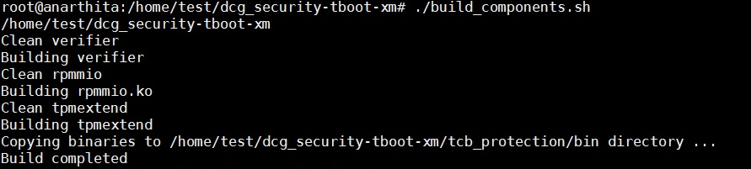

* After the build is successful, the built components are available under the /tcb_protection/bin folder as shown below.

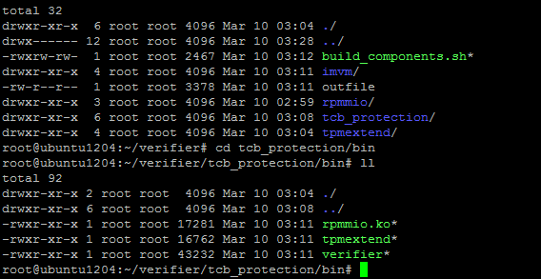

* Go to the /tcb_protection folder. Update the permissions if needed for both the scripts.
* Run the "generate_initrd.sh" script.
* Sample output of the .generate_initrd.sh script

For Ubuntu:

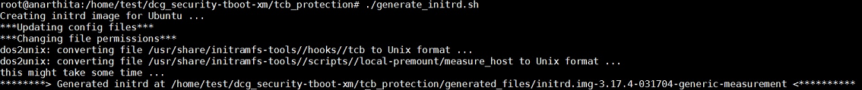

For RHEL (for Fedora it would be almost similar to this):

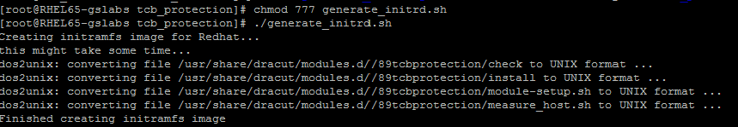

For SUSE:



* "generate_initrd.sh" script would create the new initrd image under the "generated_files" folder.

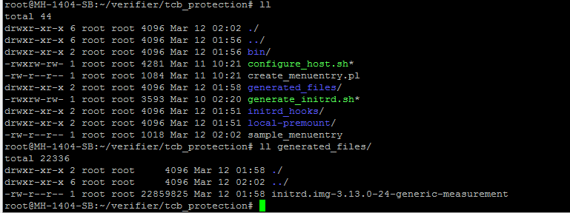

* You can verify if the image was created successfully and having all the Measurement Agent components by running the following command
  + lsinitramfs initrd.img-3.2.0-65-generic-measurement | grep "rpmmio.ko"
* Ensure that the manifest file exists before executing the next step. A sample is show below. It can be modified to add any File or Directory.

<?xml version="1.0"?>

<Manifest digestAlg="sha1">

<File Path="/root/trustagent.env"/>

</Manifest>

* Run the "configure_host.sh" script. As shown in the output below, the script would get the manifest file and grug.cfg file path as input from the user, and creates grub entry in ./sample_menuentry file. It behaves differently based on Grub version used. By default, Ubuntu 12.04+ & Fedora 20+, RHEL 7+ uses grub 2. RHEL 6.x & SUSE11+ uses grub legacy.
* For Ubuntu / Fedora [OS with Grub 2], this script will append generated grub entry in /etc/grub/40_custom file and do update-grub to update grub.cfg automatically.
* Following is the output for Ubuntu [Similar output will get generated for Fedora as well]

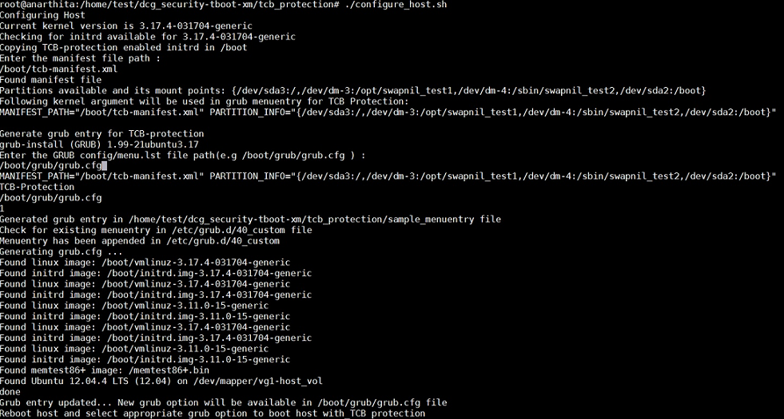

* For RHEL / SUSE [with Grub legacy], this script will append generated grub entry in menu.lst and do update-grub to update menu.lst automatically.
* Following is the output for RHEL[Similar output will get generated for SUSE as well]

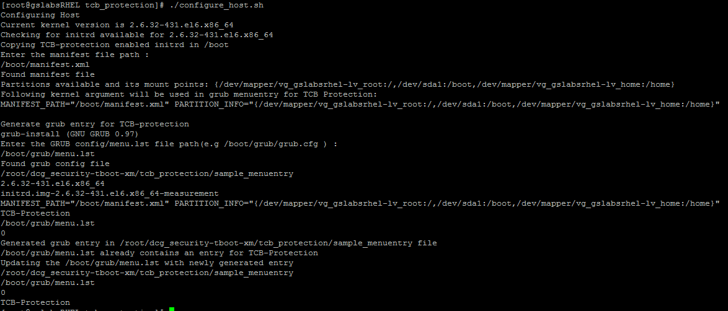

Grub entry for Ubuntu / Fedora (Grub 2) will look like below:

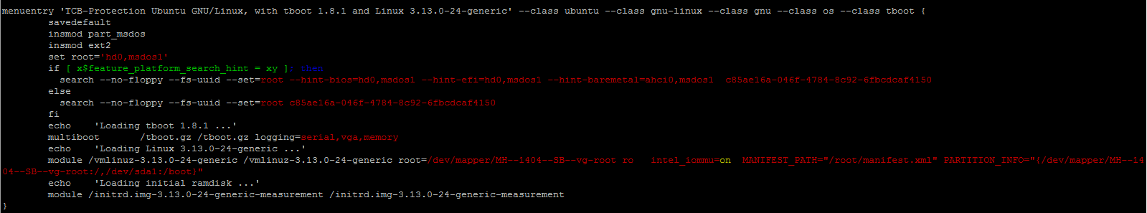

Grub entry for RHEL /SUSE (grub legacy) looks like below:

