Multi-Rail Power Sequencer
and Monitor
Reference Design

Description
The Multi-Rail Power Sequencer and Monitor is a highly parameterizable set of IP blocks that can be customized to meet your power sequencing needs. It controls the enable sequence of up to 143 output rails, can be distributed across multiple Max10 devices to increase the number of monitored channels, and can draw from a mixture of Power Good (POK) inputs as well as monitored voltage rails. The sequencing can be based on voltages reaching a certain threshold as well as timed events, it offers parameterizable levels of glitch filtering on PG or voltage inputs, customizable retry responses, a comprehensive PMBus interface, and numerous other options to tailor the sequencer to the needs of your application.

Overview of the Design Archive
The Multi-Rail Power Sequencer and Monitor archive (Power_Sequencer.zip) contains the following directories:

 <path>/Power_Sequencer
Installation Directory. Contains source, documentation, and top-level Quartus project and constraint files

 docs
Contains documentation for the reference design

 quartus
Contains an example design for a full-featured six-rail sequencer
 source
Contains all design files for the Multi-Rail Power Sequencer and Monitor design.

 sequencer_qsys_tb
Contains simulation support files to simulate the example design using Mentor Graphics® ModelSim® / QuestaSim® simulation tool.

Architecture and Operation
Electronic systems containing FPGAs, CPUs, DSPs and ASICs require specific sequences for the power to be applied to and removed from those devices. The Multi-Rail Power Sequencer and Monitor provides the ability to monitor and correctly sequence up to 144 rails (including monitoring VIN) through normal as well as errored conditions. It accepts any combination of analog voltage and digital Power Good inputs, and maps any ADC input or Power Good signal as any monitored VOUT or VIN rail. These remapped and decoded inputs are passed to the “Sequencer Voltage Monitor” block, which checks and reports the status for power good, undervoltage, overvoltage, alarms, present voltage levels, and so on. The power sequencer design implements a sequential approach when powering up the rails, and powers them down in the reverse order. Information regarding the state of the various rails is provided to the PMBus slave interface. PMBus is a protocol that operates on the I²C physical interface. It is compliant with the PMBus specification revision 1.3.1, available from http://www.powersig.org/, and is capable of operating at both 100KHz and 400KHz modes. The output of the “Sequencer Voltage Monitor” block provides the status used by the “Power Sequencer” block, for enabling and disabling the various power rails.

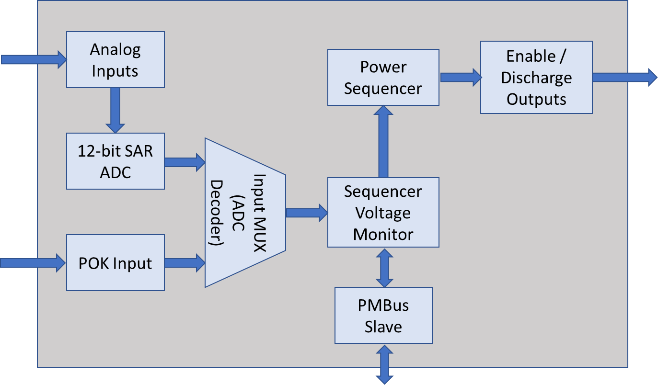
Figure 1: Top-level block diagram

Since the functionality is partitioned into multiple blocks, the user can easily remove any blocks that might not be needed, customizing the sequencer to fit their needs in the most cost-effective implementation. When only a simple sequencer which bases its control on the state of the POK signals is needed, the “Power Sequencer” block (shown below, in the green-shaded area of Figure 2) can be used without any of the other blocks. If voltage rails are being monitored, but PMBus support is not required, the PMBus slave block (shown in the yellow-shaded area of Figure 2) can be removed.

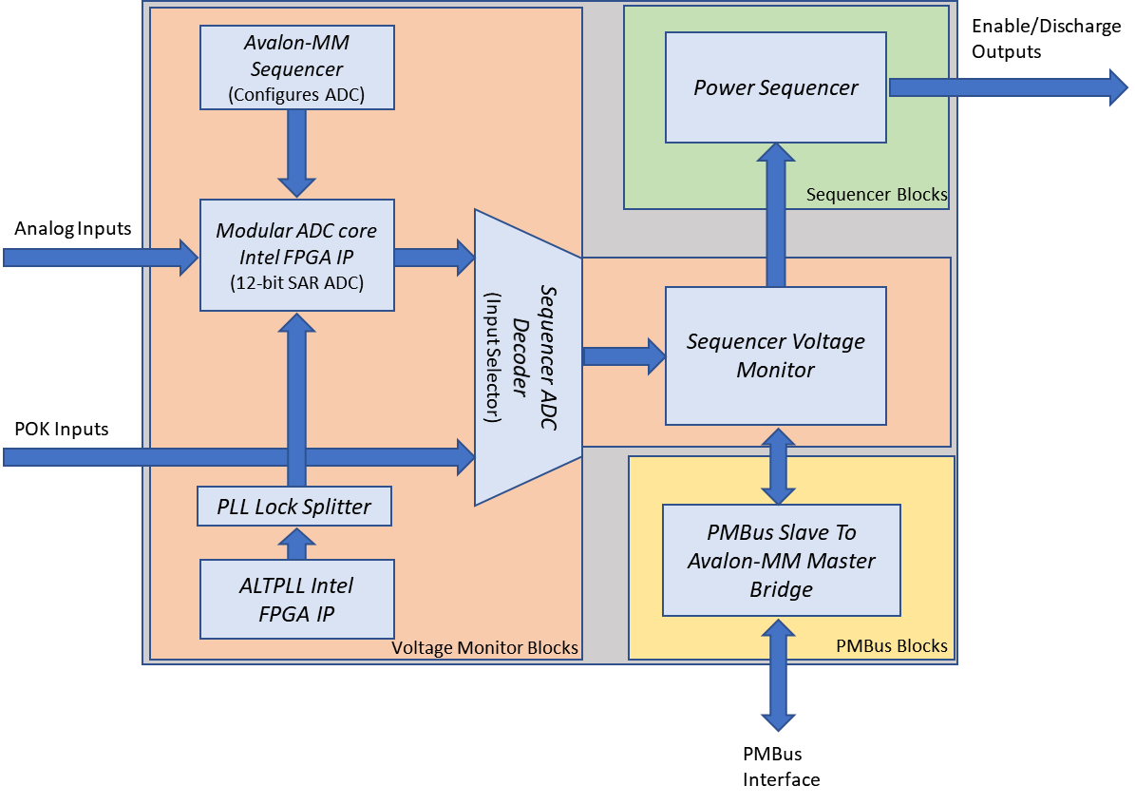
Figure 2: Power Sequencer Design Blocks

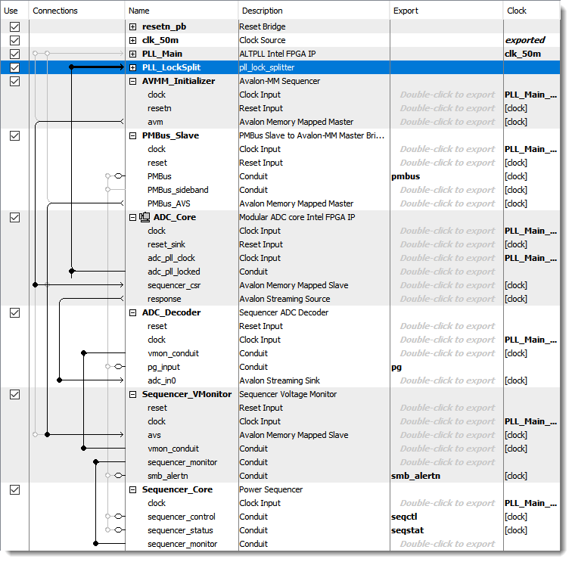

Figure 3: Full-Featured Power Sequencer Design Implementation in Platform Designer

The sections below will show how the blocks are parameterized for the example reference design, why they are parameterized in a given manner, and provide descriptions for alternate configuration options.

12-bit SAR ADC
This standard Intel® IP block for Max10 sequences through the various analog input channels, providing a 12-bit representation of the input voltage level. The SAR has a sampling rate of 1MSPS. It is configured to directly pass the sampled input to a streaming output interface (Standard sequencer with external sample storage), instead of buffering the data internally. For higher accuracy, the external reference voltage should be used. Dual-supply Max10 devices require this to be 2.5V, whereas single-supply devices should have this set at 3.0V or 3.3V. External voltage dividers should be used on the monitored rails with values that maximize the measurement accuracy yet keep thresholds such as the overvoltage fault less than the reference voltage, to ensure that the maximum value of the rail is within the measurement range of the ADC.

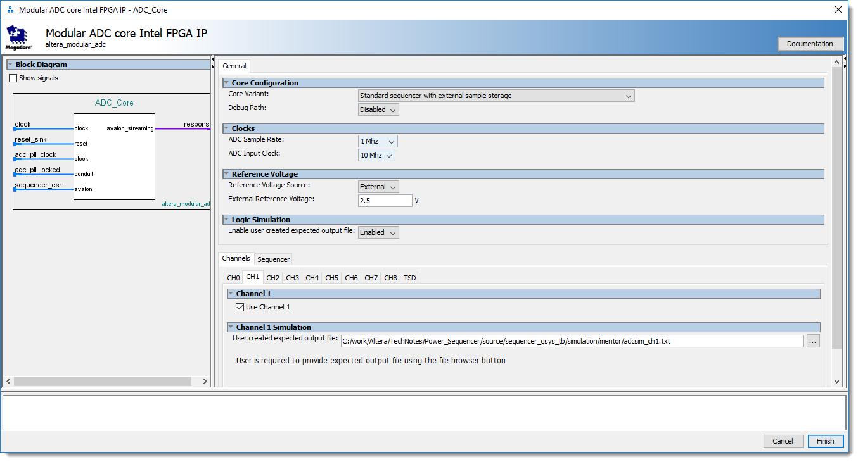
Figure 4: ADC channel configuration

The programmable ADC sequencer has been configured to operate in a round-robin fashion, sequencing through each of the analog inputs:

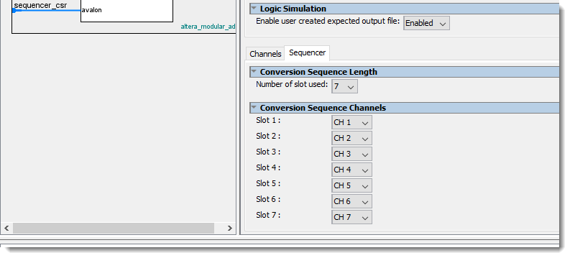
Figure 5: ADC sequencer configuration

Sequencer ADC Decoder
The Sequencer ADC Decoder block decodes up to 16 Avalon Streaming ADC interfaces (each interface can contain voltage levels from up to nine analog input channels, for a total of 144 monitored voltage levels) to sets of voltage level busses. In addition, it allows the designer to map any of the voltage level busses or external POK signals as any monitored VOUT or VIN rail. Configurable options allow the user to specify the number of VOUT rails, the number of ADC interfaces, the number of Power Good (POK) inputs, and how long the Power Good inputs should be debounced. The debouncer passes through the POK signal only once it has been stable for the duration of the debounce interval. There are 28 levels of debounce that can be selected, and the duration of the interval depends on the clock frequency provided to the IP block. The progression of the debounce level is exponential in time, and the GUI calculates its duration only once the IP block’s clock has been connected to the Platform Designer’s system clock. Otherwise, the Clock Frequency will display as 0MHz, and no calculations will be made. For every VIN and VOUT rail, an option is provided to select the “ADC Interface / PG” input, as well as the “ADC/PG Channel”. A unique interface and channel combination should be selected for each rail. When multiple rails are set to the same combination, a warning message will be displayed in the bottom status window, but a system will still be allowed to generate, if that is the desired functionality.

Parameter | Description
Output Voltage Rails | The number of output voltage rails being sequenced. This must match the values specified in the other components, or the interface bus widths between components will not match.
ADC Streaming Interfaces | This provides the Avalon-ST interface from the Sequencer ADC Decoder to the ADC component. A single ADC Max10 has one interface, whereas a dual-ADC Max10 offers two of these Avalon-ST interfaces. If additional Max10 devices are used to monitor voltage inputs, the number of streaming interfaces can be increased accordingly, and they should be exported from the system to allow external interconnect.
Power Good Inputs | The number of Power Good inputs to be monitored. This must match the values specified in the other components, or the interface bus widths between components will not match.
Component’s Clock Frequency | Read-only parameter, specifying the clock frequency of the input clock for the component, as specified by which clock is connected in the Platform Designer system. This value must be correct, or the derived debounce values will not be calculated properly.
Power Good Debounce Setting | The number of clock cycles (2^n) that the Power Good input signal needs to be stable, before it is forwarded downstream.
Power Good Debounce Interval | Duration in µs for which the Power Good input needs to be stable. This value cannot be calculated when the input clock rate is unknown or unconnected to a clock signal.
ADC Interface Number / PG | Specifies which Avalon-ST ADC interface is transmitting the voltage level for the given rail, or whether the Power Good (PG) signal will be used to control a particular rail.
ADC / PG Channel | Defines which physical ADC channel (ADC0 - ADC8), or Power Good (PG) input bit should be mapped to a particular rail.
Table 1: Sequencer ADC Decoder Configuration Table

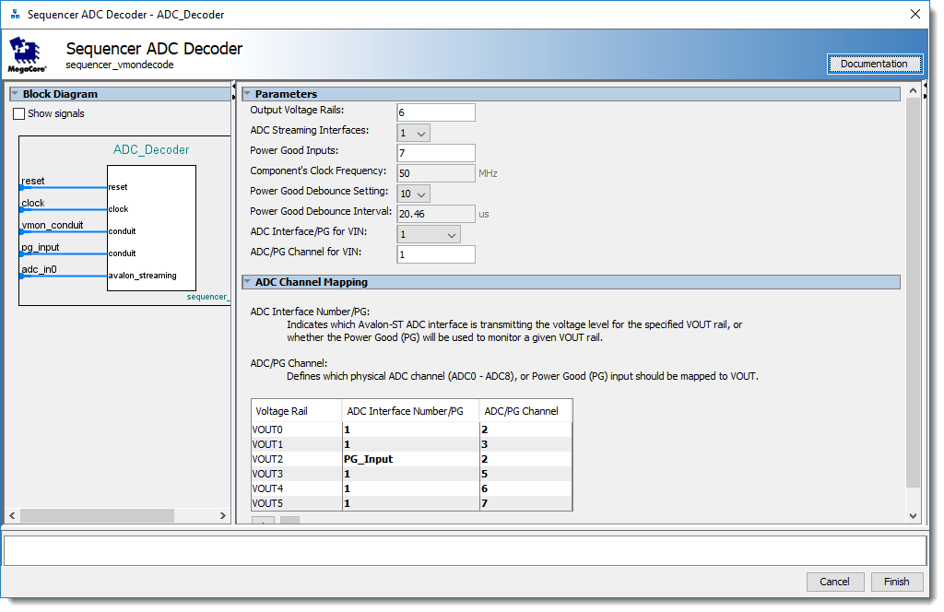
Figure 6: Sequencer ADC Decoder GUI

Sequencer Voltage Monitor
The Sequencer Voltage Monitor performs two primary functions: it monitors the voltage levels provided by the ADC inputs, providing status and alerts via PMBus communication, and creates Power Good (POK) signals that can be used by the Power Sequencer to appropriately power up and down the various VOUT rails. There are several configurable parameters for this IP block. In order that it may properly interface to the Sequencer ADC Decoder, the number of “Output Voltage Rails” as well as “Power Good Inputs” should be accurately specified.

Parameter | Description
Output Voltage Rails | The number of output voltage rails being sequenced. This must match the values specified in the other components, or the interface bus widths between components will not match, causing an error.
Power Good Inputs | The number of Power Good inputs to be monitored. This must match the values specified in the other components, or the interface bus widths between components will not match, causing an error.
ADC Reference Voltage | Used to calculate the various power good, undervoltage, and overvoltage thresholds for comparing to the ADC output.
Functionality Level | This option allows the user to optimize the desired functionality and reduce the overall logic footprint of the design. Please refer to Section 9: Resource Utilization for logic utilization estimates of some example configurations.
- No PMBus | Design uses the hard-coded levels specified in the GUI. No dynamic adjustment or monitoring via PMBus is available.
- Hard-Coded Thresholds | The PMBus slave interface is present for fault and status monitoring, but voltage level thresholds cannot be dynamically adjusted.
- Full-featured | Design contains the full PMBus command set for dynamic adjustment, status, and error monitoring, described in Section 6: PMBus Command Description.
ADC Samples to Check | Number of contiguous ADC samples for a given input to check, before declaring a warning or fault (overvoltage, undervoltage, power good, etc.).
Retry Attempts | The number of attempts the sequencer should make to fully sequence back up (following a complete, controlled sequence down), after detecting an error condition.
Timeout Interval on Retry | The delay interval that the sequencer will wait between retries. The option allows the user to select either no delay, or the delay specified within the sequencer block.
VIN/VOUT Typical Voltage, Monitored | The typical voltage level, expected to be observed at the ADC analog input. This should take into account whatever voltage divider circuitry has been implemented on the board.
VIN/VOUT Overvoltage Fault | Voltage level at which the voltage monitor should declare an overvoltage fault. This is expressed as a percentage of the typical voltage level specified for the voltage rail above. The calculated voltage level will be displayed in the “Derived Thresholds” section of the GUI, and should not exceed the ADC Reference Voltage Level. This will be converted internally to PMBus DIRECT mode in the associated PMBus register.
VIN/VOUT Overvoltage Warning | Voltage level at which the voltage monitor should declare an overvoltage warning. This is expressed as a percentage of the typical voltage level specified for the voltage rail above. The calculated voltage level will be displayed in the “Derived Thresholds” section of the GUI, and should not exceed the ADC Reference Voltage Level.
VIN/VOUT Undervoltage Warning | Voltage level at which the voltage monitor should declare an undervoltage warning. This is expressed as a percentage of the typical voltage level specified for the voltage rail above. The calculated voltage level will be displayed in the “Derived Thresholds” section of the GUI, and should not exceed the ADC Reference Voltage Level.
VIN On/VOUT Power Good Assertion Level | Voltage level at which the voltage monitor determines that the monitored input rail is good, and at a level at which it should start sequencing the output rails up, or, if monitoring an output rail, that the output voltage of the rail is OK and that the next rail can be sequenced. This is expressed as a percentage of the typical voltage level specified for the voltage rail above. The calculated voltage level will be displayed in the “Derived Thresholds” section of the GUI, and should not exceed the ADC Reference Voltage Level.
VIN/VOUT Undervoltage Fault | Voltage level at which the voltage monitor should declare an undervoltage fault. This is expressed as a percentage of the typical voltage level specified for the voltage rail above. The calculated voltage level will be displayed in the “Derived Thresholds” section of the GUI, and should not exceed the ADC Reference Voltage Level.
VIN Off/VOUT Power Good Dessertion Level | Voltage level at which the voltage monitor determines that the monitored input rail is not good, and at a level at which it should start sequencing all rails down, or, if monitoring an output rail, that the output voltage of the rail is not OK and that it should start sequencing all rails down. This is expressed as a percentage of the typical voltage level specified for the voltage rail above. The calculated voltage level will be displayed in the “Derived Thresholds” section of the GUI, and should not exceed the ADC Reference Voltage Level.
Overvoltage Faults cause controlled sequence down | When enabled, the sequencer sequences all rails down according to the fault response, in the presence of an overvoltage fault.
Undervoltage Faults cause controlled sequence down | When enabled, the sequencer sequences all rails down according to the fault response, in the presence of an undervoltage fault.
Table 2: Sequencer Voltage Monitor Configuration Table

In order to suppress spurious errors that might be caused by noise on monitored voltage rails, error and warnings are debounced via the “ADC Samples to Check” setting in the GUI. For a warning or error to be reported, it must be present for the specified number of samples. The duration of that interval is dependent on the sample rate, as well as the configuration of the sequencer in the ADC. For example, the ADC in Figure 5 is configured in a round-robin fashion, and it reports the voltage levels for each channel in sequence, over seven timeslots. If the sample rate is 1MSPS and the voltage monitor is checking that five samples exceed the threshold before declaring a given warning or error, then the warning or error must be present for 1us * 7 * 5 = 35us.

Please note that the “Retry Attempts” and “Timeout Interval on Retry” are global settings. They can be dynamically controlled via the subset of PMBus commands that affect any of the VIN or VOUT error responses, and changing any of these values effects a change across all registers.

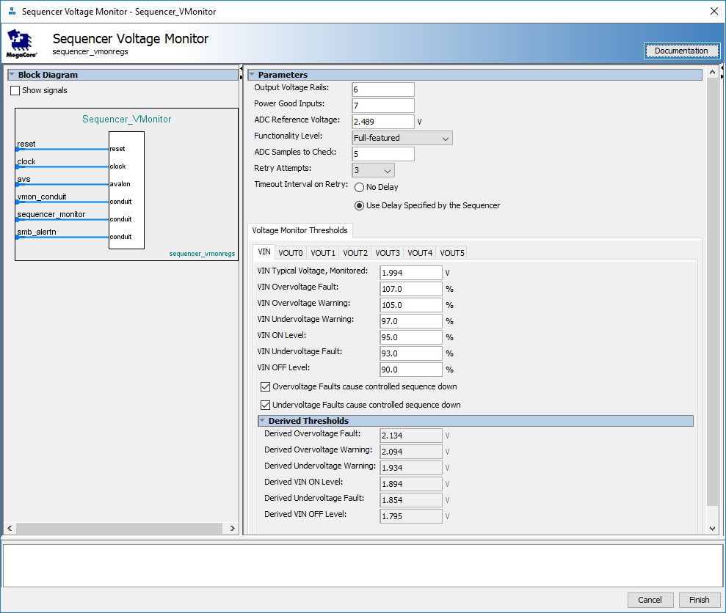
Figure 7: Sequencer Voltage Monitor GUI

If a rail is monitored by an ADC VIN pin, its Power Good status (which is later on used by the Power Sequencer block to sequence the rails or power groups up/down) is determined either by the levels set in the default configuration of the Sequencer Voltage Monitor within Platform Designer, or the dynamically modified levels set through the PMBus interface. The PMBus commands VIN_ON and VIN_OFF dynamically adjust the levels at which Power Good is asserted or deasserted for VIN, and the commands POWER_GOOD_ON and POWER_GOOD_OFF dynamically adjust the levels at which Power Good is asserted or deasserted for VOUT. The other thresholds (undervoltage warning and fault, and overvoltage warning and fault) provide a comprehensive monitoring approach to safely track all input and output voltages, and allow the designer to automatically or manually sequence the rails down in case of an error.

As seen in Figure 7 above, as the rails voltage ramps up, it can pass through one of six possible voltage thresholds. Here are the default settings, based on the typical expected voltage for that rail:
Overvoltage Fault (107%)
Overvoltage Warning (105%)
Typical (100%)
Undervoltage Warning (97%)
Power Good On (95%)
Undervoltage Fault (93%)
Power Good Off (90%)

Once the voltage rail is enabled by the sequencer and its level rises, it will transition through the Undervoltage Fault region, and into Power Good. All voltage faults for a given rail are masked when Power Good is not asserted, so this portion of the ramp up cycle will not be considered a fault. Once the Power Good level is attained, the rail will still be in a state where Undervoltage Warning is reported. This is normal and expected, and the PMBus may report undervoltage warnings for some of the rails (depending on ADC sample rates and the rise time of the rail). Once the rail reaches its nominal voltage, simply sending the “CLEAR_FAULTS” command will clear out any latched warnings in the VOUT status registers, which can safely be ignored. At this point, the sequencer should be in a normal operation state. If the rail drifts outside the typical operating range for longer than the “ADC Samples to Check” duration, overvoltage or undervoltage warnings will be reported, causing the SMB_ALERTN pin to be asserted. If no other devices are asserting SMB_ALERTN at this time, the page associated with the warning will also assert STATUS_OTHER bit 0: “First to Assert SMBALERT#”. This can be used to indicate which rail was first to experience an error. If it exceeds the levels for an overvoltage or undervoltage fault for longer than the “ADC Samples to Check” duration, the sequencer will behave according to the programmed response.

Independent checkboxes for each rail allow for a controlled, automatic sequence down in case of overvoltage or undervoltage faults. These responses can dynamically be adjusted with the PMBus commands for VIN_OV_FAULT_RESP, VIN_UV_FAULT_RESP, VOUT_OV_FAULT_RESP, and VOUT_UV_FAULT_RESP. There are four different behaviors supported by the sequencer for a fault. The sequencer can ignore that fault and continue operation, it can sequence down immediately, it can retry for a selectable number of times from 1 to 6 attempts, or it can retry indefinitely. The Power Sequencer will not retry until all Power Good signals for the VOUT rails are deasserted. There is also a programmable delay setting (labeled “Delay Time Between Restarts” and set within the Power Sequencer parameters), which can be enabled to cause the sequencer to wait between retry attempts. This timer is started after the Power Good signals are deasserted.

If a rail uses an external Power Good signal (typically a POK output from a power supply) and the rail is not monitored by the ADC VIN, that signal is passed directly to the sequencer and no PMBus-accessible monitoring or adjustments for that rail can be performed.

PMBus Slave Interface

When the PMBus interface is enabled, each rail can be monitored on its own page, provided that its level is measured by an ADC VIN pin. VOUT rails are numbered sequentially starting at 0, such that a six rail sequencer will expect to have rails VOUT0 through VOUT5. Rail 0 (VOUT0) will be observed on page 0, rail 1 (VOUT1) will be observed on page 1, and so on. VIN is a special case – the input supply is observed on all pages, and clearing an input fault on one page will clear the fault on all pages, since those status registers are simply mirrored across all pages. If a rail is not monitored by an ADC pin (i.e. it is using an external Power Good signal, such as the POK signal from the regulator), that page is not considered to be a valid page and attempting to change to that page will cause a PMBus error to be reported to the STATUS_CML register, bit 6 (Invalid or unsupported data received). If the only rail being monitored is VIN, and all VOUT rails use external Power Good indicators, VIN will be present on page 0, and all commands relating to VOUT will result in a PMBus error to be reported to the STATUS_CML register, bit 7 (Invalid or unsupported command received). Likewise, if VIN is not monitored, all commands relating to VIN will result in a PMBus error to be reported to the STATUS_CML register, bit 7 (Invalid or unsupported command received). The PMBus interface does not support a page setting of 0xFF. It only allows for pages that correspond to a monitored VIN rail (page 0), or monitored VOUT rails.

If PMBus functionality is not required, this component can be removed from the design.

Power Sequencer
The Power Sequencer block implements the decision-making state machine and delay timer for sequencing the output rails. It is a stand-alone block, and can provide the most minimal implementation if voltage rail monitoring and PMBus control is not required. It makes its sequencing decisions based upon the levels of the Power Good inputs, and provides enable and discharge outputs to the power modules. The following configuration options are available:
Parameter | Description
Output Voltage Rails | The number of output voltage rails being sequenced. This must match the values specified in the other components, or the interface bus widths between components will not match.
Component’s Clock Frequency | Read-only parameter, specifying the clock frequency of the input clock for the component, as specified by which clock is connected in the Platform Designer system. This value must be correct, or the timer values will not be calculated properly.
Combine rails into groups | Group power rails with common enable signals, and individual Power Good status signals. The Power Good status signals from all rails within the group are combined, to affect the enable signal.
Number of Power Groups | Number of power groups implemented by the sequencer. There will be one set of enable/discharge outputs per group.
Sequencer Delay (PG to next OE) | Defines the delay from when the master enable is asserted before output enable is asserted, or from when Power Good is asserted until the next rail or group's output enable is asserted. A value of "0ns" will bypass this delay. Units can be specified as s, ms, us, and ns (e.g. 1ms).
Qualification Window (OE to PG) | Defines the qualification window for which Power Good must be asserted, after output enable is asserted. If this time is violated, a fault will be indicated and the power rails will sequence down in reverse order. Units can be specified as s, ms, us, and ns (e.g. 10ms).
Power Group Number | Defines which power group number (starting from '0') the rail belongs to. All rails with the same group number should use the same enable/discharge signal, and their Power Good signals will be evaluated (ANDed) together.
Delay Time Between Restarts | Define the delay interval between restart attempts for the sequencer. Units can be specified as s, ms, us, and ns (e.g. 100ms).
Maximum Specified Delay in Table Above | Displays the maximum delay from all parameterizations. This is a derived value, shown for reference, but is passed to the design to accurately size counters.

Table 3: Power Sequencer Configuration Table

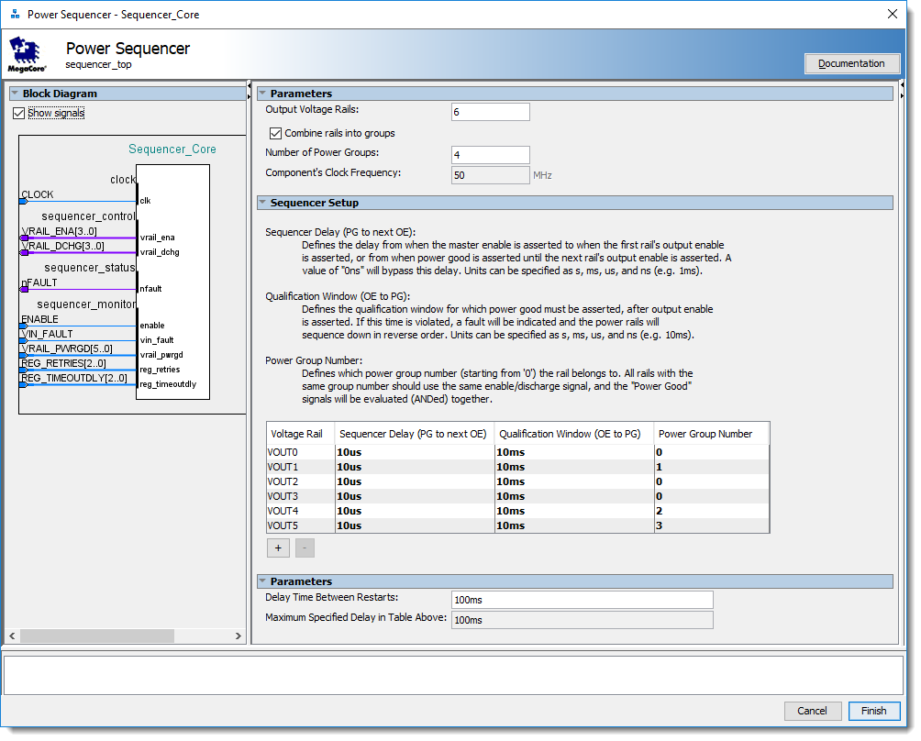
Figure 8: Power Sequencer GUI

If multiple rails should be enabled or disabled simultaneously, they can be combined into a single group. Groups with the same “Power Group Number” will have their Power Good signals ANDed together, and will share the same enable and discharge output. Power rails within the same group must have the same values for "Sequencer Delay" and "Qualification Window", or a warning message will be issued by Platform Designer. When power groups are not enabled, the “Power Group Number” column in the table is set to read-only, and each VOUT rail has its own unique power group number. For example, in Figure 8: Power Sequencer GUI, the rails for VOUT0, VOUT2, and VOUT3 will share the same enable, and will ramp up together. Once the Power Good input for all of those rails is high (and occur within the 10ms qualification window), the enable for VOUT1 will be asserted (following a 10us delay). Once the Power Good input for VOUT1 is high (and occurs within the 10ms qualification window), the enable for VOUT4 and VOUT5 will be asserted (following a 10us delay). After the Power Good input for both VOUT4 and VOUT5 is high (within the 10 ms qualification window), the sequencer will have fully ramped up all six rails in three power groups. Please note that the delay between when rails are sequenced will not only depend on the value of “Sequencer Delay”, but any additional delay caused from the debouncing of Power Good inputs or how many ADC samples are checked in the Sequencer Voltage Monitor block. The total delay will be the sum of the two delays.

When the Power Sequencer is in a normal operational state and all of the rails are enabled, if a Power Good signal from one of the VOUT rails becomes deasserted, the sequencer will immediately assert nFAULT and gracefully sequence down. If retries are enabled, the sequencer will wait for all Power Good signals to be asserted, wait the delay time between retries, and attempt to sequence back up. At this point, nFAULT will automatically be cleared. If the failure persists, nFAULT will continue to toggle in a similar fashion until the maximum number of retries has been reached (unless the retries are set to “Infinite”), at which point nFAULT will remain asserted. Once the maximum number of retries has been exhausted, the only way to reset the sequencer is to either toggle the ENABLE signal, or use a PMBus command to increase the number of retries.

Design components not specified above
A few other custom blocks are included in the design that are not listed in the sections above. They will be briefly described here, but they serve supporting roles and do not require parameterization.

The PLL Lock Splitter receives the “pll_locked” signal from the PLL, fanning it out to the reset logic as well as the ADC PLL Locked input. All blocks within the sequencer are held in reset until the PLL is stable and has locked.

The Avalon-MM Sequencer generates the required control-plane commands to initialize the ADC for use. This is required if the ADC will be used to monitor voltage rail levels (as opposed to a power-sequencer only design that only used POK signals from the power regulators).

☞ | The Avalon-MM sequencer expects the ADC interface to reside at a base address of 0x00. If this is not the case, the avmm_sequencer_pkg.sv file should be adjusted to write the initialization command to the proper address offset.

Data Formats For The Output Voltage And Output Voltage Related Parameters
All data for the input or output voltages for current status, warning levels, or error levels is stored in the DIRECT format, as defined by the PMBus™ Specification. Coefficients will be determined by the user, are specific to each voltage rail for every page, and are based upon the voltage scaling resistors used in the design.

The ADC in dual supply MAX 10 devices can measure from 0 V to 2.5 V, with 12 bits of resolution. In single supply MAX 10 devices, it can measure up to 3.0 V or 3.3 V, depending on your power supply voltage. Appropriate values for the voltage divider must be chosen, in order to provide a sufficiently large scale that retains enough resolution for accurate measurements

For example on 3.3V input, if I want to set my OV_Fail at 115%, I would need to measure a range of 0-3.8V. We will also assume that an external reference voltage (ADC_VREF) of 2.5V is used, and the following voltage divider is applied to the monitored voltage rail:

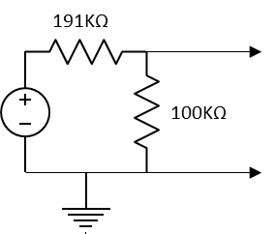
Figure 9: Example Voltage Divider on 3.3V rail

☞ | When using the Platform Designer GUI, all of the calculations below are automatically made for you. This description is provided to show how the settings and reported values relate to the PMBus™ Specification. You just need to ensure that the output of the voltage divider will not exceed ADC_VREF for an overvoltage condition.

Given the DIRECT format definition of

X = 1/m (Y × 10^{−R} − b)

Where:
X, is the calculated, “real world” value in the appropriate units (A, V, °C, etc.);
m, the slope coefficient, is a two byte, two’s complement integer;
Y, is a two byte two’s complement integer received from the PMBus device;
b, the offset, is a two byte, two’s complement integer; and
R, the exponent, is a one byte, two’s complement integer.

We can determine our coefficients for the above, knowing that:
X = Y/4096 × 2.5V × (191KΩ + 100KΩ) / 191KΩ
X = Y × 9.29907 × 10⁻⁴
X = 1/1075.375945 × Y

Using the 16 bits of resolution available for m, we obtain the following constants:
m = 10753
b = 0
R = -1

Therefore, if we read back a value of 3549 when sending the READ_VOUT command, we simply need to apply the constants to the formula and solve
X = 1/10753 (3549 × 10¹ − 0)
X = 3.300

Opening and Customizing the Design Example
The power sequencer archive contains a design example that has been configured to control six ADC-monitored voltage rails. It also contains seven Power Good inputs (one for each VOUT rail, as well as VIN), but none of them are used; the ADC voltage monitors are used to control the sequencer. It is a full-featured configuration that includes PMBus support, but can be customized to fit the design requirements for your system. The following steps should be taken, in order to compile the design.

- Open …/quartus/Sequencer.qpf from Quartus to load the example project.

- Once the project has loaded, we need to open the Platform Design system. This should be done within the File -> Open window. Browse back to the “../source” directory, and select the sequencer_qsys.qsys file. (Do not select the sequencer_qsys_tb.qsys – that is the simulation testbench)

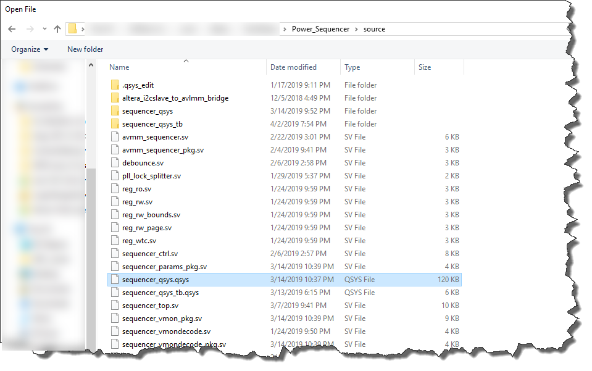
Figure 10: File location for Platform Designer source

- Customize the various IP parameterizations, according to the requirements of the system. Many of the IP blocks have built-in error checks to prevent you from generating invalid code. Be sure to check the message window for any interface mismatches between components, or potentially incorrect settings.

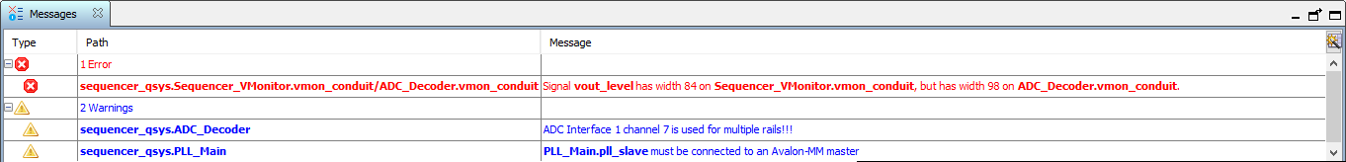
Figure 11: Platform Designer messages window

Note –the reference clock frequency is defined as 50MHz in the example project. If this changes, you need to adjust the inclk0 frequency for the “PLL_Main” block in the design to the new reference clock frequency:
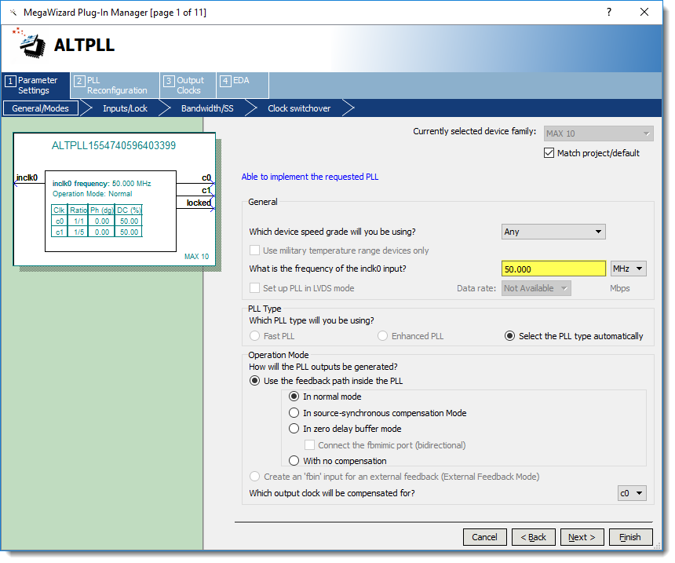
Figure 12: PLL_Main settings in Platform Designer

- Once changes have been completed, click the “Generate HDL…” button. This will open a dialog box, allowing you to generate the customized code for the sequencer design.

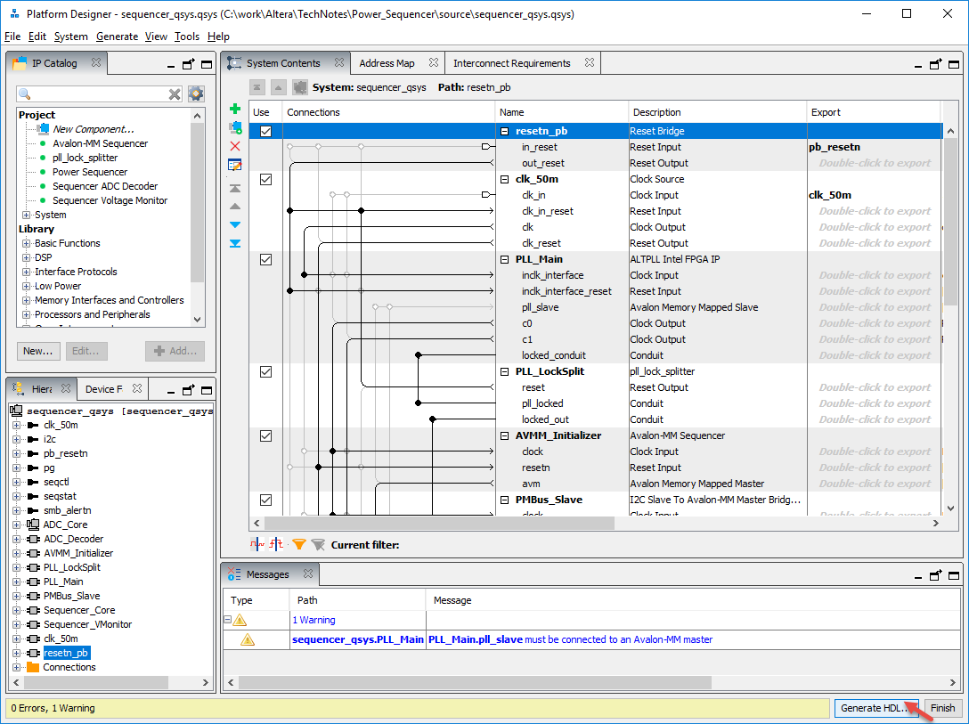
Figure 13: Platform Designer HDL generation

- In the window that pops open, ensure that the Synthesis options are set to create HDL files in either VHDL or Verilog, and that the .bsf symbol is created. Click “Generate”. Note – there are three files in the source directory that must be writable and should not be placed under version control. They are named “sequencer_params_pkg.sv”, “sequencer_vmon_pkg.sv”, and “sequencer_vmondecode_pkg.sv”. These files are automatically regenerated during this step with the parameterizations specified in the Platform Designer GUI. If the files cannot be written, they may not be accurately parameterized.

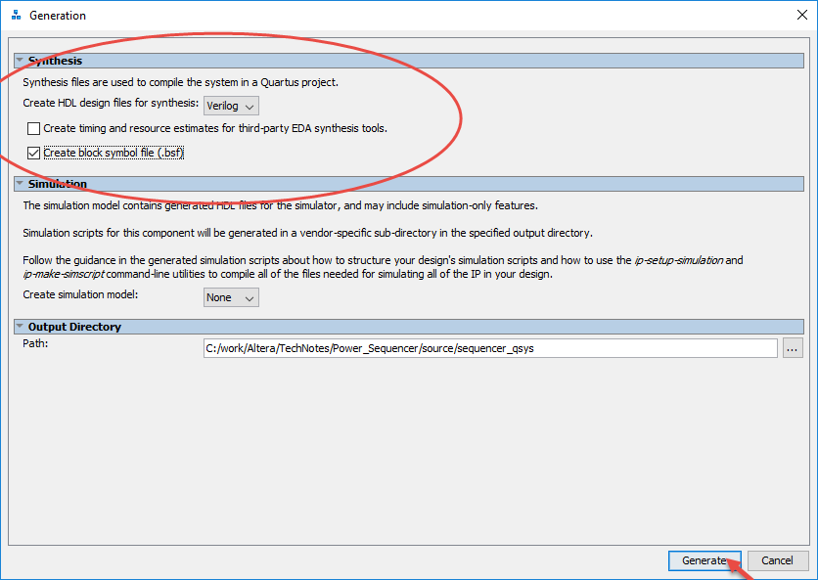
Figure 14: Platform Designer HDL generation dialog window

- Now all of the code for the sequencer has been generated. If any changes have been made that affect the top level, the top-level schematic will need to be updated accordingly, to match those customizations. For example, if the PMBus is removed, the SMB_SCL and SMB_SDA signals will need to be removed as well. If the number of rails is increased or decreased, the widths of the VRAIL_POK, VRAIL_ENA, and VRAIL_DCHG signals will need to change accordingly. In order to update the sequencer’s symbol, right-click and select “Update Symbol or Block…”
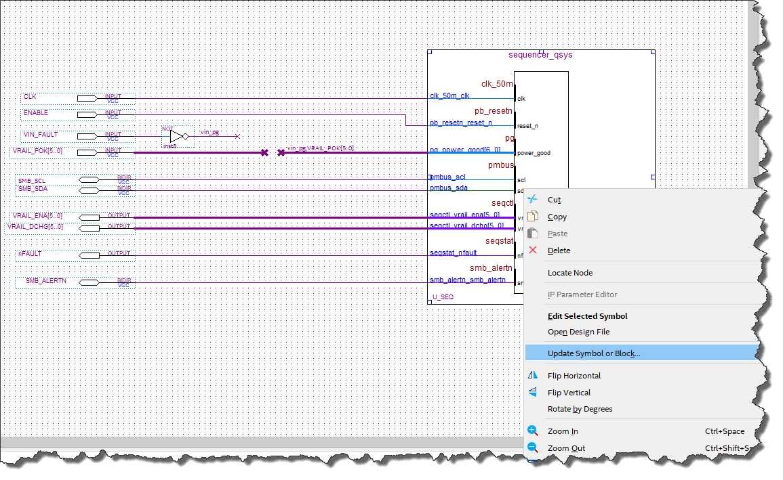
Figure 15: Updating symbol in top-level schematic for sequencer component

Once the symbol has been updated with the changes to the Platform Designer system, the PMBus interface is removed, and the bus widths for the VRAIL_ENA and VRAIL_DCHG signals have decreased from 6 to 4 bits. The top-level schematic needs to be updated to reflect these changes as well.

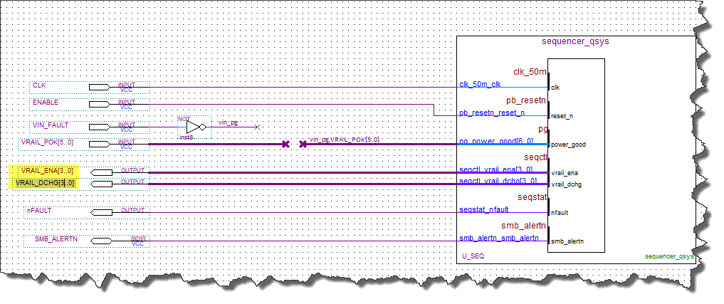
Figure 16: Correcting the I/O connections in top-level schematic

- Select the appropriate target device.

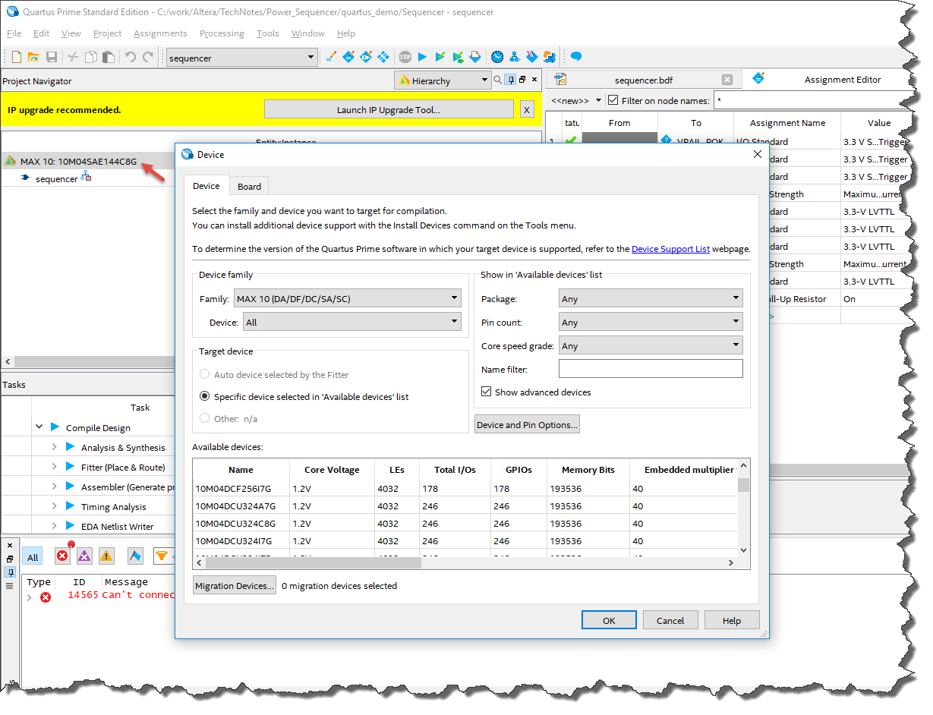
Figure 17: Choosing the target device in Quartus

- Assign pins, using the pin planner (in the pulldown menu Assignments -> Pin Planner). Simply drag pin names from the spreadsheet in the bottom pane of the Pin Planner window to the pin location on the physical representation of the device in the middle pane, or type the pin number into the location column.

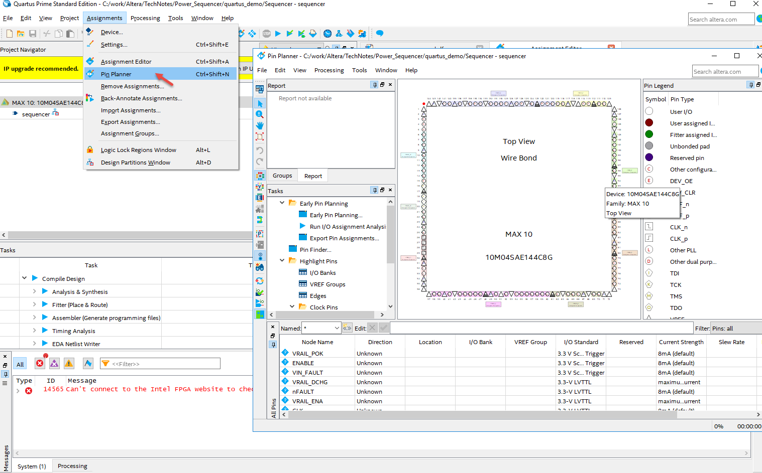
Figure 18: Assigning pins in Quartus

- If the reference clock frequency to the PLL had changed in Platform Designer, you need to adjust the timing constraint for this input in the Sequencer.sdc file. Search for the line:
create_clock -name clk_ref -period 50.0MHz [get_ports {clk}]
If the reference clock were to change from 50MHz to 25MHz, you would simply make the following change:
create_clock -name clk_ref -period 25.0MHz [get_ports {clk}]

- Compile the design by either clicking the icon, or use the pulldown menu item Processing -> Start Compilation. Once compilation has completed, the CPLD can be programmed with the sequencer.pof file.

Pin Description
NAME | DIRECTION | TYPE | Description
CLOCK | Input | 3.3-V LVTTL | Free-running global clock, used as a timing reference for calculated delays.
ENABLE | Input | 3.3 V SCHMITT TRIGGER | Master enable signal which allows sequencing when asserted and sequences down deasserted.
VIN_FAULT | Input | 3.3 V SCHMITT TRIGGER | Indicates an external fault has occurred. Sequences down, when asserted.
VRAIL_PWRGD[n:0] | Input | 3.3 V SCHMITT TRIGGER w/ WEAK_PULL_UP | Power Good indication from each rail’s supply.
VRAIL_ENA[n:0] | Output | 3.3-V LVTTL | Enable signal for each rail’s supply.
VRAIL_DCHG[n:0] | Output | 3.3-V LVTTL | Discharge signal for each rail’s supply.
nFAULT | Output | 3.3-V LVTTL | Indicates that the sequencer has detected a fault and is sequencing down.
VRAIL_MON [n:0] | Input | 3.3-V LVTTL | Externally scaled voltage monitor for VOUT supplies (this input is not present at the top level – it is directly connected by the ADC).
VIN_MON | Input | 3.3-V LVTTL | Externally scaled voltage monitor for VIN supply (this input is not present at the top level – it is directly connected by the ADC).
SMB_SCL | Input | 3.3-V LVTTL, Open-Drain | PMBus Serial Clock Line, generated by the PMBus master.
SMB_SDA | Bidir | 3.3-V LVTTL, Open-Drain | PMBus Serial Data Line. In transmit mode, this pin is open drain. Data is acquired on the positive edge, and is delivered on the negative edge of SCL.
SMB_ALERTN | Output | 3.3-V LVTTL, Open-Drain | PMBus Alarm Indication.
Table 4: Power Sequencer Signal Table

PMBus Command Description
The following table describes the register control and status interface. Shaded rows are not implemented when the Voltage Monitor’s Functionality Level is set to “No PMBus” or “Hard-Coded Thresholds”. Commands are capable of addressing one or two bytes of data. All data for the output voltage and output voltage related parameters will be stored in the DIRECT format.

Command Code (Address) | BIT | Name | SMBus Transaction | Description
0x00 | [7:0] | PAGE | Read Byte / Write Byte | Selects the page of registers for the Voltage Rail being accessed. Valid page values range from 0x00 through 0x8F (143), and relate to each VOUT rail.
0x03 |  | CLEAR_FAULTS | Send Byte | Sending this command clears all warnings and faults in write-to-clear status bits.  NOTE: This command will be ignored if sent multiple times in succession. Some other kind of command (such as reading or writing one of the status registers) must occur in-between CLEAR_FAULTS commands for the subsequent clears to be performed.
0x35 | [15:0] | VIN_ON | Read Word / Write Word | Sets the value of the input voltage, at which it is sufficiently high to begin sequencing the output rails on.
0x36 | [15:0] | VIN_OFF Error: Reference source not found | Read Word / Write Word | Sets the value of the input voltage, at which it has dropped low enough that the design must sequence the output rails off.
0x40 | [15:0] | VOUT_OV_FAULT_LIMIT Error: Reference source not found | Read Word / Write Word | Sets the value of the output voltage that causes an output overvoltage fault.
0x41 |  | VOUT_OV_FAULT_RESP | Read Byte / Write Byte | Instructs the device on what action to take, in response to an output overvoltage fault.
0x41 | [7:6] | Response |  | 00: Device continues operation without interruption.  01: Invalid  10: Device sequences down in reverse order, and responds according to the retry setting in bits [5:3].  11: Invalid
0x41 | [5:3] | Retry Setting |  | Indicates the number of times the device will attempt to restart from a fault. A value of “0” indicates that the device will not attempt to restart, and it will remain disabled until the fault is cleared and the ENABLE input is toggled. A value of “7” indicates infinite retries.
0x41 | [2:0] | Delay Time |  | Specifies the delay interval between attempts to restart. A value of “0” specifies no delay, whereas values of 1 through 7 use the delay specified in the parameters for the sequencer block.
0x42 | [15:0] | VOUT_OV_WARN_LIMIT Error: Reference source not found | Read Word / Write Word | Sets the value of the output voltage that causes an output voltage high warning.
0x43 | [15:0] | VOUT_UV_WARN_LIMIT Error: Reference source not found | Read Word / Write Word | Sets the value of the output voltage that causes an output voltage low warning.
0x44 | [15:0] | VOUT_UV_FAULT_LIMIT Error: Reference source not found | Read Word / Write Word | Sets the value of the output voltage that causes an output undervoltage fault.
0x45 |  | VOUT_UV_FAULT_RESP | Read Byte / Write Byte | Instructs the device on what action to take, in response to an output undervoltage fault.
0x45 | [7:6] | Response |  | 00: Device continues operation without interruption.  01: Invalid  10: Device sequences down in reverse order, and responds according to the retry setting in bits [5:3].  11: Invalid
0x45 | [5:3] | Retry Setting Error: Reference source not found |  | Indicates the number of times the device will attempt to restart from a fault. A value of “0” indicates that the device will not attempt to restart, and it will remain disabled until the fault is cleared and the ENABLE input is toggled. A value of “7” indicates infinite retries.
0x45 | [2:0] | Delay Time Error: Reference source not found |  | Specifies the delay interval between attempts to restart. A value of “0” specifies no delay, whereas values of 1 through 7 use the delay specified in the parameters for the sequencer block.
0x55 | [15:0] | VIN_OV_FAULT_LIMIT Error: Reference source not found | Read Word / Write Word | Sets the value of the output voltage that causes an output overvoltage fault.
0x56 |  | VIN_OV_FAULT_RESP | Read Byte / Write Byte | Instructs the device on what action to take, in response to an output overvoltage fault.
0x56 | [7:6] | Response |  | 00: Device continues operation without interruption.  01: Invalid  10: Device sequences down in reverse order, and responds according to the retry setting in bits [5:3].  11: Invalid
0x56 | [5:3] | Retry Setting Error: Reference source not found |  | Indicates the number of times the device will attempt to restart from a fault. A value of “0” indicates that the device will not attempt to restart, and it will remain disabled until the fault is cleared and the ENABLE input is toggled. A value of “7” indicates infinite retries.
0x56 | [2:0] | Delay Time Error: Reference source not found |  | Specifies the delay interval between attempts to restart. A value of “0” specifies no delay, whereas values of 1 through 7 use the delay specified in the parameters for the sequencer block.
0x57 | [15:0] | VIN_OV_WARN_LIMIT Error: Reference source not found | Read Word / Write Word | Sets the value of the output voltage that causes an output voltage high warning.
0x58 | [15:0] | VIN_UV_WARN_LIMIT Error: Reference source not found | Read Word / Write Word | Sets the value of the output voltage that causes an output voltage low warning.
0x59 | [15:0] | VIN_UV_FAULT_LIMIT Error: Reference source not found | Read Word / Write Word | Sets the value of the output voltage that causes an output undervoltage fault.
0x5A |  | VIN_UV_FAULT_RESP | Read Byte / Write Byte | Instructs the device on what action to take, in response to an output undervoltage fault.
0x5A | [7:6] | Response |  | 00: Device continues operation without interruption.  01: Invalid  10: Device sequences down in reverse order, and responds according to the retry setting in bits [5:3].  11: Invalid
0x5A | [5:3] | Retry Setting Error: Reference source not found |  | Indicates the number of times the device will attempt to restart from a fault. A value of “0” indicates that the device will not attempt to restart, and it will remain disabled until the fault is cleared and the ENABLE input is toggled. A value of “7” indicates infinite retries.
0x5A | [2:0] | Delay Time Error: Reference source not found |  | Specifies the delay interval between attempts to restart. A value of “0” specifies no delay, whereas values of 1 through 7 use the delay specified in the parameters for the sequencer block.
0x5E | [15:0] | POWER_GOOD_ON Error: Reference source not found | Read Word / Write Word | Sets the value of the output voltage at which it is sufficiently high to assert the POWER_GOOD signal to the Power Sequencer block, indicating that the output voltage is valid.
0x5F | [15:0] | POWER_GOOD_OFF Error: Reference source not found | Read Word / Write Word | Sets the value of the output voltage at which it has dropped low enough that the POWER_GOOD signal should be negated to the Power Sequencer block, indicating that the output voltage is not valid.
0x78 | [7:0] | STATUS_BYTE  [7]: BUSY  [6]: OFF  [5]: VOUT_OV_FAULT  [4]: Reserved  [3]: VIN_UV_FAULT  [2]: Reserved  [1]: CML  [0]: NONE_OF_THE_ABOVE | Read Byte | A value of ‘1’ for any of the bits indicates that a fault or warning has occurred in the associated status registers.
0x79 | [15:0] | STATUS_WORD  [15]: VOUT  [14]: Reserved  [13]: INPUT  [12]: MFRSPECIFIC  [11]: PG_STATUS#  [10]: Reserved  [9]: OTHER  [8]: UNKNOWN  [7]: BUSY  [6]: OFF  [5]: VOUT_OV_FAULT  [4]: Reserved  [3]: VIN_UV_FAULT  [2]: Reserved  [1]: CML  [0]: NONE_OF_THE_ABOVE | Read Word | A value of ‘1’ for any of the bits indicates that a fault or warning has occurred in the associated status registers. (Bits [7:0] duplicate STATUS_BYTE)
0x7A | [7:0] | STATUS_VOUT  [7]: VOUT_OV_FAULT  [6]: VOUT_OV_Warning  [5]: VOUT_UV_Warning  [4]: VOUT_UV_FAULT  [3]: Reserved  [2]: Reserved  [1]: Reserved  [0]: Reserved | Read Byte / Write Byte | A value of ‘1’ for any of the bits indicates that a fault or warning has occurred and was flagged for the various conditions. The flag can be cleared by writing a ‘1’ to that particular bit in the register.
0x7C | [7:0] | STATUS_INPUT  [7]: VIN_OV_FAULT  [6]: VIN_OV_Warning  [5]: VIN_UV_Warning  [4]: VIN_UV_FAULT  [3]: Unit Off for Low VIN  [2]: Reserved  [1]: Reserved  [0]: Reserved | Read Byte / Write Byte | A value of ‘1’ for any of the bits indicates that a fault or warning has occurred and was flagged for the various conditions. The flag can be cleared by writing a ‘1’ to that particular bit in the register.
0x7E | [7:0] | STATUS_CML  [7]: Invalid/Unsupported Command  [6]: Invalid/Unsupported Data  [5]: Reserved  [4]: Reserved  [3]: Reserved  [2]: Reserved  [1]: Reserved  [0]: Reserved | Read Byte / Write Byte | A value of ‘1’ for any of the bits indicates that a fault or warning has occurred and was flagged for the various conditions. The flag can be cleared by writing a ‘1’ to that particular bit in the register.
0x7F | [7:0] | STATUS_OTHER  [7]: Reserved  [6]: Reserved  [5]: Reserved  [4]: Reserved  [3]: Reserved  [2]: Reserved  [1]: Reserved  [0]: First to Assert SMBALERT# | Read Byte / Write Byte | A value of ‘1’ for any of the bits indicates that a fault or warning has occurred and was flagged for the various conditions. The flag can be cleared by writing a ‘1’ to that particular bit in the register.
0x88 | [15:0] | READ_VIN Error: Reference source not found | Read Word | Present input voltage level
0x8B | [15:0] | READ_VOUT Error: Reference source not found | Read Word | Present output voltage level
Table 5: Power Sequencer PMBus Command Description Table

Simulating the Testbench System / Design Behavior
The reference design includes a simple testbench that can be used as a springboard to understand design behavior, if desired. The testbench implements a 6-rail voltage-monitored sequencer design with full functionality. There are some important caveats, relating to simulation, that should be understood. The analog inputs for the ADC come from voltage levels listed in text files that are continuously looped through during simulation. Because of this, there is no effect from the VRAIL_EN signal on the simulated analog input. The analog input will not rise when VRAIL_EN is asserted, nor will it fall with VRAIL_EN is deasserted. Therefore, when modifying the simulation behavior, it is important that the user keep this in mind and create simulation voltage files (currently named “adcsim_ch*.txt”) that match the intent of the simulation test. Likewise, if one were to configure the design to use the external “POWER_GOOD” signals for simulation, it would be necessary to incorporate a design block that adjusts the POWER_GOOD status, based on the VRAIL_EN level (which could be as simple as a loopback).

The following steps can be followed, to create and execute the simulation:
- In order to configure the simulation environment, open the sequencer_qsys_tb.qsys file. This system instantiates the sequencer_qsys.qsys subsystem, as well as simple BFM models for clock and reset. Select “Generate HDL…”, and ensure that the simulation model (either Verilog or VHDL) is being generated.

- Once generation is complete, ModelSim or QuestaSim can be opened in the .../source/sequencer_qsys_tb/simulation/mentor directory. In the tcl command window, type “source msim_setup.tcl”. This loads in the command aliases for compilation and simulation, which are echoed to the transcript:
# dev_com -- Compile device library files
# com -- Compile the design files in correct order
# elab -- Elaborate top level design
# elab_debug -- Elaborate the top level design with novopt option
# ld -- Compile all the design files and elaborate the top level design
# ld_debug -- Compile all the design files and elaborate the top level design with -novopt

- At the tcl prompt, type “ld_debug” to compile both device and design libraries, and load the simulation.

- Once the simulation has loaded, type “do setup_wave.do” to display some of the key signals within the design.

- Type “do force.do” to provide the appropriate stimulus and run the simulation. The following waveforms should be displayed:

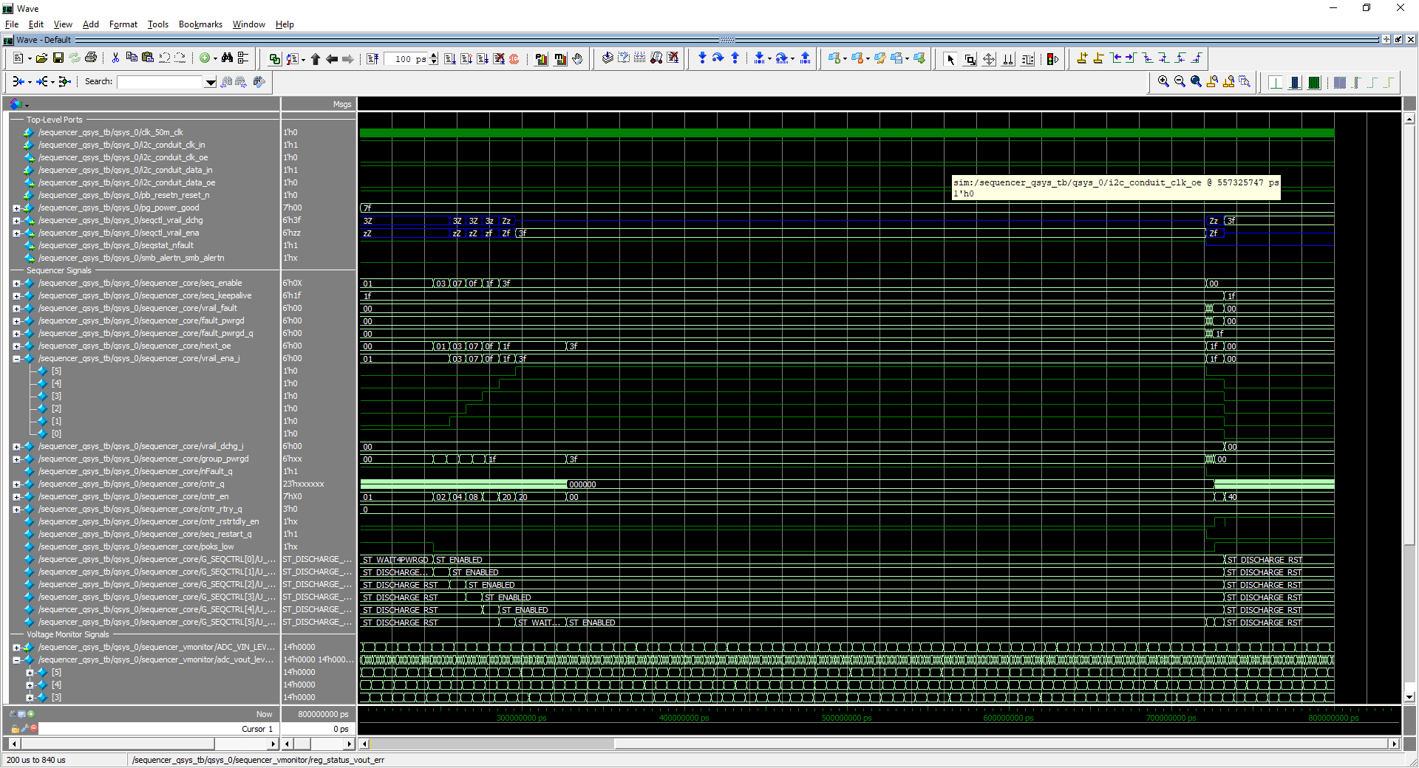
Figure 19: Power Sequencer simulation waveforms

PCB Implementation

Resource Utilization
The following table estimates the approximate resources required to implement various configurations of the Power Sequencer.

Design Block | Max 10
Design Block | LEs | FFs
6-rail sequencer, all rails monitored, full PMBus support | 2870 | 1370
12-bit SAR ADC | 120 | 90
Sequencer ADC Decoder | 300 | 100
Sequencer Voltage Monitor | 2125 | 1000
PMBus Slave Interface | 150 | 100
Power Sequencer | 175 | 80
6-rail sequencer, all rails monitored, hard-coded PMBus thresholds | 1770 | 870
12-bit SAR ADC | 120 | 90
Sequencer ADC Decoder | 300 | 100
Sequencer Voltage Monitor | 1025 | 500
PMBus Slave Interface | 150 | 100
Power Sequencer | 175 | 80
6-rail sequencer, all rails monitored, no PMBus support | 820 | 400
12-bit SAR ADC | 120 | 90
Sequencer ADC Decoder | 300 | 100
Sequencer Voltage Monitor | 225 | 130
Power Sequencer | 175 | 80
3-rail sequencer, all rails monitored, full PMBus support | 1870 | 885
12-bit SAR ADC | 120 | 90
Sequencer ADC Decoder | 200 | 60
Sequencer Voltage Monitor | 1300 | 575
PMBus Slave Interface | 150 | 100
Power Sequencer | 120 | 60
6-rail sequencer, no monitored rails, no PMBus support | 160 | 80
Power Sequencer | 160 | 80
Table 6: Resource Utilization Estimate

The levels are specified in the PMBus DIRECT format, as discussed in Section 3.7.
The “Retry Setting” value is common across ALL pages and Warnings/Faults. The controller will attempt to recover after any fault until it has reached the global retry number of times. The retry counter is reset whenever the ENABLE input is toggled low. The “Response” setting for this same command is unique to each Warning/Fault.
The “Delay Time” setting is common across ALL pages and Warnings/Faults. Once all Power Good signals have been deasserted, the controller will wait between retry attempts for the specified time (which is either no delay, or to wait for the time specified in the Sequencer parameters), before sequencing the rails back up. The “Response” setting for this same command is unique to each Warning/Fault.

