**Website and Online Account Tender Specification**

Contents

1.0 Introduction 4

2.0 Current situation 4

3.0 Tender Process 5

3.1 Tender objective 5

3.2 Pricing 5

3.3 Key performance indicators (KPIs) 5

4.0 Specification 6

4.1 Overview 6

4.2 Objectives 6

4.3 Stakeholders 7

5.0 Self-service solution 7

5.1 User Accounts 7

5.2 Capabilities 7

5.3 Council 8

5.4 Management 8

5.5 Online Payments 8

6.0 Website (Content Management System) 8

6.1 Content 9

6.2 Content writing 9

6.3 Design 9

6.4 Site Map 12

6.5 Navigation 13

6.6 Website Features 13

7.0 Online forms 13

7.1 Form creation 14

7.2 Location-based services 14

7.3 Form uploads 14

8.0 Integration 14

9.0 Search engine optimisation (SEO) 14

10.0 Reporting 15

11.0 Training 15

12.0 Mobile devices 15

13.0 Data security 15

14.0 Accessibility 15

15.0 Hosting 16

16.0 Security 16

17.0 Support 16

18.0 Project Management 16

19.0 GDS Approach 17

20.0 Copyright 17

22.0 Appendix 18

Appendix 1 – Integration details 18

Appendix 1 19

Appendix 2 – Brand details 22

Crest/Logo 22

Colours 22

Fonts 22

Watermark 22

Corporate Plan 22

# 1.0 Introduction

South Derbyshire District Council (SDDC) serves a growing population, with more than 110,000 people expected to live in South Derbyshire by 2028. With more and more people accessing services and information online, the web experience and associated customer platforms must be fit for purpose.

Within the Council’s Corporate Plan 2016-2021, ‘maintaining customer focus’ and advancing digital inclusion are key aims.

Underpinning this is a Channel Shift Strategy to allow more customers to self-serve online. This provides convenience and ease for the customer as well as value for money.

The web services platform must become our primary customer information source and number one contact mechanism.

It is our ambition to establish and maximise transactional, task oriented online services, which are flexible, accessible and easy to use.

The website should become the ‘shop window’ for all the services it offers including everything from recycling collection dates and paying council tax to checking business rates and looking at leisure activities. The website should demonstrate the vision for South Derbyshire and highlight the desire and plans for growth the District has.

As well as implementing a new web services solution, we are looking to achieve:

* A primary customer information and contact centre
* Change the customer experience of using web services and make it the channel of choice
* Maximise transactional self-service options
* Improve the customer journey using mapping and research
* Create an omni-channel solution that enables information sharing between customer and Council seamlessly.

The Council wishes to put in place a Contract for the development and ongoing support of a new website, as detailed within this document. The Contract will initially be for 12 months, with the option, at the Councils discretion, to extend for a further 48 months in blocks of 12 months.

# 2.0 Current situation

The current website solution is provided by Derbyshire County Council using a platform called Tridion. We have worked with Tridion since the site was developed in 2002.

Feeding into this are a series of customer platforms including online payments, CMIS (Council meeting database), planning and building control portal and bin collection database to name a few. Where possible the project hopes to integrate these platforms into one suitable, cost-effective, customer friendly solution.

Current self-service functions for customers are sparse and unreliable. The new website must provide a series of self-service solutions that are easy to use, manage and monitor. This function must enable SDDC to save money and reduce customer contact and automate processes as much as possible.

Current anecdotal feedback about the website content and structure, includes comments such as ‘dull’, ‘out-dated’, ‘confusing’, ‘bland’, ‘cluttered’ and ‘misleading’.

What we are looking for is ‘informative’, ‘easy-to-use’, ‘modern’, ‘attractive’ and ‘essential’.

Currently the website is hosted by Derbyshire County Council and all website amendments and requests are actioned through the e-communications team there. Although having access to a wider team is useful, internal feedback suggests it causes frustration and slows the updating process down, meaning the SDDC site is often outdated.

We will be looking to implement a new CMS platform and to bring all website maintenance, requests and management back in house. Therefore, the platform needs to be easy to use, accessible, quick and flexible and suitable for the future.

The new online services should help improve the customer journey and provide useful, timely, accurate information from any device including mobile and tablets.

The current website is ranked with one star in the SOCITM Better Connected review. Our aim is to increase this as a result of the new web solution.

# 3.0 Tender Process

SDDC is looking to appoint a single supplier to provide a new website solution including CMS, online forms and self-service platform. Services must also include options for project management, integration, design, testing, training, hosting and support.

It is anticipated that tenders will initially be assessed by price. We will only carry out a full technical assessment of the most cost effective solutions offered. Technical assessments will be carried out by a panel of evaluators. Full details of the tender process are included in the Instructions to Tenderers.

## 3.1 Tender objective

To develop an efficient, value for money solution that provides the best outcome for South Derbyshire District Council.

## 3.2 Pricing

Prices must be held for 12 months at the agreed rate. Thereafter any changes will be based on an agreed formula, using a suitable, freely available statistical index, less any deemed improvement in efficiency. Please include suggestions for an appropriate formula and index. Any requests for change must be submitted for approval by the Council at least 30 days prior to the proposed effective date. Any agreed change must be effective for at least 12 months.

## 3.3 Key performance indicators (KPIs)

We expect the supplier to suggest a minimum of five KPIs which could be used to monitor the delivery of the service. The KPIs should provide a basis for continuous improvement.

# 4.0 Specification

## 4.1 Overview

We are looking to appoint a supplier who can provide full project management, design, hosting and support services, ultimately creating a self-service led website solution.

At a high level we require:

* Recommendations of a suitable CMS including implementation, support and initial training
* Functionality to provide a self-service platform for customers that includes making payments
* System to produce, manage and track online forms and online event booking
* Selection of designs and concepts that show consistency with the SDDC brand
* Concepts that meet our target audience’s requirements
* A site that is fully accessible and DDA compliant
* Recommendations for the best user experience for our audience
* Fully mobile and tablet responsive designed site
* Integration with back office systems listed in Appendix 1
* Fully utilises the latest website design trends and technology and supports all modern browsers.
* Secure site that protects customer data

## 4.2 Objectives

We are looking to create a fit for purpose website and self-service solution that fulfils the needs of our target audiences:

|  |
| --- |
| Objectives |
| Create a site that reinforces the SDDC brand, key messages and values including supporting the Corporate Plan vision, themes and objectives. |
| Encourages and directs customers to use self-service functions, for example paying Council Tax bills online. |
| Allow customers to search and find relevant information easily and quickly to decrease avoidable customer contact via Customer Services and direct to departments. |
| Increase the number of web visitors. |
| Create a website that provides self-service solutions that result in cost savings. |
| Improve the SOCITM Better Connected 2015 rating and fix the current ‘fail’ scores for usability, transactions, mobile and accessibility. |
| Allow SDDC to showcase its business credentials, tourism, partnership, career and leadership opportunities. |
| Create a mobile-responsive website that enables customers to access services via smartphones and tablet devices as well as computers. |
| Ensure online services are fit for the future and use a platform to enable development and new tools as required. |

## 4.3 Stakeholders

The SDDC website and self-service platforms serve a variety of audiences, each with different requirements and customer journeys. This list gives an idea of the stakeholders:

* SDDC
* General public/local residents
* Business partners
* Contractors
* Professional bodies
* Media
* Potential employees
* Regulators
* Councillors
* Tenants
* Potential tenants

# 5.0 Self-service solution

## 5.1 User Accounts

1. The self-service solution must provide customers with a secure online account to manage all their transactions with us. Customers should be able to access their account 24 hours a day, from any device, including mobile phones.
2. Customers must be able to register and create a single account using a fully automated process that requires email verification.
3. Customers must be able to track their requests and view progress.
4. There must be a level of authentication to verify who they are and their connection to the data.
5. It must be a secure and PCI compliant service that can handle and process personal information and payment transactions.
6. The ability for customers to login by social media accounts such as Facebook is desirable.

## 5.2 Capabilities

The solution must have the potential to enable customers to login, report and track the following:

|  |  |
| --- | --- |
| Repair requests and book appointments | Events and activities |
| Anti-Social Behaviour | Rent payments |
| Gas Servicing | Satisfaction surveys |
| Complaints | Fraud |
| Pest control | Housing benefit |
| Bin collections | Job applications (optional) |
| Bulky waste collections | Pay land charges |
| Council tax and make payments | Community building hire |

Other capabilities may also be required. Customers must be able to track progress of requests and update us if their circumstances change.

## 5.3 Council

The self-service solution must offer the Council a platform to transform its online services for customers and staff. The solution will help deliver key elements of the Council’s Channel Shift and IT Strategies.

It must offer a more cost-effective way to manage customer contact and do business with customers by reducing time for administration and processing.

By introducing self-service functions, the Council aims to increase self-service to 70%.

## 5.4 Management

The self-service solution must offer the Council a mechanism to access and process customer requests via a simple and intelligent system. The product must offer staff a CRM type solution, providing an easy way to respond to customers, track their history and bring services together.

We should be able to monitor and manage customer accounts and amend and delete them if required.

The solution must enable us to remove silo working and share information across departments.

## 5.5 Online Payments

The ability for customers to make online payments, view their accounts and receive a confirmation of payment is essential. The solution must provide a secure, PCI compliant service for customers. We currently use Capita payments so any online payment integration must operate via this solution.

# 6.0 Website (Content Management System)

The content management system (CMS) used ideally should be an Open Source solution such as Wordpress, Drupal or similar. We currently use Joomla for our intranet.

The CMS should be easy to use and allow quick editing, uploading and management features using a WYSIWYG editor. It must be easy to use for those without technical web development skills. The use of Cascading Style Sheets (CSS) should be available.

The CMS must allow us to make structural and menu changes to the site as we require and offer various levels of administration, editing, authoring and approvals.

Regular CMS updates must be completed by the supplier with all changes communicated to SDDC.

The ability to preview content before go live is also essential.

## 6.1 Content

The following content types should be fully supported for this website project:

* HTML
* Text
* PDF
* Photos
* Graphics
* Video
* Word, Excel and Publisher Documents.

## 6.2 Content writing

The current site has more than 3,500 pages with multiple attachments and photos. Our aim is to dramatically reduce and condense the overall site content as part of this project.

We want to create content that better serves the customer journey and guides customers through the information they need most. The content and the site structure must link together.

There is some in-house resource to complete the content writing but we are looking for additional support from the chosen web supplier. Guidance and support in content writing and page layout would also be beneficial.

## 6.3 Design

We are looking to achieve a clear, simple, engaging design that encourages customers to use the self-service features of the website.

The website design must reflect the SDDC branding, fonts and style within our brand guidelines (see appendix 2).

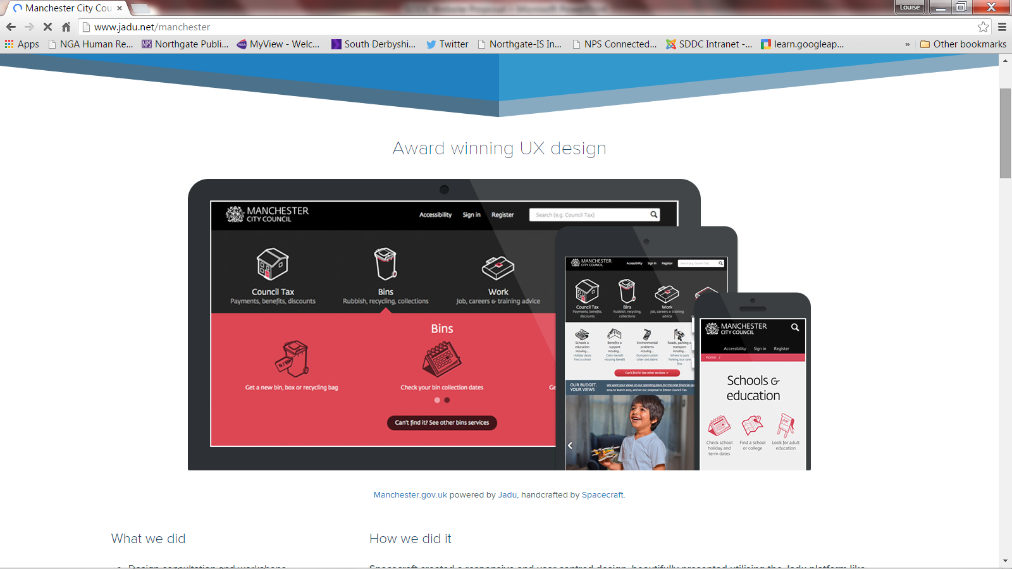Here are some examples of sites we like:

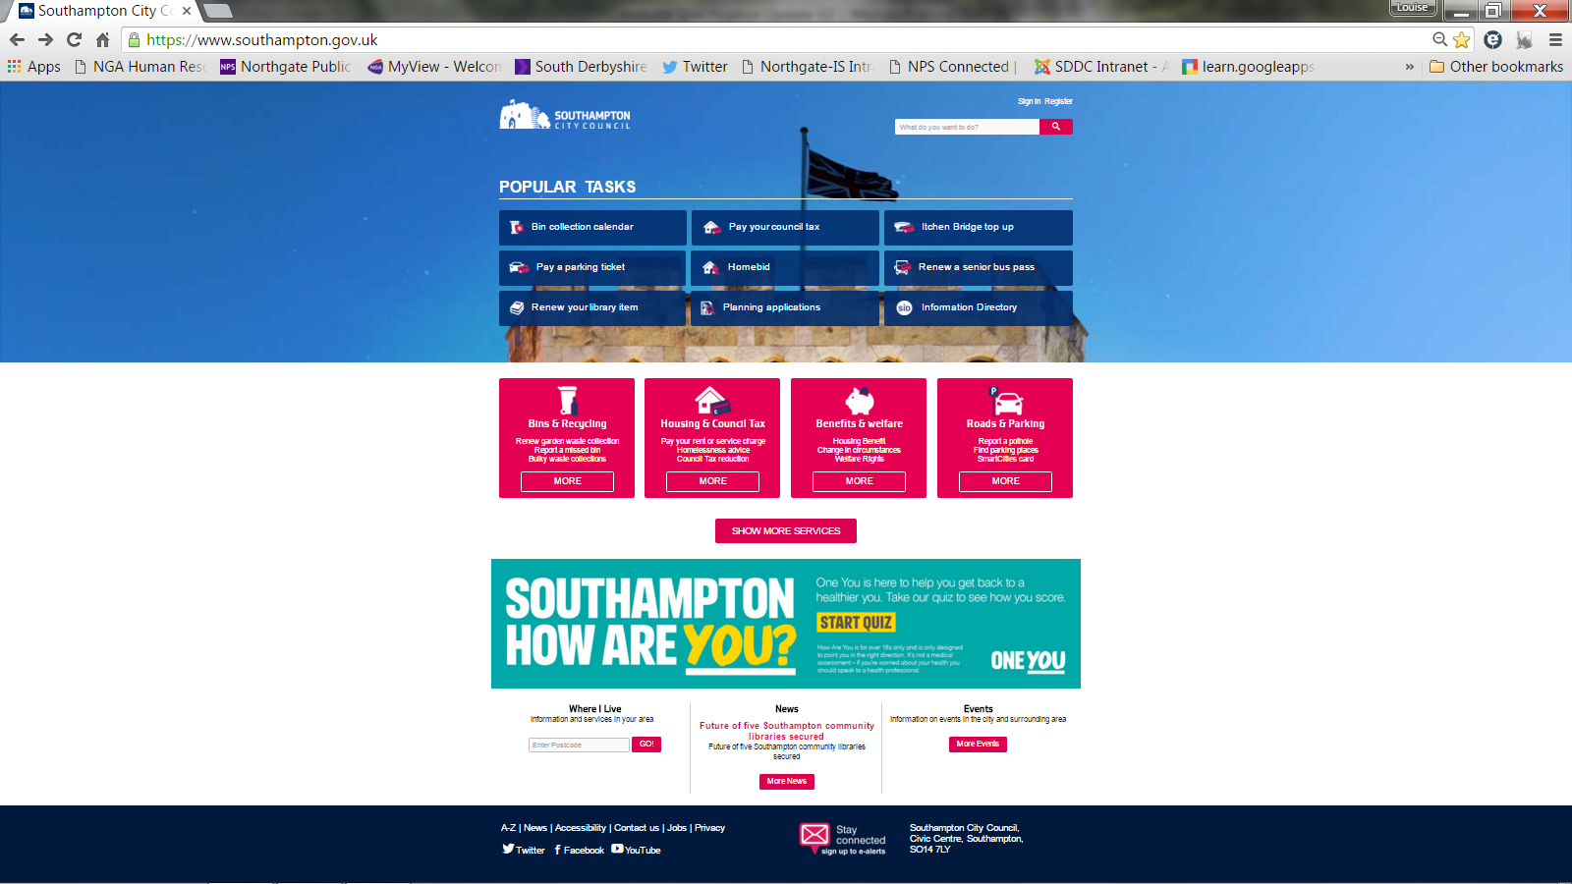

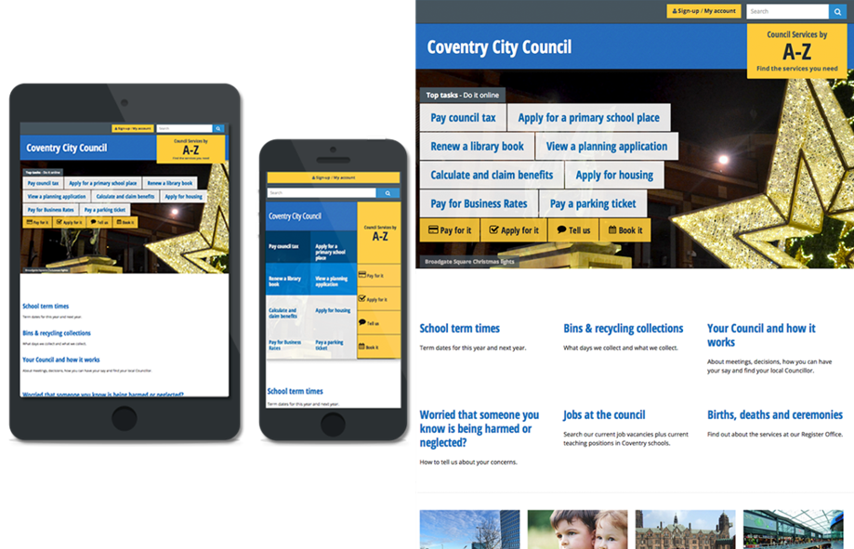

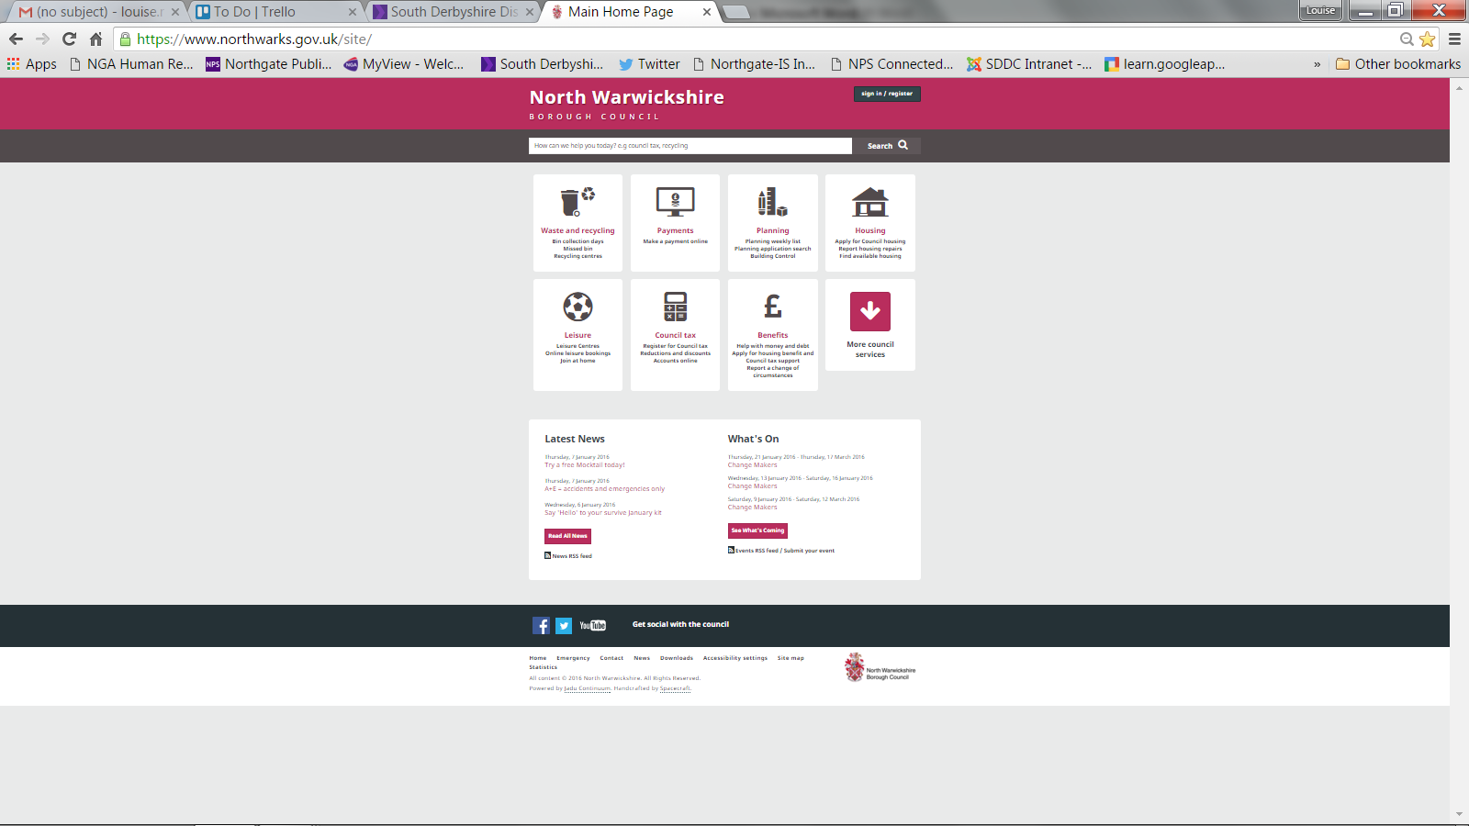

## 

## 6.4 Site Map

The website site map is currently organised by internal departments and is not customer friendly. The new site map must provide an improved customer journey, allow customers to find what they need and offer flexibility as services change.

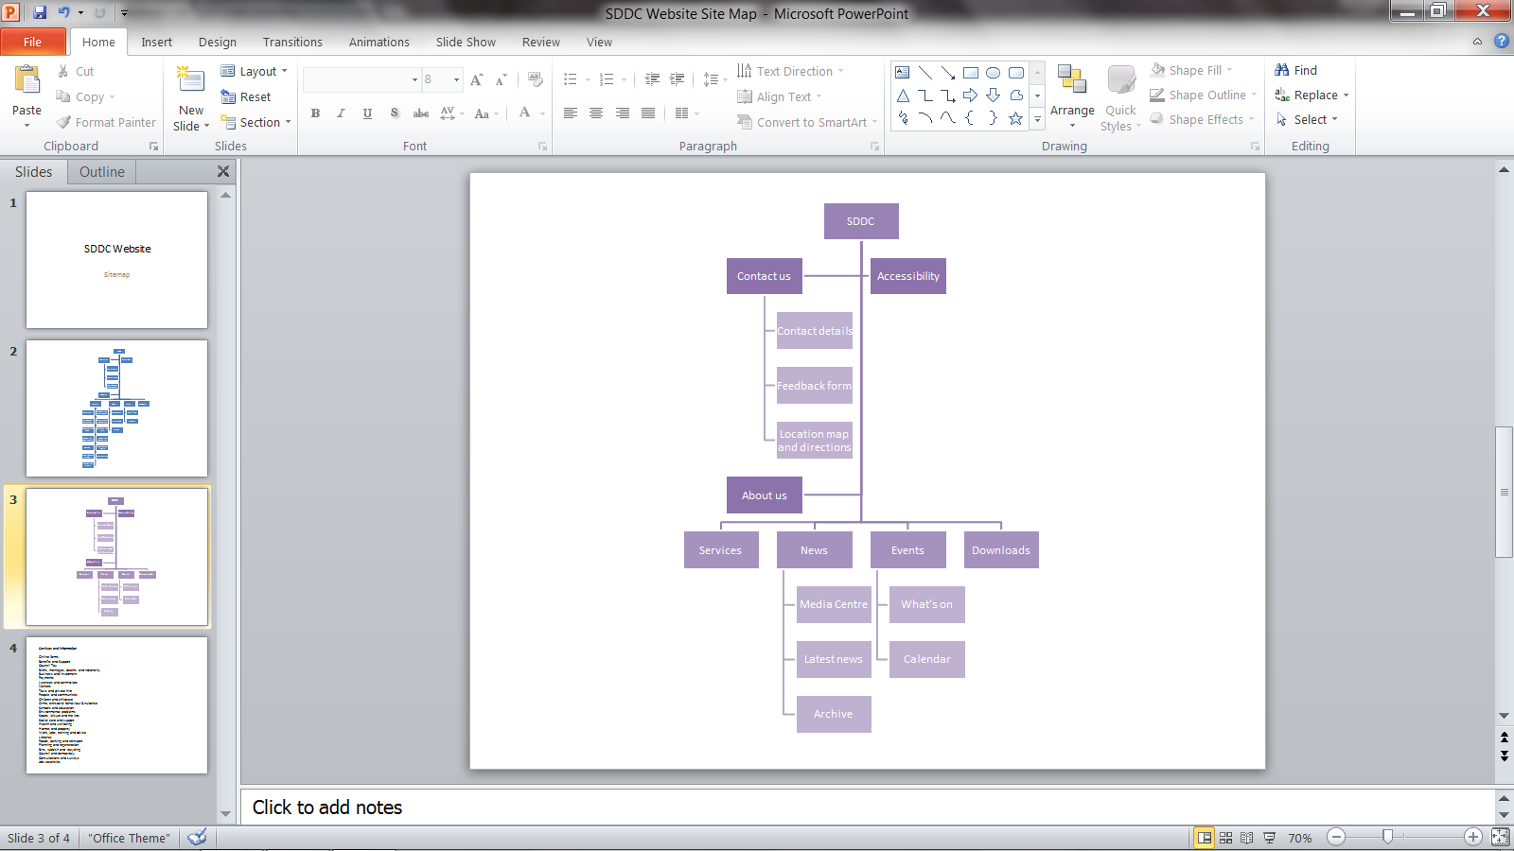These examples show some of the potential features for the site. We would expect the chosen website supplier to advise on this and undertake the appropriate user testing.

## 6.5 Navigation

The website must provide various ways for customers to navigate the site including quick links from the homepage, a breadcrumb trail, an a-z feature with page listings, search facility and a menu.

Our expectation is that the chosen navigation options would be tested with users to ensure they are appropriate and fit for purpose.

## 6.6 Website Features

We expect to see the following features throughout the site and have the ability to manage them in house:

* Dynamic home page
* Blogs
* Social media feed, functions, shortcuts
* Email newsletter sign up
* News feed
* Photo banner
* Video
* Online forms
* Search
* Accessibility features
* Space for logos, accreditations and awards
* Site map
* Mobile/tablet responsive
* Feedback/surveys
* Photo gallery
* Events calendar
* Pop ups
* RSS feeds

# 7.0 Online forms

Online forms will be required throughout the website and self-service account feature.

The online forms solution must:

1. Provide simple, user-friendly forms
2. Be accessible on any device including mobile phones
3. Meet accessibility standards
4. Can be saved as drafts and submitted later
5. Pre-populate with customer data to improve experience
6. Validate information to avoid incorrect data entry
7. Guide customers to questions relevant to them
8. Easy and quick to create including the workflows and testing
9. Reduce paperwork and postage costs
10. Track progress and status of submission.

## 7.1 Form creation

The solution must enable us to create online forms and the corresponding processes in-house without the need for technical skill or on-going development.

Templates and pre-built forms would be beneficial.

## 7.2 Location-based services

Location-based services should be provided within the creation of forms and reporting information, eg. maps, postcode search etc.

## 7.3 Form uploads

Customers must have the ability to upload Microsoft Office documents, photographs or PDFs when they submit a form.

# 8.0 Integration

The chosen supplier must provide expertise and project management to successfully install, integrate and launch each self-service function, online forms and web services throughout the project.

The solution must either link to, integrate with or access information from a variety of products and functions. For example:

* Building control register
* Competent person’s register
* Bulky waste collections
* CMIS
* Events calendar
* Bin collections
* E-balance Council Tax and NDR checker
* Council Tax and Housing Benefit calculator
* Bedroom calculator
* Online payments.

*Other products and functions will be included.

The supplier must provide the expertise and resources to integrate these systems and data with the self-service solution. More details of the integration requirements are in appendix 1.

Our expectation is to understand which of these aspects can be delivered as part of this project, how the solution will work and the cost for each function.

# 9.0 Search engine optimisation (SEO)

The solution must be search engine optimised to ensure that key features of the site are tagged and listed. Customers must be able to search and select the service directly from the search engine results.

# 10.0 Reporting

The solution must provide a tool for reporting information about all aspects including the website, self-service platform and online forms. We currently use Google Analytics.

Results must be easy to access, interpret and report on. We must be able to extract data and produce reports on a regular basis as well as get live data.

We require a solution that has the potential to display a performance dashboard, potentially on a screen if required.

# 11.0 Training

The solution will be primarily managed by non-technical staff with support from the Communications Team where appropriate.

Training must be provided for all elements of the project including the website, self-service platform and online forms.

Onsite support, training and setup of these services initially is essential. We would also expect user guides and a support forum/network so staff can diagnose problems themselves.

# 12.0 Mobile devices

The solution should be optimised for accessibility via mobile devices as well as computers; the W3C’s Mobile Web Best Practice 1.0 guidelines must be consulted in order to ensure that mobile versions of the site are accessible and usable.

A consideration of the SOCITM assessment framework is also important in terms of accessibility and mobile devices.

# 13.0 Data security

The solution must provide a secure solution for customers to share, record and transfer data to the Council.

# 14.0 Accessibility

The SDDC website should comply with the Disability Discrimination Act.

Translation services should be available to users.

As a minimum the website should aim to meet Level AA of the [Web Content Accessibility Guidelines](http://www.w3.org/WAI/intro/wcag.php) (WCAG) 2.0.

The website should be usable by recent versions of these screen readers:

* [JAWS](http://www.freedomscientific.com/Products/Blindness/JAWS), [NVDA](http://www.nvaccess.org/)
* [VoiceOver for OS X](https://www.apple.com/accessibility/osx/voiceover/)
* [Window Eyes](http://www.gwmicro.com/Window-Eyes/) and [Supernova](http://www.yourdolphin.co.uk/productdetail.asp?id=5)

The website should also be usable by basic operating system screen magnifiers like:

* [ZoomText](http://www.aisquared.com/zoomtext/)
* [MAGic](http://www.freedomscientific.com/Products/LowVIsion/MAGic)

The website should be usable by speech recognition software including [Dragon Naturally Speaking](http://www.nuance.com/dragon/index.htm), and native operating system speech packages.

An Equality and Diversity review will take place before the website goes live to check these requirements are in place.

# 15.0 Hosting

Currently the website is hosted by Derbyshire County Council. We are looking for an alternative hosting solution such as cloud-based via the website supplier. Recommendations will be reviewed as part of the tender process.

The hosting solution must allow reliable speed for visitors and administrators and any issues must be investigated and resolved via the supplier.

A service level agreement with the hosting provider must be in place to ensure issues are resolved in a timely way and keep service disruption to a minimum.

# 16.0 Security

By providing customer data via the website solution we must ensure high levels of security are maintained. If highly confidential data is accessed incorrectly there would be reputational damage for SDDC and distress for the residents involved.

# 17.0 Support

As part of the ongoing support and maintenance of the website SDDC will require a Service Level Agreement (SLA) with the chosen supplier. This will ensure that any issues, upgrades and training requirements are addressed within a set time and cost.

We would expect:

* a service desk available Monday to Friday (8-6pm minimum)
* occasional out of hours support (or an agreement in place with pre-arranged pricing)
* dedicated support desk contacts who understand the requirements of our SLA and website
* agreed SLA timescales and response times.

We would also expect the support agreement to including the monitoring of any downtime including alerts and trouble shooting.

# 18.0 Project Management

The appointed supplier must provide project management services throughout to ensure the project runs to time and budget.

Regular project updates must be provided to the in house Project Manager at agreed points.

More complex project stages including the integration of back-office systems and self-service solutions. These must be completed with a number of days on site to improve communication and speed.

Suppliers must provide an outline project plan indicating tasks, dates and responsibilities of both parties. The project milestones should also be suitable for a staged payment process.

The deadline for the completion of the project is December 2016 - February 2017.

# 19.0 GDS Approach

Although we do not have to comply with the Government Digital Service’s (GDS) Digital Service Standard, we do expect to follow the 18 principles. We would expect the supplier to utilise these principles throughout their approach and implementation of the project.

# 20.0 Copyright

The copyright for all designs and solutions remains with SDDC. Permission must be sought for use of the designs, content or solutions by the supplier for case studies etc.

# 22.0 Appendix

## Appendix 1 – Integration details

The supplier must provide expertise, development and support to enable us to integrate, link to and run the following self-service functions. As part of the tender response we would like to understand the options for achieving this and the costs.

This table below is an indicative list of requirements and possible solutions. Our expectation is that the supplier would explore and confirm the exact requirements as part of the project delivery.

* Repair requests and appointment booking
* Reporting anti-social behaviour
* Request gas servicing appointments
* Report complaints and track
* Book pest control services
* Look up bin collection timetable
* Report missed bin
* Book bulky waste collections
* Review council tax account
* Pay council tax bill
* Look up events
* Book events and sporting activities
* Check rent balance
* Make rent payments
* Report fraud
* Housing benefit calculator
* Housing benefit application
* Pay land charge fees
* Building control register
* Competent person’s register
* Job applications
* CMIS (link to and possible iframe only)
* Vacant property search
* Planning portal (link to)
* GIS (link)
* Planning land searches (link to and possible iframe)
* E-balance CTax and NDR checker
* CTax and housing benefit calculator
* Bedroom calculator
* Online payments (Capita)

*Other functions may be required

Appendix 1 This is an indicative list of our requirements:

|  |  |  |  |  |  |
| --- | --- | --- | --- | --- | --- |
| Function | Current method | System | Solution required | Comments | Owner |
| Repair requests | Online form (emailed to repairs team), telephone, email | Orchard, Locata Plus, Live Span | Online form, self-service account, self-diagnose issue | Customers can diagnose repair issue using something like M3 Housecall or drop down lists, report repair, request appointment slot, pay for any recharges up front. | Housing |
| Repair appointment booking | None | N/A | Online form, self-service account | Customer request repair and book appointment time slot. Customers get confirmation email/text. | Housing |
| Report anti-social behaviour | Online form, telephone, email | N/A | Online form | Customer can report ASB issues via online form. | Communities |
| Request gas servicing appointments | Telephone | N/A | Online form | Online form to send request to inbox | Housing |
| Report and track complaints | Online form, telephone, email, letter | Database | Online form with tracking | Customer complete online form and submit. Staff can review and save submissions. | Corporate Services |
| Book pest control services | Telephone, email | Northgate Front Office CRM linking to Civica | Online form, booking and payments | Customers fill in online form, book time slot and make payment. | Environmental |
| Look up bin collection times | Bespoke online search tool | Access Database | Online search tool | <http://www.south-derbys.gov.uk/environment/recycling_rubbish_and_waste/collection_dates/default.asp> | Waste |
| Report missed bin collection | Telephone, email | Northgate Front Office CRM | Online form with tracking | Customer can complete online form. Staff can review form submission. | Waste |
| Book bulky waste collection | Telephone | Northgate Front Office CRM | Online form, booking and payment | Customer fills in online form, makes payment and submits. Staff can access submissions. | Waste |
| Review Council Tax Account | Online form, telephone, email | Capita | Online form, self-service account | Customer can login and review bill and previous bills <https://ip.e-paycapita.com/AIP/itemSelectionPage.do?link=showItemSelectionPage&siteId=058&languageCode=EN&source=AIP> | Client Services |
| Pay Council tax bill | Online, telephone | Capita | Online form, payments, self-service account | Customer reviews bill and pays online  <https://ip.e-paycapita.com/AIP/itemSelectionPage.do?link=showItemSelectionPage&siteId=058&languageCode=EN&source=AIP> | Client Services |
| Council tax application | Pursuing IEG4 online forms as interim | IEG4 Forms but direct integration into Capita and Academy | Online form, self-service account | Customer can login, complete an online form and submit it. Customer can track application. Staff can access applications. | Client Services |
| Search for events in calendar | Google Calendar | N/A | Online search, calendar | Easy to populate and search events calendar | Sports/Events |
| Book events/activities | Online form, telephone, email | N/A | Online form, payments, self-service account | Customers must be able to view event details and book and pay for places. Staff must be able to review attendance lists and print lists. | Sports/Events |
| Check rent balance | Online | Capita/Orchard | Self-service account | Customer can login, check rent balance and make payment. | Housing |
| Pay rent | Online | Capita/Orchard | Online form, self-service account, payments | Customer can login, check rent balance and make payment. | Housing |
| Report fraud | Online form, telephone, email | N/A | Online form | Online form and access to submitted forms. | Client Services |
| Housing benefit calculator | Online, telephone | Bespoke application with scripting – data scripts run weekly | Online calculator | Customer can enter a few details and are presented with estimated housing benefit amount. | Client Services |
| Housing benefit application | PDF download and currently pursuing online form application in interim | IEG4 Forms but direct integration into Capita and Academy | Online application form, self-service account | <http://www.south-derbys.gov.uk/Images/SDDC%20HB.LHA.CTR%20App%20Form_tcm21-103663.pdf> | Client Services |
| Pay land charges | PDF download | N/A | Online application form, self-service account | Online form and access to submitted forms. | Land Charges |
| Building control register | Online database/form | Data Identic | Link to site | <http://planning.south-derbys.gov.uk/iregister.aspx> | Building control |
| Planning applications | Link to Government Planning Portal | Planning Portal | Link to Planning Portal | Link to <https://www.planningportal.co.uk/applications> | Planning |
| Planning search | Online search database | Data Identic | Link to site | <http://www.planning.south-derbys.gov.uk/> | Planning |
| Competent person’s register | Online search database | Data Identic | Link to site | <http://planning.south-derbys.gov.uk/competentpersons.aspx> | Building control |
| Job applications | Online, post | Abacus | Link to external site or Self-service, online applications, full job application process | <https://jobs.derbyshire.gov.uk/southderbyshire/index.asp>  Run and hosted by Derbyshire Jobs. Contract due for renewal Dec 2016. | SDDC/HR |
| CMIS | Online | Astech | Link to CMIS and html template | <http://south-derbys.cmis.uk.com/south-derbys/Home.aspx> No plans to currently update this system but would like to refresh the templates. <http://cmis.astech.co.uk/CMIS/about/> | Democratic Services |
| Planning enforcement register | Online tool | Data Identic | Link to | <http://planning.south-derbys.gov.uk/enforcements.aspx> | Planning |
| Planning land searches | Online forms | N/A | Online forms or data base | Forms must be submitted and stored for staff to search and action requests. | Land charges |
| Bedroom tax calculator | Online search | Database | Online calculator | Online tool must enable people to add in details of property and household make-up and calculate predicted bedroom tax amount. | Corporate Services |

*Other products and functions may be required by SDDC.

## Appendix 2 – Brand details

## Crest/Logo



## Colours

C 29

M 0

Y 100

K 0

R 153 G 204 B 0

#99CC00

C 49

M 0

Y 100

K 39

R 0 G 204 B 0

#00CC00

C 78

M 100

Y 0

K 33

R 45 G 0 B 84

#2D0054

## Fonts

Titles and sub headers – Trebuchet Bold for in-house documents, Aleo Bold for external materials.

Main text – Arial 12pt

## Watermark

As part of the Corporate Plan 2016-21 we have introduced the use of a Venn Diagram watermark for corporate documents. This may or may not be appropriate for use within the website design.

## Corporate Plan

There are four main themes within our Corporate Plan that must be considered throughout the project through images or content. They are: People, Place, Progress and Outcomes.