Lab 1 Assignment

YingTa Lin (ytl287)

Thursday 10th September, 2015

Assignment 1:
(Nothing need to be submit on this assignment)

Assignment 2:
1. See file “bubbleSort.py” and “insertionSort.py”
2. See file “lab1_generate_list.py”. This python code has imported “sorting.py” as a module which include two sorting method in the previous question. It generates a list of 9 random non-negative integers from a sample space of 1 through 100. And, given the list, we print out the two sorted result from both sorting methods.
3. I demo both of my sorting functions. Considering how many operation is done by two of these sorting methods, the effort is nearly the same. The complexity of these two codes are simple, too. However, if we were doing a longer list, the chances of doing comparison operation is higher for insertion sort than for bubble sort.

Assignment 3:
1. See “sample.wav”
2. See “read_wav_example_01.py” which first print out the header information of “sample.wav” and print out the header information of “sample_8bit.wav” and ”“sample_32bit.wav”. The information are: number of channels, framerate, signal length, and bytes per frame.

sample.wav header:
0000000: 5249 4646 5c99 0000 5741 5645 666d 7420 RIFF\...WAVEfmt
0000010: 1000 0000 0100 0100 803e 0000 007d 0000 .........>...}..
0000020: 0200 1000 6461 7461 5e98 0000 FFFF 0200 ....data^.......

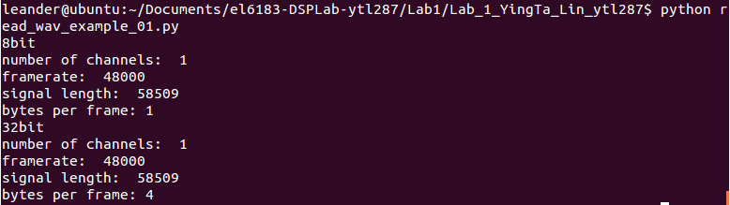
Interpret with appendix-A, we have the following information:
(which matches the print from python script)
3. The read width is the frame size and is the sample width since this audio record is monotonic. We can tell from the capture in previous question that the “bytes per frame” equals to 1 which means the read width is 1 bytes. For the 32 bit format is 4 bytes per frame.
4. The relation of the width value to the digital sample depends on the file storing format such as unsigned 8bits PCM, signed 16 bits PCM or 32 bits PCM and also depends on how many channels the audio file has. The width value is one digital sample from all channels combined, which is
width value = byte per sample * number of channels
The sample audio record we have in previous question is monotonic which contain only one channel, so the width value is equal to the sample width.

Appendix-A

WAV file header format
Positions | Sample Value | Description
1 - 4 | "RIFF" | Marks the file as a riff file. Characters are each 1 byte long.
5 - 8 | File size (integer) | Size of the overall file - 8 bytes, in bytes (32-bit integer). Typically, you'd fill this in after creation.
9 -12 | "WAVE" | File Type Header. For our purposes, it always equals "WAVE".
13-16 | "fmt " | Format chunk marker. Includes trailing null
17-20 | 16 | Length of format data as listed above
21-22 | 1 | Type of format (1 is PCM) - 2 byte integer
23-24 | 2 | Number of Channels - 2 byte integer
25-28 | 44100 | Sample Rate - 32 byte integer. Common values are 44100 (CD), 48000 (DAT). Sample Rate = Number of Samples per second, or Hertz.
29-32 | 176400 | (Sample Rate * BitsPerSample * Channels) / 8.
33-34 | 4 | (BitsPerSample * Channels) / 8.1 - 8 bit mono2 - 8 bit stereo/16 bit mono4 - 16 bit stereo
35-36 | 16 | Bits per sample
37-40 | "data" | "data" chunk header. Marks the beginning of the data section.
41-44 | File size (data) | Size of the data section.
Sample values are given above for a 16-bit stereo source.

