Install and start jenkins server using terraform On EC2 instance.

To install and start Jenkins on an EC2 instance using Terraform, you will need to create an EC2 instance, install Jenkins on it, and configure Jenkins to start automatically when the instance launches

# Step 1 - Set up Terraform:

If you haven't already, you need to install Terraform and configure it for your AWS account. You can follow the official Terraform documentation for installation and setup: <https://learn.hashicorp.com/tutorials/terraform/install-cli>

# Step 2 - Write an Terraform Configuration File:

Create An ec.tf file into VSCode

# 1)Configure AWS Provider and set default VPC

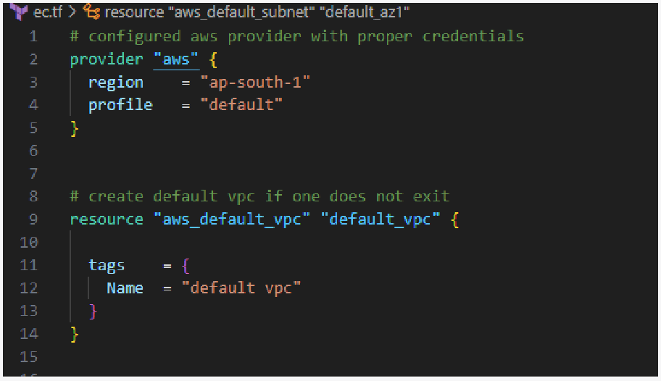

1. **use data source to get all availability zones in region and create default subnet if one does not exist**

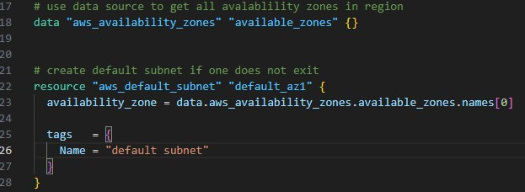

# Create security group for the ec2 instance and set access of port numbers

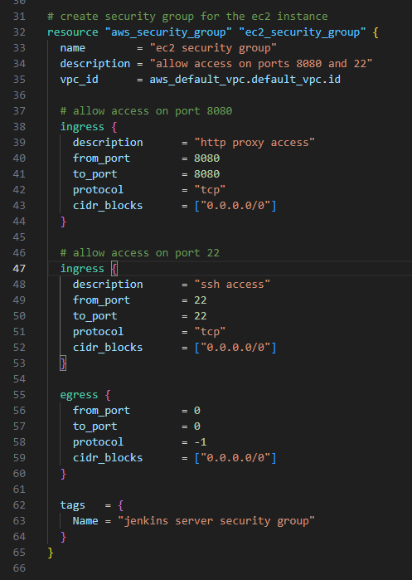

1. **Use data source to get a registered amazon linux 2 ami (ami of instance)**

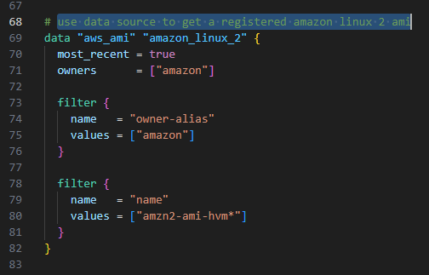

# launch the ec2 instance

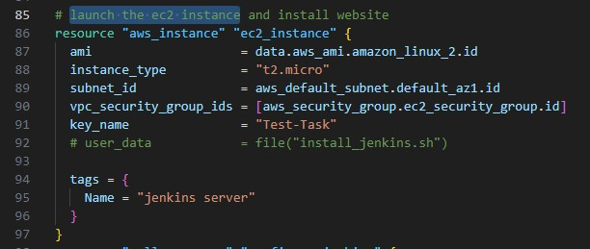

1. **Install jenkins on launched EC2 and start jenkins server.**

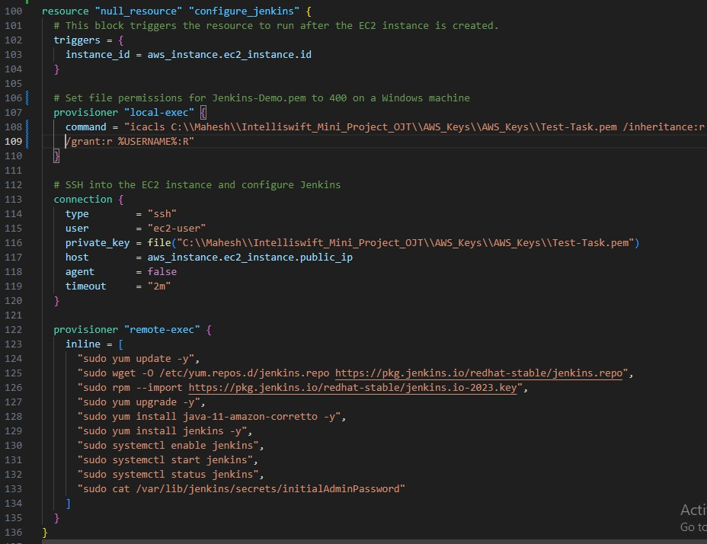

# Website to access the jenkins server by using public Ip of EC2 instance

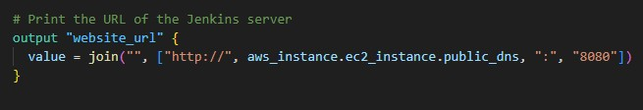

**Step 3 - Initialize Terraform:**

Run the following commands in the same directory as your Terraform configuration file: Command -

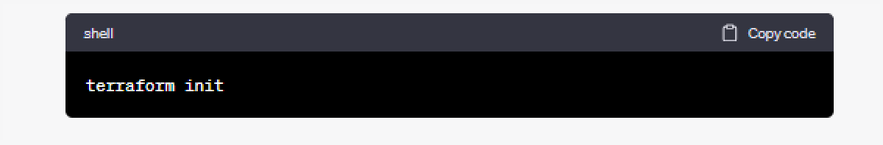

# Step 4 - Preview the changes

The terraform plan command allows you to preview the changes that Terraform will make to your infrastructure before actually applying them. It provides you with a detailed summary of what resources will be created, updated, or destroyed based on your configuration Command-

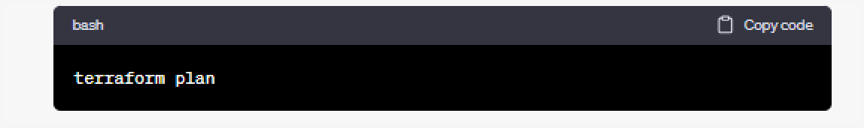

# Step 5 - Apply Terraform Configuration:

Deploy the resources by running:

Command -

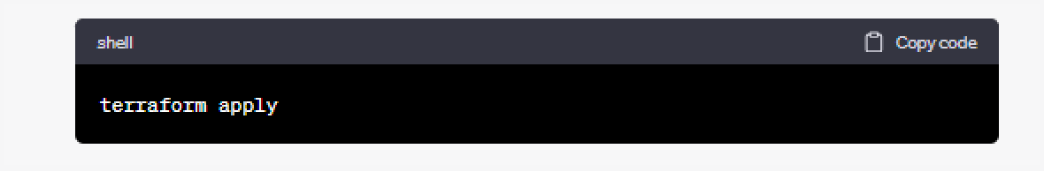

Terraform will create the EC2 instance and execute the installation and startup of Jenkins using the remote-exec provisioner.

# Step 6 - Access Jenkins:

Once Terraform has completed the setup, you can access Jenkins by opening a web browser and navigating to the public IP of your EC2 instance:

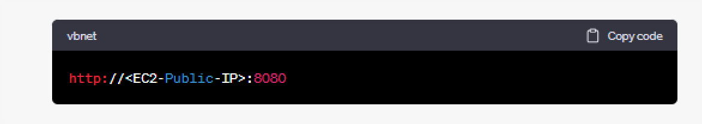

You will need to retrieve the initial administrator password from the Jenkins server, which can be found in the following file on your EC2 instance:

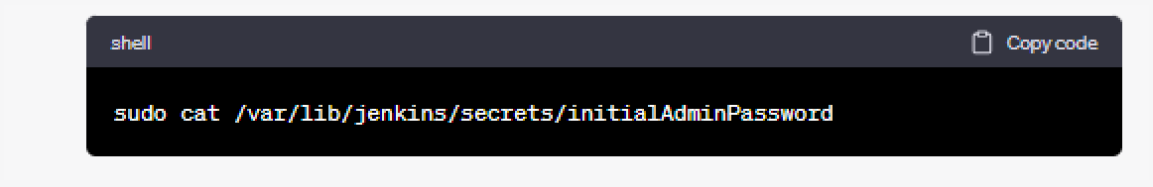

Enter this password when prompted during the Jenkins setup process.

Please make sure to adjust the Terraform configuration to your specific needs, such as the AMI,

instance type, SSH key, and security group. Also, ensure that your AWS credentials are

properly configured and that your security group allows incoming traffic on port 8080 for Jenkins access.