**Grafana-Loki-Promtail**

## **What is Loki?**

**Loki** is a **log aggregation system** designed to collect, store, and query logs from different sources. It is lightweight and works well alongside **Prometheus** for monitoring metrics. Unlike other log management systems, Loki doesn't index the content of logs but instead indexes labels (like job name or service), which makes it more efficient and cost-effective.

### **Why Use Loki?**

* **Scalable and Efficient**: Loki is designed to handle a large volume of logs with minimal overhead.
* **Prometheus Integration**: If you are already using Prometheus for metrics, Loki fits perfectly to handle your log data in a similar way.
* **Cost-effective**: Loki only indexes labels, not the full log content, reducing storage and computation costs.
* **Easy to Query**: You can search logs using PromQL (Prometheus Query Language) through **Grafana**.

### **Key Features of Loki:**

* **Label-based log organization**: Logs are grouped and indexed based on labels, making searches faster and storage more efficient.
* **Integration with Grafana**: Easily visualize and query logs in Grafana.
* **Multi-tenancy support**: You can separate log data for different teams or environments.  
    
  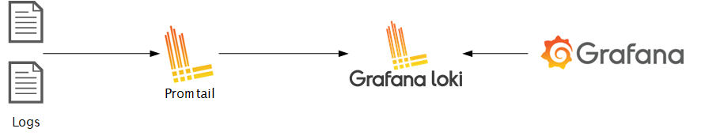

**What is Promtail?**

**Promtail** is an agent that runs on your servers or Kubernetes clusters to collect logs and send them to Loki. It works by reading log files and attaching labels to the log entries before sending them to Loki.

### **Why Use Promtail?**

* **Log Collection**: Promtail efficiently collects logs from various sources, like system logs or application logs.
* **Seamless Integration with Loki**: It is the recommended log collector for Loki, and it sends logs directly to it in the correct format.
* **Kubernetes-native**: Promtail works well with Kubernetes, automatically attaching labels like pod name, container name, and namespace to logs.

### **Key Features of Promtail:**

* **Tail-based log collection**: Promtail reads logs as they are written to files, similar to how the Linux tail command works.
* **Kubernetes Support**: It automatically labels logs from your Kubernetes pods, helping you to filter logs based on clusters, nodes, or applications.
* **Configurable**: Promtail can be configured to work with various input sources and log formats.

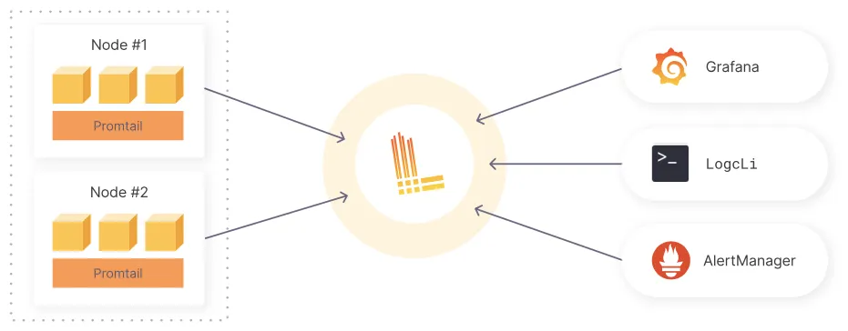

### **Loki Architecture Overview**

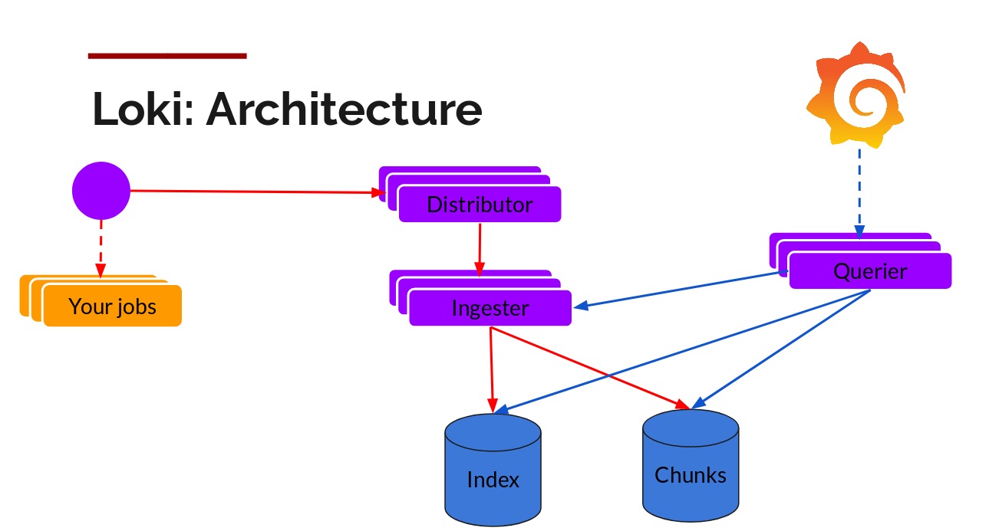

Loki is designed to handle large volumes of logs in a scalable and efficient manner. It uses a distributed system with various components to store, index, and retrieve log data.

* **Distributor**: Receives log data and forwards it.
* **Ingester**: Processes and temporarily stores logs. It divides logs into chunks and creates index entries.
* **Index**: Used for quick log search.
* **Chunks**: Stores compressed log data.
* **Querier**: Retrieves logs based on search queries.
* **Object Store**: Can store logs and index data in cloud storage (like S3).
* **Ruler**: Sets conditions to monitor logs for specific events (alerting).
* **Memcache**: Temporarily stores data to speed up queries.

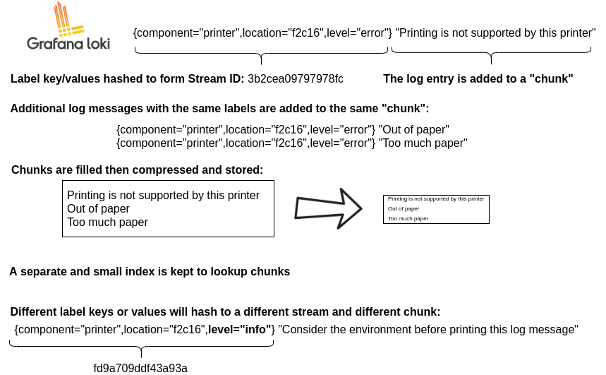

This architecture ensures efficient log storage, search, and retrieval, making Loki scalable for large deployments.

### **Components Overview**

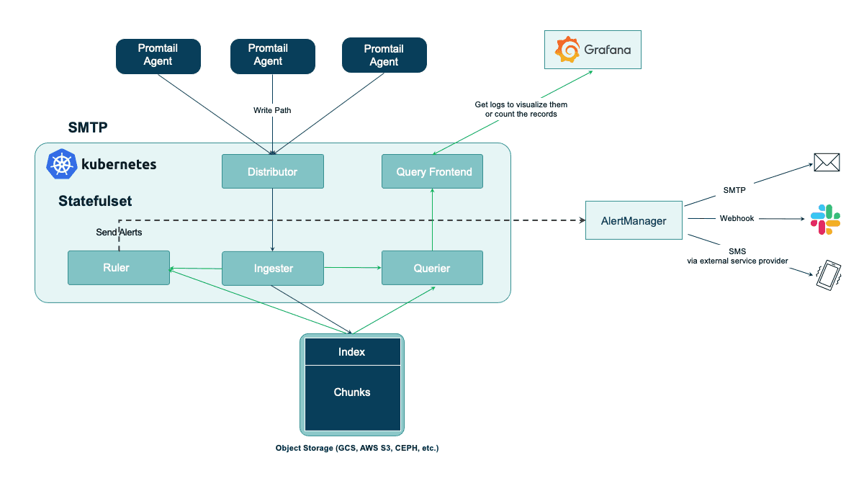

### **Promtail Agents**:

* 1. These are agents responsible for collecting logs from various sources within your Kubernetes environment. They send the logs to the **Distributor**.
  2. Multiple instances of Promtail can run in parallel to handle log collection efficiently.

1. **Distributor**:
   1. The Distributor receives incoming log data from the Promtail agents. It is responsible for managing the flow of logs into the Loki system.
   2. It routes the logs to the appropriate Ingester for processing.
2. **Ingester**:
   1. The Ingester processes the incoming logs, splitting them into **chunks** (smaller pieces) and creating index entries.
   2. The Ingester temporarily stores these chunks and indices, allowing for efficient querying later.
3. **Index and Chunks**:
   1. **Index**: Maintains a structure that allows quick lookups of log data.
   2. **Chunks**: Contains the actual log data in a compressed format, stored for efficient retrieval.
4. **Query Frontend**:
   1. This component handles user queries. It interacts with the Ingester and Index to retrieve logs based on user search requests.
   2. It optimizes queries and can manage multiple concurrent requests.
5. **AlertManager**:
   1. Monitors logs for specific conditions based on rules defined in the **Ruler**.
   2. When a specified condition is met (e.g., error logs exceed a threshold), the AlertManager sends alerts to designated endpoints, such as email, Slack, or SMS.
6. **Ruler**:
   1. Defines alerting rules based on log data. It evaluates logs against these rules and triggers alerts when necessary.
   2. This helps in proactive monitoring and response to critical issues.
7. **Object Storage**:
   1. Loki can store log data in various object storage solutions (like **GCS**, **AWS S3**, or **CEPH**). This allows for long-term retention and durability of logs.

### **Data Flow**

* **Write Path**:
  + Logs are collected by Promtail agents, which send them to the Distributor.
  + The Distributor routes logs to the Ingester for processing and storage in chunks and index.
* **Read Path**:
  + Users can query logs via the Query Frontend. The Querier interacts with the Ingester and Index to retrieve the requested logs.
* **Alerts**:
  + The Ruler evaluates log data against predefined rules, sending alerts to the AlertManager, which can notify users via different communication channels.

**How It Works Together:**

Logs from your applications or systems flow into the Distributor.

The Distributor sends logs to the Ingester, where they are processed and stored in both Index (for searching) and Chunks (for storing the actual logs).

When you want to search logs, Grafana queries Loki. The Querier component retrieves the logs and displays them in the Grafana dashboard.

## **What is Grafana?**

**Grafana** is a powerful open-source visualization and monitoring tool. It is widely used for creating dashboards that display metrics, logs, and other data from different sources like **Prometheus**, **Loki**, **Elasticsearch**, and many more.

### **Why Use Grafana?**

* **Data Visualization**: Grafana makes it easy to visualize and analyze metrics and logs in one platform.
* **Unified Dashboard**: You can create a unified view of metrics, logs, and traces from various sources like Prometheus (for metrics) and Loki (for logs).
* **Alerting**: Grafana allows setting up alerts based on certain conditions in your logs or metrics.

### **Key Features of Grafana:**

* **Multi-data source support**: Grafana supports many different data sources, including Loki for logs, Prometheus for metrics, and Elasticsearch.
* **Custom Dashboards**: Build and customize your own dashboards based on the data you want to see.
* **Query and Filter Logs**: With Loki as a data source, you can query logs alongside your metrics for detailed analysis.

### **How Loki, Promtail, and Grafana Work Together:**

1. **Promtail** collects logs from your applications or infrastructure.
2. **Loki** stores the logs and makes them searchable using labels.
3. **Grafana** visualizes and queries the logs stored in Loki, allowing you to analyze log data in dashboards.

This combination provides a complete monitoring and logging solution that is easy to use, scalable, and cost-efficient.

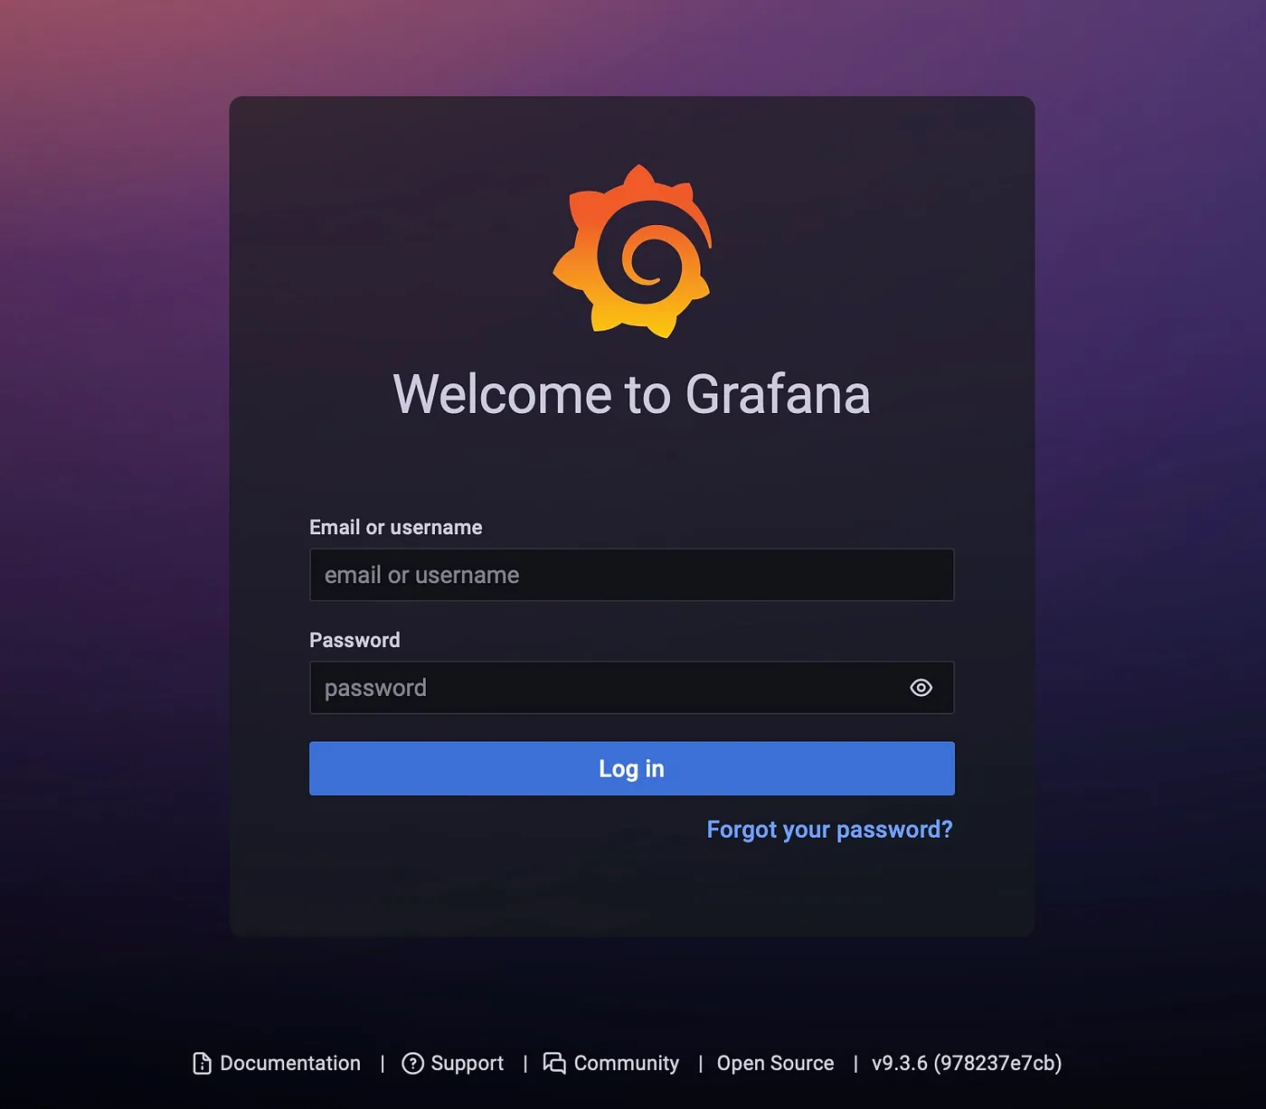

## **Conclusion**

Loki, Promtail, and Grafana are powerful tools for log aggregation and visualization. They allow you to efficiently manage and analyze log data, especially in environments using Prometheus for metrics. Together, they help you build a robust system for monitoring both logs and metrics from a single dashboard.

**A Hands-On Guide to Kubernetes Logging Using Grafana Loki**

### **Prerequisites**

Before you start, ensure you have:

* A **Kubernetes** cluster up and running.
* **Helm** installed on your system.
* **kubectl** configured to interact with your cluster.

### **Step 1: Add the Grafana Helm Repository**

First, you need to add the Grafana Helm repository to your system:

|  |
| --- |
| helm repo add grafana https://grafana.github.io/helm-charts  helm repo update |

### **Step 2: Search for the Loki Stack**

You can search for the Loki stack in the Grafana repository:

|  |
| --- |
| helm search repo loki |

### **Step 3: Get Default Values for the Loki Stack**

Retrieve the default values of the Loki stack and save them to a file:

|  |
| --- |
| helm show values grafana/loki-stack > loki-stack-values.yaml |

### **Step 4: Edit the loki-stack-values.yaml File**

Open the loki-stack-values.yaml file in a text editor and make the necessary modifications. Ensure that you enable Grafana and customize any other settings as required. Below is a sample configuration:

|  |
| --- |
| test_pod:  enabled: true  image: bats/bats:1.8.2  pullPolicy: IfNotPresent    loki:  enabled: true  isDefault: true  url: http://{{(include "loki.serviceName" .)}}:{{ .Values.loki.service.port }}  readinessProbe:  httpGet:  path: /ready  port: http-metrics  initialDelaySeconds: 45  livenessProbe:  httpGet:  path: /ready  port: http-metrics  initialDelaySeconds: 45  datasource:  jsonData: "{}"  uid: ""      promtail:  enabled: true  config:  logLevel: info  serverPort: 3101  clients:  - url: http://{{ .Release.Name }}:3100/loki/api/v1/push    fluent-bit:  enabled: false    grafana:  enabled: true  sidecar:  datasources:  label: ""  labelValue: ""  enabled: true  maxLines: 1000  image:  tag: latest    prometheus:  enabled: false  isDefault: false  url: http://{{ include "prometheus.fullname" .}}:{{ .Values.prometheus.server.service.servicePort }}{{ .Values.prometheus.server.prefixURL }}  datasource:  jsonData: "{}"    filebeat:  enabled: false  filebeatConfig:  filebeat.yml: |  # logging.level: debug  filebeat.inputs:  - type: container  paths:  - /var/log/containers/*.log  processors:  - add_kubernetes_metadata:  host: ${NODE_NAME}  matchers:  - logs_path:  logs_path: "/var/log/containers/"  output.logstash:  hosts: ["logstash-loki:5044"]    logstash:  enabled: false  image: grafana/logstash-output-loki  imageTag: 1.0.1  filters:  main: |-  filter {  if [kubernetes] {  mutate {  add_field => {  "container_name" => "%{[kubernetes][container][name]}"  "namespace" => "%{[kubernetes][namespace]}"  "pod" => "%{[kubernetes][pod][name]}"  }  replace => { "host" => "%{[kubernetes][node][name]}"}  }  }  mutate {  remove_field => ["tags"]  }  }  outputs:  main: |-  output {  loki {  url => "http://loki:3100/loki/api/v1/push"  #username => "test"  #password => "test"  }  # stdout { codec => rubydebug }  }    # proxy is currently only used by loki test pod  # Note: If http_proxy/https_proxy are set, then no_proxy should include the  # loki service name, so that tests are able to communicate with the loki  # service.  proxy:  http_proxy: ""  https_proxy: ""  no_proxy: "" |

### **Step 5: Install Loki, Promtail, and Grafana**

Now that you've customized your configuration, you can install the Loki stack using the following command:

|  |
| --- |
| helm install loki-stack grafana/loki-stack |

### **Step 6: Deploy the Loki Stack with Custom Values**

Deploy the Loki stack with your customized values by specifying the values file you edited:

|  |
| --- |
| helm install --values loki-stack-values.yaml loki grafana/loki-stack |

### **Step 7: Access Grafana**

Once the installation is complete, you can access Grafana to visualize your logs. By default, Grafana is exposed through a **LoadBalancer** service in Kubernetes. You can find the external IP by running:

|  |
| --- |
| kubectl get svc -n default |

### **Step 8: Set Up Data Sources in Grafana**

1. Log in to Grafana using the default username (admin) and password (prom-operator).

Once you log in you can see the home screen of Grafana, press the three lines at the top left corner you can see the menu then go to **Connections > Data sources** as shown in the below image.

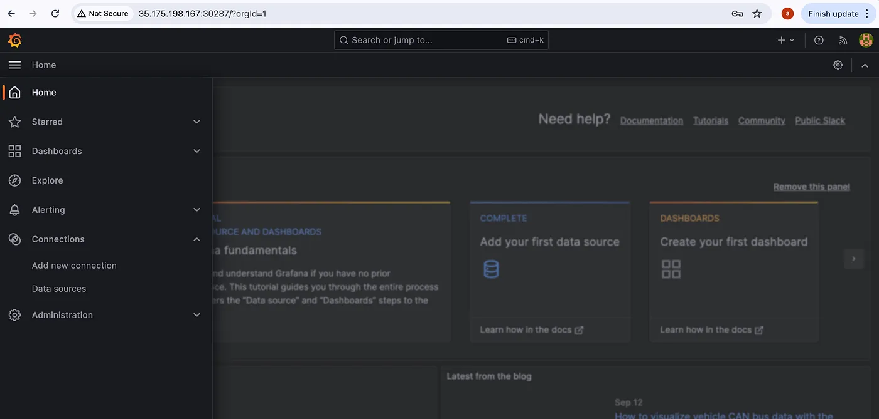

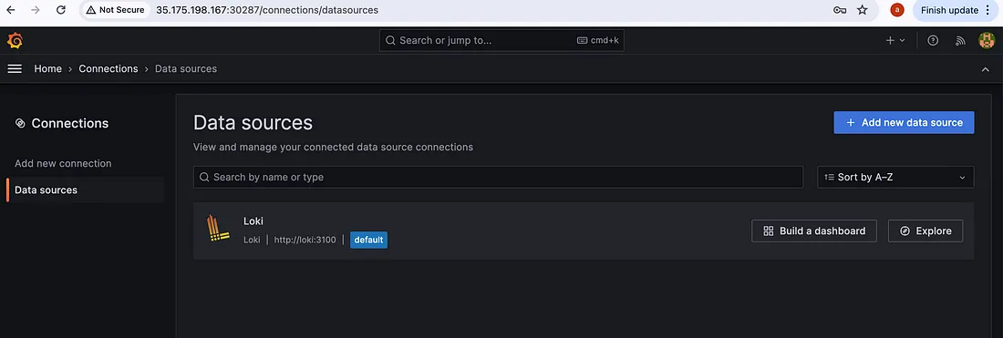  
Now, check if you are getting logs or not. Go to **Explore** by pressing the **Explore** button.

To query logs select a **Label** and **Value**, Loki will collect every log in your Kubernetes cluster and label it according to container, pod, namespace, deployments, jobs and other objects of Kubernetes.

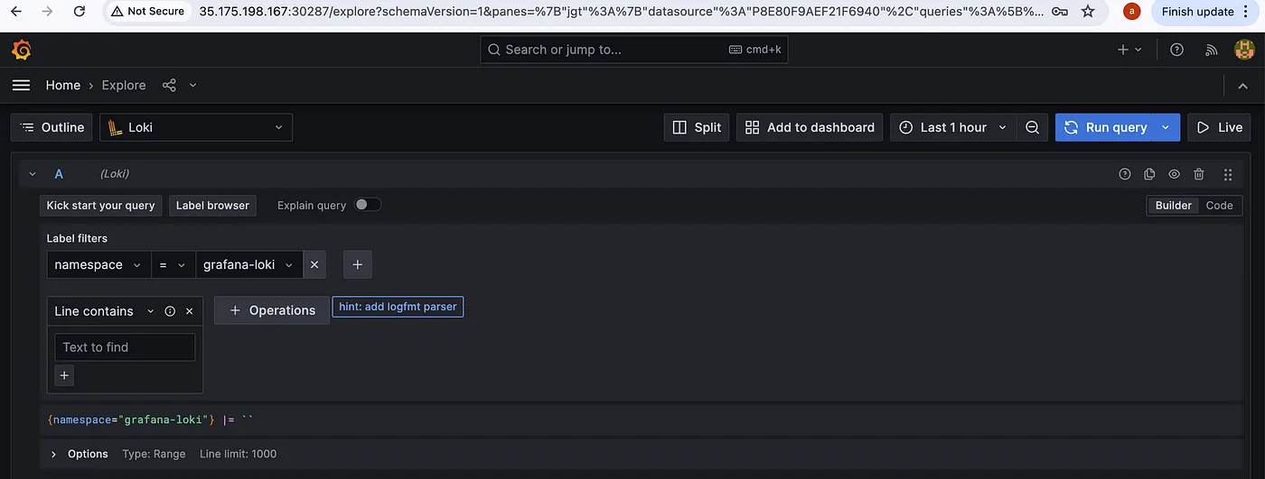

After selecting a **Label(namespace)** and **Value(grafana-loki)**, press the blue button at the top right corner(**Run Query**)to query logs.

