Android UI Specification

for

mobeegal v1.0.0
find stuff closer

Version 0.2 Draft
Muthu Ramadoss
created - Apr 23, 2008 / updated - Apr 24, 2008

Introduction
This specification is simply a starting point for the design of mobeegal v1.0, not a final blueprint. As we start to build the content, we’ll discover a lot of things that won’t work exactly as planned. We’ll invent new features, we’ll change things, we’ll refine the wording, etc. We’ll try to keep the spec up to date as things change. By no means should you consider this spec to be some kind of holy, cast-in-stone law.

mobeegal Android Screens
The mobeegal menu for ALL screens will contain exactly 3 menu items namely

- mStuff
- Catalogs
- Settings

Screen 1

Launch screen
There will be one icon called “mobeegal” - this would let the user enter into mobeegal application.
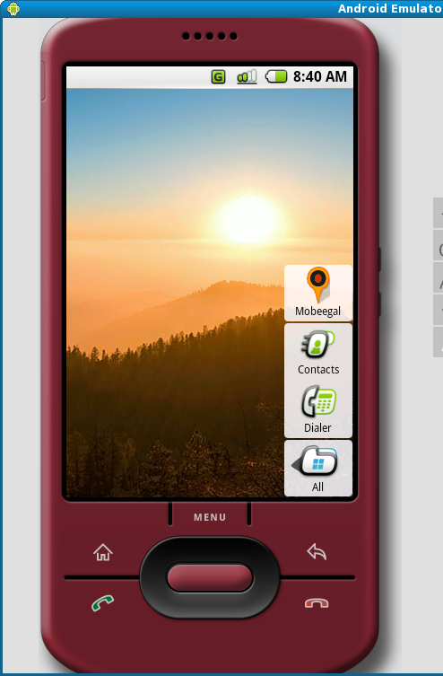

NOTE: Screen 1 must always lead to Screen 2

Screen 2

mStuff screen – can also be launched from the menu

This screen lets the user view all his mStuff (matches). There are 2 view modes – text view and map view.

Both view will contain a search box to search within mStuff. There will also be a drop down to filter the search results by catalogs. This search panel must be at the top of the mStuff screen and must have show/hide icons for better user experience.

Text View mStuff
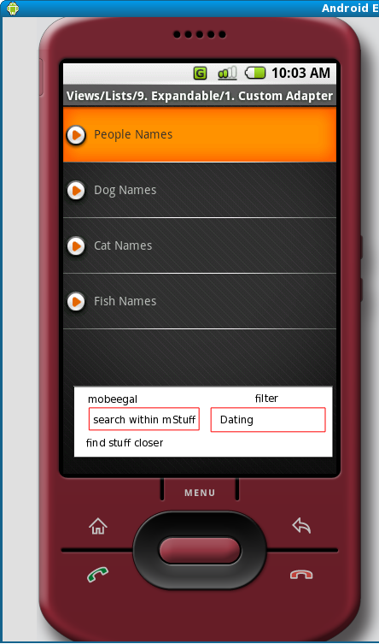
The mStuff match results for text view mode will be shown as a List. Each of the list item will be an mStuff. Clicking on the mStuff will take you to the mStuff detail screen.

Map View mStuff

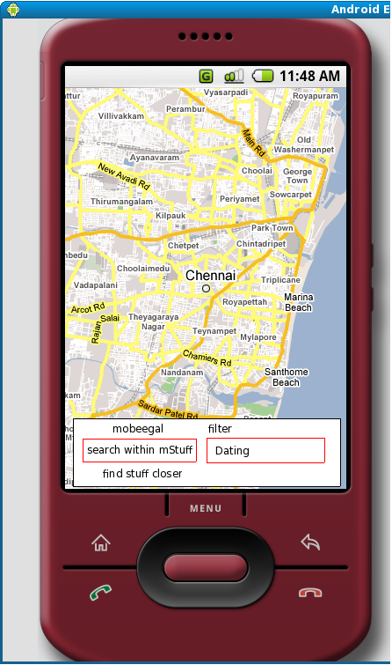
The map view will show the mStuff items in a map. Clicking on the mStuff will take you to the mStuff detail screen.

Catalogs Screen – launched by clicking the menu item.
This catalogs screen will show the installed and available catalogs. At the bottom of the screen will be an “Find and Install” button which will let the user explore and install the module that are free, available and also commercial pay per install modules.

Clicking on the catalog button will take the user to the Catalog detail screen.

Catalog Detail Screen
The Catalog detail screen will let the user enter mStuff search profiles. An mStuff search profile will contain a iStuff and an uStuff entry. User can enter as many mStuff search profiles as he likes. Currently mobeegal might support only a single mStuff search profile to be active at any time. Future releases might support multiple active mStuff search profiles.

Settings Screen – launched by clicking the menu item.
The Settings screen will contain 3 buttons namely

- Activate Service
- Preferences
- Help

Activate Service Screen
The Activate Service screen will let the user enable/disable his service. This might also have the time interval for service request to the server.

Preferences Screen
The Preferences screen will let the user record his mobeegal preferences like
- mStuff view in Text/Map mode
- Notification alert types etc.,

Help Screen
The Help screen displays help about mobeegal.

Summary

mobeegal is an innovative mobile search engine application built for mobile users all around the world. Finding your match be it for dating, shopping, jobs, marriage etc., in your location is only one click away from your mobile. Happy mobeegal!

