User Guide

for

mobeegal v1.0.0
find stuff closer

Version 0.1 Draft
Muthu Ramadoss
created - Apr 26, 2008 / updated - Apr 26, 2008

Introduction
mobeegal is a revolutionary mobile search engine to “find stuff closer” developed by IntelliBitz Technologies, Chennai, India.

mobeegal works on the following premise:
- Tell mobeegal what you are - iStuff.
- Tell mobeegal what you want – uStuff.
- mobeegal gives you the perfect match – mStuff.

Overview

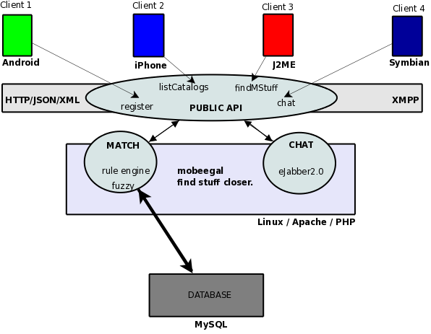
mobeegal helps users “find stuff closer” the mStuff, by matching “what you are” the iStuff, with “what you want”, the uStuff. Simple, yet Relevant!

Installation
Download mobeegal directly to your device. The exact installation procedure is not clear as of now since the SDK is final. We'll give the exact instructions once SDK makes it clean on the installation front.

Alternatively a zip file containing mobeegal client will be provided on the website.
Download the Android client from mobeegal website. The android client will come in a zip file. The zip file contains:
- Mobeegal.apk – the installable for your mobile.
- UserGuide – this document.
If you have the apk, do 'adb install Mobeegal.apk' in your android device.

Getting Started
Click the mobeegal launch icon from the launch screen.

Navigation between screens by Menu
3 Menu items will be shown in ALL the mobeegal screens.
- Matches
- Catalogs (The category you are interested in)
- Settings (and Preferences)

From any of the screen, you must be able to jump to one of the menu item as described above.

Welcome screen
The Matches screen will be the first screen the user view after entering mobeegal. If you have matches from your search query, it will be displayed here. The matches will be showed in a map, or in a list based on the user preference.

Clicking Matches in the map view or the list view will take you to the details screen.

Steps to do for doing a mobeegal search

Fill your profile
Filling your profile is done after selecting a catalog. There are 2 profiles that you can fill inside a catalog. The profiles are represented in a tab view. The first tab is called “iStuff” which means your profile.

Fill your target profile
Filling your target profile is done after selecting a catalog. There are 2 profiles that you can fill inside a catalog. The profiles are represented in a tab view. The second tab is called “mStuff” which means your match profile.

Activate service
To search using mobeegal, the mobeegal service in your mobile needs to be activated. To activate the service, hit the “Settings” menu. In the settings screen, there'll be a button named “Activate Service”. Push this button to start the service.

Thats it. Now mobeegal will begin searching for the perfect match. So to recap, to do a mobeegal search, you need to

- Fill your profile (iStuff)
- Fill target profile (uStuff)
- Activate Service

FAQ

- My Profile - again, care to explain?
My Profile is what the user is. This is the criteria that the user uses to describes his stuff.
Ex: In a Dating scenario, MyProfile would be your age, height, weight etc.,

- Target Profile - what is this?
Target profile is what the user wants. This is the criteria that the user is looking for in his match.
Ex: In a Dating scenario, TargetProfile would be your partners age, height, weight etc.,

- Match - can you explain?
Match is something that you wanted and is retrieved from the match result. The mobeegal server given your search Query, will find relevant Match results and return to the mobile. The server will return most probably a collection of Match results.

- Will there be User registration?
No. mobeegal will be completely stateless and anonymous as far as the User is concerned.

- Is mobeegal Secure?
Yes. All requests are encrypted for maximum User security.

- Is mobeegal Private?
Yes. Private information will never ever be send to the mobeegal server. Only the public information is shared with his matches.

- How can I search?
The User fills MyProfile and TargetProfile for whatever catalog that he cares. Now the search can begin.

- Do I need to activate the Service to search?
Yes. The service must be activated for search. The service will send the Query to the server only after its activated.

- How many service runs in mobeegal client?
Exactly one.

- Does the Service send the Query with every request to the Server?
No. The Service will be smart enough to send it only once. If the Query has not changed, any future service request might just be a ping to the server to retrieve only the Match results.

- Do I need to fill both MyProfile and TargetProfile for searching?
Yes. Filling both MyProfile and TargetProfile will be required for search. Just like you need a search query for searching, mobeegal requires the profiles to be filled which will included in your search criteria to bring you the relevant Match results.

- Can I have multiple Search Profiles filled up?
Yes. Any number of Search profiles can be filled for as many catalogs as the User likes. All Search queries will be bundled into exactly one Query.

- Can I search more than 1 catalog?
Yes, More than one catalog will be available for searching. Multiple profiles will be send as a single Query which will span multiple catalogs.

- Can I filter the Match results?
Yes. You can filter the Matches by catalogs. There will be a search button and a filter drop down available in your Match result views.

- Can I search within the Match results?
Yes. A search box will be provided to search within the Match results.

- Is there more than one way of looking at my Match results?
The user can switch between text mode and map mode for viewing the Match results. The search and filter widget will be available for both modes of viewing.

- How do I activate the Service?
The User can hit the menu, go to settings. Activate/De-Activate Service is available here.

- Where do I store my Preferences?
The User can hit the menu, go to settings. Preferences button is available here. This would take the User to a separate screen to store the User preferences.

- Help?
Available in the Settings menu. Click Settings menu, and Help is one of the buttons available.

- mobeegal rocks!
Glad you liked it.

Summary

mobeegal is an innovative mobile search engine application built for mobile users all around the world. Finding your match be it for dating, shopping, jobs, marriage etc., in your location is only one click away from your mobile. Happy mobeegal!

