Testcase Specification

for

mobeegal v1.0.0
find stuff closer

Version 0.2 Draft
Muthu Ramadoss
created - Apr 25, 2008 / updated - Apr 25, 2008

Introduction
This specification is simply a starting point for the design of mobeegal v1.0, not a final blueprint. As we start to build the content, we’ll discover a lot of things that won’t work exactly as planned. We’ll invent new features, we’ll change things, we’ll refine the wording, etc. We’ll try to keep the spec up to date as things change. By no means should you consider this spec to be some kind of holy, cast-in-stone law.

Overview

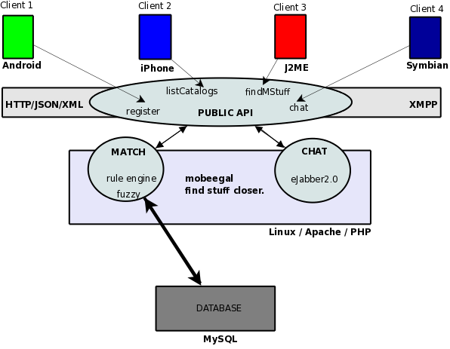
mobeegal is a revolutionary search engine to “find stuff closer” developed by IntelliBitz Technologies, Chennai, India.

Getting Started
The following mobeegal systems will be tested.

Android Client
mobeegal Server – match, chat

FAQ
What kind of testing will be done?
The test case will model User Acceptance testing.

mobeegal v1.0.0-alpha Testcase

Android Client

Menu (Common Testcase for ALL screens)
3 Menu items will be shown in ALL the mobeegal screens.
- mStuff
- Catalogs
- Settings

Launch
- Verify if launch icon is correctly shown in the main screen.

Click Launch
Clicking Launch icon must enter the user into mobeegal. User must have landed in mStuff MapView.
- Verify the screen currently is mStuff MapView.
- Verify menu is shown correctly as per the menu testcase.

Click Catalog Menu Item
Clicking catalog menu items must take the user to the catalog screen.
- Verify catalogs are shown in the catalog screen. For Alpha there'll be exactly one button named “Dating”.
- Verify menu is shown correctly as per the menu testcase.

Click Dating Catalog button in the Catalog screen
Clicking dating catalog button must correctly take the user to the Dating screen.
- Verify iStuff tab is shown.
- Enter attributes in iStuff.
- Verify uStuff tab is shown.
- Enter attributes in uStuff.
- Verify matching has begun and mStuff results are starting to come in as per your preferences.

Click Settings Menu Item
Clicking settings menu item will enter the user into the settings screen. There'll be 3 buttons on this screen.
- Verify Activate Service button is the first button.
- Verify Preferences is the second button.
- Verify Help is the third button.
- Verify menu is shown correctly as per the menu testcase.

Click Activate Service in Settings screen
Clicking activate service must start the mobeegal service.
- Verify a message is shown indicating the service is started. If the service is already started, verify a message shown indicating service already started.
- Stop the service and verify message shown.
- Start the service again and leave it running.

Click Preferences in Settings Screen
Clicking Preferences button must take the user to the preferences screen.
- Verify user preferences including mStuff View, Service request interval, Notification alerts type can be set from here.
- Verify menu is shown correctly as per the menu testcase.

Set mStuff View preference to TextView in Preferences screen
Clicking the radio button option will correctly set it to TextView. You can toggle between MapView and TextView. Leave the checked option to TextView.
- Click mStuff View menu item and verify the view has changed to TextView.

Set service request interval in Preferences screen
- Verify “Auto”, “Manual” radio button available.
- Click “Auto”.
- Verify dropdown appears for setting the request time like every minute, 5 minutes etc.,

Click mStuff menu item
Clicking mStuff menu item will take the user to the mStuff view.
- Verify mStuff results are shown. Verify mStuff results match your mStuff Query.
- Verify search text box is available to search within mStuff results.
- Verify filter drop down is available to filter by catalogs.
- Each mStuff result will show the mStuff details.
- Clicking mStuff marker will take the user to the mStuff detail page.

Click mStuff marker in mStuff MapView

Click mStuff item in mStuff TextView
Clicking mStuff will take the user to the mStuff detail page.
- Verify mStuff details are shown.
- Verify chat can be initiated.
- Verify like, dislike can be voted.

mobeegal Server

HTTP/JSON API Testcase
Invoking each of the method will return an appropriate response. Please refer to the API docs for details on each of the Http/Json methods.

mobeegal match

User Foo: Create mStuff Query:
Create iStuff:
Age – 20, Sex – M, Height-170cms, Weight-65kg, Location-Tnagar
Create uStuff
Age – 18-20, Sex-FM, Height-145-165cms,Weight-45-55kg,Location-Tnagar

Foo does a mStuff Query.
Foo will not get a match yet since there's no other users in the system. So no matching can be done.

User Bar: Create mStuff Query:
Create iStuff:
Age – 18, Sex-FM, Height-155cms,Weight-50kg,Location-Tnagar
Create uStuff
Age – 18, Sex – M, Height-170cms, Weight-65kg, Location-Tnagar

Bar does a mStuff Query.

EXACT MATCH - RESULTS:

In the above scenario, Bar will not get a match.
Reason: Since its an EXACT MATCH Bar uStuff Age criteria fails.

Foo gets Bar as a match.
Reason: Foo uStuff criteria has been set to a range, and the range falls within the EXACT MATCH of Bar.

NON EXACT MATCH - RESULTS:

Both Foo and Bar will get a match since one of the attributes have matched in their Query.

mobeegal v1.0.0-beta Testcase
Coming soon.

Summary

mobeegal is an innovative mobile search engine application built for mobile users all around the world. Finding your match be it for dating, shopping, jobs, marriage etc., in your location is only one click away from your mobile. Happy mobeegal!

