Mobeegal

Home Page

Mobeegal
Server DB

Response from the Mobeegal server to
catalogs
local database.
Mobeegal
Local
sqlite DB

Catalogs Loaded in to local
database table.
FindandInstall
Table Name : Catalogs
Table Name: Category

Send Request to server

(find catalogs)

Dating
Display Catalogs available in Local DB

FindandInstall

MOBEEGAL HOME SCREEN

- User enters a mobeegal search catalog, and can select any of the mobeegal search category available. Dating will be the available catalog for alpha with no sub-categories. Shopping, Jobs, Rental, Restaurants, Movies are other catalogs available but are inactive. These additional catalogs will be made available for beta.

FindandInstall
Dating
Istuff
Details
iStuff
uStuff
ustuff
Details
iStuff
uStuff
submit
Local
SQLite
DataBase

store iStuff and uStuff Results

Steps:
Step 1: User have to select catalogs by clicking catalog button.
Step 2: Click event makes request to the server.
Step 3: Server Response by loading the available catalogs into Local database.
Step 4: FindandInstall page fetches the available catalogs from the local database.
Step 5: By clicking catalog(Dating) icon the istuff and ustuff details will display.
Step 6: User can create and submit iStuff, User can create and submit uStuff.
Step 7: User can submit a mStuff Query (iStuff+uStuff)

FIND AND INSTALL SCREEN
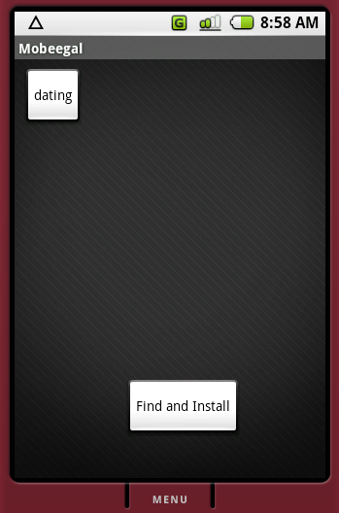
RELATED TABLES:
- catalog
- categories
- iStuff
- uStuff

Mobeegal

Home Page

Service Start/Stop Response
Mobeegal
Server
Activate
Deactivate

Service Start /
settings
Stop Request
Activateservice
(mStuff Query)
Start/Stop
Preference
( iStuff mStuff
MapView
TextView

view
service
Auto
Manual

view
service
+ Data's
Help
uStuff )
Minutes
(user Guide)
submit
Local
Sqlite
DataBase
submit
Manual
Guide
for
mobeegal
Users
view type service type
Map/Text Auto/Manual

Change Setting will Load in DBTable

USER SETTING SCREEN
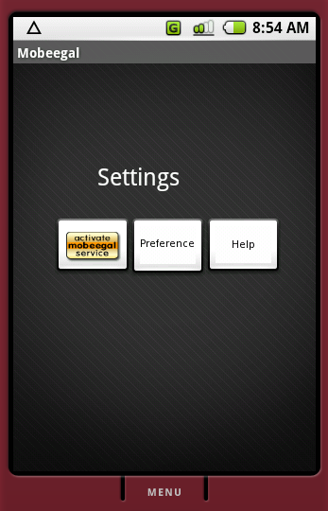
- User can start/stop the mobeegal service. User can set the location broadcast to “auto” or “manual” mode. Anonymous Registration of the User will be done when the Service is first activated. Once Registered the User registration will not happen again.
Location
Brodcasting

Turn On
Turn Off

Service Start/Stop Response
Mobeegal
Server
(Notification Alerts for mStuff Query)

Service Start/Stop Request
Start/Stop
( Latitude and Longitude information)

Steps:
Step 1: User have to set the type of view (Map/Text) in Preference Settings
Step 2: User have to set the service Notification Intervals by setting (Auto/Manual) in Preference Settings.
Step 3: User can Activate/Deactivate the services from Active Mobeegal Service.
Step 4: Anonymous Registration of the User will be done when the Service is first activated
Step 5: User gets notifications about mStuff results (matches) without interfering his normal activities
Step 6: User can view mStuff results (matches) in his Map/ Text where the results show up in a list.
Step 7: mobeegal service will be broadcasting the mobile user current locations to the mobeegal server when the user is on the move
SERVICE ACTIVATION SCREEN
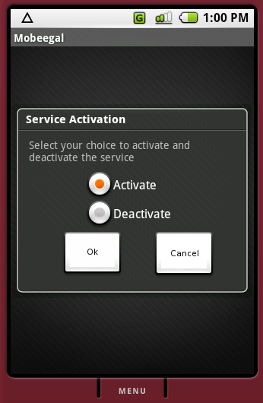
RELATED TABLES:
- Mobeegaluser
- Service
- iStuff
- uStuff
- mStuff
- Preferences
Mobeegal

Home page

mStuff
Map View
or
Text View

View type Setting set by the user in setting screen
Local
Sqlite
DataBase
Request to fetch the mStuff Result
(Add to favorites/ Ignore Results/ Search)

Response by fetching the available MStuff Result
As per the request made by User
Chat

MSTUFF MAPVIEW SCREEN
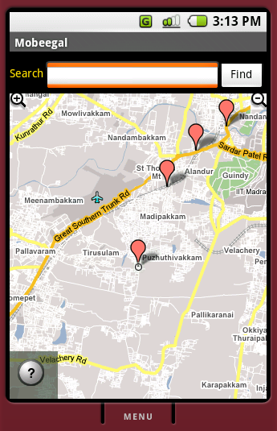
- mStuff is the matched results for a particular search criteria. The search criteria is applicable for a search category in a catalog. The mStuff can be rated and voted up and down. Voting up means the user likes it, and voting down means he dislikes it. This rating will be send to the server, and would be of impact in future search results.
Xmpp
Chat
with
mStuff
Result
(iStuff User)
Xmpp
Chat
with
mStuff
Result
(User-n)
Xmpp Chat

Mobeegal
Server provides
Connection
Establishment

Request to chat mStuff Matches Posting request to mStuff Matches

Steps:
Step 1: User can view mStuff results (matches) in his MapView
Step 2: User can view mStuff results (matches) in his TextView
Step 3: User can add one or more of the match as favorites. This is voting up.
Step 4: User can add one or more match as ignore. This is voting down.
Step 5: User can search within the mStuff results.
Step 6: Only the public information as allowed by the user will be visible to the match
Step 7: User can chat with one or more of his match at any time, chat will also depend on the willingness and availability of the match.
MSTUFF TEXTVIEW SCREEN
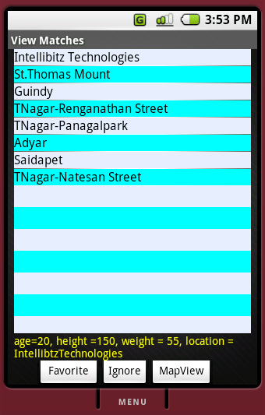
RELATED TABLES:
- mStuffmapview
- favorites
- searchResults
- selectedlocation
- mStuff

