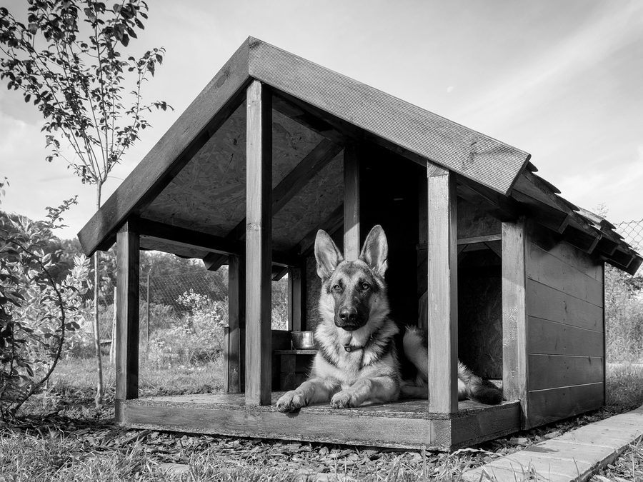

**Sustainable Doghouse Challenge**

**UT CAEE and TexASHRAE present the 4th annual:**

**First place teams from each division receive $1000 and second place teams receive $500!**

**Competition on ECJ Plaza**

**Wednesday, April 8th**

**2:00 pm – 5:00 pm**

**Compete against your fellow students for prizes in this year’s challenge!**

* **Feb 4th 5:00 – 6:00 pm**
* **Feb 7th 1:00 – 2:00 pm**
* **Jan 28th 3:30 – 4:30 pm**
* **Jan 29th 3:00 – 4:00 pm**
* **Jan 30th 5:00 – 6:00 pm**

**Attend one of the remaining info sessions to learn more**

**Jan. sessions held in ECJ 5.442 – Feb. sessions held in ECJ 4.304**