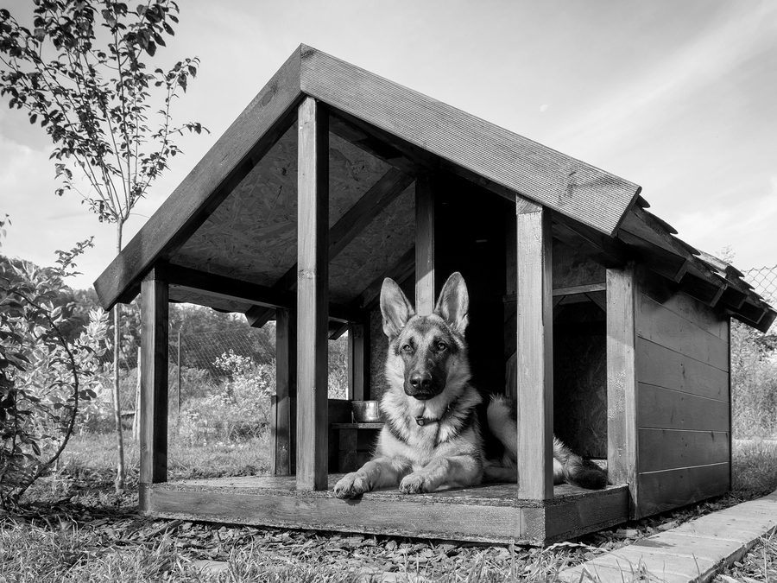

**Sustainable Doghouse Challenge**

**UT CAEE and TexASHRAE present the 4th annual:**

**Info Sessions:**

* **Jan 28th 3:30 – 4:30 pm**
* **Jan 29th 3:00 – 4:00 pm**
* **Jan 30th 5:00 – 6:00 pm**

**All sessions will be held in ECJ 5.442**

**T-R-E-A-T-S provided!**

**Learn how you can compete against your fellow students for prizes in this year’s challenge!**