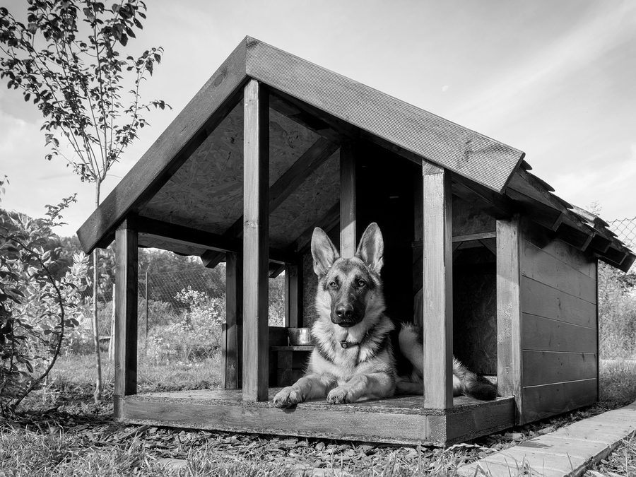

**Sustainable Doghouse Challenge**

**UT CAEE and TexASHRAE present the 4th annual:**

**Feb 4th 5:00 – 6:00 pm**

**Feb 7th 1:00 – 2:00 pm**

**Attend one of the remaining info sessions to learn more**

**Sessions held in ECJ 4.304**

**All teams must send at least one representative to an info session.**

**Can’t make the info session or looking for a team? Email texasashrae@gmail.com**

**First place teams from each division receive $1000 and second place teams receive $500!**

**Competition on ECJ Plaza**

**Wednesday, April 8th**

**2:00 pm – 5:00 pm**

**Compete against your fellow students for prizes in this year’s challenge!**