BEVO Beacon IAQ

Building EnVironment and Occupancy (BEVO) Beacon for Indoor Air Quality (IAQ)

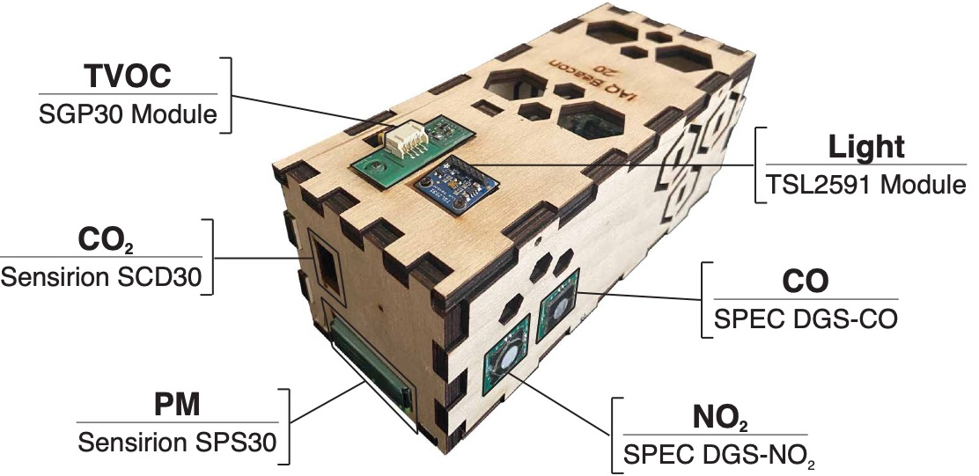

# Variables Measured

* Total Volatile Organic Compounds
* Carbon Dioxide
* Particulate Matter
* Light
* Temperature
* Relative Humidity
* Carbon Monoxide
* Nitrogen Dioxide

# Sensor List

* Sensirion SVM30/SGP30: Sensor used to measure **Total Volatile Organic Compounds** (TVOCs) associated with cleaning materials, personal care products, and some naturally occurring compounds.
* Sensirion SCD30: Measures **Carbon Dioxide** (CO2) primarily associated with human respiration that allows us to estimate occupancy and ventilation rates
* Sensirion SPS30: Used to measure **Particulate Matter** (PM) – more typically referred to as “dust” – associated with many indoor and outdoor sources like smoking, candles, cooking, traffic, construction, etc.
* Adafruit TSL2591: Sensor used to measure **Light**
* SPEC DGS-CO: Sensor capable of measuring **Carbon Monoxide** (CO), typically associated with natural gas/petroleum burning in homes and vehicles. This sensor also measures **Temperature** and **Relative Humidity.**
* SPEC DGS-NO2: Sensor that measures **Nitrogen Dioxide** (NO2), a pollutant typically generated outdoors from vehicle emissions. This sensor also measures **Temperature** and **Relative Humidity.**

# Component List

* Raspberry Pi 3B+: Microcomputer with no attached user-interface that runs all the sensing modules and stores measurements from these modules locally on a SD card. Has WiFi and Bluetooth capabilities and can be access remotely by researchers.
* Computer Fan: a 40mm-by-40mm low-noise fan to help cool the processing unit on the Raspberry Pi.
* OLED Screen (not pictured): A small 0.96-inch screen that displays the latest measurements made by each sensor. The display cycles through each of the variables listed above.
* Real-Time Clock: A battery powered clock (part name: Adafruit PCF8523) keeps accurate time if the device is disconnected from WiFi.