Environment and Experiences Survey

A survey to assess the participant’s living environment, health practices, and recent activity to be asked a few times during the study period.

# Initial Questions

# Built Environment Questions

# Home Cleaning Questions

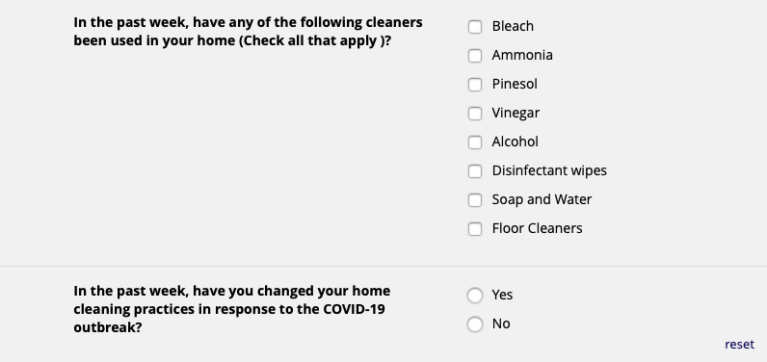

# Hand Hygiene

# Additional Activity Questions



