**PURPOSE:** To provide a framework for the operation and deployment of the Building EnVironment and Occupancy (BEVO) Beacon. The SOP will outline interfacing with the device, the deployment process, how to diagnose common issues, the location and format of the locally stored data, and how to successfully download data from the device.

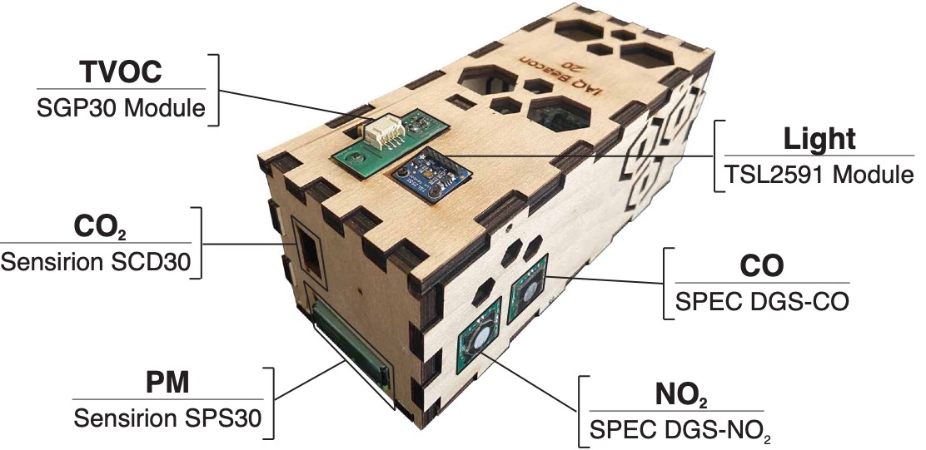

**POLICY:** This SOP should be referenced when researchers deploy and operate the BEVO Beacon device in studies to monitor indoor environmental conditions.

**TRAINING:** No specific training is required, but familiarity with Raspberry Pi (RPi) devices and a Linux-based operating system is recommended. The following is an exhaustive list of acronyms that the reader can refer back to:

* BEVO: Building EnVironment and Occupancy
* I2C: Inter-Integrated Circuit
* IEL: Intelligent Environments Lab
* IoT: Internet of Things
* RPi: Raspberry Pi
* SSH: Secure Shell Protocol
* VPN: Virtual Private Network

**PROCEDURE:**

1. Deployment
   1. Deployment of the device is a straightforward process: researchers and/or participants simply need to power the device on by inserting the micro-USB end of the provided power cable into the small cutout in the wooden housing and plug the other end into a standard wall outlet.
      1. Researchers and/or participants should be able to locate the small, red LED light (see picture below). If the light is red, the device is receiving power.

* + 1. Periodically, a green LED light next to the red light mentioned in the previous bullet point should flicker on and off. This light activates when the BEVO Beacon is processing and normally only activates sporadically for a very short period. **The green light is most active at initial boot.**
    2. Additionally, the small cooling fan should start if correctly powered on and a small humming noise should be audible.

1. Diagnosing Common Issues
   1. **No power**: If the red LED does not light up or the operation of the fan is not audible, try the following to correct the issue
      1. Check that the micro-USB end is firmly and completely plugged in to the RPi. Plugging in this end can take considerable effort.
      2. Use a different outlet: The outlet might not be providing sufficient power
      3. Try using a different cable: Using another approved Micro-USB to standard wall outlet plug, try powering on the device again.
      4. If problems persist, the device might have been accidently shorted. To check for this:
         1. Unplug the device
         2. Carefully remove the top panel by unscrewing the wood screws
         3. Locate the Raspberry Pi: The Raspberry Pi will be the green, credit-card size chip in the larger partition of the device.
         4. Locate the group of wires near one of the top corners of the Raspberry Pi
         5. Unplug *all* wires from the Raspberry Pi (the sensors connected to the USB-A ports at the opposite end of the Raspberry Pi can be left plugged in)
         6. Try powering on the device again
            1. If the red light illuminates with none of the components plugged in, then there is a wiring issue, and the device needs maintenance
            2. If the red light does *not* illuminate, then the Raspberry Pi needs to be replaced
2. Data Storage on the BEVO Beacon
   1. Measurements made by the BEVO Beacon are stored locally on the device on an 8 GB SD card
      1. Measurements are made at 1-minute intervals
      2. 24 individual fields including the timestamp and concentration/measurements of 23 environmental measures
      3. Data files are generated per day and are a maximum of ~445 KB
   2. Data on each device are stored in the /home/pi/DATA/ directory with a file format of b##_YYYY-MM-DD.csv where the ## refers to the beacon number. Device, month, and day numbers less than 10 are padded with a leading zero in the filename i.e. data from device 7 on June 16th, 2021 would be under b07_2021-06-15.csv
3. Downloading Data from the BEVO Beacon
   1. There are multiple ways to download data from the Raspberry Pi, but the simplest way is to use a Secure Copy (SCP) command.
      1. The SCP command connects to the BEVO Beacon via SSH and copies a directory or file to the location that you specify.
      2. From the command line interface on your device, you will type the following command:
         1. “scp -r ConnectTimeout=3 pi@<tailscale_ip_address>: /home/pi/DATA/ <location_on_your_device>”
         2. This will copy the /home/pi/DATA directory and all the files within to the location that you specify. If prompted for a password, use the default “raspberry”.
         3. Make sure that you have followed all the instructions in Section 1 of this document to successfully interface with the BEVO Beacon.
   2. Data can be downloaded to a USB drive, but is not recommended as it would require dismantling the device to get to an open USB-A connection.
   3. Data can be downloaded directly from the SD card by removing the small side panel opposite the small side panel with the CO2/PM sensors. This process is less invasive than using a USB drive, but again requires dismantling the device to a certain extent.