

KENYATTA UNIVERSITY

SCHOOL OF ENGINEERING AND TECHNOLOGY

CIT DEPARTMENT

SIT 400

PROJECT PROPOSAL

TOPIC: KILIMO CHA MAZIWA APP

BY

JOSEPH KATHIRU

Registration No: J31/3669/2017

kathirujoseph@gmail.com.com

SUPERVISOR: MR. Joseph Muriuki

Table of Contents

CHAPTER FOUR: SYSTEM ANALYSIS 1

4.1 INTRODUCTION 1

4.2 Data Collection Techniques 1

4.2.2 Document Analysis 1

4.2.3 Current System Analysis 1

4.3 Description of the proposed system 2

4.4 FEASIBILITY ANALYSIS 2

4.4.1 Technical Feasibility 2

4.4.2 Operational feasibility 2

4.4.3 Economic Feasibility 2

4.5 REQUIREMENT ANALYSIS 3

4.5.1 Functional Requirements 3

4.5.2 Non-Functional Requirements 3

CHAPTER FIVE: SYSTEM DESIGN 4

5.1 INTRODUCTION 4

5.2 SYSTEM ANALYSIS 4

5.2.1 Use case diagram 4

5

5.2.2 Activity diagram 6

5.2.3 Sequence diagram 7

5.2.4 Class diagram 8

5.2.5 Entity Relation Diagram 9

5.3 SYSTEM ARCHITECTURE. 10

## CHAPTER FOUR: SYSTEM ANALYSIS

## 4.1 INTRODUCTION

This section is going to highlight the overall functional requirements, performance requirements and the design constraints of the system. It will be a phase divided into three main stages, which are:

**Analysis strategy:** This is the phase which the study of the current system will be carried out, and the findings from the study used to develop the proposed system.

**Requirements gathering:** This phase will mainly involve the analysis of the information gathered in order to come up with the concept of the proposed system, that is, the user and system requirements.

**System proposal:** This is the document which will be presented, outlining all the phases and information for the proposed system.

## 4.2 Data Collection Techniques

4.2.1 Interviews

Further data from the company will be needed to ensure all the user requirements are well captured in the system implementation. Therefore, interviews will come in handy to collect data from the company’s management and staff on the problems they are facing with the current system, what they prefer to be including in the proposed system and any other useful information.

## 4.2.2 Document Analysis

After conducting the interview and acquiring a nutshell of information about the current system, analysis of the current system documentation will take place, helping get the information of the modules already assembled, the flow implemented in the system, the requirements of the system and this information will be used to decide on what to modify or do away with in the proposed system.

## 4.2.3 Current System Analysis

Mukurweini Dairy Ltd still hasn’t embraced technology as the milk recording is still done manually for each farmer and give receipts to the farmers. The milk agents also get to keep a copy of the receipt which they keep in physical files. The information is then entered to the database manually and used to make payments to the farmers at the end of the month. This manual recording can sometimes lead to misplacement of receipts leading to the farmer’s information getting lost or errors may arise when updating the information in the database, making an inconsistency between the farmer’s receipts and what exists in the database.

## 4.3 Description of the proposed system

The proposed system will be an android based mobile system, deployable in an online server. The proposed mobile application will help in automatic milk recording by the farmers and the receiving organization at the selling point. This will enable the farmers to be aware of much they have sold at a particular time in the month and can also know how much to expect in terms of payment at the end of the month. The farmers will also be able to have access to veterinary services in the mobile application will be able to contact the veterinary personnel who will find them by their location. The farmers will also have access to financial services through the mobile application whereby their can apply for the Maziwa Mingi loan.

# 4.4 FEASIBILITY ANALYSIS

# 4.4.1 Technical Feasibility

We carried out a technical feasibility analysis to find out whether the existing technology supports the proposed mobile application. Due to growing use of smart phones, the technology used in development of the Kilimo Cha Maziwa App is supported by most of the Android devices available to the farmer. Also due to high growth of the smart phones, most farmers have become literate on how to operate their phones hence they are highly unlikely to experience difficulties while using the mobile App.

# 4.4.2 Operational feasibility

We carried out this study to find out how well the mobile application will deliver the operations needed efficiently. We ensured sufficient storage and processing capability of the server to ensure that the system has good operational capability. This included ways of how to handle network errors while a transaction is happening.

# 4.4.3 Economic Feasibility

We examined the cost incurred and the benefit. It involves the cost incurred for the resources required for development. The mobile application though it doesn’t generate income, it saves resources such as time and ensures dependability and efficiency of the Dairy farmer’s data that will lead to the generation of his or her income.

# 4.5 REQUIREMENT ANALYSIS

A requirement is a description of features and functionalities of the target system Requirements analysis is the process of developing software specifications that are intended to communicate the system needs of the customer to the system developers. It involves determining the user expectations for the system. It can be classified as either functional or non-functional requirements.

# 4.5.1 Functional Requirements

These requirements specify the functions that the system is expected to perform.

They included the following:

1. To allow a user to sign up and login to the account in the mobile application.
2. To allow the dairy farmer to input the daily milk records sold in the mobile application.
3. To allow the dairy farmer generate reports of each transaction made to the database.
4. To allow dairy farmer contact the Vet inside the mobile application.
5. To allow the Vet locate the geo-location of the farmer.
6. Allow the dairy farmer apply for the Maziwa Mingi Loan.

# 4.5.2 Non-Functional Requirements

1. Reliability -The mobile application ensures minimum failure, and the rate of occurrence of failures for instance in the case of Network errors.
2. Ease of use – The mobile application is easy to use for all the users involved especially because of the good user Interface and clear instructions.
3. Confidentiality – The information gathered during the authentication is confidential.
4. Availability - The services offered by the mobile application will always be available at all times needed.
5. Understandability- The mobile application is easy to understand by new users based on the user-friendly interface.
6. Performance - the response time of the mobile application to user requests. The response of the system should be fast in that it meets the user requests with minimum delay or no delay at all.

# CHAPTER FIVE: SYSTEM DESIGN

# 5.1 INTRODUCTION

This chapter describes the feasibility analysis, functional and non-functional requirements result of the interview analysis and design of the Kilimo Cha Maziwa Mobile Application. It involves feasibility analysis, functional and non-functional requirements and UML diagrams. The designed UML diagrams represent the system, its flow and the expected interactions with the various users.

# 5.2 SYSTEM ANALYSIS

It’s a technique that divides a system into its components to understand how the components work and interact to accomplish the designed purpose.

# 5.2.1 Use case diagram

This diagram shows how actors interact with the system. There are five actors, Dairy Farmer, Manager, Vet and the App Admin. In this case the Dairy Farmer is the primary actor while the manager, vet and App admin are the secondary actors.

# 

# 5.2.2 Activity diagram

The diagram shows the flow of activities in the system. It also shows who initiates the actions performed.

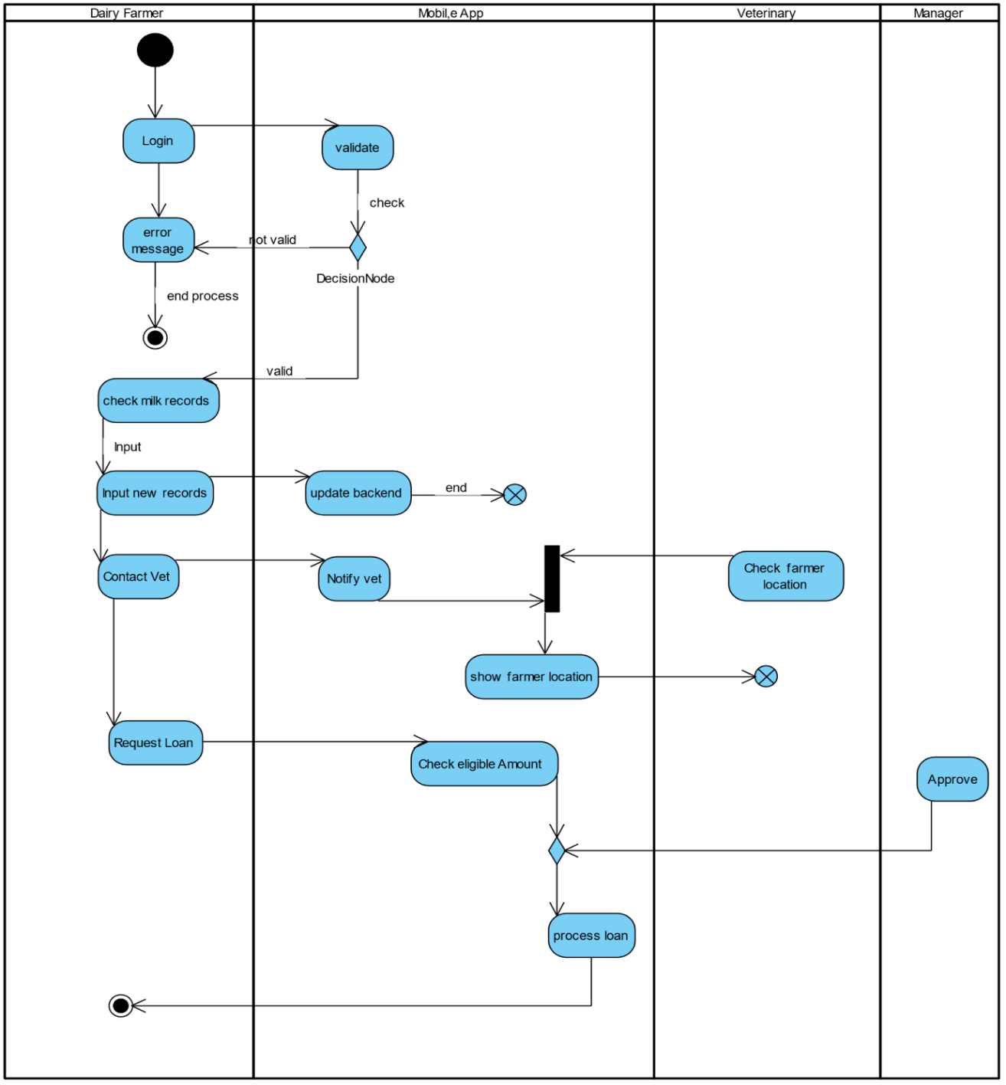

# 5.2.3 Sequence diagram

The diagram gives the sequence of activities in the system. There are five actors, Dairy Farmer, Manager, Vet and the App Admin. The different actors have different objects to interact. The diagram shows which activities precedes others for instance, updating a milk record cannot be performed before authentication of the user is done.

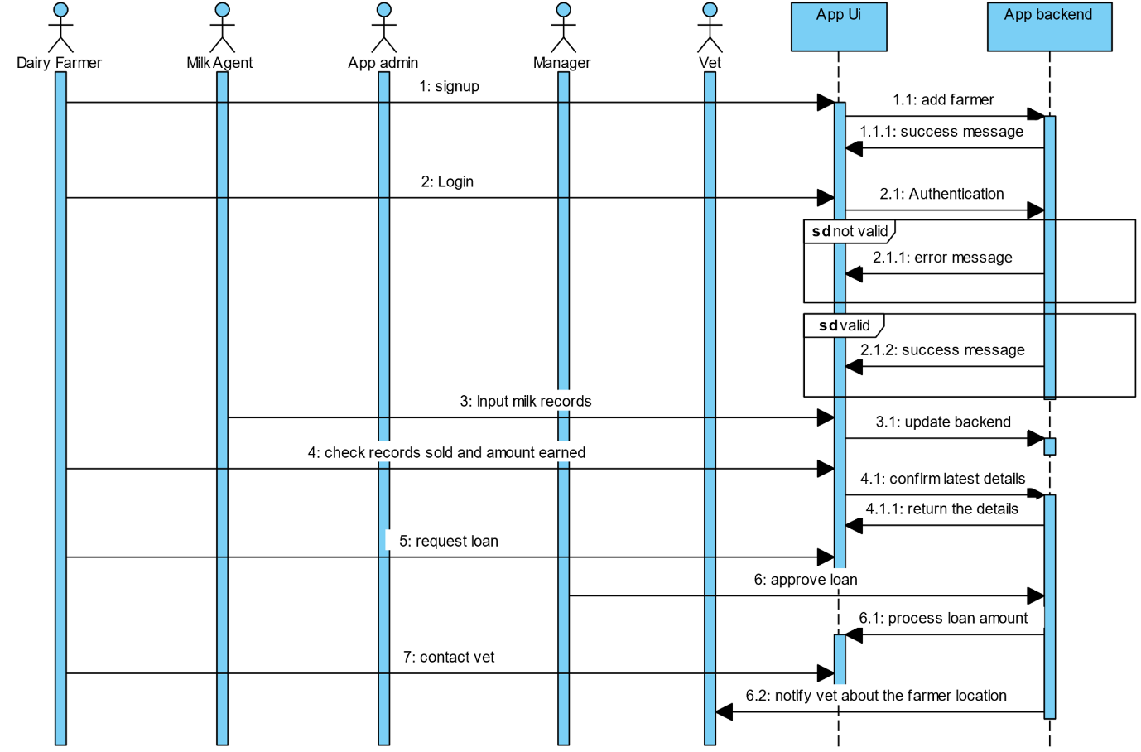

# 5.2.4 Class diagram

The diagram shows the relationship among the main classes. There are four main classes, Dairy Farmer, Vet, Manager and the App admin. For instance, many dairy farmers can contact many veterinaries and many veterinaries can provide services to many dairy farmers. This is a many to many relationship.

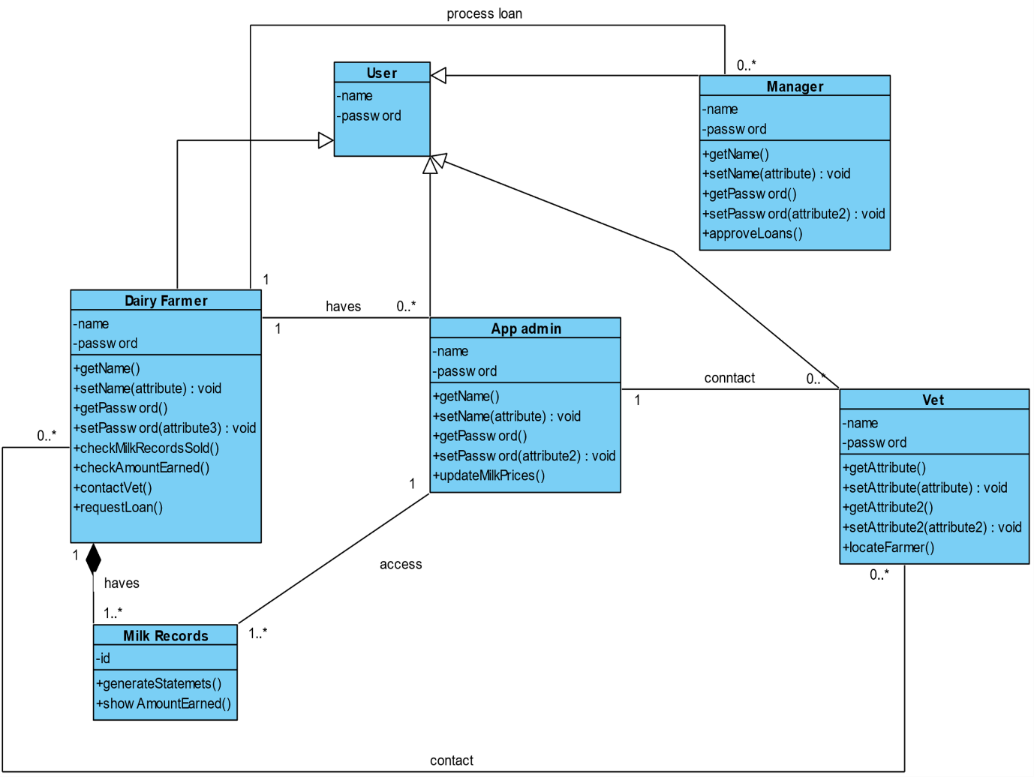

# 5.2.5 Entity Relation Diagram

The diagram shows the relationships between different entities of the database. It makes use of primary keys which are unique columns in the rows of a database and also the foreign keys which are primary keys of other tables in the database.

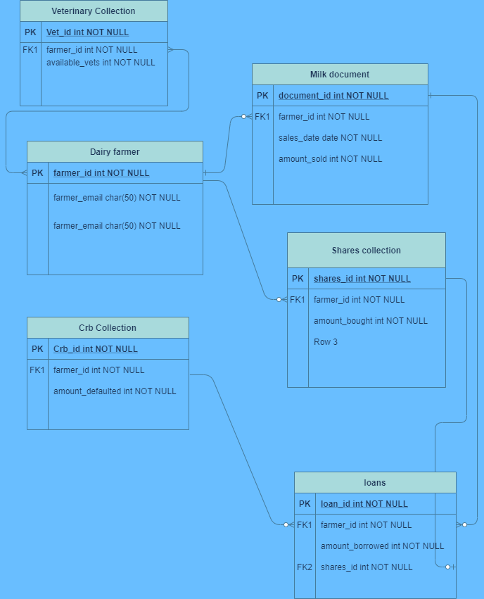

## 5.3 SYSTEM ARCHITECTURE.

The proposed system will make use of three-tiered client-server architecture due to its simplistic nature which allows the three tiers (presentation tier, application tier and data tier) to work as separate modules hence making tiers to be developed separately.

The system’s components will comprise both the software and hardware parts of the system. The hardware components shall constitute of the client, server and the network that will be used to connect both the client and the server. At the client level, the system will be accessed through a mobile based application. A network connection of various speeds will be ample to gain access into the system. Only authenticated persons will get access to the system database.