PROJECT REPORT

BUILD AN EMPLOYEE TRAVEL APPROVAL APPLICATION FOR CORPORATES

1. **INTRODUCTION:**
   1. **Overview**

Our project is to build a travel approval application for corporates using the salesforce platform and its products.

* 1. **Purpose**

The travel approval application is the one which helps an employee to seek his travelling approval from the manager through emails.

1. **PROBLEM DEFINITION AND DESIGN THINKING:**
   1. **EMPATHY MAP**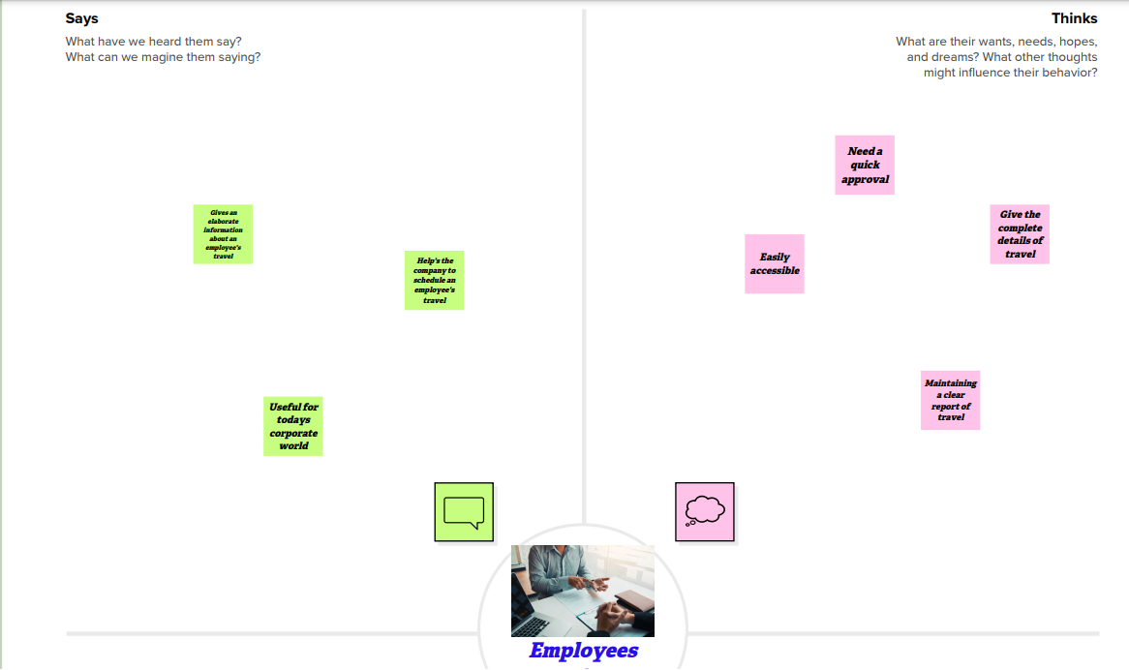

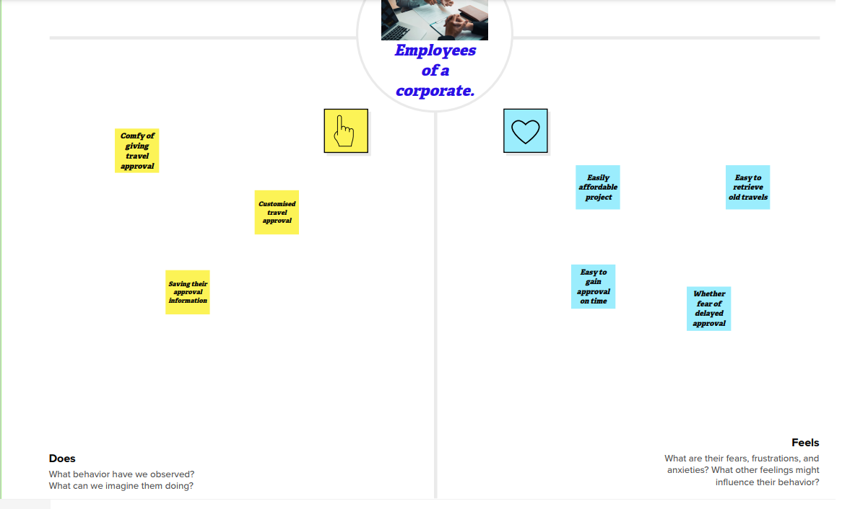

In this we discuss what people says, feels, thinks and does about the travel approval application for corporates,

* 1. **IDEATION AND BRAINSTORMING MAP**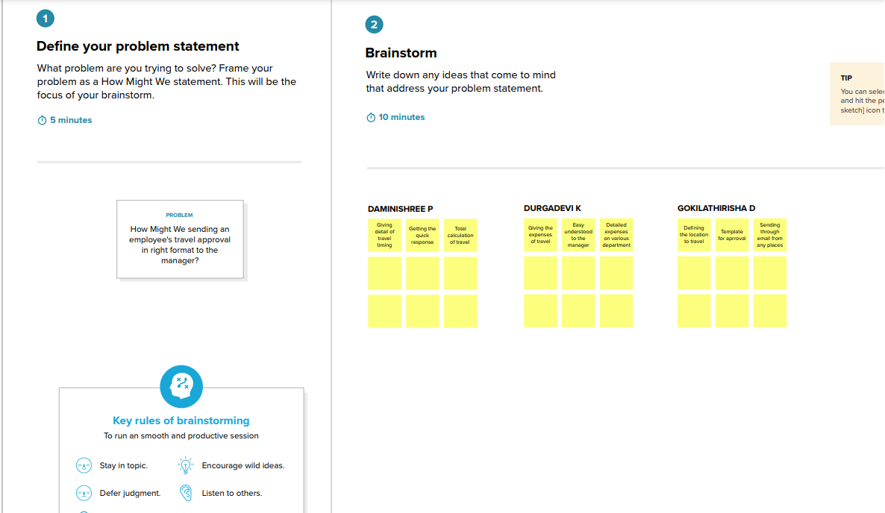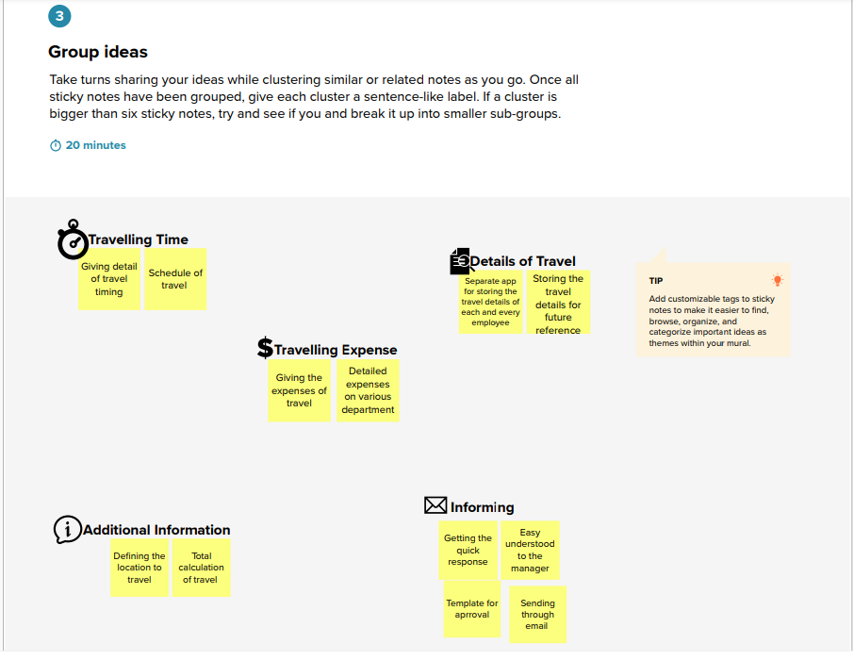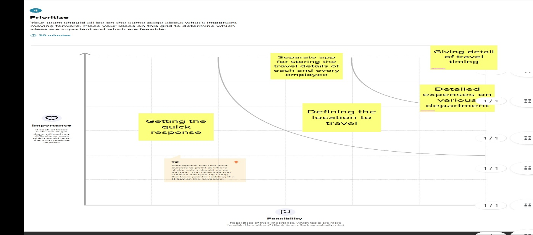

In this we discuss the main problem and seek a solution for it in the project given.

1. **RESULT:**
   1. **DATA MODEL**

|  |  |
| --- | --- |
| **Object name** | **Fields in the Object** |
| **DEPARTMENT** | |  |  | | --- | --- | | **Field Label** | **Data type** | | Expense Type | Picklist | | Travel Approval | Master-Detail Relationship | |
| **EXPENSE ITEM** | |  |  | | --- | --- | | **Field Label** | **Data type** | | Travel Approval | Master-Detail Relationship | | Amount | Currency | | Department | Text | |
| **TRAVEL APPROVAL** | |  |  | | --- | --- | | **Field Label** | **Data type** | | Department | Text | | Expense Type | Picklist | | Amount | Currency | | Destination state | Text | | Purpose of Trip | Long Text Area | | Status | Picklist | | Status Indicator | Formula | | Total Expense | Rollup summary | | Trip start date | Date | | Trip end date | Date | |

* 1. **ACTIVITY AND SCREENSHOT**

1. **Creating Developer Account**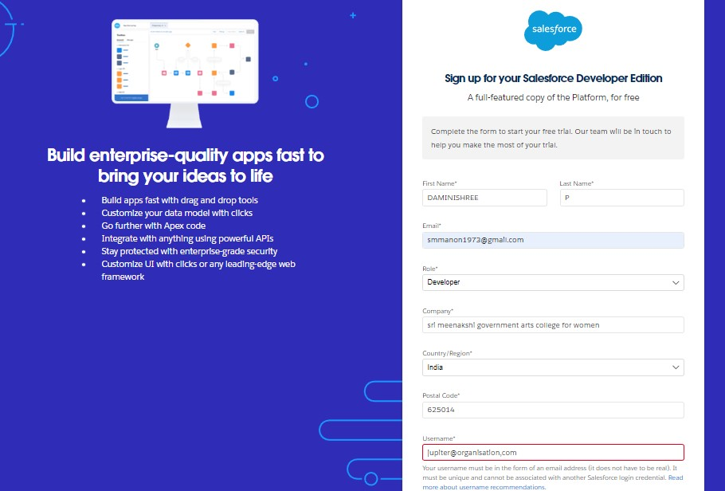

In this we have created the developer account in salesforce platform and give our roll as developer.

1. **Account Activation**

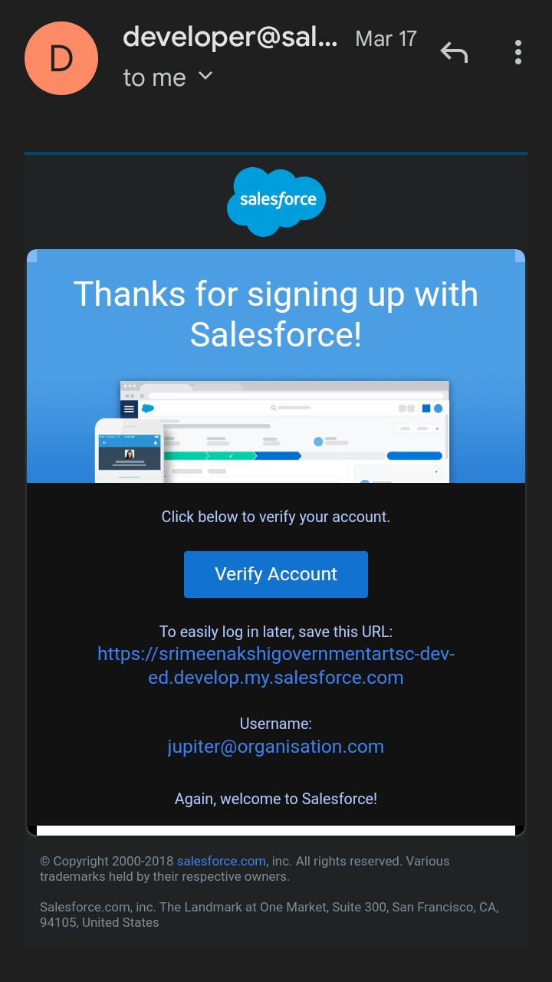

In this we have verified the developer account created in salesforce platform by the verification message sent by salesforce through the email we have used to login the salesforce profile.

1. **Create Travel Application**

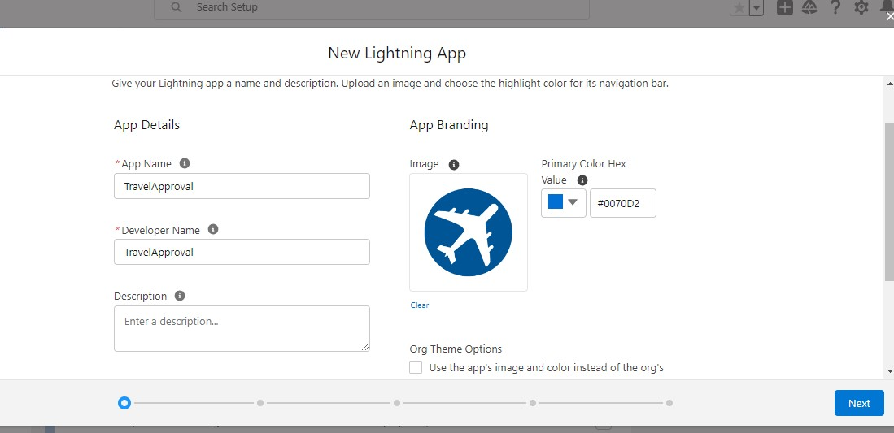

By login into org profile created earlier select the new lightening app and create an application named as Travel Approval and insert the necessary standard objects and set it as the system administration.

1. **Custom Object Creation**

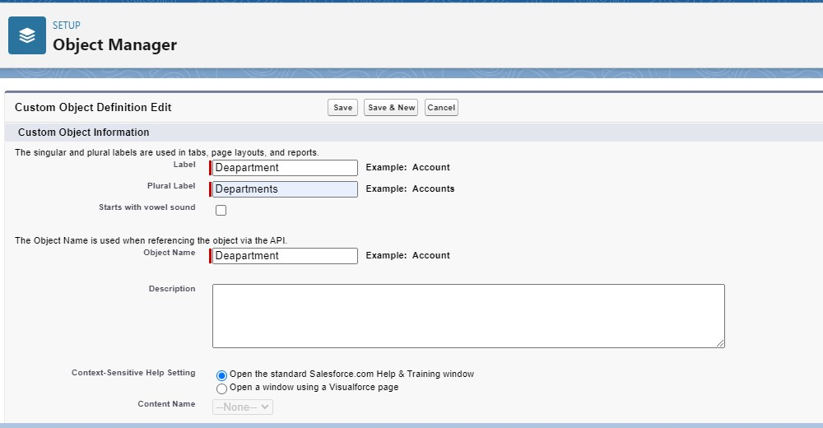

In this select setup and in that select object manager and in object manager click New custom object and start creating the objects we want for our travel approval application.

1. **Create 3 custom objects and tabs**

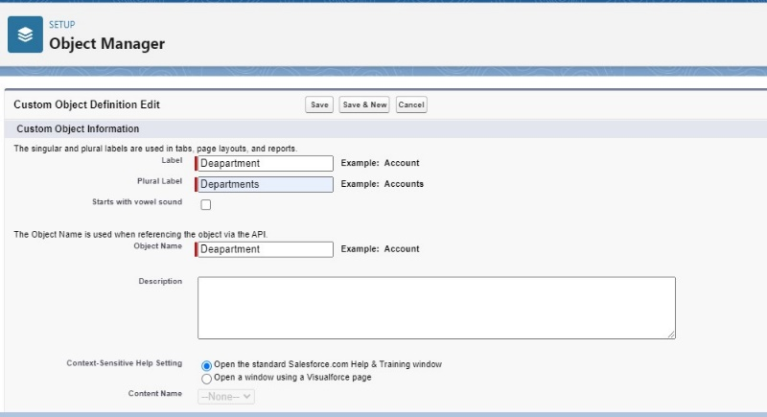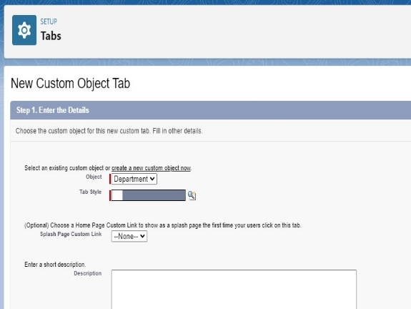

In this create three objects namely, Department, Expense Item and Travel Approval.

In that select Launch Tab option and after finishing each object the tab opens.

1. **Create a custom tab**

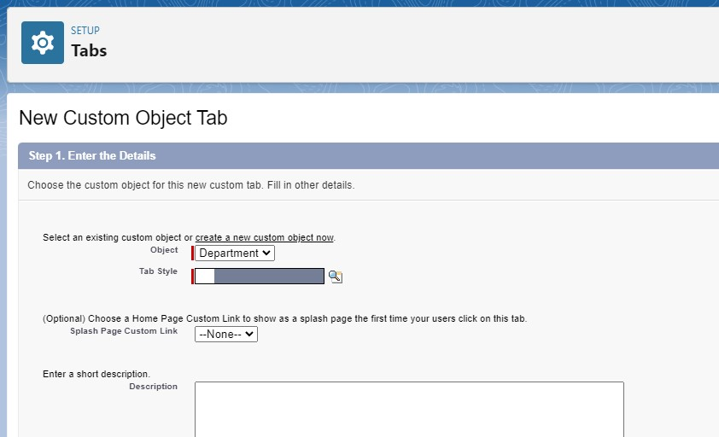

In this select the apt object and fix an icon to it. Do this for all objects we have created for our travel approval application.

1. **Create fields and relationships**

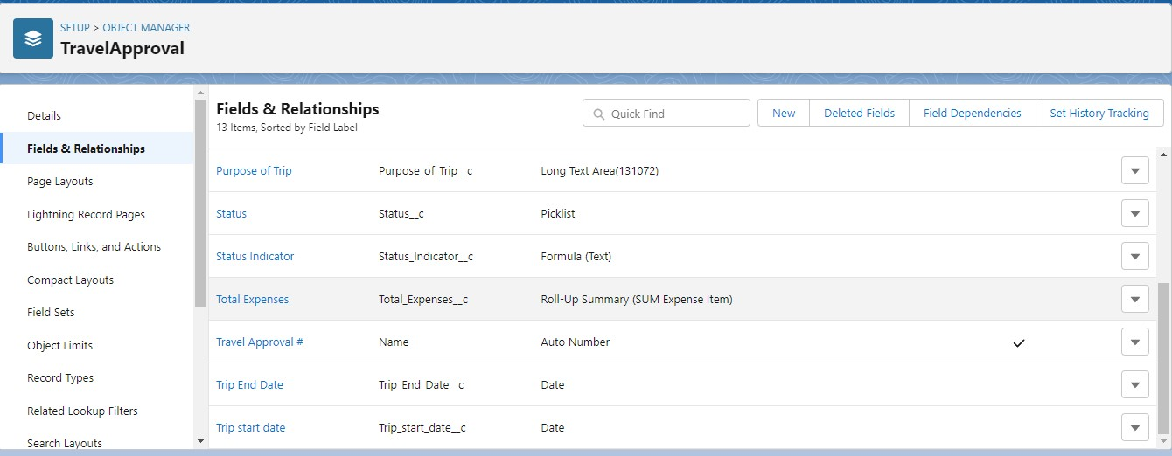

In this for the custom objects we have created select field and relationships in it then create the necessary field.

1. **Create the expense type field**

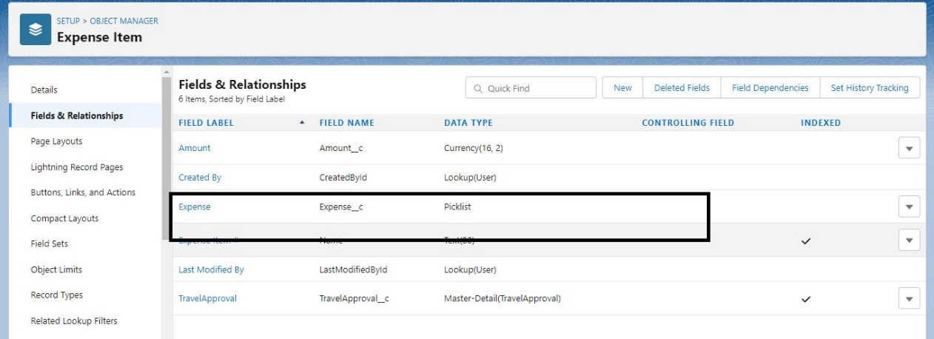

In the custom object create the field named expense and select its data type as Picklist.

1. **Create the travel approval field**

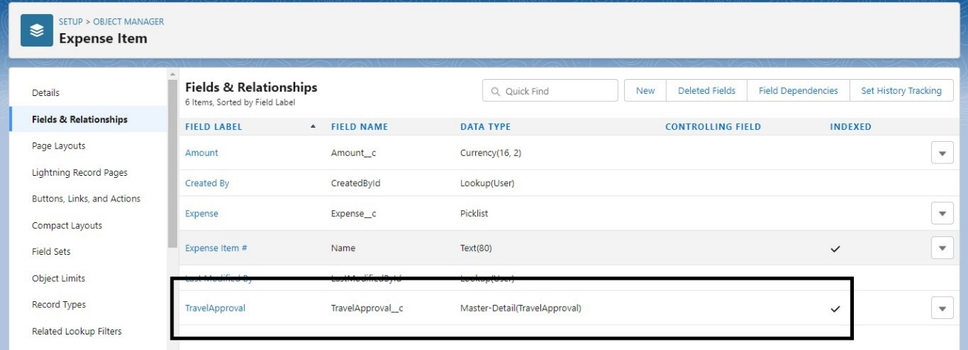

In the custom objects create the field named Travel Approval and master-detail relationship as its data type.

1. **Import departments**

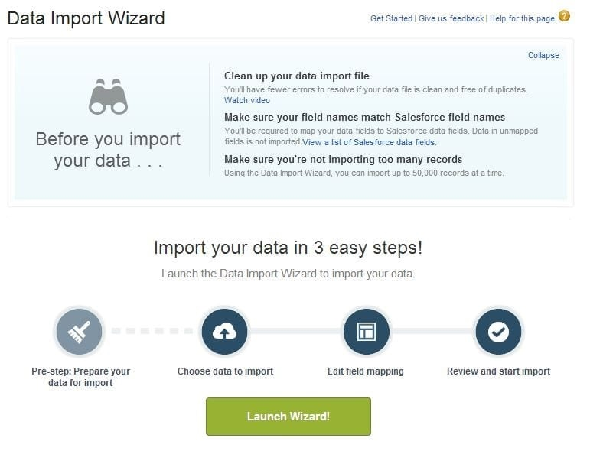

For custom object named Department select the import data wizard and import the files we have downloaded while doing this workshop and import department csv files in it.

1. **Create user and set up approvals** 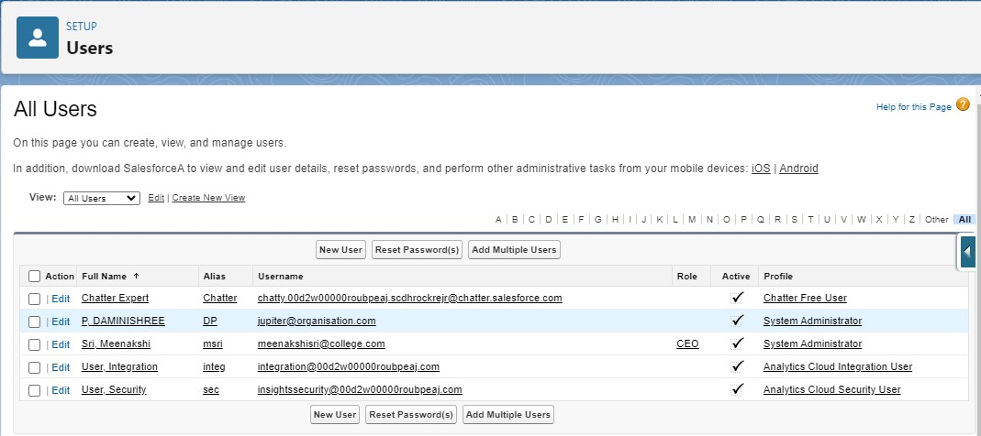

In the user layout create a new user and set its profile as system administrator and its role as CEO.Then in our profile set this user as manager .

1. **Customize travel approval object page layout**

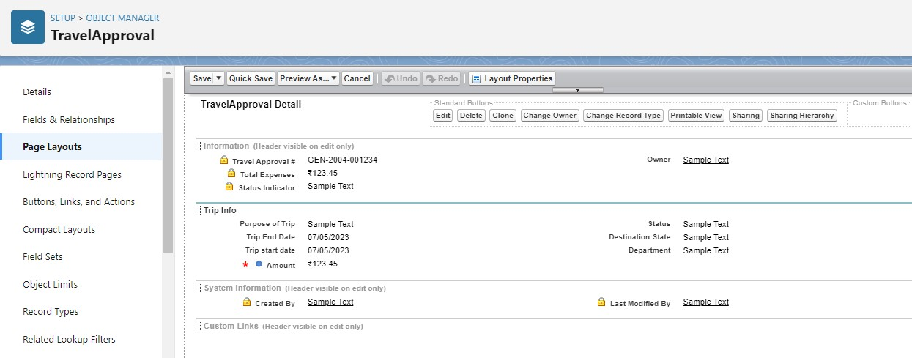

In this create the page layout of travel approval object by selecting the necessary fields created in the object and introduce a section named Trip Info which carriers all the information related the travel of the employee.

1. **Create validation rule**

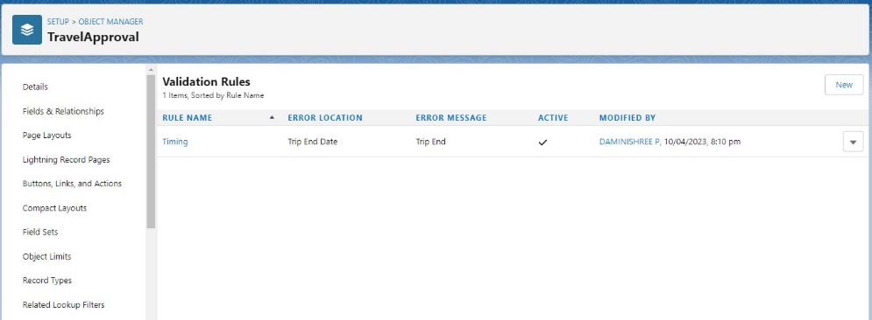

In this create the validation rules of the travel approval object by giving the error location as Trip End Date and message as Trip End.

1. **Create roll up summary fields**

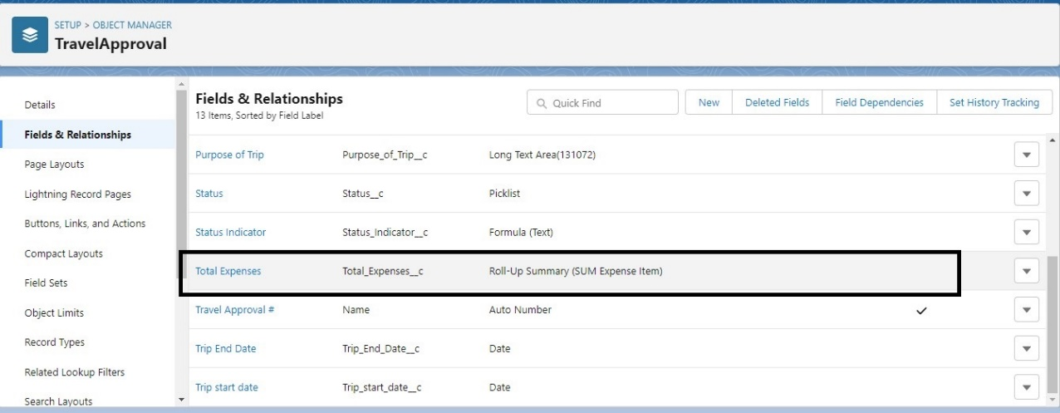

In the field of travel approval object create the field named Total Expenses and give its data type as Roll up summary (sum expense item).

1. **Created formula fields**

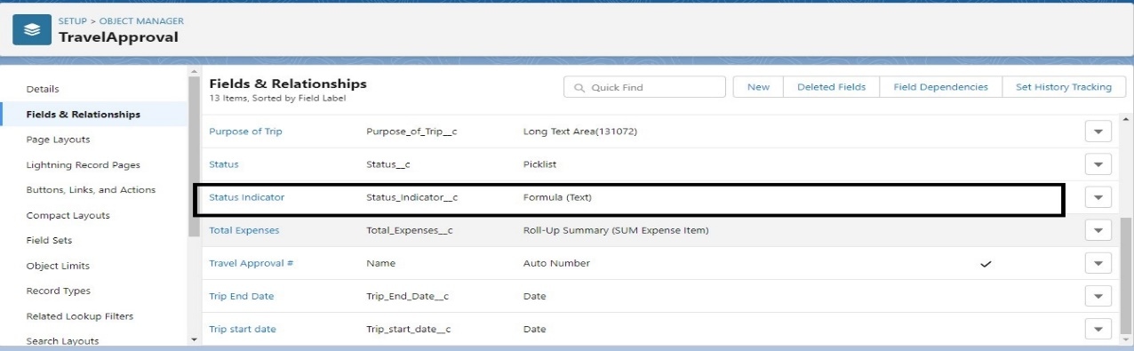

In this create field named Status Indicator and its data type as Formula by including the formula given in the project manual.

1. **Add report**

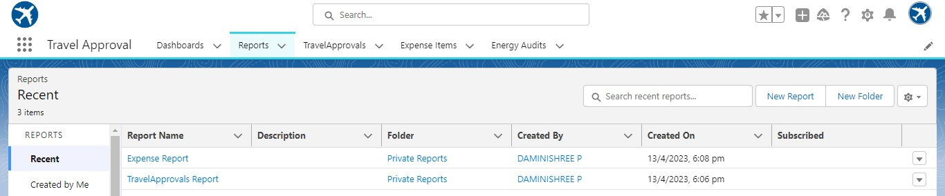

In this create a new report in the App created as Travel Approval and save it.

1. **Create travel approval dashboard**

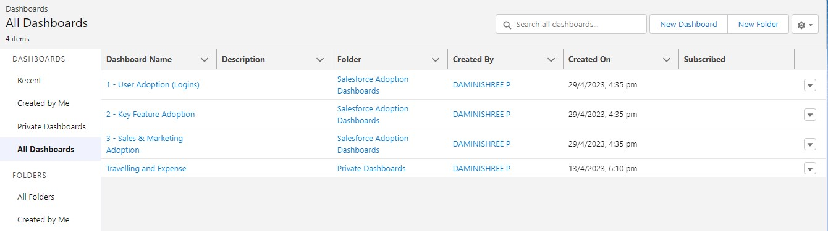

At last create a new dashboard in the Travel Approval Application and save it.

1. **TRAILHEAD PROFILE PUBLIC URL:**

***TEAM LEAD***: <https://trailblazer.me/id/damip1>

***TEAM MEMBER 1:*** <https://trailblazer.me/id/durgk13>

***TEAM*** ***MEMBER 2***: <https://trailblazer.me/id/gokid>

1. **ADVANTAGES AND DISADVANTAGES:**

* This project helps an employee to seek the approval of his travel from his manager. This also helps the corporate company to maintain a complete data of the travel of its employees.
* Since this uses the email for contact it will depend on the third-party application which will reduce its safety and the information could be stolen. So more security measures should be taken.

1. **APPLICATIONS:**

* This will be useful to most of the corporate companies and MNCs and this will be used in the private companies.
* This will also be used now a days in the companies which have its branches all over the world.
* It is useful in the travelling companies also.

1. **CONCLUSION:**

Thus, by this application we could help the corporates as well as its employees related to travelling details. By this we could store an employee travelling detail and it could be used to retrieve any older travels done by the employee. This gives the entire detail of the travel including the travel expenses and the location of the hotels along with the expenses done by the employee. This will be useful to categories the detail of travel as which department the employee belongs, the expenses made by him/her during his travel, the approval of manager, the details of his stay in the countries to which he has travelled.

1. **FUTURE SCOPE:**

In future, the features of the application will be made more convenient and the communication mode will be made more efficient as seeking the approval through WhatsApp and Telegram. The categories of travelling detail will be made wider by including the shots of bills of employees stay in hotels and the maximum storing year will be made to 10 years, which will help the company to retrieve the older travels done by its employee’s.The safety of the information will be enhanced.