**Exception Handling:** The **Exception Handling in Java** is one of the powerful mechanism to handle the runtime errors so that normal flow of the application can be maintained.

**Example:** Suddenly A boy comes in front of bike when he is going on highway and his accident happen

Then you go there and tell someone what happen and whose fault is.

Exception type : Syntax Error :easily removed, Logical Error, Runtime Error

**Dictionary Meaning:** Exception is an abnormal condition.

In Java, an exception is an event that disrupts the normal flow of the program. It is an object which is thrown at runtime.

**What is Exception Handling**

Exception Handling is a mechanism to handle runtime errors such as ClassNotFoundException, IOException, SQLException, RemoteException, etc.

### Advantage of Exception Handling

The core advantage of exception handling is **to maintain the normal flow of the application**. An exception normally disrupts the normal flow of the application that is why we use exception handling. Let's take a scenario:

* statement 1;
* statement 2;
* statement 3;
* statement 4;
* statement 5;//exception occurs
* statement 6;
* statement 7;
* statement 8;
* statement 9;
* statement 10;

## Suppose there are 10 statements in your program and there occurs an exception at statement 5, the rest of the code will not be executed i.e. statement 6 to 10 will not be executed. If we perform exception handling, the rest of the statement will be executed. That is why we use exception handling in Java.

## Difference between Checked and Unchecked Exceptions

### 1) Checked Exception

The classes which directly inherit Throwable class except RuntimeException and Error are known as checked exceptions e.g. IOException, SQLException etc. Checked exceptions are checked at compile-time.

### 2) Unchecked Exception

The classes which inherit RuntimeException are known as unchecked exceptions e.g. ArithmeticException, NullPointerException, ArrayIndexOutOfBoundsException etc. Unchecked exceptions are not checked at compile-time, but they are checked at runtime.

### 3) Error

Error is irrecoverable e.g. OutOfMemoryError, VirtualMachineError, AssertionError etc.

## Hierarchy of Java Exception classes

The java.lang.Throwable class is the root class of Java Exception hierarchy which is inherited by two subclasses: Exception and Error.

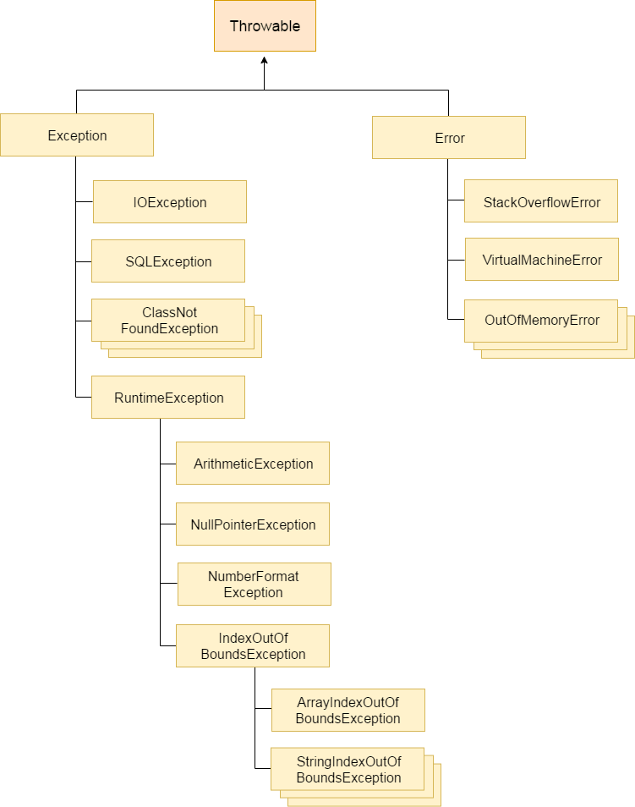

**Q: the difference between checked and unchecked exceptions.**

**==========================**

**Java Multi-catch block**

A try block can be followed by one or more catch blocks. Each catch block must contain a different exception handler. So, if you have to perform different tasks at the occurrence of different exceptions, use java multi-catch block.

**Points to remember**

At a time only one exception occurs and at a time only one catch block is executed.

All catch blocks must be ordered from most specific to most general, i.e. catch for ArithmeticException must come before catch for Exception.