**JavaScript Interview Question**

https://www.youtube.com/watch?v=iccdL8-SF7c

1. Void(0) – Prevent page refresh and pass 0 while calling and call another method without refreshing page
2. == and ===
3. Delete operator

var student = {age:23, batch:”abc”}

delete student.age

1. difference b/w alert and confirmation?
2. What is javascript Cookies?

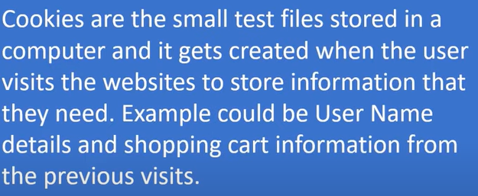

1. Array push method

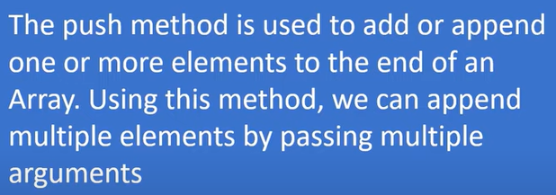

1. Javascript unshift method

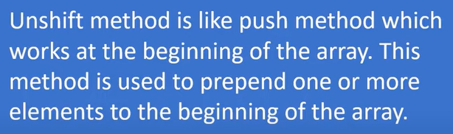

1. Explain Window.onload and onDocumentReady method?

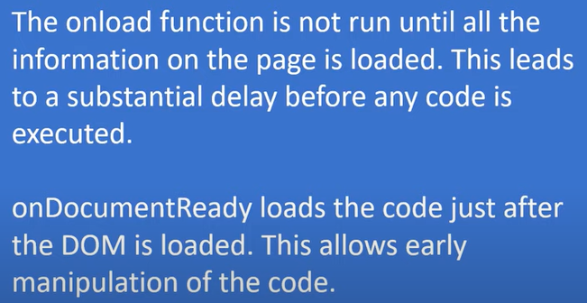

1. d
2. d
3. d
4. d
5. d
6. d
7. d
8. d
9. d
10. d
11. d
12. d
13. d
14. d
15. d
16. d
17. d