AI Educational Platform

Grant Application Proposal – Sponsorships for Open Source AI Educational Platform

￼￼
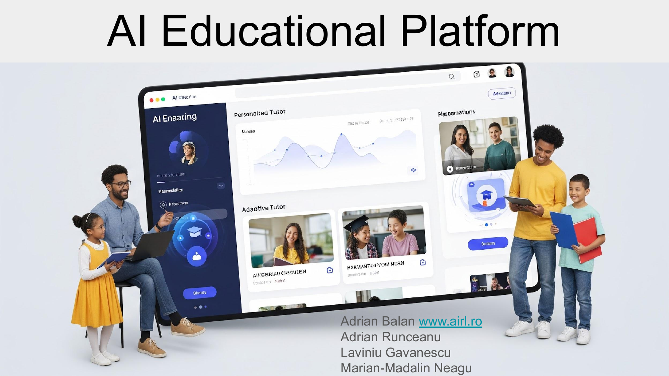

Overview
This proposal seeks corporate sponsorship to support the scaling and adoption of the Open Source AI Educational Platform — a proven, easy-to-use, AI-powered tool for transforming traditional education. With sponsorship, your company can directly impact thousands of students and educators, demonstrate social responsibility, and gain brand visibility in the education sector.

Key Opportunities for Sponsors
• Positive publicity: Your company logo can be placed within the platform/app (with user visibility at login or footer).
• Access to educational communities: Sponsoring companies may reach students, teachers, and academic institutions directly.
• Co-branding in workshops, press releases, and events associated with the platform.
• Option for featured content, such as “Sponsored by” or “Brought to you by [Your Brand]” on select materials.

About the Platform
The Open Source AI Educational Platform enables non-technical teachers to quickly turn their course materials into interactive, AI-enhanced, online learning experiences.
It contains a Learning Module, a Mock Evaluation Module and a Final Evaluation Module.
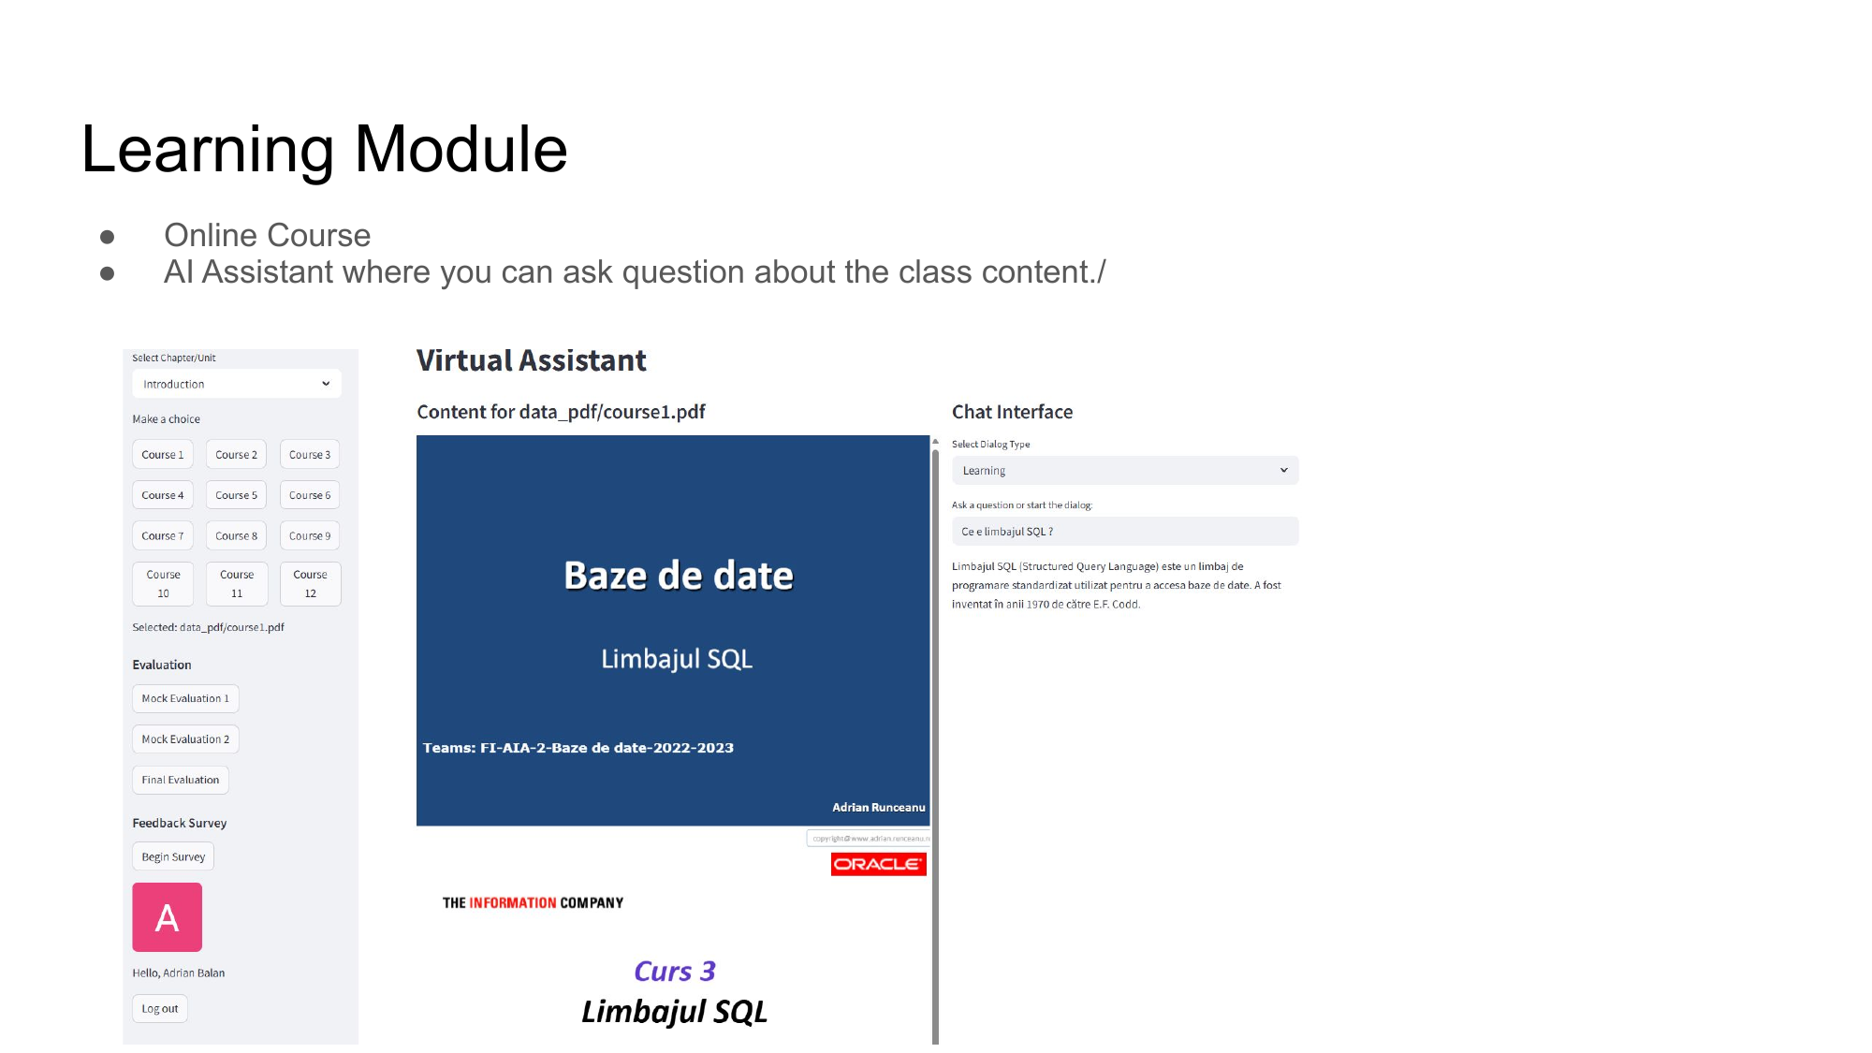
Key benefits:
• One-click deployment, simple upload of existing courses (PDF, PPT, DOC).
• 24/7 AI-powered Q&A, practice exams, and auto-grading.
• Free and open source; available for deployment or accessible through a sponsored cloud instance.
Pilot programs show high student engagement, improved learning outcomes, and positive feedback from both teachers and students.
Learn more:
• Platform Paper: https://lnkd.in/d2EKCAay
• GitHub Source: https://lnkd.in/dKUx5xrz
• Online Demo: https://lnkd.in/dxjj6TXb (request access: adrian.balan@airl.com)

Sponsorship Benefits
• Visibility: Company logo and link displayed on the platform for all users.
• Engagement: Opportunity to offer guest speakers, mentorship, or content modules.
• Data-driven impact reporting for your CSR or ESG initiatives.
• Early access to emerging talent and educational trends.

Potential Sponsorship Packages
Bronze, Silver, Gold – with increasing levels of visibility and partnership engagement.
- Bronze: Logo in app footer, mention in press releases
- Silver: Above, plus participation in events, branding in webinars
- Gold: Above, plus co-hosting hackathons, first look at results and platform data (anonymized)

How to Get Involved
• Contact us to discuss a tailored sponsorship or partnership agreement.
• Receive regular reports on usage, student engagement, and platform impact.
• Option to participate in launch events, webinars, or code sprints.
Contact: Adrian Balan – adrian.balan@airl.com

Team : Adrian Runceanu, Laviniu Gavanescu, Marian-Madalin Neagu , Adrian Balan www.airl.ro

