Project Proposal – Promoting the Open Source AI Educational Platform

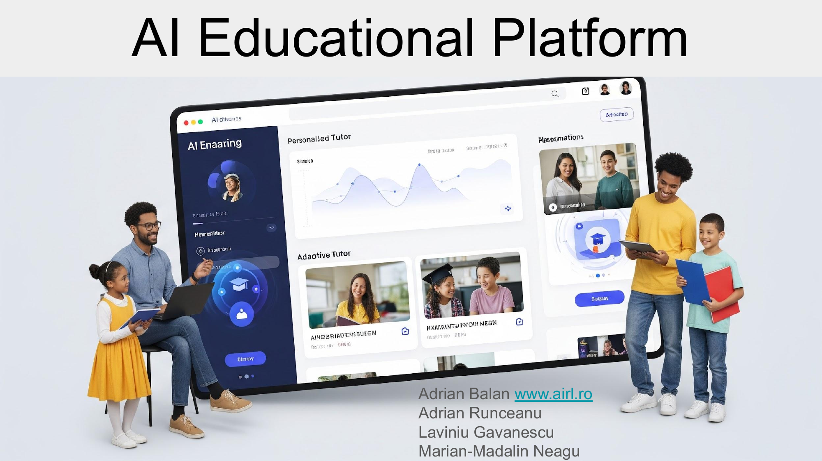

1. Executive Summary
This proposal aims to promote the newly developed Open Source AI Educational Platform, an intuitive tool designed to empower educators, regardless of their technical background, to transform traditional course materials into interactive, AI-enhanced learning environments. The platform enables teachers to upload existing courses, offer them online to students, and integrate AI-driven assistants for Q&A, exam preparation, and automated assessment—all while being easy to deploy on local or cloud infrastructure. Early pilots, such as the one at Constantin Brancusi University, have demonstrated its effectiveness and ease of use.

2. Background and Motivation
Despite rapid advancements in AI and digital learning, most educational institutions worldwide have yet to benefit from these technologies due to barriers like technical complexity, high costs, and lack of digital literacy among educators. Research shows that while students increasingly prefer digital learning modes, traditional formats remain dominant in most settings. The platform addresses this gap by offering an open-source, low-cost, and highly accessible solution for secondary and higher education institutions.

3. Description of the AI Educational Platform
Key Features:
• Easy Course Upload: Teachers can drag-and-drop PDFs, PowerPoint slides, or papers, instantly converting them into interactive, online courses accessible on any device.
• Student-Focused Delivery: Courses are presented in a mobile- and desktop-friendly format, allowing students to study anytime, anywhere.
• AI Assistant: An integrated chatbot answers students’ questions—especially those they might hesitate to ask in class—24/7, increasing engagement and confidence.
• AI-Powered Exam Support: The platform generates practice and exam questions and provides AI-driven hints and feedback, supporting exam readiness and self-paced learning.
• Automated Evaluation: Teachers can use AI-generated or custom exams, with grading handled automatically or verified manually for final results.
• Accessible Deployment: The app is open-source and can be deployed with one click on any university server, or accessed through an existing cloud-based deployment.
The Open Source AI Educational Platform enables non-technical teachers to quickly turn their course materials into interactive, AI-enhanced, online learning experiences.
It contains a Learning Module, a Mock Evaluation Module and a Final Evaluation Module.
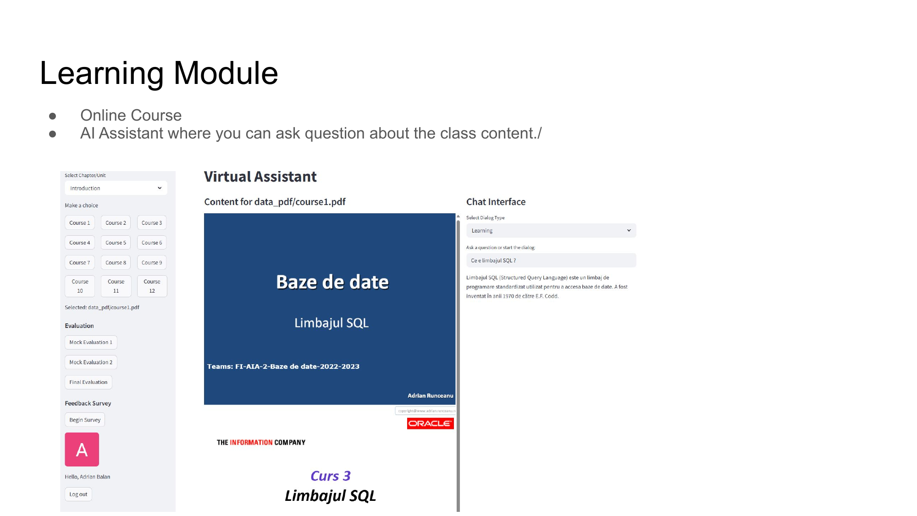
Demo & Access:
• Platform Paper: https://lnkd.in/d2EKCAay
• GitHub Source: https://lnkd.in/dKUx5xrz
• Online Demo: https://lnkd.in/dxjj6TXb (request access: adrian.balan@airl.com)

4. Pilot Project and Initial Results
The platform is currently in use in a pilot program at Constantin Brancusi University in Prof. Adrian Runceanu's class, with positive feedback from both instructors and students.
Teachers: Reported significant time savings, easier digital course migration, and more focus on deep teaching over repetitive Q&A and grading.
Students: Valued the ability to ask “any question”, clarity of AI answers, and the convenience of learning and reviewing on mobile devices.
Evaluations show high accuracy (up to 100% on single-choice and 95–100% on open questions), strong engagement, and usability—even for non-IT users.

5. Project Objectives
The promotion project seeks to:
• Raise awareness among educators and institutions about the platform’s benefits and ease of adoption.
• Encourage usage in high schools, universities, and other educational settings.
• Facilitate partnerships with public and private organizations to expand hosting capacity and support more users.
• Invite contributions from the open-source and academic community to enhance features and adapt the platform to diverse needs.
• Demonstrate impact through data collected from pilot programs and new adopters.

6. Action Plan
a. Public Initiative
• Workshops & Seminars: Organize events for teachers and administrators to showcase the platform and offer live demos.
• Pilot Programs: Partner with interested institutions to run pilot classes, gathering feedback and success stories.
• Conference Presentations: Present results at educational and technology conferences.
• Educational Networks: Collaborate with ministries of education, school boards, and teacher associations for broader reach.
b. Private Initiative
• Corporate Partnerships: Engage companies interested in supporting education or deploying the platform in employee training.
• Cloud Service Providers: Seek sponsorship for hosting infrastructure or reduced-cost LLM/API access.
• EdTech Collaborations: Work with startups and EdTech companies to integrate or extend the platform’s capabilities.
c. Open-Source Community Engagement
• Development Sprints: Invite developers and researchers to contribute code, documentation, and new features.
• User Feedback Forums: Create online communities for user support and platform improvement suggestions.
• Localization Projects: Encourage volunteers to help translate the platform for wider accessibility.

7. Expected Outcomes
• Increased adoption in both secondary and higher education.
• Stronger educator and student engagement with AI-assisted learning.
• Evidence-based improvements in teaching efficiency and student performance.
• Broadened global access to advanced educational tools, regardless of institutional resources.
• A growing network of contributors and institutional partners.

8. How to Get Involved
• Use the Platform: Request access or deploy your own instance.
• Propose Partnerships: Contact us to discuss hosting, sponsorship, or joint research.
• Contribute Code/Content: Join the open-source project on GitHub.
• Share Feedback: Provide testimonials, results, or suggestions from your experience.
Contact:
Adrian Balan, AI Research Laboratory
adrian.balan@airl.com

9. Conclusion
The Open Source AI Educational Platform represents a transformative step in democratizing AI-enhanced education. With its user-friendly design, proven effectiveness, and open-access philosophy, it offers a path forward for any educational institution seeking to modernize teaching and learning—without the barriers of high cost or technical complexity.
[Insert an image here: For example, a screenshot of the platform, a conceptual illustration, or your project logo.]
Prepared by: [Your Name/Team]
[Date]

Example: Evaluation Module and Learning Module in the Platform


