High-Level Design (HLD)
User Posts & Albums Viewer
Client-side web application using HTML, CSS, JavaScript and jQuery
Document Version | 0.1
Status | Draft - based on confirmed RUD v1.1
Prepared By | Atul Sharma
Technology | HTML5, CSS3, JavaScript (ES6+), jQuery 4.0.0
Data Source | JSONPlaceholder REST API
Application Type | Client-side / presentation-layer web application

Design intent
Define the major components, responsibilities, boundaries and data/request flow before implementation. Detailed functions, selectors and jQuery operations are intentionally deferred to the LLD.

1. Purpose
This High-Level Design defines the major components, responsibilities, external interface and high-level request/data flows for the User Posts & Albums Viewer. It is derived from the confirmed requirements recorded in RUD v1.1 and is intentionally kept above implementation-level detail.

Design objective
- Keep the solution client-side and presentation-focused, matching the confirmed scope.
- Separate presentation responsibilities from client-side API interaction and orchestration.
- Use JSONPlaceholder as the only external data source for users, posts and albums.
- Make the separate Posts and Albums views explicit at the architecture level.

2. Scope and Design Boundaries
Area | Design boundary
Application | Browser-hosted client-side web application.
Presentation | HTML5 + CSS3 for page structure and visual presentation.
Client logic | JavaScript (ES6+) + jQuery for interaction, API communication, response processing and DOM updates.
External data | JSONPlaceholder REST API only.
Not included | Custom backend, database, authentication, authorization, persistent storage or application-owned service layer.

3. Architecture Overview
The solution follows a simple client-to-external-API architecture. The browser contains the complete application logic required by this assignment, while JSONPlaceholder supplies user, post and album data.
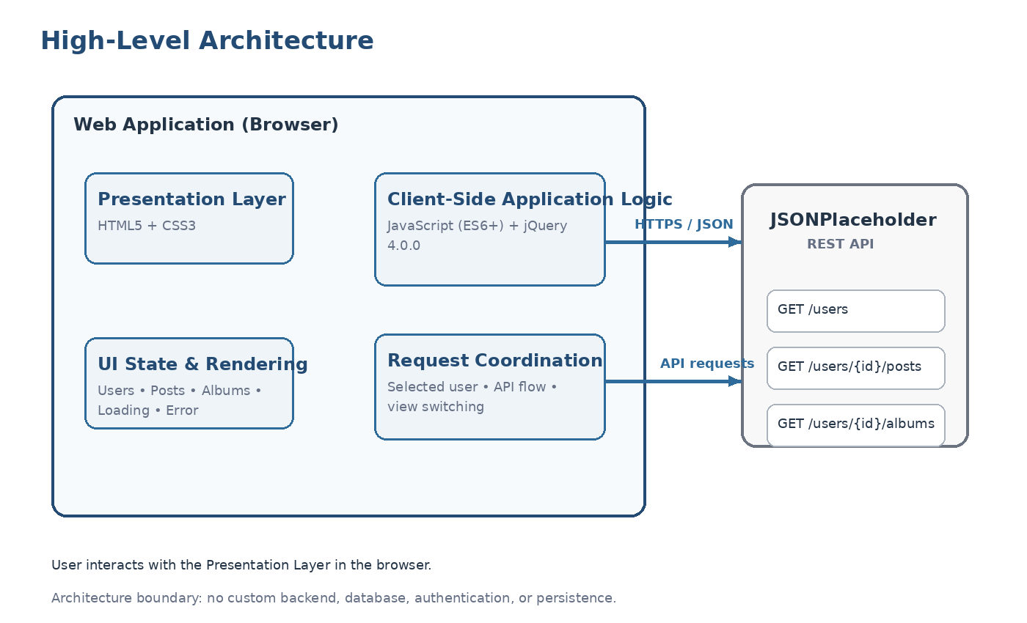
Figure 1. High-level component and interaction view

Architecture characteristics
- No application-owned server-side component is required for the current scope.
- The UI interacts directly with JSONPlaceholder through HTTP requests from the browser.
- The application keeps transient state only for the current page session.
- Posts and Albums are represented as separate selectable views over a shared content region.

4. Major Components
Component | Responsibility | Technology
Presentation Layer | Renders the user list, selected-user area, Posts/Albums controls, content and loading/error feedback. | HTML5 + CSS3
Client-Side Application Logic | Handles user interaction, API requests, HTTP success/failure handling, response processing and coordination of UI updates. | JavaScript (ES6+) + jQuery 4.0.0
External API | Provides user, post and album records through read-only REST-style GET endpoints. | JSONPlaceholder

Component interaction principle
Separation of concerns
The presentation layer should not know how the API is called, and the client API/request logic should not directly own visual markup. The HLD establishes these boundaries; the LLD defines exact functions and selectors.

5. High-Level Data / Request Flow
- Application initialization starts the user-list retrieval.
- The client requests GET /users from JSONPlaceholder.
- Returned user records are rendered using the required first-name + last-name display.
- The user selects one displayed user.
- The client retrieves that selected user's posts and albums using the selected user ID.
- The UI exposes separate Posts and Albums options; the selected option determines the content shown in the shared content area.
- Loading feedback is shown while retrieval is in progress and an error state is shown if a request fails.
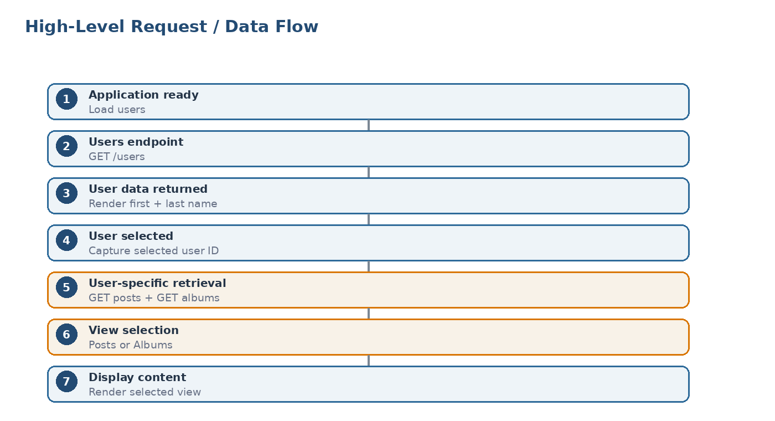
Figure 2. High-level request and data flow

6. External API Interface
Purpose | Method | Endpoint | When used
Retrieve users | GET | /users | Application initialization
Retrieve posts | GET | /users/{userId}/posts | After user selection
Retrieve albums | GET | /users/{userId}/albums | After user selection

Interface boundary
The client treats these endpoints as read-only data sources. Detailed response schemas and jQuery AJAX option objects belong in the API Specification / LLD.

7. Component Responsibilities and Interactions

7.1 Presentation Layer
- Display the user list with first name and last name.
- Provide the user selection control.
- Provide separate Posts and Albums controls/views in the selected-user area.
- Display loading, error and empty-state feedback.

7.2 Client-Side Application Logic
- Capture user interactions and maintain the selected-user context.
- Initiate API requests and process JSON responses.
- Coordinate the selected user's Posts and Albums retrieval.
- Coordinate state transitions and trigger the appropriate UI rendering.

7.3 External API Boundary
- Provides user, post and album records needed by the UI.
- No application-owned business database or service layer is introduced.

8. Interaction Scenarios
Scenario | High-level client flow | Result
Initial application load | Initialize UI → GET /users → process JSON → render user list | Users visible
User selection | Capture selected user → request posts + albums → store returned data | Selected-user data available
Posts view | Posts option selected → render posts into shared content area | Only posts are shown
Albums view | Albums option selected → render albums into shared content area | Only albums are shown
API failure | Request failure → transition to error state | User-facing error message

9. UI State Model
State | When it applies | Expected UI behavior
Initial / Users Loading | During GET /users | Show loading indication in users area
Users Loaded | Users successfully retrieved | Render first name + last name list
User Detail Loading | Posts/albums being retrieved after selection | Show loading indication in selected-user area
Posts View | Posts option selected | Render posts only
Albums View | Albums option selected | Render albums only
Error | Relevant API request fails | Show appropriate user-facing error state

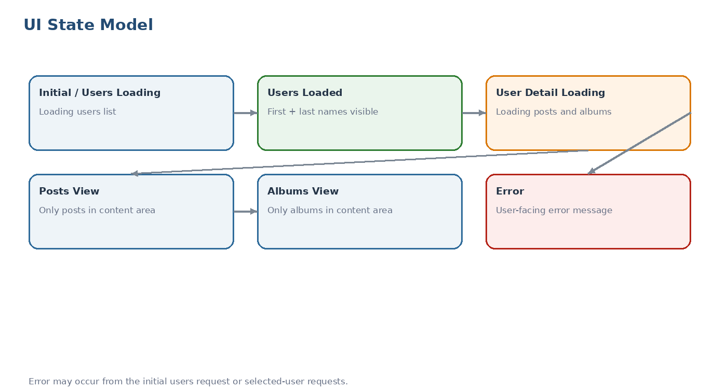
Figure 3. High-level UI state model

10. Cross-Cutting Design Considerations

10.1 Error Handling
- Non-success HTTP responses and network/request failures are treated as request failures at the client-logic boundary.
- Errors are surfaced through a user-facing error state.
- A failed request must not leave the user with an unexplained loading state.

10.2 Loading and Feedback
- Loading feedback is associated with the request currently in progress.
- The selected-user area communicates that user-specific data is being retrieved.

10.3 Maintainability
- Keep API communication, interaction handling and DOM rendering logically separated.
- Construct user-specific endpoint URLs from the selected user ID rather than hard-coding individual users.
- Avoid unnecessary architectural abstraction because the assignment has a small scope.

10.4 Security / Trust Boundary
- JSONPlaceholder is an external data source and should be treated as untrusted input for rendering purposes.
- API-provided text should be inserted using text-oriented DOM operations where practical rather than unnecessary raw HTML injection.
- No authentication credentials or secrets are required by this assignment.

11. Performance Considerations
- The initial request retrieves only the user collection required to populate the directory.
- Posts and albums are retrieved for the selected user rather than loading unrelated users' detail data.
- Because Posts and Albums are independent resources, their requests may be initiated concurrently during implementation.
- The current scope does not require persistent caching or advanced client-side state management.

12. Deployment Assumption
The application is expected to run as a static/client-side web application capable of serving the HTML, CSS and JavaScript assets to a modern browser. The browser communicates directly with JSONPlaceholder over HTTPS. No server-side application component is defined in this HLD.

13. HLD-to-LLD Boundary
HLD defines | LLD defines
Major components and system boundaries | Exact file/module structure
Component responsibilities | Exact function names and parameters
High-level request/data flows | Detailed event-handler and request implementation
Major UI states | Exact DOM hierarchy/selectors and markup
External API endpoints | Detailed AJAX configuration and response handling

14. Traceability to Confirmed Requirements
Confirmed requirement | HLD coverage
Retrieve users | Client logic communicates with GET /users.
Display first + last name | Presentation layer owns user-list rendering.
Select user | User interaction flows into client-side logic.
Retrieve posts | Client logic calls GET /users/{userId}/posts.
Retrieve albums | Client logic calls GET /users/{userId}/albums.
Separate Posts and Albums | UI state model defines distinct Posts and Albums views.
Loading state | Cross-cutting feedback/state model includes loading states.
Error handling | Client logic detects failures and the presentation layer displays errors.
Dynamic update without full refresh | Architecture keeps interaction and rendering in the browser.

15. Assumptions and Design Decisions
- The solution is intentionally modeled as client-side only, consistent with the confirmed assignment scope.
- JSONPlaceholder is the only external data source; no persistence layer is introduced.
- The UI uses first name + last name as the displayed user identity.
- Posts and Albums are separate user-selectable views in a shared content area.
- Posts and Albums are independent resources and may be requested concurrently after user selection.
- Detailed implementation decisions are intentionally deferred to the LLD.

