HIGH-LEVEL DESIGN
User Posts & Albums Viewer
Client-side web application using HTML, CSS, JavaScript and jQuery
Document Version | 0.2
Status | Revised Draft - review feedback incorporated
Prepared By | Atul Sharma
Technology | HTML5, CSS3, JavaScript (ES6+), jQuery 4.0.0
Data Source | JSONPlaceholder REST API

Revision Summary
Review update: The HLD has been updated to make Posts and Albums explicitly visible as two independent API requests in the high-level request flow. The API interface also shows complete request URLs, while remaining at architecture-level detail.

1. Purpose
This High-Level Design defines the major components, responsibilities, external interface, and high-level request/data flows for the User Posts & Albums Viewer. It is derived from the confirmed requirements recorded in RUD v1.1 and remains above implementation-level detail.

2. Scope and Design Boundaries
- The solution is a client-side / presentation-layer web application.
- HTML and CSS provide the page structure and visual presentation.
- JavaScript with jQuery provides client-side interaction, API communication, response processing, and DOM updates.
- JSONPlaceholder is the only external data source currently in scope.
- No custom backend, database, authentication, or persistent storage is part of this design.

3. Architecture Overview
The system follows a simple client-to-external-API architecture. The browser hosts the complete application logic. The external REST API supplies user, post, and album data.
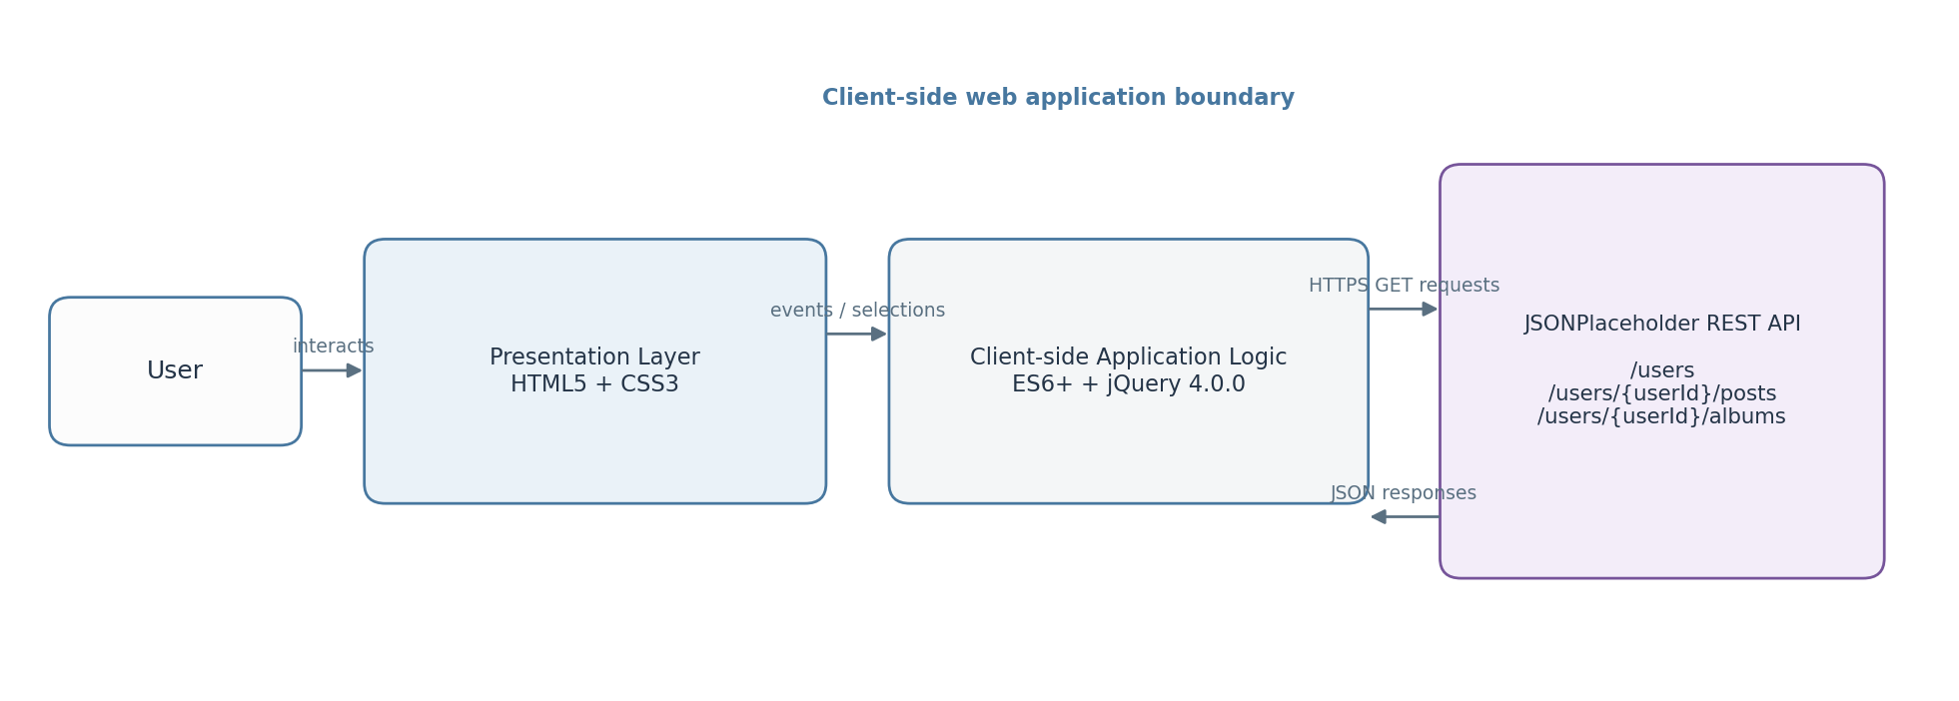
Figure 1. High-level component and interaction view

4. Major Components
Component | Responsibility | Key technology
Presentation Layer | Renders users, selected-user area, Posts/Albums controls, content, loading and error states. | HTML5 + CSS3
Client-side Application Logic | Handles user interaction, API requests, HTTP success checks, JSON processing and coordination of UI updates. | JavaScript (ES6+) + jQuery 4.0.0
External API | Provides user, post and album records through REST-style GET endpoints. | JSONPlaceholder

5. High-Level Data / Request Flow
- Initial load: The application requests the user collection from GET https://jsonplaceholder.typicode.com/users.
- User rendering: Returned users are rendered using the API name value as the required first-name + last-name display value.
- Selection: The user selects one displayed user.
- Independent user-specific retrieval: the client starts two separate requests using the selected user ID - Request A for Posts and Request B for Albums. The requests are independent and may execute concurrently.
- Response handling: Posts and Albums are retained as separate datasets in client-side memory.
- Separate presentation: the UI exposes separate Posts and Albums options; the selected option controls the displayed content area.
- Feedback states: loading is shown during retrieval; an error state is shown when a required API request fails.
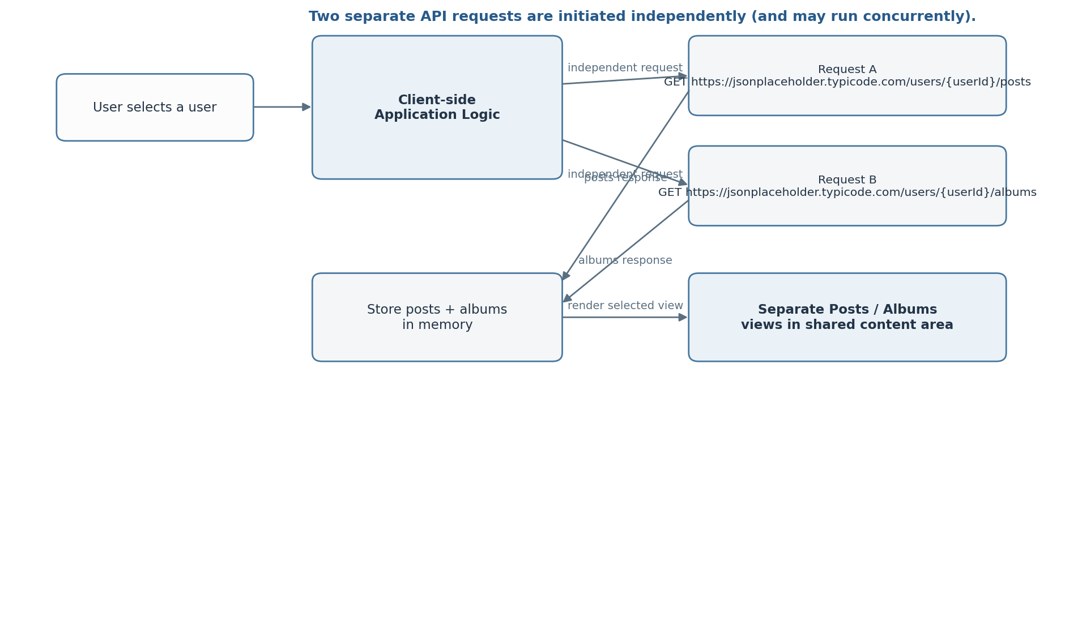
Figure 2. Explicit independent Posts and Albums request flow

6. External API Interface at HLD Level
Purpose | HTTP Method | Complete URL pattern | Used when
Retrieve users | GET | https://jsonplaceholder.typicode.com/users | Application initialization
Retrieve posts | GET | https://jsonplaceholder.typicode.com/users/{userId}/posts | After a user is selected - independent request A
Retrieve albums | GET | https://jsonplaceholder.typicode.com/users/{userId}/albums | After a user is selected - independent request B

Architecture clarification: Posts and Albums use distinct endpoints and are represented as distinct requests. The HLD intentionally does not prescribe the exact Promise/callback mechanism; that implementation detail remains in the LLD.

7. Component Responsibilities and Interactions

7.1 Presentation Layer
- Displays the user list with first name and last name.
- Provides the user selection control.
- Provides separate Posts and Albums controls/views in the selected-user area.
- Displays loading and error feedback to the user.

7.2 Client-side Application Logic
- Initiates API requests using jQuery-based HTTP/AJAX operations.
- Checks whether API responses indicate success before processing returned data.
- Processes JSON responses and passes resulting data to the rendering layer.
- Tracks the selected user and coordinates the displayed Posts or Albums view.
- Coordinates independent Posts and Albums requests without combining the API calls.

7.3 External API Boundary
- Provides the user, post, and album records needed by the UI.
- No application-owned business database or service layer is introduced in this assignment.

8. Interaction Scenarios
Scenario | Client-side flow | Result
Initial application load | UI initialized -> GET /users -> parse JSON -> render user list | Users visible
User selection | Selection event -> capture user ID -> independent Posts request + independent Albums request | Selected-user data available after required requests succeed
Posts view | Posts option selected -> render posts in shared content area | Only posts are shown
Albums view | Albums option selected -> render albums in shared content area | Only albums are shown
API failure | Request fails or returns non-success -> error handling | User-facing error message

9. UI State Model
State | When it applies | Expected UI behavior
Initial / Users Loading | During initial GET /users | Show loading indication in users area
Users Loaded | Users successfully retrieved | Render first-name + last-name display list
User Detail Loading | Posts and Albums requests are in progress after selection | Show loading indication in selected-user area
Posts View | Posts option selected and detail data is available | Render posts only
Albums View | Albums option selected and detail data is available | Render albums only
Error | Relevant API request fails | Show appropriate user-facing error state

10. Cross-Cutting Design Considerations

10.1 Error Handling
- Non-success HTTP responses are treated as request failures at the client-logic layer.
- Network/request failures are surfaced to the UI through an error state.
- The user should not be left with an unexplained loading state when a request fails.

10.2 Loading and Feedback
- Loading feedback is associated with the requests currently in progress.
- The selected-user content area should communicate that Posts and Albums are being fetched.

10.3 Maintainability
- API communication, interaction handling, and DOM rendering should remain logically separated where practical.
- Endpoint construction should use the selected user ID rather than hard-coded user-specific URLs.
- Independent request behavior should remain visible at HLD level; exact coordination belongs in LLD.

10.4 Security / Trust Boundary
- JSONPlaceholder is an external data source and should be treated as untrusted input for rendering purposes.
- User-provided or externally returned text should be inserted using safe text-oriented DOM operations where practical, rather than unnecessary raw HTML injection.
- No application authentication or authorization is included because it is outside the confirmed assignment scope.

11. Performance Considerations
- The initial request retrieves only the user collection required to populate the directory.
- Posts and albums are retrieved for the selected user rather than loading unrelated users data.
- Because Posts and Albums are independent resources, their requests may be initiated concurrently to avoid unnecessary serial waiting.

12. Deployment Assumption
The design assumes a static/client-side deployment capable of serving the HTML, CSS and JavaScript assets to a modern browser. The application communicates directly with JSONPlaceholder over HTTPS. No server-side application component is defined in this HLD.

13. HLD-to-LLD Boundary
The following items are intentionally deferred to Low-Level Design and implementation documentation:
- Exact JavaScript/jQuery function names and module/file structure
- Detailed event-handler implementation
- Exact DOM element hierarchy and selectors
- Detailed AJAX option objects and Promise/callback handling
- Exact loading/error component markup
- Detailed validation and rendering procedures
- Expected response examples and exact fields consumed by the UI

14. Traceability to Confirmed Requirements
Requirement | HLD coverage
Retrieve users | Presentation and client-logic components communicate with GET https://jsonplaceholder.typicode.com/users.
Display first + last name | Presentation layer owns user-list rendering; the API name value is treated as the required display value.
Select user | Presentation event flows into client-side application logic.
Retrieve posts | Client logic calls GET https://jsonplaceholder.typicode.com/users/{userId}/posts as an independent request.
Retrieve albums | Client logic calls GET https://jsonplaceholder.typicode.com/users/{userId}/albums as an independent request.
Separate Posts and Albums | UI state model defines distinct Posts and Albums views.
Loading state | Cross-cutting feedback/state model includes loading states.
Error handling | Client logic detects failures and presentation layer displays errors.

15. Assumptions / Design Decisions
- The application is intentionally modeled as client-side only, consistent with the confirmed assignment scope.
- JSONPlaceholder is the only data source; no persistence layer is introduced.
- The UI remains simple and feature-focused because no strict visual design requirement was specified.
- Posts and Albums are separate user-selectable views in the same content area.
- Posts and Albums are separate API requests and are not modeled as a combined API operation.

16. Revision Notes - v0.2
Area | Change made
Request flow | Updated the high-level flow to show two independent Post and Album API requests after user selection.
API interface | Added complete URL patterns for Users, Posts, and Albums.
Architecture boundary | Clarified that the HLD identifies independent requests, while request coordination mechanics remain an LLD concern.
Name display | Clarified that JSONPlaceholder exposes a single name field and that the full value is used as the requested first-name + last-name display.

17. Document Status
HLD v0.2 - REVISED DRAFT. This revision incorporates the review feedback by making the independent Posts and Albums requests explicit in the high-level request flow and by making the endpoint URL patterns explicit. The document remains at architecture level and does not introduce backend, database, authentication, or persistence components.

