HIGH-LEVEL DESIGN
User Posts & Albums Viewer
Client-side presentation-layer web application
Field | Value
Document Version | v0.3
Status | Draft - requirements clarification incorporated
Prepared By | Atul Sharma
Technology | HTML5, CSS3, JavaScript (ES6+), jQuery 4.0.0
Data Source | JSONPlaceholder REST API

Revision Summary
Requirements clarification incorporated: Explicit independent Posts/Albums requests, simultaneous two-panel presentation, and presentation-only application boundary.

1. Purpose
This HLD defines the major components, responsibilities, external interface, and high-level request/data flow for the User Posts & Albums Viewer. The application is intentionally limited to the presentation layer and consumes a ready-made external API/data layer.

2. Scope and Design Boundaries
- The solution is a client-side / presentation-layer web application.
- HTML and CSS provide page structure and presentation.
- JavaScript with jQuery provides interaction, API communication, response processing, state, and DOM updates.
- JSONPlaceholder provides the ready-made user, Post, and Album data layer used by the application.
- No custom backend, application-owned business/service layer, database, authentication, or persistent storage is introduced.

3. Architecture Overview
The browser contains the application-owned presentation and client-side logic. The external API provides the required data. After a user is selected, Posts and Albums are requested as two independent API calls and are rendered into two separate UI panels visible at the same time.

Figure 1. High-Level Architecture
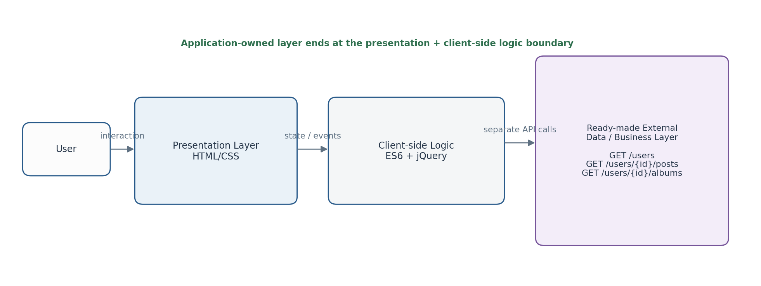

4. Major Components
Component | Responsibility | Key technology
Presentation Layer | Renders users, selected-user area, Posts panel, Albums panel, loading, error, and empty states | HTML5 + CSS3
Client-side Application Logic | Handles user interaction, separate API requests, response processing, state, and DOM updates | JavaScript (ES6+) + jQuery 4.0.0
Ready-made External API/Data Layer | Supplies user, Post, and Album records | JSONPlaceholder

5. High-Level Data / Request Flow
- Initial load: GET https://jsonplaceholder.typicode.com/users.
- User rendering: render the returned name value as the requested first-name + last-name display.
- User selection: capture the selected user ID.
- Start two independent requests for the selected user: GET https://jsonplaceholder.typicode.com/users/{userId}/posts and GET https://jsonplaceholder.typicode.com/users/{userId}/albums.
- These requests may execute concurrently because they are independent resources.
- Render the returned Posts and Albums into separate panels.
- Both panels remain visible at the same time.
- Selecting another user clears the previous detail data and repeats the two requests.

Figure 2. Explicit Independent Request Flow
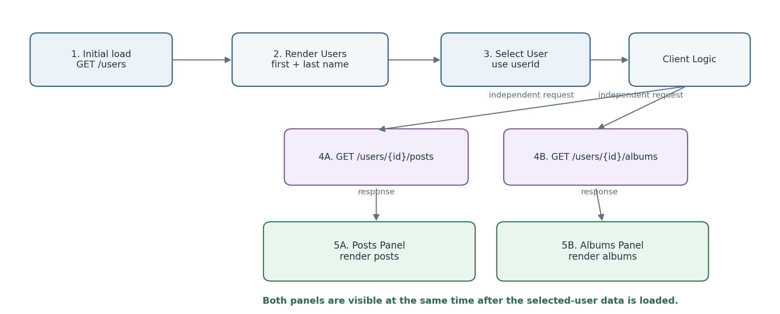

6. External API Interface
Purpose | Method | Complete URL | Used when
Retrieve users | GET | https://jsonplaceholder.typicode.com/users | Application initialization
Retrieve posts | GET | https://jsonplaceholder.typicode.com/users/{userId}/posts | After a user is selected
Retrieve albums | GET | https://jsonplaceholder.typicode.com/users/{userId}/albums | After a user is selected

7. Component Responsibilities and Interactions

7.1 Presentation Layer
- Displays the user list and selected user.
- Provides separate Posts and Albums sections that are both visible simultaneously.
- Displays loading, error, and empty feedback.

7.2 Client-side Application Logic
- Initiates independent Posts and Albums requests after selection.
- Tracks the selected user and request lifecycle.
- Processes JSON responses and updates the presentation layer.
- Prevents stale results from an earlier user selection from overwriting the current selection.

7.3 External API Boundary
- Provides user, Post, and Album data.
- No application-owned business service is inserted between the browser and the external API.

8. Interaction Scenarios
Scenario | Client-side flow | Result
Initial load | Initialize -> GET /users -> render users | Users visible
User selection | Capture ID -> GET posts + GET albums independently | Selected-user data retrieved
Posts rendering | Post response -> render Posts panel | Posts visible
Albums rendering | Album response -> render Albums panel | Albums visible
Simultaneous detail view | Two panels rendered together | Posts and Albums visible at the same time
API failure | Request failure -> error handling | User-facing error feedback

9. UI State Model
State | When it applies | Expected UI behavior
Initial / Users Loading | Initial GET /users | Show users loading indication
Users Loaded | Users successfully retrieved | Render user list
User Detail Loading | Posts and/or Albums are being retrieved | Show loading feedback in relevant detail sections
Posts Loaded | Posts response available | Render Posts panel
Albums Loaded | Albums response available | Render Albums panel
Error | A required request fails | Show meaningful error feedback in affected area
Empty | Successful response contains no items | Show explicit empty-state message in that panel

10. Cross-Cutting Design Considerations

10.1 Error Handling
- Non-success HTTP responses and network failures are treated as request failures.
- Because Posts and Albums are independent requests, failure handling can identify the affected resource.
- The UI should not remain in an unexplained loading state.

10.2 Loading and Feedback
Loading feedback is associated with the data currently being retrieved. Posts and Albums are separate resources, so their panel states may be tracked independently.

10.3 Maintainability
API communication, interaction/state handling, and DOM rendering remain logically separated. Endpoint construction uses the selected user ID rather than hard-coded user-specific URLs.

10.4 Security / Trust Boundary
API-returned text is treated as untrusted input and rendered using safe text-oriented DOM operations where practical. No authentication or authorization is included.

11. Performance Considerations
- Initial load retrieves only the users collection.
- User-specific requests are limited to the selected user.
- Posts and Albums may be requested concurrently because they are independent resources.

12. Deployment Assumption
The application is deployed as static/client-side assets and communicates directly with JSONPlaceholder over HTTPS.

13. HLD-to-LLD Boundary
The LLD defines exact files, functions, selectors, state fields, AJAX handling, loading/error markup, and rendering procedures.

14. Updated Design Decisions
- Presentation layer only; no application-owned business/service layer.
- Posts and Albums are separate API calls.
- Posts and Albums are rendered as separate panels and are visible simultaneously.
- JSONPlaceholder name is the display value for the requested first-name + last-name presentation.
- Client-side logic prevents stale user-detail responses from replacing current-user data.

15. Status
HLD v0.3 - Draft. This revision incorporates the latest requirements clarification about the presentation-only scope and simultaneous Posts + Albums display.

