**Introduction**

Prior to management of State Cell Research project, selection of development process was done based on following criteria:

* Backtracking to previous **process**(explained later)
* Staff Management in hierarchical format, encompassing amount
* Supports collaboration, multi-tasking, insertion at any process and stage
* Frequency of Progress Reporting: How constant the updated progress information is revealed to domain management

Out of 13 well known Software Development Life Cycles, presented custom designed development pipeline was developed from combination of stages of SCRUM, Feature Driven Development, Waterfall Model, Dynamic System Development Method and principles of Agile methodology. During modelling process, a crucial point was determined that separates software development life cycle from an ideal research and development life cycle.

"If we knew what it was we were doing, it would not be called research, would it?" - Albert Einstein

Above quote sheds light on the underlying fact of any study based development that components: Concept, Features (dynamic requirement constituting to “goal”) and prototype are subjected to constant refactoring, improvements, merges and expansion. Thus that concluded crucial point is: research projects must be time independent or should not be constrained by any deadline. Infact the only time based constrains a research project should have is the budget set for a targeted duration. In consideration to that point, it becomes apparently clear that existing software development life cycle cannot be adopted primarily because of necessity to deploy a working product demanded by domain managers and clients, as quickly as possible.

Time Independent Research and Development Pipeline in the broadest scale follows a cyclic model of a hypothesis led experiment whose analysis from results leads backto form another hypothesis as illustrated in Figure. To attain a sequential flow of events, the pipeline then partly takes form of Waterfall model having **processes** of Problem Study, Feature Study, Design Study, Prototype Study, Result Study and Forecast Study. Every **content** generated from each of these processes, expands in a tree hierarchy illustrated in Figure, giving birth to possible new content in each process. To further define it, a process generates new content based on previously existing contents. However, the content generated from Feature study sets a goal which then sets new **stages**. Each of the process conforms to a **routine report** consisting of logging processes called Identify, Obstacle and Decision. This routine report is vital for periodic monitoring, assessing progress of the project and measuring assertion, methodology and technical skills of a researcher.

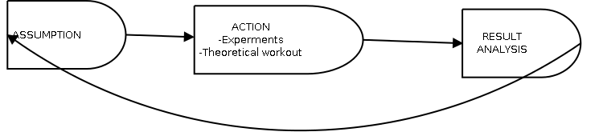

**Figure: D1**

**Steps**

**Process**

**Content**

**Refactoring**

**Staff**

**Study Domain**

Prospected area of study:

* Industry specific Marketed technologies
* Published articles
* Research Publications
* Published books on specific subject matter.
* Discussion groups in internet
* Organized meeting with professionals

**Problem Study Process**

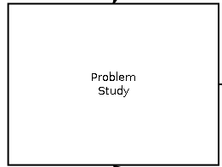

This process marks the beginning of a research project. To make call for such a decision more reasonable, parameters can be weighed to check if any custom criteria was met. Parameters illustrated in Figure is merely an example but for formality they seem suitable. Reported problems are initially listed and documented. Now during further exploration and analysis, it is very likely to discover more potential problems. New problems are included back in the original list and analysed again. This is a small example of backtracking but restricted to this process only. Problems falling within the same category, for example the cause found to be a single source, can be merged to account as a single problem.

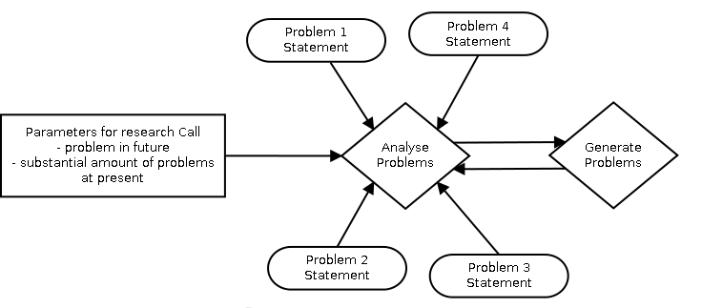

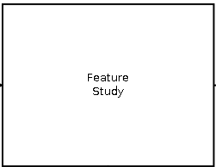

In this process, a study is launched in an attempt to produce well-defined requirement from problems found in Problem Study process. Studying would involve exploring existing market or common grounds for solutions. If solutions are found to be inadequate or none at all, topics related to listed problems are identified and studied. Sub-process of lunched study is then used to generate requirements. Created requirement is still subjected to study because it has only been identified thence sub-process must be backtracked to previous sub-process to check if it is a known requirement and the solution for that already exists in study domain. Only then requirement conduces to Feature content. Feature similar to its description in Feature Driven Design software development life cycle is analogous to a set goal. Feature is an aspect of functionality that needs to be included as well as determines the direction the project should be heading towards.

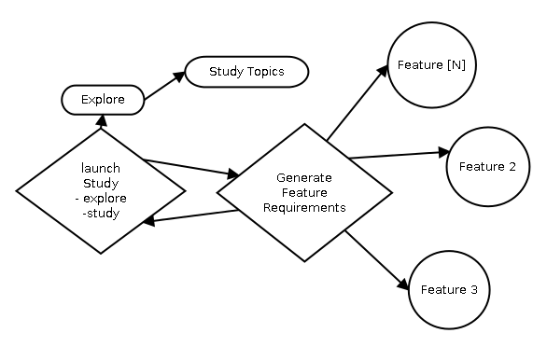

**Design Study**

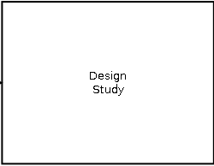

This process deals with construction of concept deigns. Procedure normally begins by proposal of a concept encompassing all features. Subsequently, sub-process involving investigation of existing or similar design into study domain is carried out. If explored concept design does not fully encompass a feature or all features or fails to satisfy a procured specification, a necessity emanates to develop a custom design.

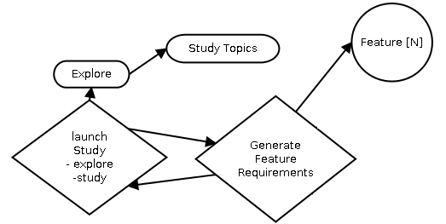

**Prototype Study**

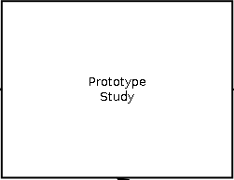

Before further explanation on this process, it must be understood that without measuring instruments an experiment cannot be conducted. Existence of measuring tools is vital for next process, Result Study. Implementation of concept design can follow a development process for management of prototype construction. At this process, it is recommended to carry out development of custom tool, if not already available, in parallel to prototype development since it optionally allows for control to choose upon implementation of important features or early implementation of interfaces to tools. Moreover, simultaneous production can also verify connection between prototype and its measuring tools is stable. Sub-process of tool implementation does involve exploration into study domain before actual implementation.

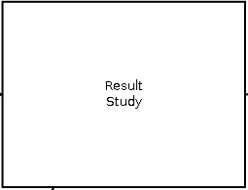

This process is where prototype systems can be tested, evaluated and analyzed. Since this is a generic pipeline, any type of methodologies for can be used. Sequential order of steps execution is important.

Evaluation: Procedures used to determine whether system meets planned criteria.

Testing: Determine system’s ability to complete certain test cases deigned.

Analysis: Data collection from measurements from simulations or actual specimen.

<http://www.softwaretestingclass.com/what-is-software-testing-methodologies/>

<https://engineering.purdue.edu/~engelb/abe565/sysanal.htm>

<http://www.slideshare.net/norazmi3003/testing-assessment-measurement-and-evaluation-definition>

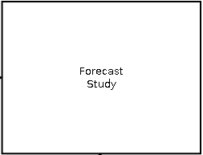

Final process that will mark the end of current stage. This is the process where collected documented efforts and results are analysed. This process is the key for evolution of research work to higher degree. Prospection of current development depends on retrospection from previous processes of collective stages, forecast of where this development is ultimately headed and assessment of changes that will be allowed or focused at next stage.

Retrospect: Past

Forecast: Future prediction of goals

<http://assessment.uconn.edu/what/index.html>

**Routine Report**

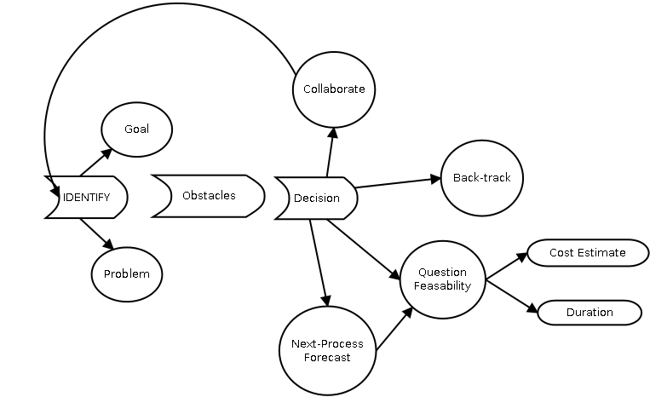

Routine report pipeline is the driver of all processes. This reporting pipeline is to be followed in parallel to all processes conducted. While working with every sub-processes and step, reports called identification, obstacles and decision are filled in appropriately with every information processed. Every member of the research team will be absolutely required to create everyday logs entailing all personal reactions, information discovered, resources found and ideas realized. By manual filtering or automated filtering by small programs, points marked can be characterized and grouped into either Identify or Obstacles report. This logging pipeline has the ability to track the measure of assertion and quality of applied methods and technical knowledge of the researcher creating the log. Measurement of assertion can easily be done by checking duration between past and present logs. Identification report will have sections of goals and problems that will used to log identified goals or problems. For few processes, goals could also imply as solutions. Obstacles report will contain obstacles encountered in getting information by lack of resources, computing gathered information, obtaining solutions, lack of equipment or hardware resources and other miscellaneous impedance. A decision log is final report that will contain sections of collaborate, back-track, next process forecast and question feasibility. When either identity report or obstacles report begins to substantially outweigh the other, any ongoing process is halted and following decisions needs to be made.

Collaborate: If there’s any discrepancy detected from inspection of logs or whether it is predicted that elements needed to be identified will not be completed within planned duration, the process can be restarted with greater workforce or replaced workforce with previously accumulated logged data.

Back-track: Normally when the list of obstacles grows substantially or even after successful carrying out the process, it is realized that goal pursued is not correct, it becomes apparent that an unexplored or misinterpreted factor is the cause. The only sound decision is to backtrack any process that is assumed to be the culprit.

Question Feasibility: Influence for this decision is attributed by both Obstacle report and Identity report. When list of problems in Identity report becomes substantially large than the time allotted to identify goals of that process, it is understood that extension of allotted time is required. From Obstacle report if it observed that numerous points imply either better hardware or software resources or cost associated to get certain task completed ( i.e work contracted, hired professional, hired member) than what the current budget supports, then question of feasibility rises again. Question of feasibility has mainly two domains of enquiry: Cost Estimate and Time Duration. Combined weight of both these factors determine whether if it is feasible to continue with current process, step to next process, stop the stage or put an end to the whole research.

Next Process: Once all problems have been resolved to identify goals, it is safe to move on to the next process. Though before doing so, it is rational to contemplate about the cost and time duration taken for the next process.

|  |  |  |  |
| --- | --- | --- | --- |
| Decision | Identify  Problems Goals | | Obstacles |
| Collaborate | - | - | + |
| Back-Track | + | - | - |
| Question Feasibility | + | - | + |
| Next Process | + | + | - |