Labyrinth v0.5
05/11/03
Michael Williams
phead@ucla.edu
http://www.zervent.com/michael/labyrinth/default.php

- Introduction
  - Labyrinth is a little VB game that I’ve been putting together for the past few years in my spare time. As such, it’s rather randomly organized and probably difficult to figure out for someone who has never seen it before (i.e., everyone other than me).

  - The general premise of the game is simple: you’re an adventurer who is trapped in a Labyrinth (a la the character Haplo from the Death Gate Cycle, if that means anything to you). You start the game at a city in the center of the maze with some money you can use to buy equipment and some character points you can spend to improve your stats. You must find your way to the end of the maze in order to win. I’ve never done it without cheating, because it takes a long time. I’d guess around 10 hours, but your mileage may vary.
- Interface
  - Click “Start New Game” on the start window to generate the Labyrinth. 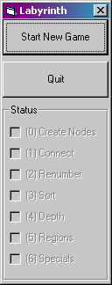
  - Once the world is generated, you will be presented with the main game window.
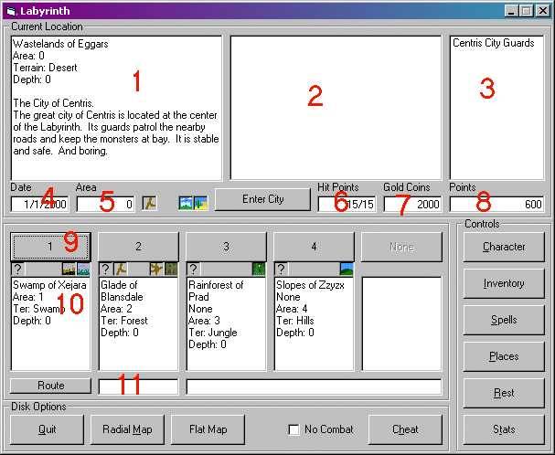
    - Let me briefly explain what red numbered items mean (ha):
      - Current location: this field describes where you are at the moment. The first line tells you the name of the “region” that you are in (in this case the “Wastelands of Eggars”). The “area” is the sector number that can be used to refer to the area you are in. The “terrain” determines what types of monsters live in the area. The “depth” is distance you are from the starting zone (explained in more detail later, think of it as a “dungeon level”, the higher it is the farther you are in the game).
      - History window: this field will contain a recent history of things that happen to you, such as moving between areas and encountering monsters.
      - NPC window: this window lists the NPCs that are in the same area as you are. Double-click on one to talk to them.
      - Date: the date inside the game. Each move takes up one day. Stores are restocked every month, and other events are timer-driven as well.
      - Area: again, the number of the area you are in.
      - Hit Points: an immediate indicator of how many hit points you currently have.
      - Gold Coins: how many gold coins you have. This number increases from time to time if you find pennies lying on the road.
      - Points: the number of character points you have available to spend.
      - Movement buttons: numbered 1 through 5, pressing one of these buttons will take you to the area that is described in the text box below the button.
      - For instance, pressing “1” here will take you to area 1 in the region “Swamp of Xejara”. The little icons underneath the button give further information about the area. The question mark indicates that you have not yet explored it, for instance.
      - Route Entry: entering an area number into this text box and then pressting the “Route” button to the left will cause the game to plot the shortest-path from your current location to the destination you choose. Note that it will only plot a route that goes through areas you have explored.
    - Here is a description of the rest of the buttons on the main interface.
      - Enter City: if there is a city (or other structure, such as a Fairy Pond or Haunted House) in your area, press this button to enter it. Enter Centris to start with and buy some equipment from the various stores.
      - Character: opens the character window that can be used to increase your stats by spending character points. Do this at the beginning of the game.
      - Inventory: opens the inventory window that is used to manage your inventory and equip items. Be sure to buy some equipment from Centris and equip it before setting out!
      - Spells: opens the spell window that allows you to cast spells, if you know any. Some spells can only be cast in combat and will not work from the main interface. Spells can be bought in shops in cities, or found on dead monsters.
      - Places: shows a list of all the places that you know about (such as cities, Goblin Mines, Carnivals, etc.). Clicking on one of them will load it into the route box, and you can then press the “Route” button to plot a path to the place of your choosing.
      - Rest: waits one day at your current location. Good if you need to heal or something.
      - Stats: shows some stats about the current game world.
      - Quit: quit the game. There’s no way to save it, sorry!
      - Radial Map: shows a map of the areas around your current location and the paths that connect them. Each area is color coded by terrain, and cities are shown on the map as white dots. Quite useful!
      - Flat Map: another map, but pretty useless.
      - No Combat: a cheat, check the box if you want to wander around without fighting anything. Disabled.
      - Cheat: another cheat, gives you a bunch of money and character points. Disabled.
  - The Character window lets you spend your character points.
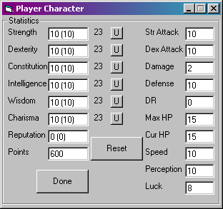
    - The numbers in parenthesis indicate the level of the Attribute in question after item modifiers have been applied. The “U” button raises the Attribute by one point; each increase costs a number of character points equal to the number directly to the left of the “U” button.
    - Reset: removes all the changes you have made since opening the window and gives you all your character points back.
    - The derived abilities on the right cannot be improved directly; they increase as your Attributes rise.
    - Done:
  - The Inventory screen has a lot of useful info on it.
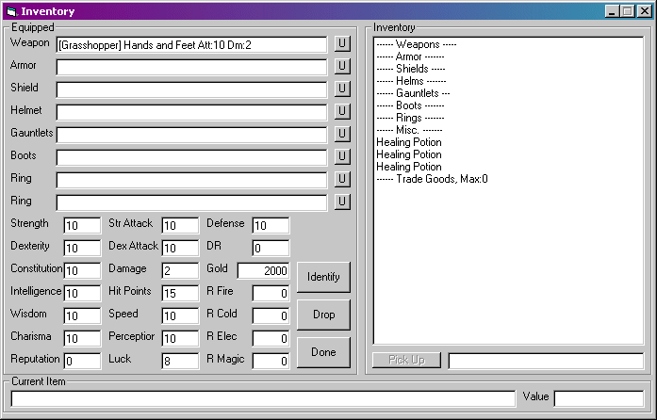
    - The Equipped box shows all the items you currently have equipped. At the beginning of the game you won’t have anything, just your bare hands and feet. The value in [brackets] in the Weapon field indicates your skill with your current weapon (in this case, Hands and Feet). The “U” button to the right of each slot removes whatever item you are wearing in that slot.
    - Beneath your equipped items is a readout of your current character stats, with the modifiers from your equipment taken into account. The seven stats in the left column are your character Attributes, which are determined by how you spend your character points. The other stats are derived from these seven base Attributes.
      - Strength: your raw physical power. Some weapons are based on strength, some on Dexterity. Affects damage, hit points, and many other things.
      - Dexterity: your agility and quickness. Some weapons use Dexterity for their base attribute. Affects speed, defense, damage, and other things.
      - Constitution: your health and fitness. Affects hit points, defense, damage resistance, etc.
      - Intelligence: your brains and smarts. Affects spell damage and learning, identifying items, speed, defense, perception, bartering, etc.
      - Wisdom: the ability to make good decisions. Affects perception, learning spells, identifying items, bartering, etc.
      - Charisma: how good you are with people. Affects bartering a lot… not that useful maybe…?
      - Reputation: how well known you are. This affects how much experience you get for killing various monsters, bartering, and many other things. Think of it as your “level” in some sense, except that it can go up and down from time to time. It does not directly affect combat ability as “level” in most RPGs does, don’t worry.
    - The three buttons in the center of the window affect any item you may have selected in the Inventory pane on the right.
      - Identify: you make an attempt to identify the item you have selected. May or may not work, depends on the depth of the item and your intelligence, perception, wisdom, reputation, etc.
      - Drop: drops the currently selected item.
      - Done: closes the inventory window.
  - Combat is simple!
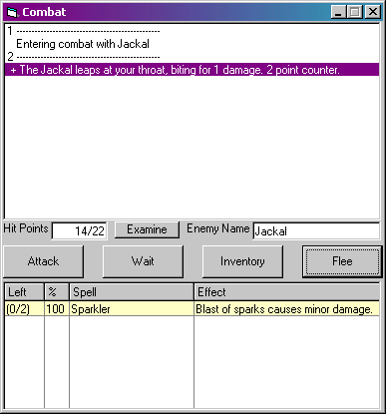
    - The main window displays the recent combat events.
    - Hit Points: your current and max hit points are displayed here.
    - Examine: pressing this button will give you some information about the monster you are fighting. The accuracy of this information will depend on many factors, such as your intelligence, wisdom, perception, reputation, how many of the monster you have killed before, whether or not you have studied the monster at an Academy, and what rumors you have heard about the monster from other travelers.
    - Enemy Name: the type of enemy monster you are fighting.
    - Attack: attack with your current weapon. Your speed determines how often you get to attack relative to the monster you’re fighting.
    - Wait: do nothing.
    - Inventory: change equipment or use an item from inventory. This counts as an attack.
    - Flee: run away! Or try to.
    - Under the four command buttons is the list of spells that you know and can cast.
      - Left: how many times you can cast it out of the max number that you can have ready at any one time. The max is determined by your wisdom, and the speed that you regain them is based on your intelligence.
      - %: the percentage chance that the spell will work successfully. This depends on how many times you have cast it before, as well as your intelligence, wisdom, reputation, etc.
      - Spell: the name of the spell.
      - Effect: a brief description of the effect of the spell.
  - Other stuff:
    - Death
      - If you die you will lose half the gold you are carrying and ten points of reputation. You will be returned to Centris. Not really a big deal unless you’re saving up for a big purchase.
    - Items:
      - Many items can be used by double-clicking them in the inventory window. Play around.
      - You can’t use wands, scrolls, and some other things until they are identified.
      - There are lots of artifacts in the game that are dropped randomly by monsters. They have pretty interesting effects.
      - Identifying items gives you some character points.
      - The price of trade goods at each city largely depends on the terrain the city is located in.
      - The number of trade goods you can carry depends on your reputation.
      - Attributes on gloves affect combat when you’re armed or fighting with hands and fists. Boot attributes come into play when you kick.
    - Combat:
      - It’s cheap to listen to monster rumors from travelers and to learn about monsters from Academies. This knowledge will help you in combat.
      - You’ll get less experience when you fight the same monster over and over again, so move around.
      - The gold you get from combat is somewhat related to reputation, so don’t fight too far below your level or you’re just wasting time.
      - Monsters have weaknesses to different elements, so use weapons and spells to your advantage.
      - Monsters on roads are weaker than monsters in the wild.
    - Character:
      - Specialize in magic or physical combat, but don’t neglect the other one.
      - Hand to hand combat can get pretty powerful once you get good at it.
      - Watch for Attribute thresholds that give improvements to derived characteristics. For example, damage resistance goes up every 15 constitution points.
    - Specials:
      - Watch for specials as you walk around, most of them have useful stuff.
      - You can build your own castles if you buy a Foundation from a city. You can then store gold and even get income from your castles, as long as they aren’t robbed while you’re away.
      - Follow roads to find new cities.
      - Resting at an inn in a city or at a crossroads is cheaper than dying.

