## Preparing to Share Your Life Journey

### Purpose and Overview

The purpose of reflecting on your life journey is twofold:

1. To gain self-insight into what God has been doing to better discern what He may desire for your future path and calling
2. To allow others in our group to see what God has been doing in your life so they can encourage you and perhaps help you hear from God

We'll dedicate approximately one hour per person. The suggested structure is:

* 30 minutes to share your life story
* 15 minutes to discuss your current spiritual state
* 15 minutes to field questions from the group

Plan to set aside 1 to 5 hours for the reflection process described below. You might want to do this in smaller segments if that works better for you.

### Reflecting on Your Journey

There are many approaches to reflecting on your life journey, and there are even retreats devoted solely to this purpose. What follows is simply a suggestion—please feel free to approach this in whatever way works best for you.

#### Step 1: Brainstorming Key Moments

When preparing, focus on movements rather than getting bogged down in details:

1. **Gather supplies:** You'll need post-it notes (or small pieces of paper), a pen, and a large workspace (wall, table, or large sheet of paper) to arrange your timeline later.
2. **Begin with prayer:** Ask the Holy Spirit to bring to mind important life events He wants you to reflect on.
3. **Brainstorm without filtering:**
   1. Write each life event on a separate post-it note
   2. Keep it simple—just a few words to identify the event (e.g., "Parents divorced", "Moved to Seattle", "Baptism", "Fired from RadioShack”, etc.)
   3. Don't worry about chronology or significance, just get all your ideas on paper.
4. **Consider including:**

* Your family of origin experiences
* Your spiritual origin story
* Key relationships that shaped you
* Moments of conviction or spiritual insight
* Substantive dreams and visions
* Successes and celebrations
* Failures and disappointments
* Times of grief or loss
* Significant life transitions / redirections
* Early desires for and or experiences in ministry / service
* Anything else that comes to mind

When you've exhausted your mental resources, ask the Holy Spirit if there's anything else He wants to bring to mind. Set aside a few minutes of quiet waiting. Take a few deep breaths and wait expectantly. Note anything additional that emerges. Consider setting a timer for 2 to 5 minutes to make sure you don’t give up too soon.

#### Step 2: Organizing Your Timeline

After collecting your memories on post-it notes:

1. Add dates to each post-it (approximate years are fine)
2. Arrange them in chronological order:
   1. Lay out your post-its in a line, with earliest on the left and most recent on the right
   2. If you have many notes, you might start by sorting them into life phases (childhood, teens, 20s, etc.)
3. For each experience / memory, reflect and mark the **emotional impact** on the bottom left of the post-it. This should be what it felt like at the time. Write simple descriptives or emojis on each post-it. E.g.,
   * 😊 happy
   * 😢 sad
   * 😕 confused
   * 😫 anguished
   * 😃 excited
4. For each experience / memory, reflect and mark the **spiritual significance** on the bottom right of the post-it. This should be, with hindsight, what you believe was happening spiritually at the time. Write one of the following symbols on each post-it:

* ↑ = rapid growth toward God
* ↗ = growth
* ↔ = plateau
* ↘ = backsliding
* ↓ = severe backsliding away from God

1. If you have post-it notes that don’t appear to be particularly meaningful in their emotional impact or spiritual significance, discard them. The goal is not to catalog everything that happened to you, but rather the experiences that contributed substantially to your formation.

*This can be an emotionally demanding exercise. If needed, take a break before continuing.*

#### Step 3: Visualizing Your Journey

Now comes the most insightful part—arranging your timeline visually. Choose one (or ideally both) of these methods:

##### Option A: Spiritual Growth Trajectory

1. Arrange post-it notes horizontally in chronological order at the bottom of your workspace
2. Establish a horizontal midline on your workspace representing your spiritual state when you first experienced the love of Jesus
3. Place the post-it for when you encountered the love of Jesus on the mid-line. Every other post-it note will be relative to the one next to it.
   1. Notes with ↑ or ↗ should be placed higher than the previous post-it
   2. Notes with ↓ or ↘ should be placed below the previous post-it
   3. Notes with ↔ should stay in line with the previous post-it
4. For example, see this example of a simplified life journey of King David of Israel:  
   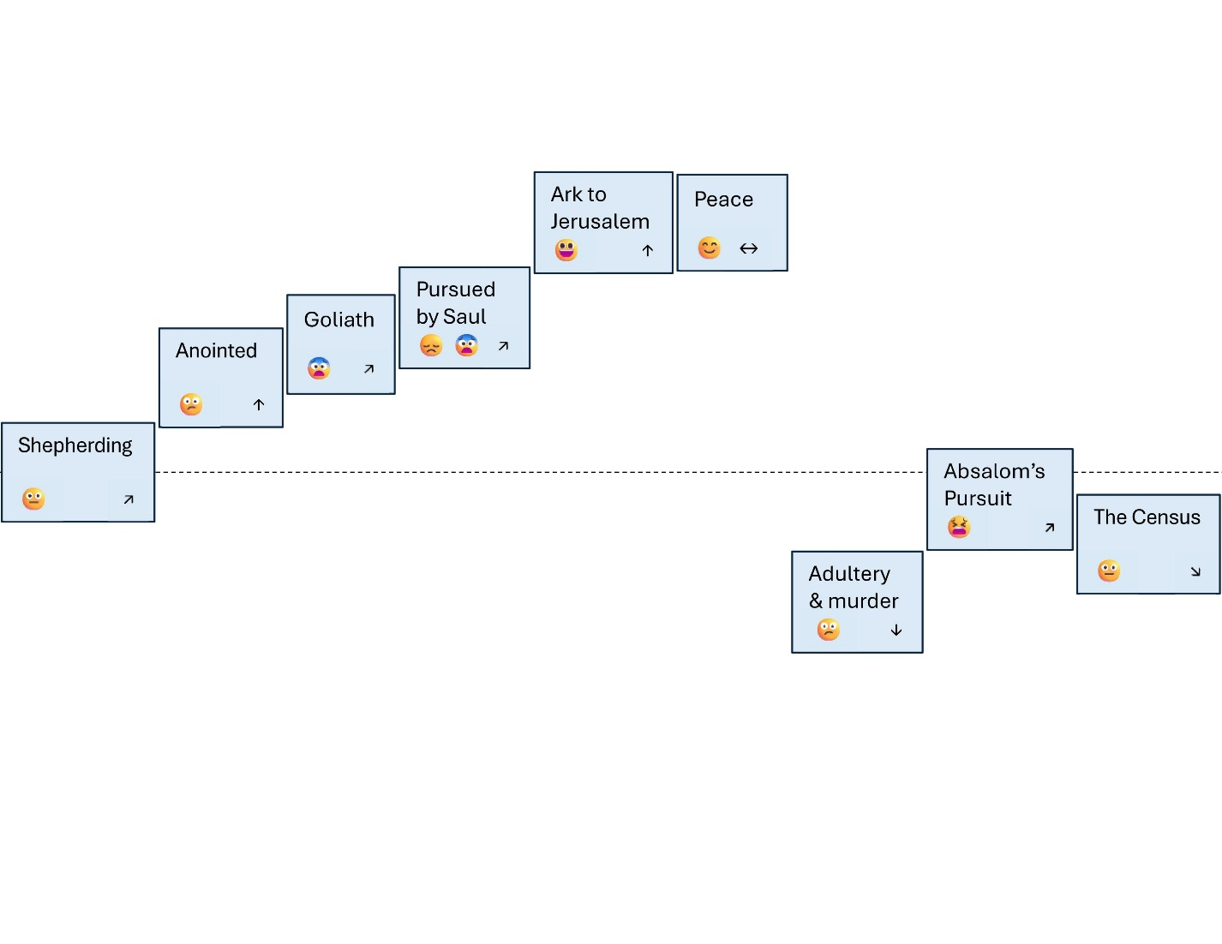
5. Step back and reflect on the pattern of your spiritual journey:

* Has it been like downhill skiing?
* Like living on a plateau?
* Like hiking up and down the Issaquah Alps?
* Like ascending Mt. Rainier?
* Like a rocket ship?
* Like something else?

1. Pray about what you see
   1. Be honest with yourself about the patterns
   2. Ask God if He perceives things similarly
   3. Be open to adjusting the post-it symbols and positions based on the promptings of the Holy Spirit

##### Option B: Emotional Experience

1. Arrange post-it notes horizontally in chronological order at the bottom of your workspace
2. Establish a horizontal midline on your workspace representing emotional/social contentment (a healthy, theoretically sustainable, baseline)
3. Position each post-it note relative to this midline based on your emotional experience at that time
4. Happy/joyful experiences go higher above the line
5. Difficult/painful experiences go lower below the line
6. The distance from the line represents the intensity of feeling
7. For example, see this example of a simplified life journey of King David of Israel:  
   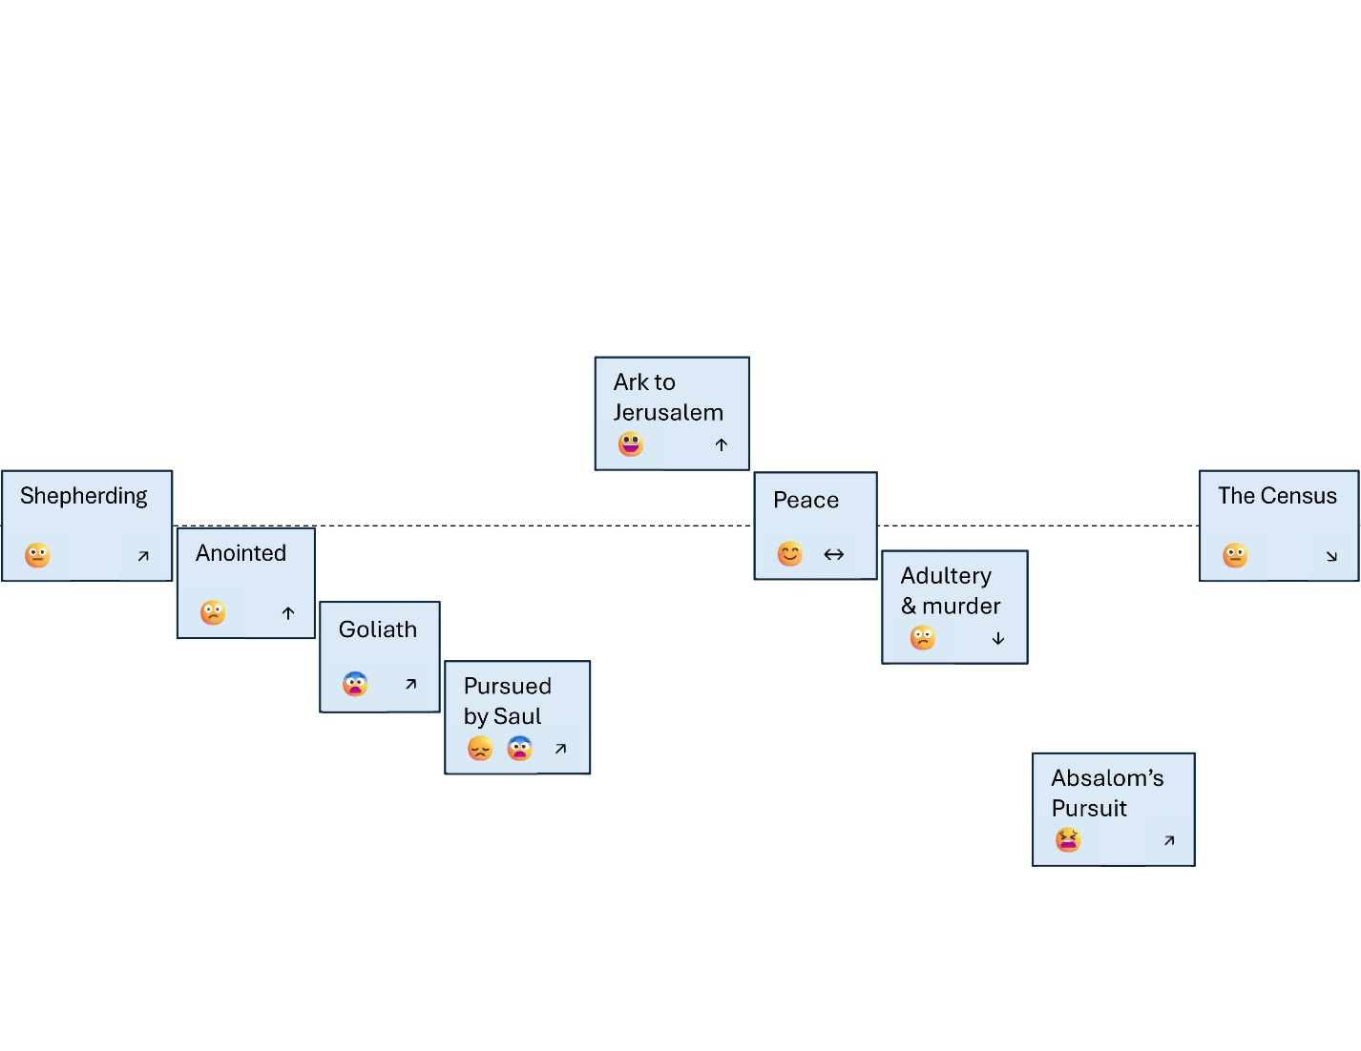
8. Reflect on the patterns:

* How do you interpret what you see?
* Where was God during these ups and downs?
* While acknowledging that we live in a profoundly broken world, how did God redeem (or might He be redeeming) difficult experiences?
* Are there any surprising patterns or insights?

1. Pray about what you see

**With either option**, take time to acknowledge God as the God of your past, present, and future. As Revelation 1:4 reminds us, He is the one "*who is, and who was, and who is to come*."

**Tip:** Take a photo of your final arrangement. This can help you remember insights and prepare for sharing with the group.

### Preparing to Share with the Group

#### Selecting What to Share

After your reflection process, it's time to prepare what you'll share with the group:

* Review your timeline and identify 5-10 key moments or seasons that have significantly shaped your spiritual journey
* Consider both heights and depths - meaningful spiritual growth often happens in both joyful and difficult seasons
* Look for patterns or themes that might have emerged in your reflection
* Consider preparing brief notes to guide your sharing. However, you don't need a script

I encourage appropriate vulnerability about both the ups and downs of your journey, but remember—it's your story, so you decide what feels right to share.

Note that the time frame described below is a guideline to help us stay on track with approximately one hour per person each week. Feel free to deviate, but please limit the entire session to one hour.

#### Your Life Story (30 minutes)

* Feel free to bring your post-it notes, a simple outline, or anything that will help you feel more comfortable.
* Focus on telling your story directly rather than creating presentations
* Share honestly about significant movements and moments that have shaped you
* You might want to practice beforehand to ensure you can share your journey in about 30 minutes

#### Your Current Spiritual State (15 minutes)

Please prepare to share about your current experience with God. Some suggested questions you might answer include:

* What is your current experience of intimacy with God?
* Do you have any practices or routines that you find life-giving in any domain?
* Do you have a current practice of prayer? If so:
  + What do you do?
  + How often?
  + What is that experience like for you?
* Do you have a current practice of Scripture engagement? If so:
  + What do you do?
  + How often?
  + What is that experience like for you?
* Are there any key Scripture verses, images, or theological concepts that you currently find motivating, intriguing, life-giving, or simply echoing in your mind?
* Do you currently have any strong spiritual desires or longings? If so, what are they?
* Is there anything else you'd like to share about where you are currently?

#### Group Questions (15 minutes)

If you're comfortable with it, we'll conclude with time for questions from others in the group. This is optional but potentially insightful, as others may notice patterns or God's work in ways you haven't seen.