|  |
| --- |
| EEL 4742C-12 |
| EEL 4742 Laboratory |
| Experiment #4 |
|  |
| **Daniel Franco, Andrew Mendez**  **3/18/2014** |
|  |

|  |
| --- |
|  |

**Objective:** To develop C language and assembly language programs that provide an interface to a standard matrix LCD module. In particular, the experimenter board which contains the MSP430FG4618 and the on board LCD display will be used.

**Apparatus List:**

* Dell Computer
* Monitor
* Keyboard
* Mouse
* CCS software
* MSP430FG4618

**Procedure and/or Design Methodology:**

This experiment had two separate parts to it, which we will describe in order as we worked on them. We will only provide screenshots of our code for parts 4 through 7 since the first three parts are already provided to us in the manual.

Part One, C code:

1. Read the C language program included with this laboratory experiment. Become familiar with the setting of the various registers used by the MSP430FG4618 to configure the LCD.
2. Build a CCS project using the steps described in experiment #1 using the C language program included with this laboratory.
3. Run the program and verify that all of the LED segments have turned on and that the yellow LCD is blinking.
4. Write a C language program to display the number 2 (segments a,b,d,e,g) on the right most seven segment display.
5. Write a C language program to display the number 2 (segments a,b,d,e,g) on the left most seven segment display.
6. Write a C language program that can display the numbers 0 – 9 and the letter A, b, c, d, E, and F. Please take note the number 6 and the letter b. The number six should have a top hat where the letter b does not. Have this program count from 0 to F and then repeat
7. Write a C language program that counts up from 0 to 999 in decimal and displays this count on the LCD display approximately every tenth of a second if SW1 is pressed on the experimenter board otherwise the counter counts down is SW2 is pressed and displays the count on the LCD. If neither of the switches are pressed then the count displayed on the LCD display is the last count.

Part Two, Assembly code:

1. Read the assembly language program included with this laboratory experiment. Become familiar with the setting of the various registers used by the MSP430FG4618 to configure the LCD.
2. Build a CCS project using the steps described in experiment #1 using the assembly language program included with this laboratory.
3. Run the program and verify that all of the LED segments have turned on and that the green LCD is blinking.
4. Write an assembly language program to display the number 2 (segments a,b,d,e,g) on the right most seven segment display.
5. Write an assembly language program to display the number 2 (segments a,b,d,e,g) on the left most seven segment display.
6. Write an assembly language program that can display the numbers 0 – 9 and the letter A, b, c, d, E, and F.
7. Write an assembly language program that counts from up from 0 to 999 in decimal and displays this count on the LCD display approximately every tenth of a second if SW1 is pressed on the experimenter board otherwise the counter counts down is SW2 is pressed and displays the count on the. If neither of the switches are pressed then the count displayed on the LCD display is the last count.

**Design Specification Plan:**

C- Programs:

For the C program part of this experiment, we relied on the code that was provided to us beforehand, we simply altered it to complete the specified tasks. Parts four and five only required to get rid of the original loop in the code, and parts six and seven required us to create and store an array that contained all of the values we would be displaying and a series of loops and conditional statements that would allow us to display the correct characters on the board’s LCD screen.

Assembly programs:

Since the assembly programs were designed to complete the same tasks as the C programs, we followed the same plan, with the difference that this time we would be programming in a different language at a level closer to the hardware. The discussion provided to us in the pre-laboratory assignment helped us thoroughly because it gave us a direct idea of what we should do with the hardware in order to get it to complete the assigned tasks.

**Test Plan:**

In order to test our code we would be using the MSP-430FG4618 board. By running the code we had created in the Code Composer Studio, we would be able to communicate with the hardware through the Terminal and make sure that the input we had was dealt with correctly and displayed the proper values.

**Source Code:** (We will only be including the primary parts of the codes, if we copy the whole code into here, the report will be too long and we would not want to print too many pages)

**Part One:**

Displaying ‘2’ on rightmost segment

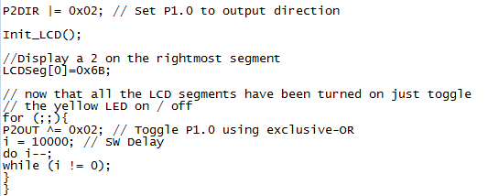

Displaying ‘2’ on leftmost segment

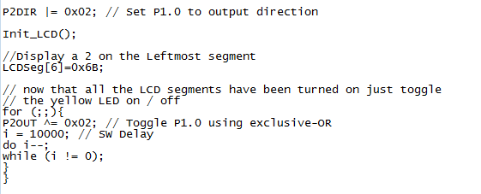

Looping from ‘0’ – ‘F’

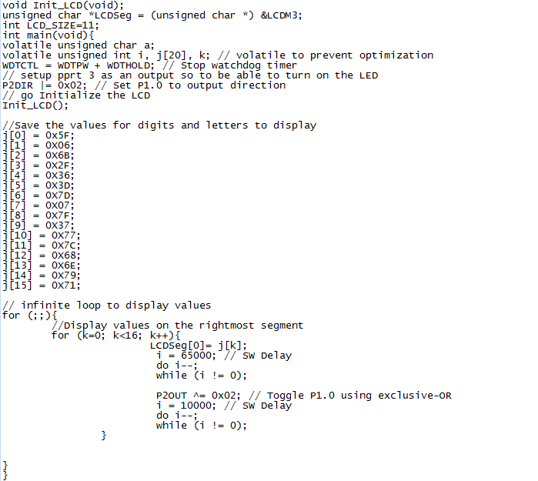

The following three screenshots compile the last piece of code in C language:

First part of program, store array, define counters and initialize display

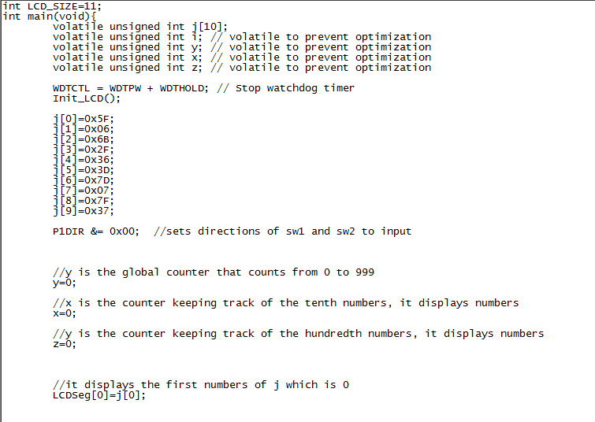

First part of loop, checks for SW1 and counts forward

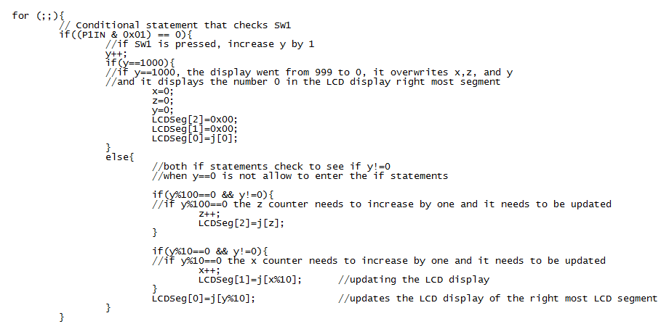

Second part of loop, checks for SW2 and counts backwards

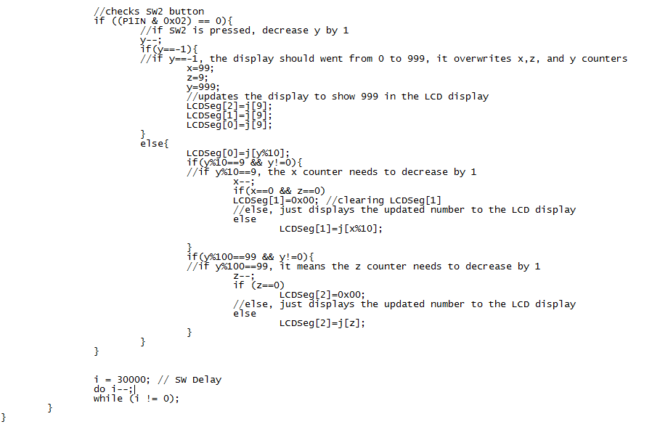

**Part Two:**

**Here is the first assignment completed in assembly**

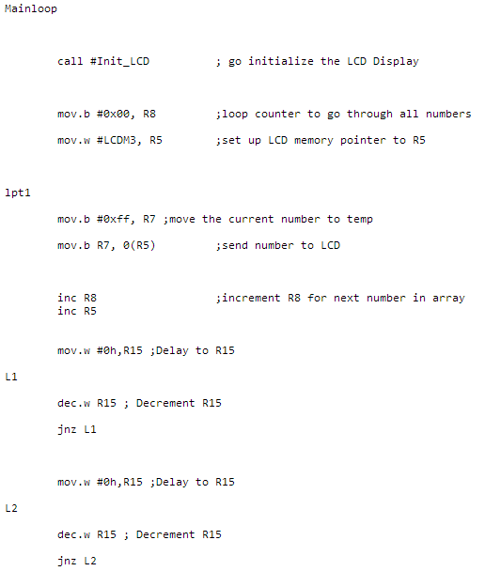

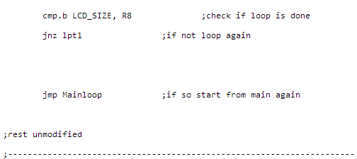

**Here is the second assignment completed in assembly**

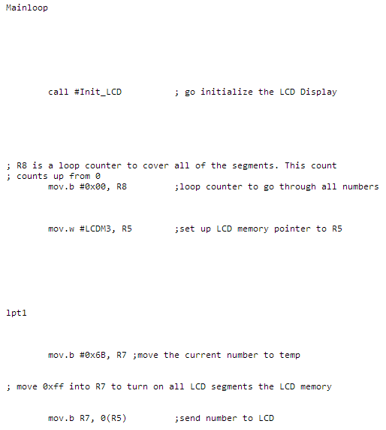

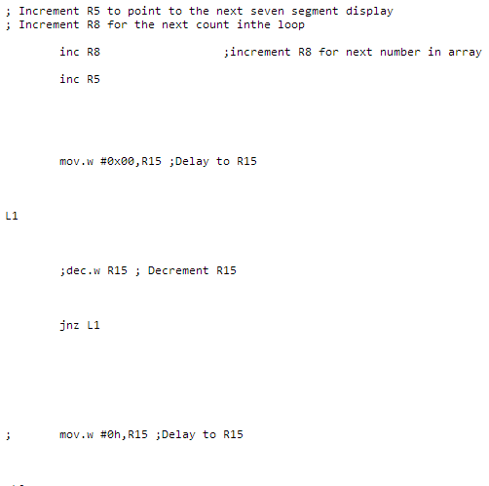

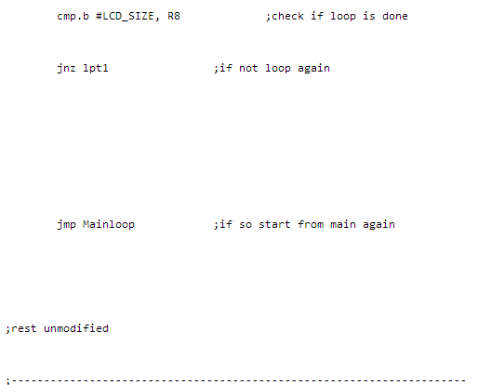

**Here is the third assignment completed in assembly**

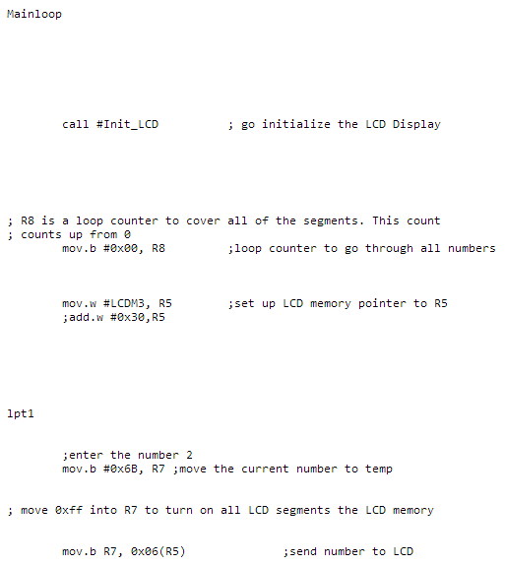

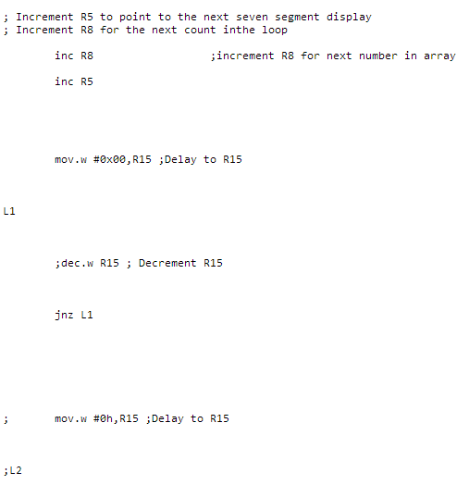

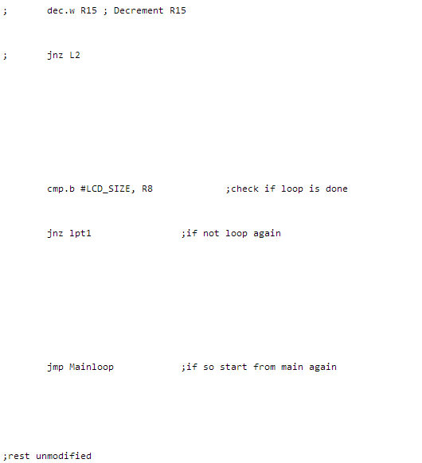



**Here is the 4th assignment completed in assembly**

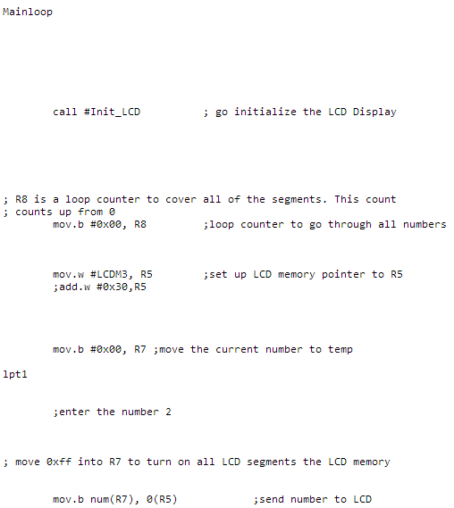

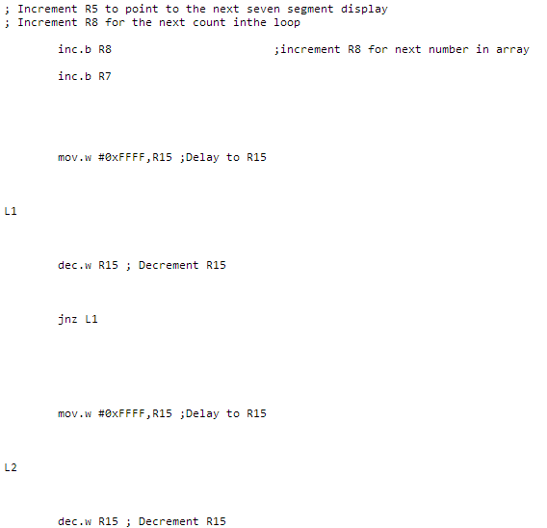

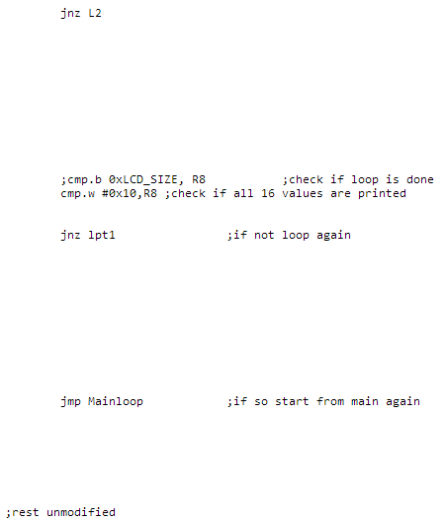



**Here is the 5th assignment completed in assembly**

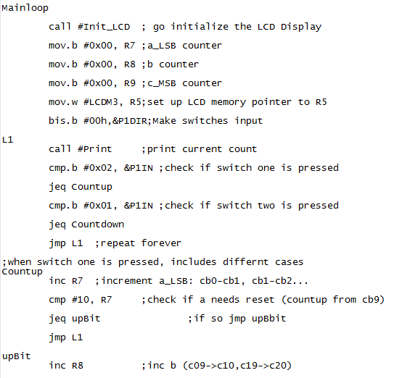

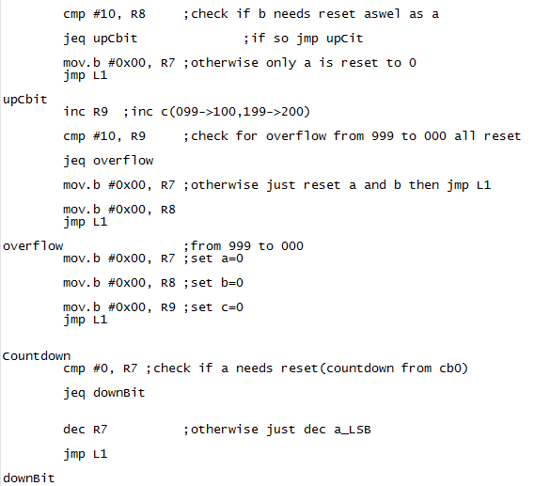

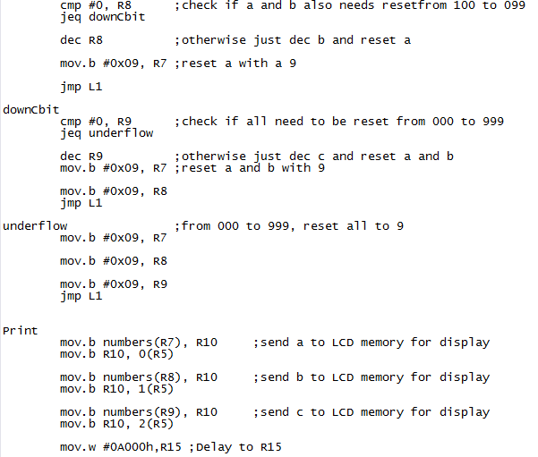

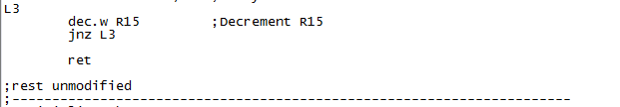

**Conclusion:**

In this lab, we learned and programed to a standard matrix LCD module using an MSP430. We developed C language and assembly language programs that provide an interface to a standard matrix LCD module. In particular, the experimenter board which contains the MSP430FG4618 and the on board LCD display will be used. We learned how to display characters, interface buttons to the LCD Module, and interface serial input to the LCD Module.