<https://www.eefahotels.com/accommodation/standard-rooms/>

**First page**

Bhubaneswar, one of the fastest growing metropolises of the country, is not only the political capital of Orissa but also is developing into an opportunity capital of the state. This has created a burgeoning floating population to the city which is on the rise every day. The mushrooming of large and medium star hotels in and around the city is an obvious indicator of this. But there is a lack of sufficient number of budget category hotels in the city, catering to the lower and middle class visitors who come for business or governmental works.

Hotel Bluestar is located geographically at the epicentre of this business, administrative as well as the political activity district of the city. The Railway station is 1.5 kms and Airport is 2 kms away. The Legislative assembly, Secretariat, Heads of the department building, banks and other allied offices, market, cinema hall are situated within a radius of half a kilometer.  
Hotel Bluestar was established in 1977 and has 13 well appointed rooms with all required amenities.

The hotel is known for its impeccable standards of hospitality amongst hotels in Bhubaneswar. The hotel staff always ensures that their guests have a memorable staying experience at our hotel. We offer a range of [facilities](https://www.beaconhotels.com/grand-ashirwad-bhopal-hotel/facilities/facilities.html) and some exciting [dining](https://www.beaconhotels.com/grand-ashirwad-bhopal-hotel/dining/dining.html) options at our ***Red Chilly*** restaurant. Enjoy a great vacation at our hotel in Bhubaneswar!!

**Second page**

The [rooms](https://www.beaconhotels.com/grand-ashirwad-bhopal-hotel/rooms.html) at Hotel Bluestar, is an absolute delight to weary travellers. Our rooms are decked with good facilities and offer a great sense of comfort that lets you unwind. We offer [Executive Double AC Rooms](https://www.beaconhotels.com/grand-ashirwad-bhopal-hotel/rooms/executive-rooms.html), [Deluxe Non AC Rooms](https://www.beaconhotels.com/grand-ashirwad-bhopal-hotel/rooms/deluxe-rooms.html), and [Single Non AC Rooms](https://www.beaconhotels.com/grand-ashirwad-bhopal-hotel/rooms/grand-executive-rooms.html). The attractively-equipped rooms are beautifully decorated with double beds and twin beds and are equipped with all the comforts that are ideal for both business and leisure travellers.

Executive Double Rooms:

Each of the rooms has been designed and furnished with a unique style with the finest features of a comfortable accommodation. All rooms have an ample sized bathroom. Some of these delightful rooms also have a balcony providing a great view.

## Deluxe A .C Room

Specially designed keeping in mind the needs of a modern-day traveller, these rooms have been thoughtfully designed with space efficient straight line furniture and comfortable beds with all amenities.

## Deluxe Room

The Delux Rooms are well-appointed, with a range of personalised services.

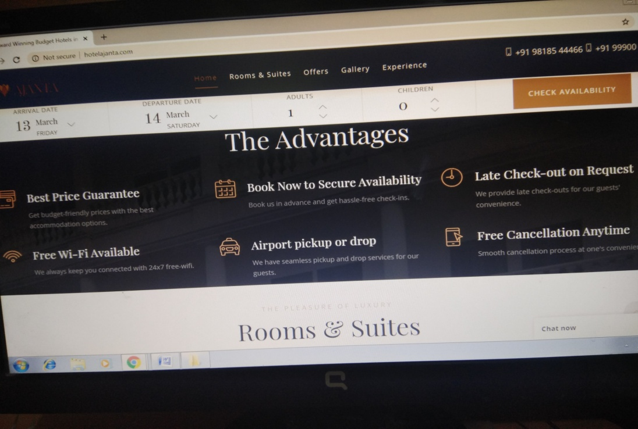

LAST PAGE

What People Say

## [Deepak](https://www.cntraveller.in/story/mumbai-now-indias-first-pod-hotel/) Ghosh

Cheap and Chic, this one will cost you a third of whatever you pay elsewhere

Srishti Sharma

*“Been here twice and have loved my stay. It's a very different experience. The service is very warm and welcoming. Would highly recommend it.”*

SumitAgrawal

*“Awesome experience....can't explain in words.....I will recommend to all my friend!”*

Nikhil Minocha

*“I was stuck at the airport for the night and my friend called me and told me to try the Bluestar Hotel. 10mins drive from airport and I landed at the Hotel. Comfortable, spacious and a complete new experience of how small budget hotels can transform into future. Thank you for the wonderful services Bluestar. Look forward to many more stays to come.”*

Srishti Dutta

*“Been here twice and have loved my stay. It's a very different experience. The service is very warm and welcoming. Would highly recommend it.”*

Amit Mukherjee

*“Awesome experience....can't explain in words.....I will recommend to all my friend!”*



**Hotel Bluestar**

powered by Google



[Rupesh Parate](https://www.google.com/maps/contrib/106779183151802671770/reviews)

3 months ago

 Awesome Experience while staying. Staff is very helpful. If you are going for first time don't hesitate just go and stay. They will explain everything if you are going for first time. Best for night read more



[Hariharan S](https://www.google.com/maps/contrib/108304147271350356787/reviews)

6 months ago

 This hotel has a good concept of providing a comfortable room A place that is even for locals and one night stay or prolonged stay || center of the city || near the airport ||super clean ||great toilet and all facilities.